
Assignment Cover Sheet

Student Name: | Joshua Alec Doulton Jones
Student Number: | 31840
Course: | Diploma in Logistics & Supply Chain Management (Level 4)
Assignment NO: | 6

Marking Criteria:
We expect the learners to write minimum one well expressed point in three lines against each allocated mark. This means one needs to write 15 lines with 5 well expressed points to get high grades for a 5 marks question.
For high grades use examples and illustrations where appropriate.

Student Statement:

By submitting this assignment, I confirm that this is my own work.

Student Signature | Joshua Jones | Date | 12/04/2019

For Tutor / Assessor Use Only
Total Marks
Marks Obtained
Percentage / Grade

1i)
Facility management refers to decision making with regards to the roles played by each facility, the capacity allocated in each facility and the allotment of suppliers and markets to each facility.
1ii)
‘Milk run deliveries’ refer to a particular method that involves carrying mixed loads for the same customer i.e. visiting all the relevant suppliers in one go and then delivering it to the customer instead of having each component delivered individually (Business Dictionary, n.d.).
1iii)
Reverse Logistics refers to the planning and implementation of every step of the manufacturing process with the intent of reusing the products and raw materials, as a form of recycling (Robinson, 2014).
1iv)
The two kinds of delivery sources are Single Product Locations and Distribution Centres.
1v)
Production scheduling typically involves the planning of procurement, personnel and the machinery, such as the hours to be allocated for each worker and machine, as well as the procurement systems to be utilised (Gartenstein, 2019).

1vi)
The key steps to Effective Order Management are as follows:
- Entering the order once and only once so as to capture the accuracy of said order
- Automate order routing procedures, with human intervention only in exceptional circumstances
- Make the order status visible to the customer, which in turn can result in a higher standard of customer service (O'Brien, 2004)
- The usage of integrated order management systems, so as to maintain the consistency and accuracy of the data involved in the production and ordering process
1vii)
Outsourcing the operations of the supply chain can have many benefits (Finn, 2017), such as:
- Allowing the company to focus on their primary task, such as Research and Development to improve their products
- Ensuring security in the supply chain, such as the quality of the materials and compliance to laws and standards every step of the way
- More effective management and reduction of costs
- Being able to meet customer demands more effectively
- Increasing the overall capabilities of the supply chain

2)
“The more flexible, responsive, and cost effective the supply chain is, the more likely the product will be to succeed in its market.”
The above statement is true to a large extent.
Regardless of the product being brought out into the market, if the supply chain (and by extension, the company in question) is unable to respond to market changes in any given scenario, then it is only a matter of time before said market changes end up spelling the end for the company. In addition, the ability of the supply chain to adapt to any outside disruptions (such as disasters, suppliers failing to adhere to contracts, etc). Also, depending on the product in question, the demand of said product may fluctuate over time, such as those for skis or surf boards in countries with four seasons (Jarmila Kopecka).
The responsiveness of the supply chain is also important. Even if a supply chain is able to change according to the current market, the timeliness of the response by the supply chain in question is paramount (Mayville, 2018). For example, it will practically be pointless if a company takes five months to respond to a spike in demand for winter clothing, for by the time the supply is able to fulfil the forecasted demand, the costumers would have turned to the company’s rivals instead, and winter would be over.
Cost effectiveness of a supply chain is also important. This is due to the simple fact behind most, if not all companies: They want to make a profit. By ensuring that their supply chain is cost effective in terms of deliveries, labour costs, automation and efficiency of the general system in place, they will be able to reduce their expenditure while increasing their profits, even if their revenue remains unchanged. Hence, the considerations and steps taken when determining the usage of assets, be they financial or technological, is also key to maximising profits (Morse, 2018).

Project
As the economy of a country expands, and the companies in every nation increase in size of operations and market, logistics continues to be a fundamental necessity in ensuring that operations can continue to be efficient. However, nothing is perfect, and sometimes flaws in the system can only be found out after it has been put into practice. Flaws are part and parcel of improving the supply chain and can generally be accepted, as long as the relevant entities do something to correct or minimise said flaws.
This report will look at some of the examples in everyday life that can be improved upon.
In every supply chain, be it one that provides goods or services, communications is a key factor in ensuring that every step and component of said chain is in line with the laid-out objectives of the company, which can and will in turn lead to overall success (Koester, 2015). Communication of information to the consumers is vital, but so is communication within the organisation. An example can be shown below.

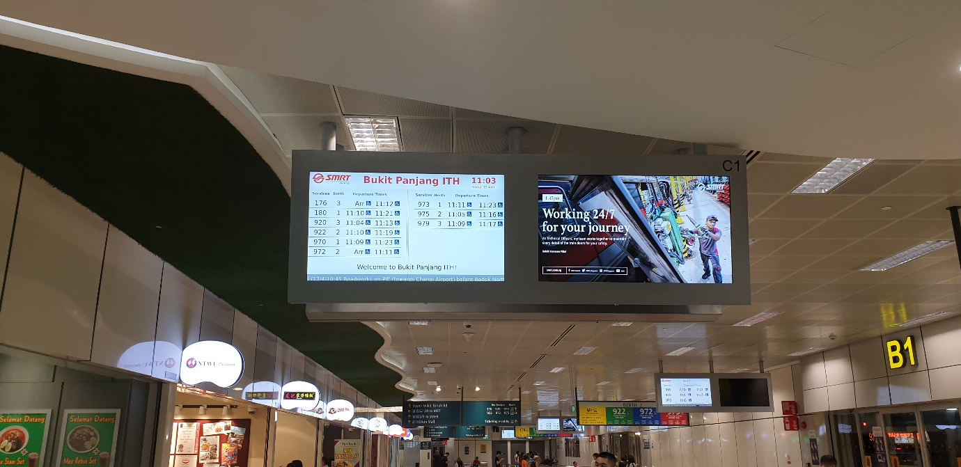
Figure 1. Bus Timings at a Bus Interchange in Singapore

The bus timings for the various bus services can be seen easily by all commuters. They are able to discern from the screen the bus number, the timing of arrival, locations that are serviced, and even the time of arrival for the next bus. When the timing for the bus is current, it is shown on the screen to have arrived. However, this is not always the case. There are numerous occasions in which the bus is a few minutes late, or a minute or so early. This can be initially be attributed to a lack of communication between the bus schedulers and the bus drivers, but upon closer look of the surroundings, one can see that there are many prompts and screens showing the drivers the timings that are to be adhered to.
If communications is the issue at hand (though it is not in this example), research and investigations need to be carried out in order to find out at which point does the communication breakdown, be it between management and operators or simple lack of resources. If it is the implementation of the standards that are expected by the company, then various penalties can be imposed, such as deduction of pay or a mark in the employee’s employment record wit the company, but that should only come into play if the standards were violated multiple times and without any reasonable excuse (e.g. urgent bathroom use).
One other prime example of poor planning of logistics is the lack of certain products that are in high demand by consumers.

Figure 2. K cereal on shelves in a supermarket
In figure 2, the K cereal, or more specifically the Vanilla-Almond flavoured variety, is rather popular amongst consumers. A majority of the time, the flavour is out of stock, and is only restocked when the other flavours are out as well. This can reflect a less-than-satisfactory standard of adjusting to the market demand for certain products. In this example, retailers and/or distributors need to take note of the data in term of market demand and stock up accordingly. If not, then customers will end up taking their business to rivals, which can and will end up being lost revenue for the companies in question.
At the end of the day, there will always be flaws in every single supply chain no matter how much effort and research in put into developing it. However, this does not mean that the companies should shy away from making improvements, especially if they want to remain competitive in the market.

