
Assignment Cover Sheet

Student Name: | Victor Omotoso
Student Number: | 34830
Course: | Advanced Diploma in Logistics Management (Level 5)
Assignment NO: | Assessment # 9

Marking Criteria:
We expect the learners to write minimum one well expressed point in three lines against each allocated mark. This means one needs to write 15 lines with 5 well expressed points to get high grades for a 5 marks question.
For high grades use examples and illustrations where appropriate.
Please insert your completed assignment ( in word format) here:
1.
i. Explain the above mentioned statements with reference to the Time Series Method.
Time series analysis comprises methods for analysing time series data in order to extract meaningful statistics and other characteristics of the data. Time series forecasting is the use of a model to predict future values based on previously observed values.
Demand is strongly related to particular environmental factors or market factors for example demand for commercial loan is often closely correlated to interest rates. So if interest rates cut are expected the next period of time, then loan forecasts can be derived using a causal relationship with interest rates.
Historical patterns of demand are a good indicator of future demand. In time series analysis it is the fundamental assumption that future forecast is based on past, historical value of the same variable. Historical variable will extend to the future in a pattern or trend. Here variable is time-period only. Historical patterns of demand are a good indicator of future demand. In time series analysis it is the fundamental assumption that future forecast is based on past, historical value of the same variable. Historical variable will extend to the future in a pattern or trend. Here variable is time-period only. From the given statements only this is the only assumption we can make. In time series analysis competitor's opening new store won't impact the result because it rely on historical data and any particular environmental factor has also no role. A simple moving averaged based on past sales is computed. Sometimes the computation are smoothed out by correcting variations or adjusting due to seasonal demand patterns like the Christmas and wet seasons, opening of schools, valentine days and so on.
What will happen if a competitor opens a new store nearby - When a competitor sets up on your doorstop it may be hard to see the silver lining, but things might not be as bleak as they first seem. There are ways to safeguard your business - and you could even benefit from this unexpected challenge. The stimulation method which are the combinations of casual and time series methods to imitate the behaviour of consumer under different circumstances. Can also be used to answer questions such as what will happen to market share if a competitor introduces a competing product or open a store nearby. Keeping your eyes on the competition. For example, if you have a tile shop on a local high street then you might think your main rival is the other independent tile shop up the road. But actually, you are both probably competing with big out-of-town retailers as well as with online tile suppliers. In fact, having more than one type of supplier in the same area can help to bring more business your way as consumers feel they can get enough choice locally."

ii. Explain the four variables of supply chain forecasts
A forecast can play a major role in driving company success or failure. At the base level, an accurate forecast keeps prices low by optimizing a business operation - cash flow, production, staff, and financial management. It also helps increase knowledge of the market for businesses.

Supply forecasting looks at data about your suppliers – whether they provide completed products or parts that are assembled further down the supply chain – and uses it to project how much product they will have available and when;

1. Supply Chain Forecasting Helps to Decrease Inventory Stockouts: Supply chain forecasting is essential even if you’re working in a just-in-time manufacturing system. That’s because it’ll assist you in timing your purchases of items to align with when sales have to be fulfilled. The faster you get your inventory out of your warehouse, the less you’ll end up paying for it to simply sit there until it’s sold. Forecasting is also critical if you’re working with suppliers who have long lead times, such as China or India. If you’re purchasing from these types of suppliers, sending a forecast of customer demand is paramount so that your suppliers can easily arrange their raw material supplies in anticipation of your actual customer orders.

2. Enhance Promotion and Pricing Management: Let’s say that your business has many promotions running at the same time. If you integrate forecasts and promotions at the distributor level, this will help you to enhance goods’ flow. Ultimately, you’ll experience better results for your stock fill rates and availability. Likewise, improving your forecasting ability in the area of price changes will have a positive impact on your gross margin and revenue dollars.

3. Schedule Production in a More Effective Manner: This can be challenging, but it’s paramount to keep your business moving in the right direction. An essential step in this is paying attention to how demand is shifting today before attempting to make predictions. An adaptive manufacturer listens and watches closely to how customers are consuming its products. If you adapt and respond to such changes, you’ll be less dependent on prediction.

4. Reduce Your Safety Stock Requirements: The following are a few scenarios you should be planning for through supply chain forecasting:
- Seasonal changes in demand
- Promotional activities
- The launch of a new product
- Production requests going to manufacturing operations
If you forecast effectively in these areas, then carrying high safety stocks to manage these events will be unnecessary.

iii. What is a Qualitative Forecasting Method in supply chain forecasts?
It is a statistical technique to make predictions about the future which uses expert judgment instead of numerical analysis. This method of forecasting depends on the opinions and knowledge of highly qualified and experienced employees to predict the future outcomes. Common types of qualitative techniques include: personal insight, sales force estimates, panel consensus, market research, visionary forecasting, and the Delphi method. Examples include developing long-range projections and new product introduction
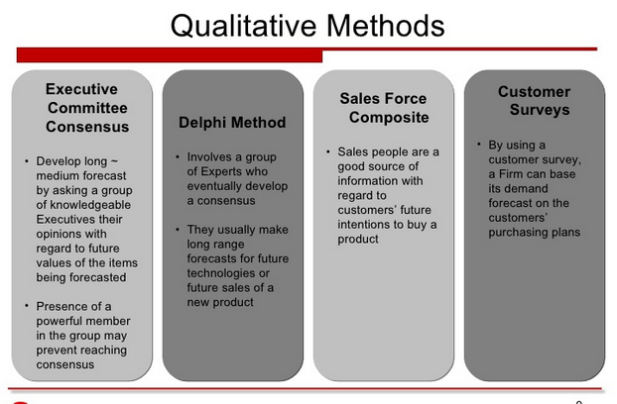
Qualitative forecasting methods in supply chain: These types of forecasting methods are based on judgments, opinions, intuition, emotions, or personal experiences and are subjective in nature. They do not rely on any rigorous mathematical computations.
- Executive Opinion – Approach in which a group of managers meet and collectively develop a forecast.
- Market Survey – Approach that uses interviews and surveys to judge preferences of customer and to assess demand.
- Delphi Method – Approach in which consensus agreement is reached among a group of experts.
- Sales Force Composite – Approach in which each salesperson estimates sales in his or her region.
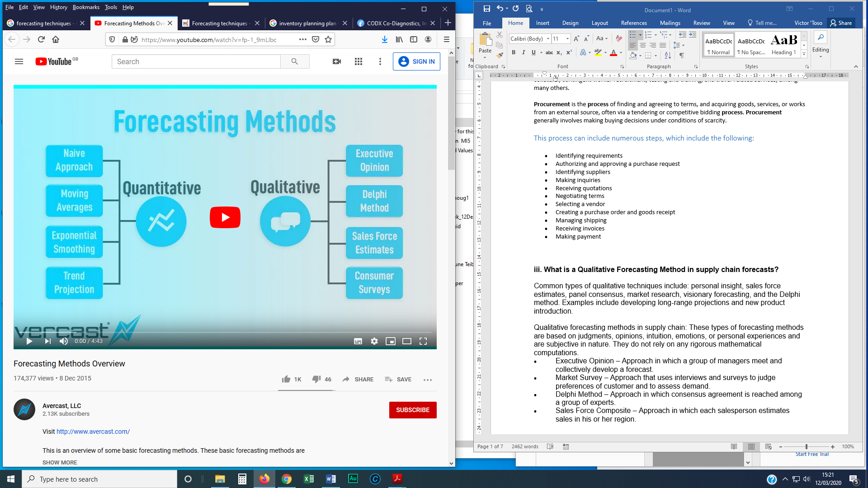

iv. Outline the different ways used for managing credit risk.
- Thoroughly check a new customer’s credit record.
- Use that first sale to start building the customer relationship.
- Establish credit limits. To set a credit limit for a new customer, you can use tools such as: Credit-agency reports, which can provide comprehensive information about a company’s financial history. Bank reports, which should give details of the bank’s relationship with the company, the company’s borrowing capacity and its level of debt. Audited financial statements, which can provide a good view of the business’s liquidity, profitability and cash flow.
- Make sure the credit terms of your sales agreements are clear. A sales agreement that includes well-worded, comprehensive terms of credit will minimize the risk of disputes and improve your chances of getting paid in full and on time.
- Use credit and/or political risk insurance.
- Use factoring. To do this, you sell your receivable to a factoring company for its cash value, minus a discount. This gives you your money immediately because you don’t have to wait for payment—the customer will pay the factoring company instead of you. But make sure the factoring is on a “non-recourse” basis, which means you’re not liable if the customer defaults.
- Develop a standard process for handling overdue accounts. Your chances of collecting on a delinquent account are highest in the first 90 days after the due date. If you have an established routine for dealing with late accounts, you can start the collection process as soon as you know there’s a problem.

OR:

- Thoroughly check a new customer's credit record
- Use that first sale to start building the customer relationship
- Establish credit limits
- Make sure the credit terms of your sales agreements are clear
- Use credit and/or political risk insurance

v. What is ‘Aggregate Planning’? Outline the approaches used in Aggregate Planning.

Aggregate planning is the process of developing, analysing, and maintaining a preliminary, approximate schedule of the overall operations of an organisation. The aggregate plan generally contains targeted sales forecast, production levels, inventory levels, and customer backlogs. This schedule is intended to satisfy the demand forecast at a minimum cost.

Aggregate planning is an operational activity critical to the organization as it looks to balance long-term strategic planning with short term production success. Following factors are critical before an aggregate planning process can actually start;
- A complete information is required about available production facility and raw materials.
- A solid demand forecast covering the medium-range period
- Financial planning surrounding the production cost which includes raw material, labour, inventory planning, etc.
- Organization policy around labour management, quality management, etc.
For aggregate planning to be a success, following inputs are required;
- An aggregate demand forecast for the relevant period
- Evaluation of all the available means to manage capacity planning like sub-contracting, outsourcing, etc.
- Existing operational status of workforce (number, skill set, etc.), inventory level and production efficiency
Aggregate planning will ensure that organization can plan for workforce level, inventory level and production rate in line with its strategic goal and objective.
Outline the approaches used in Aggregate Planning
  - Top down approach to aggregate planning involves development of the entire plan by working only at the highest level of consolidation of products. It consolidates the products into an average product and then develops one overall plan. This plan is disaggregated to allocate capacity to product families and individual products.
  - A bottom-up approach or sub-plan consolidation approach, involves development of plans for major products or product families at some lower level, within the product line. These sub-plans are then consolidated to arrive at the aggregate plan, which gives the overall output and the capacity required to produce it.

- Minimise cost/maximize profits
- Maximise customer service
- Minimize inventory investment
- Minimize changes in production rates
- Minimizes change in workforce levels
- Maximize utilisation of plant and equipment

2. What is procurement? Discuss the main categories of procurement.
Procurement, in the simplest sense, involves a series of activities and processes that are necessary for an organization to acquire necessary products or services from the best suppliers at the best price. Such products or services that are procured include raw materials, officer equipment, services, and supplies, furniture and facilities, technical equipment and support, telecommunications, printed collateral, contingent worker recruitment, testing and training, and travel-related services, among many others.

Procurement is the process of finding and agreeing to terms, and acquiring goods, services, or works from an external source, often via a tendering or competitive bidding process. Procurement generally involves making buying decisions under conditions of scarcity.

This process can include numerous steps, which include the following:
- Identifying requirements
- Authorizing and approving a purchase request
- Identifying suppliers
- Making inquiries
- Receiving quotations
- Negotiating terms
- Selecting a vendor
- Creating a purchase order and goods receipt
- Managing shipping
- Receiving invoices
- Making payment

3. Discuss what the term ‘Inventory Management Plan’ means.

Inventory management plan is a component of supply chain management that involves supervising non-capitalized assets, or inventory, and stock items. Specifically, “inventory management plan supervises the flow of goods from manufacturers to warehouses and from these facilities to point of sale.” Thus, inventory management hinges on detailed records of products or parts as they enter and leave warehouses and points of sale.
Inventory management plan sounds simple in theory: Knowing how much stock you have on hand, when to order more, and how to keep it all in balance. In reality, as any inventory manager knows too well, inventory control is a much more complicated set of systems, processes, and procedures to maintain that delicate balance.
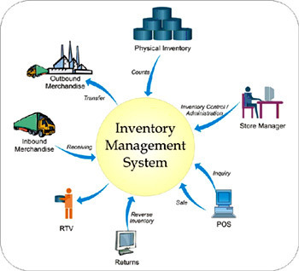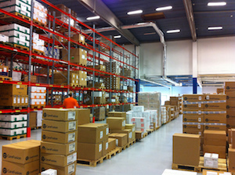

The following eight metrics are the key factors in a sound inventory control program.
1. Inventory Usage: How much inventory is used in a given time frame? Proper inventory control requires an analysis of actual usage over time. An asset tracking system lays the foundation for gathering this data, aiding employees in quickly documenting inventory as it moves through the organization. Combined with an inventory control software application, asset tracking facilitates the rapid generation of reports for in-depth analysis of inventory usage.
2. Projected Usage: Having a clear picture of actual inventory usage over time enables businesses to make more accurate projections of future usage. For example, certain products and supplies are used more often during seasonal periods or leading up to certain events or holidays throughout the year. Arming yourself with historical data allows you to accurately calculate projected usage, so you can better manage inventory and reduce unexpected supply shortages or overstock.
3. Inventory Value: what is the value of your company’s current inventory? Do certain products or supplies produce more revenue for the company? Sophisticated inventory control processes use this data to allocate storage space and utilization to boost company revenue by allocating more resources to the inventory with the greatest return. Additionally, the value of your inventory comes into play for tax and regulatory reporting.
4. Price Forecasting: Price forecasting comes into play in a variety of ways in inventory management. Supply and demand impacts the price of goods and services, for both inbound and outbound inventory. Higher supply costs may mean a company must raise end-consumer prices for final products. End-of-season leftover stock is often sold at markdown prices. The value of available and committed inventory, future inventory price forecasting, and other variables are critical for broader revenue calculations and are essential for accurate planning and inventory control.
5. Available Physical Space: Of course, an inventory manager can’t just arbitrarily re-order stock that’s running low; there must be adequate physical space in which to store it. This is where overstock becomes an issue, taking up valuable storage space that’s needed for in-season product. When these variables are out of balance, companies are faced with finding ways to move unneeded inventory fast to make room for the products they need to continue the flow of business.
6. Inventory Depletion: Inventory depletion is the process of physically removing product from stock in order to fulfil orders, generally until no stock remains. In businesses in which the age of stock is a consideration, inventory depletion may involve specifying which products should be moved first.
7. Economics of Scale: Economics of scale is the calculation of price-per-unit based on production volume. If more product is produced using the same raw materials, the price-per-unit is lower than production runs of less volume.
8. Order Cycle Time: what is the typical length of time between one order and the next? This defines order cycle time, also sometimes called order lead time. This metric is important for inventory planning purposes to ensure order fulfilment.
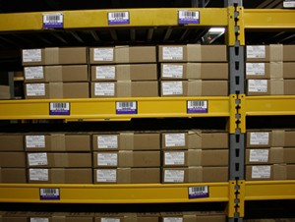
All eight of these metrics are crucial knowledge for inventory management. Without an asset tracking solution in place, it becomes much more complex to track down accurate data for forecasting and planning. A streamlined asset tracking system utilizing asset tags or warehouse labels, however, enables rapid data and automatic collection for reporting and analysis. Combined with inventory management software, inventory managers quickly generate reports, review data, and make forecasts for informed decision-making that maximizes revenue and drives business forward.

Student Statement:

By submitting this assignment, I confirm that this is my own work.

Student Signature | OmotosoVOT | Date | 26/03/2020

For Tutor / Assessor Use Only
Total Marks
Marks Obtained
Percentage / Grade

