
p
Assignment Cover Sheet

Student Name: | PEDRO MANUEL RUIZ DIAZ
Student Number: | 3091
Course: | Diploma in logistic and Supply Chain Management
Assignment NO: | 5

Marking Criteria:
We expect the learners to write minimum one well expressed point in three lines against each allocated mark. This means one needs to write 15 lines with 5 well expressed points to get high grades for a 5 marks question.
For high grades use examples and illustrations where appropriate.
1. Give brief answers for the following questions:

- What is purchasing?
Purchasing is the task accountable for acquiring all the materials requisite by an organization. Many of the purchase’s transactions are not standard, but comprised of rental, contracting, leasing, gifts, exchange, borrowing, and so on.
- Define the term ‘procurement.’
Procurement is takes care of all the materials required by a business. It consists of all the associated activities required to get goods, services, and any other materials from suppliers into a business.

- What is the importance of procurement in a supply chain?
Procurement is very important because makes a necessary connection between businesses in the supply chain, and it gives a system for coordinating the movement of materials between suppliers and consumers. At each point in the supply chain, procurement sends messages backwards to explain what customers desire in a product, and it passes messages forwards to declare what suppliers have accessible. procurement is clearly an essential function within every organization. We know that each organization requires some supply of materials and procurement is responsible for organizing this. If procurement is carried out badly, materials do not arrive, or the wrong materials are delivered, in the wrong quantities, at the wrong time, with poor quality, at too high price, low customer service, and so on.

- Who are qualified suppliers?
Qualified suppliers are financially safe with good long-standing prospects; Have the aptitude and competence to supply the essential materials; Precisely deliver the requested materials; Send materials which are high quality; Deliver reliably, on time with little lead times; Quote satisfactory prices and financing arrangements; Are flexible to customers’ demands and changes; are knowledgeable and have skill in their products; have earned an excellent reputation; Use expedient and simple procurement systems Have been used effectively in the past and can expand long-term relationships.

- What is e-procurement?
E-procurement is the electronic purchase and sale of goods and services, usually through an Internet-based platform. It is a tool designed to improve the purchasing process transparency and efficiency and help companies capture savings.

- Outline the main aims of procurement.
The main aims of procurement are:
- Organizing a consistent and continuous flow of materials into a business
- Working directly with user departments, establishing relationships, and understanding their requirements.
- Finding good suppliers, working directly with them, and developing beneficial relationships.
- Buying the correct materials and ensuring that they have satisfactory quality, arrive at the time and place required, and meet any other needs;
- Negotiating best prices and terms and conditions
- Keeping stock low, considering stock policies, investment, readily available materials, and so on.
- Moving materials rapidly through the supply chain or expediting deliveries when essential.
- Keeping abreast of conditions, including pending price increment, scarcities, new products, and so on.

- Outline some common manufacturing strategies.
The most common manufacturing strategies are:
- Make–to-Plan (MTP)
- Make-to– Order (MTO)
- Assemble–to-Order (ATO).
- Make–to– Stock (MTS).

2. Describe the procurement cycle in detail.

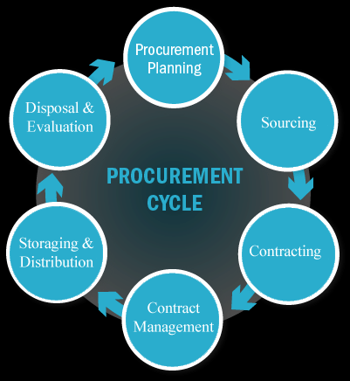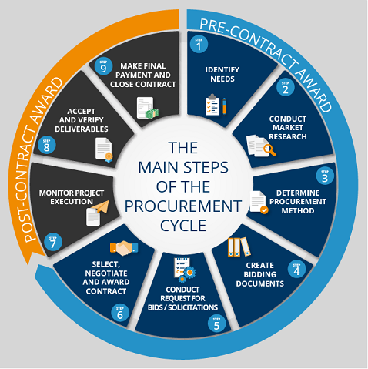
3. Which approaches are used to monitor the performance of suppliers?

Every Organizations used a negotiation that gives a sensible view of performance and requires a rational amount of effort. One general approach utilizes a checklist of significant factors and checks that the supplier meets a suitable standard in these. The checklist may ask whether the supplier is economically sound; whether it supplies on time; if material value is high enough; if there is practical support; whether the cost is competitive; about related trends, and so on.
The following seven steps comprise a process for developing and deploying supplier assessment:
1. Align supplier performance goals with organizational goals and objectives.
2. Determine an evaluation approach.
3. Develop a method to collect information about suppliers.
4. Design and develop a robust assessment system.
5. Deploy a supplier performance assessment system.
6. Give feedback to suppliers on their performance.
7. Produce results from measuring supplier performance

Student Statement:

By submitting this assignment, I confirm that this is my own work.

Student Signature | Pedro Manuel Ruiz Diaz | Date | September 17, 2018

For Tutor / Assessor Use Only
Total Marks
Marks Obtained
Percentage / Grade

