
Assignment Cover Sheet

Student Name: | Simone Wilson
Student Number: | 16582
Course: | Interior Design Level 4 Diploma
Assignment NO: | 9

Marking Criteria:
We expect the learners to write minimum one well expressed point in three lines against each allocated mark. This means one needs to write 15 lines with 5 well expressed points to get high grades for a 5 marks question.
For high grades use examples and illustrations where appropriate.
Please insert your completed assignment ( in word format) here:

Simone Wilson
16582
No.9
Interior Design Level 4
Q.

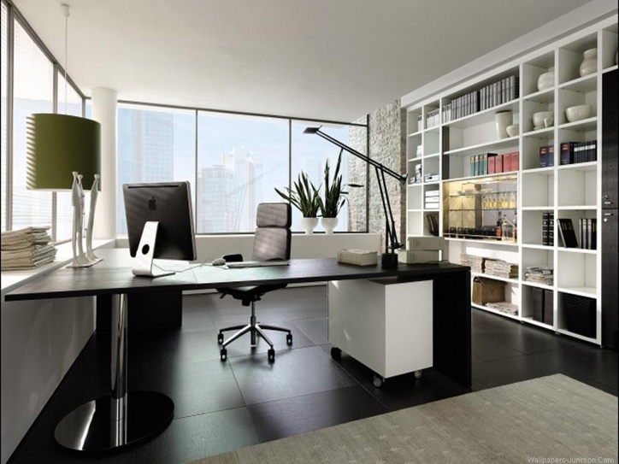
  - When starting a business it comes with many advantages and disadvantages, it requires a lot of work and motivation. Having your own company and being the manager is very rewarding–you have control over the business and you can make decisions based on what you think is best, whereas if you were a client elsewhere you would have to clarify and ask for approval on any decisions that need to be made. You have to be responsible not only for yourself but also for the employees too so it is a lot of responsibility to overcome. There are many different aspects that are essential in owning a business such as; finances, marketing, advertising etc the designer is required to know a decent amount of information on each area in order for them to have knowledge and to make the best decisions for their company. However starting a business may be risky in some cases, this is because in order to kick start a business you need to ensure that you have a great amount of finances available to do this and also enough so that the business can continue to progress in the future.

  - First of all I think one of the advantages that is very beneficial is that it offers you a long term job, you don’t need to worry about being made redundant or any other problem that can be associated with that field. Being your own boss is going to offer that security because you are self employed and have others working for you so you don’t need to be concerned. Also another advantage is the financial side of owning your own company, you could bring in a much higher income compared to if you were an employee elsewhere, guaranteed the amount you deserve some staff can get under paid. Lastly another advantage of this is that you get to explore your own design style more and present this to your clients and employees, you can also enjoy your creative side too.
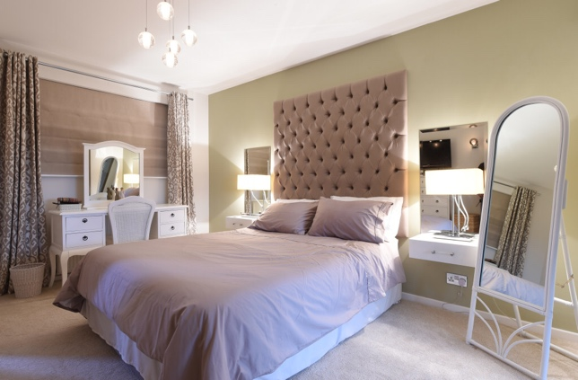

  - ‘An interior designer has to be versatile and should be able to change with time’, this is important. As an interior designer, they can have their own style and designs they like to stick with however as time progresses the designer must be able to adapt to new trends and changes with design. A client comes to the designer with confidence that they know the trends that are recent, so this can be applied to their design is some way shape or form. If the designer is unable to do this then they would lack versatility, this is not ideal for this field of work because this is where versatility is required. With the designer being aware of trends and what not this can help them with versatility and also with them being versatile this can lead to success for them also.

  - It is essential for a designer to be able to negotiate because with having a business of their own, or just dealing with clients you would have to be able to do so in order to establish an agreement. Also an interior designer each day would have to negotiate with many different areas of their projects whether it is with the clients, contract and furniture dealers and many other specialist that will be involved in the project because the designer may request one thing however any other contractor that is involved too because of prices, quantities and other services that the designer would need to deal with. Another thing which the designer would have to negotiate on is the designs with the client, they may request something that isn’t available so they would have to negotiate. If the designer was unable to do so this would be very unprofessional because in all work, negotiation is important because it may make or break a deal–however this is something that has to be done carefully and correctly because you have to make the right points and choices whether you are negotiating on costs or fabrics.

  - In interior design a portfolio is a collection of work and designs that the designer has gathered, with either work they have done in the past or just ideas all together, which includes photographs. It is crucial for a designer to have a portfolio because it gives clients an idea about the work you have done in the past, and the standard that your work is at and what you are capable of doing. This will give them a great insight into your work, it is the best way for the designer to see show their work. This is something that designer must ensure is kept professional, it needs to be organised and well put together to be presented to clients, if it was the opposite the client may perceive this as a reflection of their work. The portfolio needs to be visually appealing on the cover as well as the content it needs to be inviting and wanting the client or who ever picks it to be interested in looking onwards. When a designer finishes a project they can always ask for a letter that in other words states that they recommend the designer and would contact them in the future for more work–these can be included in your portfolio too. Also the designers portfolio could include work they have done for family members and friends too because this is mainly how and where designers start of their working career too, with these examples of work the designer can gain more experience and practice by doing this too. This is important because in the portfolio as it progresses and contains more work as time goes on, as a result of this the client can see the changes in their work and how better their work has improved overtime without a portfolio it would be difficult to secure work with clients and with keeping track of previous work.
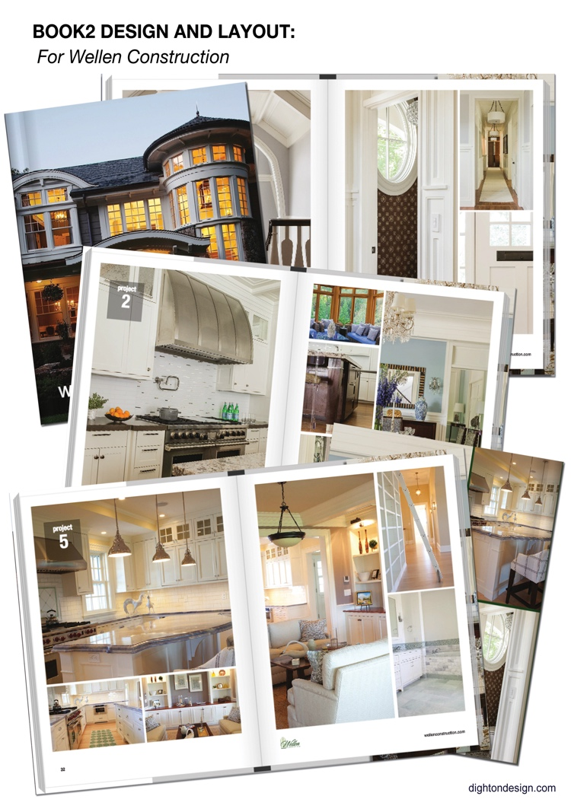

Student Statement:

By submitting this assignment, I confirm that this is my own work.

Student Signature | Simone Wilson | Date | 03/04/18

For Tutor / Assessor Use Only
Total Marks
Marks Obtained
Percentage / Grade

