
Assignment Cover Sheet

Student Name: | Nicola Young
Student Number: | 24904
Course: | Wedding planner level 4
Assignment NO: | 6

Marking Criteria:
We expect the learners to write minimum one well expressed point in three lines against each allocated mark. This means one needs to write 15 lines with 5 well expressed points to get high grades for a 5 marks question.
For high grades use examples and illustrations where appropriate.
Please insert your completed assignment ( in word format) here:
Planning for the big day
Assessment 6
- (i) Which questions should a venue manager ask when selecting a wedding venue?
There are many questions that are needed to be asked when selecting a wedding venue here are a few examples;
- What is the venues capacity?
- What does the venues catering offer? i.e. drinks and food
- Is there exclusivity of the venue
- What is included in the venue? i.e. Staff, furnishings, crockery, cutlery, chair covers and linens
- Are there special offers? i.e. off peak pricing
- What does the venue offer on the cake supplies? i.e. cake knife
- Are there any other expences that they need to be made aware of?
- What time does the venue close?
- Is there a cancellation fee?
- Is the DJ/entertainment provided or do they have to provide their own?
(ii) If the ceremony is to be conducted outdoors, what important measures should a wedding planner take in advance
A good measure to take when conducting a wedding outside is to provide rental bathrooms, especially if you’re having the wedding a someone’s home. Insects and bugs can also become a real nuisance at an outdoor wedding especially with warm weather, there are lots of options to help with this for example; citronella candles can be effective. Also a site layout map of the ceremony and the reception should be drawn up.
(iii) Briefly discuss the history of the white wedding dress.
The history of the white wedding dress varies between different cultures. The white wedding dress in England based back to Queen Victoria, it was thought to reflect purity and virginity, it was also that white material was more expensive to buy and harder to clean. However, in countries such as India the colour of white is not used for weddings but funerals. The brides in India wear pink or red.
(iv) What are the three primary food service styles used for weddings?
The three main food service styles consist of plated, buffet and French.
(v) What is the difference between buffet and French service styles?
The French service is the most formal table service available. The service provides a side table which is wheeled to the tables where the guests are seated. The food is arranged on platters, tureens and chafing dishes, and generally presented to the guests for inspection prior to the dishes being prepared, then placed on the table.
The buffet service is the most common of services, this is where each guest must leave the table, go to the buffet offering, select a plate and serve themselves from the variety of foods offered.

(vi) Compare two wedding photography styles. Provide photos as well.
Reportage photography is a natural looking, non- posed photography that follows the day as it unfolds.
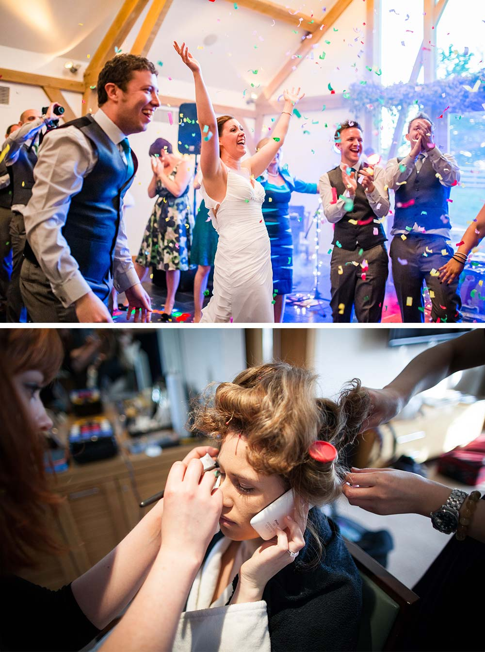
Formal/Traditional photography is the most common type of wedding photography. Your photographer will capture the key points of the day – like signing the register and cutting the cake, as well as taking staged/directed shots of you and your guests.
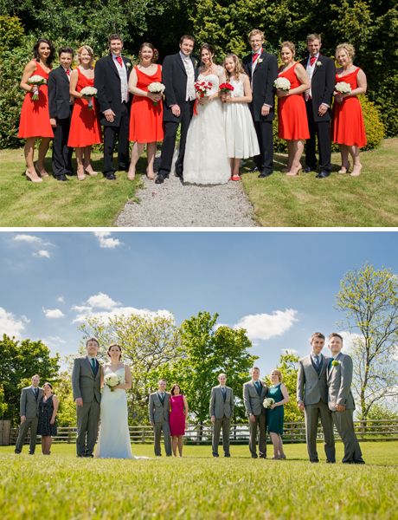

(vii) What is the tradition of the bridal bouquet?
Back in the 15th Century, brides were unable to wash properly like we can today, so the brides began to carry strong smelling flower bouquets to disguise the pungent odour. It is also believed that the bridal bouquet ward off evil spirits these bouquets were created with dill, herbs and spices.
(viii) List the different music types that can be used at weddings.
Depending on what the client wants for their wedding will depend on what type of music is used. Traditionally the most basic wedding ceremony music program involves a minimum of three types of songs; preludes, processional and recessional, also interludes and postludes.
For a more formal affair Classical singers, harpists or pianoists could be used. Possibly live bands and/or DJ’s could be used or if the couple would like a more romantic setting a harpist or violinist could be used.
(ix) What are the different parts of wedding invitations? Give details using illustrations.
- The invitation itself
- A separate reception card
- A response card with a self addressed envelope
- A directions card
- An outer envelope

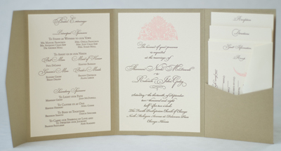

(x) List some of the questions that should be asked from the vehicle company manager when booking the vehicle.

- Are the vehicles we inspect and the staff be the ones present on the day?
- Do you have videos or photos of your vehicles in action?
- How many seats do the vehicles have?
- How many staff are provided
- Are refreshments part of the package?
- Is the company insured
- Is the vehicle exclusive to the client
- Are there any extra costs?
- What happens in the event of a breakdown?
- Is there a cancellation fee?

- Modes of transport

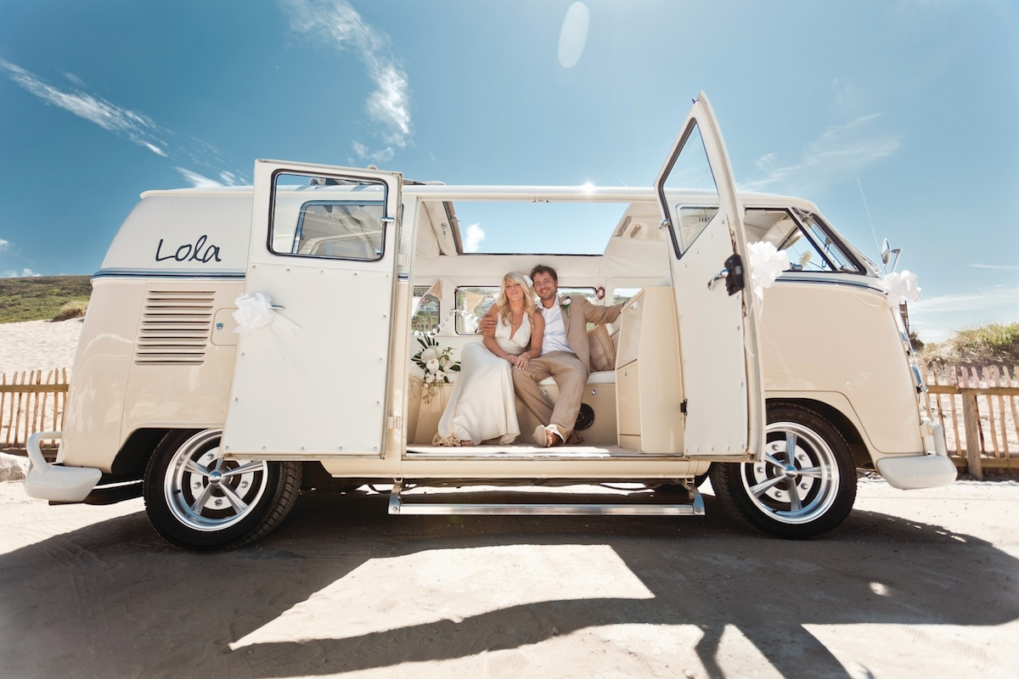

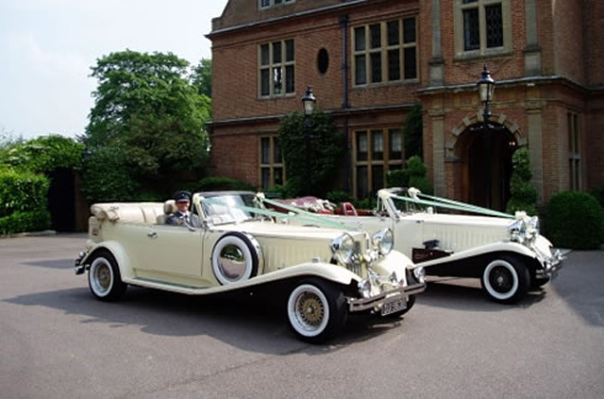
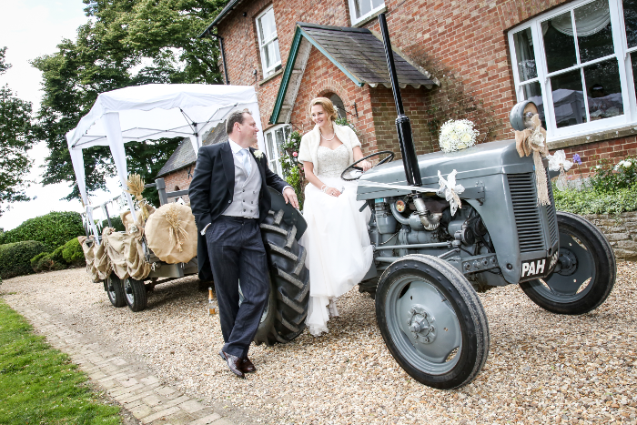
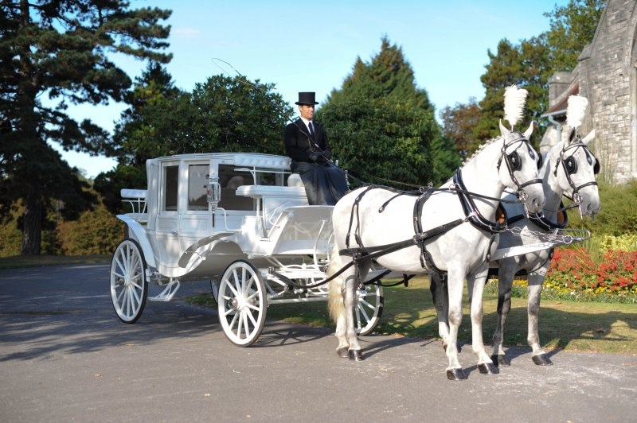
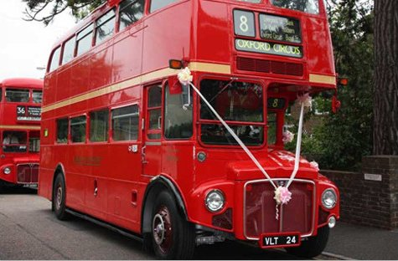
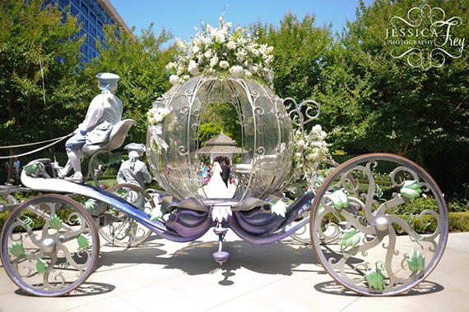
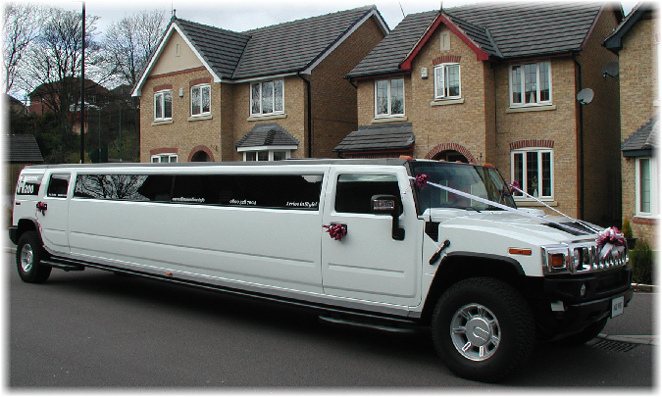
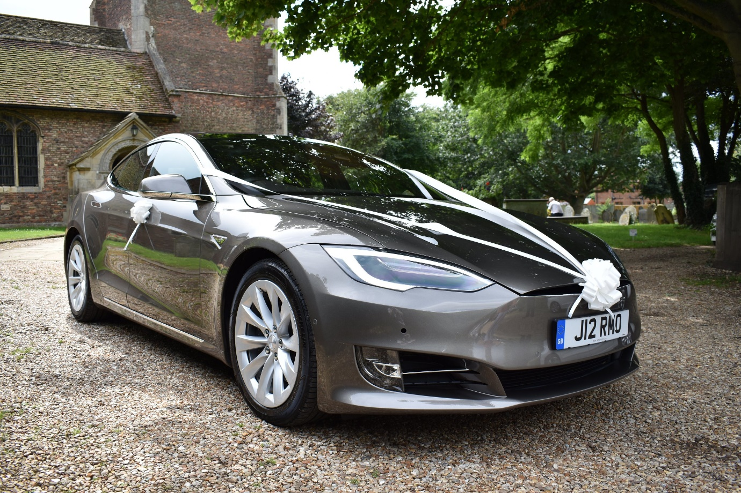

Student Statement:

By submitting this assignment, I confirm that this is my own work.

Student Signature | N.Young | Date | 1.12.18

For Tutor / Assessor Use Only
Total Marks
Marks Obtained
Percentage / Grade

