Assignment 3 Logistics Strategy and Operations

- Give short answers for the following questions:
i. What are the different types of decisions made in an organisation?
The following are the main types of decisions every organisation need to take:

1. Programmed and non-programmed decisions:
Programmed decisions are concerned with the problems of repetitive nature or routine type matters. A standard procedure is followed for tackling such problems. These decisions are taken generally by lower level managers. Decisions of this type may pertain to e.g. purchase of raw material, granting leave to an employee and supply of goods and implements to the employees, etc. Non-programmed decisions relate to difficult situations for which there is no easy solution.
These matters are very important for the organisation. For example, opening of a new branch of the organisation or a large number of employees absenting from the organisation or introducing new product in the market, etc., are the decisions which are normally taken at the higher level.

2. Routine and strategic decisions:
Routine decisions are related to the general functioning of the organisation. They do not require much evaluation and analysis and can be taken quickly. Ample powers are delegated to lower ranks to take these decisions within the broad policy structure of the organisation.
Strategic decisions are important which affect objectives, organisational goals and other important policy matters. These decisions usually involve huge investments or funds. These are non-repetitive in nature and are taken after careful analysis and evaluation of many alternatives. These decisions are taken at the higher level of management.

3. Tactical (Policy) and operational decisions:
Decisions pertaining to various policy matters of the organisation are policy decisions. These are taken by the top management and have long term impact on the functioning of the concern. For example, decisions regarding location of plant, volume of production and channels of distribution (Tactical) policies, etc. are policy decisions. Operating decisions relate to day-to-day functioning or operations of business. Middle and lower level managers take these decisions.
An example may be taken to distinguish these decisions. Decisions concerning payment of bonus to employees are a policy decision. On the other hand if bonus is to be given to the employees, calculation of bonus in respect of each employee is an operating decision.

4. Organisational and personal decisions:
When an individual takes decision as an executive in the official capacity, it is known as organisational decision. If decision is taken by the executive in the personal capacity (thereby affecting his personal life), it is known as personal decision. Sometimes these decisions may affect functioning of the organisation also. For example, if an executive leaves the organisation, it may affect the organisation. The authority of taking organizational decisions may be delegated, whereas personal decisions cannot be delegated.

5. Major and minor decisions:
Another classification of decisions is major and minor. Decision pertaining to purchase of new factory premises is a major decision. Major decisions are taken by top management. Purchase of office stationery is a minor decision which can be taken by office superintendent.

6. Individual and group decisions:
When the decision is taken by a single individual, it is known as individual decision. Usually routine type decisions are taken by individuals within the broad policy framework of the organisation. Group decisions are taken by group of individuals constituted in the form of a standing committee. Generally very important and pertinent matters for the organisation are referred to this committee. The main aim in taking group decisions is the involvement of maximum number of individuals in the process of decision making.
ii. What are the tactical decisions about?
Tactical decisions are medium term, less complex decisions made by middle managers. They follow on from strategic decisions and aim to meet the objectives stated in any strategic decision. For example in order to become the market leader, a firm may have to launch new products/services or open new branches.
iii. What is the logistics strategy about?
Logistics strategy is the set of guiding principles, driving forces and ingrained attitudes that help to coordinate goals, plans and policies between partners across a given supply chain. When a company creates a logistics strategy it is defining the service levels at which its logistics organization is at its most cost-effective. Because supply chains are constantly changing and evolving, a company may develop a number of logistics strategies for specific product lines, specific countries, or specific customers. The ultimate goal of any logistics strategy is to deliver what customers want and when they want it—and getting that done by spending as little money as possible. That means working with your logistics partners throughout the supply chain.
See below example of logistics strategy flow plan
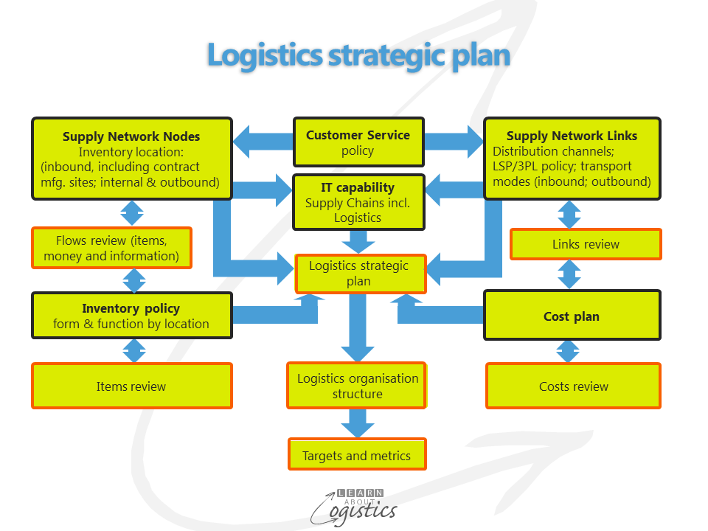

iv. What is the value added strategy about?
Different value techniques can be applied to your business to help enhance performance of sales and price of an item and the cost of production. The concept of value added is very important in marketing because it acts an incentive for customers to purchase a product or subscribe to a service.
Value added is the difference between the price of product or service and the cost of producing it. The price is determined by what customers are willing to pay based on their perceived value. Value is added or created in different ways.
v. What are the three factors to be considered when designing a logistics strategy?
Logistics is that part of supply chain management that plans, implements, and controls the efficient, effective forward and reverse flow and storage of goods, services and related information between the point of origin and the point of consumption in order to meet customers’ requirements
A few factors to be considered when planning logistics strategies are:
- The actual work of logistics is supportive in nature. Logistical support is a must for manufacturing and marketing operations.
- The concept of logistics is based on a total system view of the multitude of functions in movement of materials and goods from sources of supply to users. Accordingly, it forces management to think in terms of managing the total system; rather than just one part of it.

Classification of Logistical Activities:
Logistics may be Broadly Classified into Two Categories:
I. Inbound logistics; which is concerned with the smooth and cost-effective inflow of materials and other inputs (that are needed in the manufacturing process) from suppliers to the plant. For proper management of inbound logistics, the management must maintain a continuous interface with suppliers (vendors).
II. Outbound logistics (also called physical distribution management or supply chain management); is concerned with the flow of finished goods and other related information from the firm to the customer. For proper management of outbound logistics, the management must maintain a continuous interface with transport operators and channels of distribution.
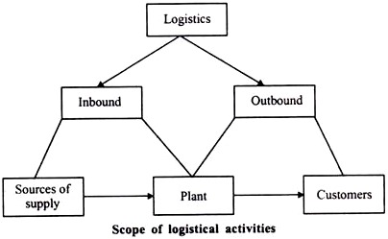

vi. How do logistics play a strategic role in organisations?
Logistics is the main running machine of a business. The business sector uses this term to describe the efficient flow and storage of goods from point of origin to the point of consumption. The supply chain is a vital part of this process, including transportation, shipping, receiving, storage, and management of all these areas. Within the business sector, logistics can be applied to information, transportation, inventory, warehousing, material handling, and packaging, disposal, and security. Whatever the size of your business, you will want to grow and expand. That probably means expanding on a regional, international or global level. Whatever your business location or industry, logistics can help cut on the costs and time you spend to move products from one point to another. The strategic plan for a successful logistics business to grow and maintain would be to ensure key staffs are on board, sales team are out visiting current and potential customers in order to ground and successfully win tenders and contracts, key staff are processing orders / bookings and ensuring product and shipments are in process whilst other departments are involved to ensure operations side is being handled e.g, product or consignments are being prepared, transportation, customs clearances are approved, documentation handling and invoicing. Also while consignments are in transit the exporter / shipper are liaising with appropriate teams to monitor and track product of goods for efficient and safe final delivery to consignee / receiver. This sort of method is a basic structure in order for the logistics of a business to maintain their strategic plan e.g,
to grow and run successfully.
REF: https://www.aacb.com/why-logistics-is-so-important-to-supply-chains/

vii. Outline the main areas that a logistics strategy emphasises.
Logistics is not confined to tactical decisions about transportation and warehousing. Longer-term decisions are needed to put in place the capabilities that ensure that logistics plays a full role in supporting a company’s products in the market place.
As such capabilities increasingly involve partners in a supply chain, the implications of this ‘full role’ extend far beyond the boundaries of the company itself. Logistics strategy is the set of guiding principles, driving forces and ingrained attitudes that help to coordinate goals, plans and policies between partners across a given supply chain.
viii. What is a lean strategy?
The primary purpose of lean management is to produce value for the customer through the optimisation of resources and create a steady workflow based on real customer demands. It seeks to eliminate any waste of time, effort or money by identifying each step in a business process and then revising or cutting out steps that do not create value. The philosophy has its roots in manufacturing.
Lean management focuses on:
- Defining value from the standpoint of the end customer.
- Eliminating all waste in the business processes.
- Continuously improving all work processes, purposes and people.
Lean management facilitates shared leadership and responsibility; continuous improvement ensures that every employee contributes to the improvement process. The management method acts as a guide to building a successful and solid organization that is constantly progressing, identifying real problems and resolving them.
Lean management incorporates five guiding principles that are used by managers within an organisation as the guidelines to the lean methodology. The five principles are:
- Identify value
- Value stream mapping
- Create a continuous workflow
- Establish a pull system
- Facilitate continuous improvement
Identifying value, the first step in lean management, means finding the problem that the customer needs solved and making the product the solution. Specifically, the product must be the part of the solution that the customer will readily pay for. Any process or activity that does not add value -- meaning it does not add usefulness, importance or worth -- to the final product is considered waste and should be eliminated.
Value stream mapping refers to the process of mapping out the company's workflow, including all actions and people who contribute to the process of creating and delivering the end product to the consumer. Value stream mapping helps managers visualize which processes are led by what teams and identify the people responsible for measuring, evaluating and improving the process. This visualisation helps managers determine which parts of the system do not bring value to the workflow.
Creating a continuous workflow means ensuring each team's workflow progresses smoothly and preventing any interruptions or bottlenecks that may occur with cross-functional teamwork Kanban, a lean management system that utilises a visual cue to trigger action, is used to enable easy communication between teams so they can address what needs to be done and when it needs to be done by. Breaking the total work process into a collection of smaller parts and visualizing the workflow in this regard facilitates the feasible removal of process interruptions and roadblocks.
Developing a pull system ensures that the continuous workflow remains stable and guarantees that the teams deliver work assignments faster and with less effort. A pull system is a specific lean technique that decreases the waste of any production process. It ensures that new work is only started if there is a demand for it, thus providing the advantage of minimizing overhead and optimising storage costs.
These four principles build the lean management system. However, the last principle -- continuous improvement -- is the most important step in the lean management method.
ix. What is the main purpose of logistics audit in organisations?
Audit is an independent and systematic examination of statutory records, books of accounts, documents and vouchers of an organisation. This mainly performed or conducted to ascertain how far the financial statements as well as non-financial disclosures present a true and fair view of the concern. Audit is an activity that attempts to ensure that the books of accounts are properly maintained by the concern as required by law. Auditing has become an ubiquitous phenomenon in the corporate as well as the public sector. It is an individual that perceives and recognises the propositions before them for examination. Auditor obtains evidence and formulates an opinion on the basis of his judgement which is communicated through their audit report.

2. Outline the steps involved in developing a logistic strategy
the supply chain constantly changes and that will affect any logistics organization. To adapt to the flexibility of the supply chain, companies should develop and implement a formal logistics strategy. This will allow a company to identify the impact of imminent changes and make organisational or functional changes to ensure service levels are not reduced.

What Is Involved in Developing a Logistic Strategy?
A company can start to develop a logistics strategy by looking at four distinct levels of their logistics organisation.
- Strategic: By examining the company’s objectives and strategic supply chain decisions, the logistics strategy should review how the logistics organisation contributes to those high-level objectives.
- Structural: The logistics strategy should examine the structural issues of the logistics organisation, such as the optimum number of warehouses and distribution centres, or what products should be produced at a specific manufacturing plant.
- Functional: Any strategy should review how each separate function in the logistics organisation is to achieve functional excellence.
- Implementation: The key to developing a successful logistics strategy is how it is to be implemented across the organisation. The plan for implementation will include development or configuration of an information system, introduction of new policies, and procedures and the development of a change management plan.
Components to Examine When Developing a Logistics Strategy
when examining the four levels of logistics organisation, all components of the operation should be examined to ascertain whether any potential cost benefits can be achieved. There are different component areas for each company but the list should at least include the following:
- Transportation: Does the current transportation strategies help service levels?
- Outsourcing: What outsourcing is used in the logistics function? Would a partnership with a third party logistics company improve service levels?
- Logistics Systems: Do the current logistics systems provide the level of data that is required to successfully implement a logistics strategy or are new systems required?
- Competitors: Review what the competitors offer. Can changes to the company’s customer service improve service levels?
- Information: Is the information that drives the logistics organization real-time and accurate? If the data is inaccurate then the decisions that are made will be in error.
- Strategy Review: Are the objectives of the logistics organisation in line with company objectives and strategies?*
A successfully implemented logistics strategy is important for companies who are dedicated to keeping service levels at the highest levels possible despite changes that occur in the supply chain.
The goal of any formal logistics or supply chain strategy is to make sure you and your company are delivering to your customers what they want and delivering when they want it. And accomplish all of that by spending as little money as possible

CASE STUDY

- How does Charlotte currently organise her logistics? What do you think are her aims and priorities?
I have concluded that Charlotte practices the Lean Management system and uses some of the guide lines to organise her logistics eg: charlotte creating more ideas and products to advertise and sell. Charlotte invented her own products to also bring a unique organisation to encourage all different age groups and backgrounds and targeting audience with healthy food products. I also firmly believe that
Reference as below to back up my conclusion from case study
- They have supplemented this income from other sources, including the conversion of old barns into holiday homes.
- Eight years ago, Charlotte took over a small field and started growing herbs. She sold a small range of herbs to local people who wanted fresh, organic produce for cooking. Passing tourists would also buy an unusual souvenir, and the herb business began to grow. Five years ago Charlotte started growing more unusual herbs, expanded her growing area into a second field and opened a visitors’ centre. People came to look at the growing process and preparation of herbs, as well as, taste samples in various foods.

- What would be the effect of the expansion on logistics? What problems would Charlotte face and what options does she have to overcome them?
- For any business that plans to expand this means more money will be needed to be invested into the business for the following:
- Sales and marketing - notice boards, pamphlets and website progression
- Social media promoting - using a facebook and instagram pages to promote sales of business
- More expenses to buy more stock for all incoming order
- An updated booking system to keep on track online orders (especially bulk orders)
- Potential small truck or van work vehicle for business to have a delivery option since location is in country. Charlotte can also charge a delivery fee to help with costing’s.
More money invested could be a problem that Charlotte faces as risk taking has its flaws. To overcome this Charlotte would need to forecast a strategic plan for at least 3 -6months in order to test how it is all running, with obviously the goal to running smoothly and successfully
For the above to be successful, sales and demand is a must and volume of orders has to be consistent. If this fails through then unfortunately the business may only have a capacity to be a small business. If Charlotte’s company becomes bigger, other alternatives for warehouse and distribution should be the next forecast, alongside with international orders to customers. With international orders Charlotte will also need an overview on how international trade works and all shipping of freight is handled both via air and sea. Custom regulations would also be involved for all overseeing of approval of goods and commodities of export and import into specific countries and abiding by their regulations and compliances.

