
Assignment Cover Sheet

Student Name: | Derrick Kofi Wiafe
Student Number: | 6356
Course: | Diploma Logistics and Supply Chain Management
Assignment NO: | 6

Marking Criteria:
We expect the learners to write minimum one well expressed point in three lines against each allocated mark. This means one needs to write 15 lines with 5 well expressed points to get high grades for a 5 marks question.
For high grades use examples and illustrations where appropriate.
1.
- Facility Management – Takes locations as a given and focuses on how best to use the capacity available and also pay attention upon the efficient and effective delivery of support services for the organization that it serves.

- Milk Run Deliveries – Are deliveries that brings products from multiple originating locations to a single receiving location.

- Reverse logistics – Is also known as reverse distribution which is the activities that are concerned with return materials back to vendors.

- The two of types deliveries made to customers are;
- Single product locations
- Distribution centres

- Procedures involved in production scheduling are;
- High utilization rates – where this often means long production runs and centralized manufacturing and distribution centres. The objective is to generate and benefit from economics of scale.
- Low inventory levels – Is a short production runs and just-in-time delivery of raw materials. The purpose is to minimize the assets and cash tried up in inventory.
- High levels of customer service – This generally requires high level of inventory or many short production runs. The aim is to provide the customer with quick delivery of products not to run out of stock in any product.

- Procedures for effective order management is as follows;
- Enter the Order Data Once and Only Once.
- Automate the Order Handing.
- Make Order Status Visible.
- Use Integrated Order Management Systems.

- The benefit of outsourcing in supply chain management are as follows;
- Focus on the business aspects
- Minimize overall costs
- Meets customer demand
- More flexibility

2. The more flexible, responsive, and cost effective the supply chain is, the more likely the product will be to succeed in its market. This is because a product design defines the shape of the supply chain and this has a great influence on the cost and availability of the product. If product design, procurement (which is the real buying or purchase of the raw materials) and the manufacture (the real maker or supplier) work together in the design of a product which gives it favorable opportunity to create products that will be successful and profitable.
In conclusion to this it can be established that design, procurement, and manufacturing maintained by effective supply chain, will give the product a great market availability at a cost effective rate while attracting high demand of the product on the market.

3. Tesco has been the be selected retailer for this case study.
as we know tesco is a the biggest retailer in the UK and they have a very high complex supply chain.On this case study we will talk about how items run out of shops and what can be done to resolve this issue.An example is if tesco sells on an average 100 boxes of cornflakes on a daily basis which means they should sell at least 700 a week.Should customers have problems with not getting products they want it clearly goes to show that the inventory levels of the shop is not being monitored properly. with high level of customers flowing through each day this can cause dissatisfaction and love turn over and customers switching to other competitors.

WHAT CAN BE DONE
- shift managers should have a minimum and maximum stock level
- they should see an eye on stock level to ensure they do not run out
- orders should be made at certain times of the day or week to ensure the replenishment cycle is completed
- regional distribution centers should be notified as soon as there is an issue with stock so they can contact suppliers.the chart below explains how this can be done

IMPACT OF THIS
-Stocks availability always
-happy customers and high level of customer retention
- able to track performance of the overall Supply chain process

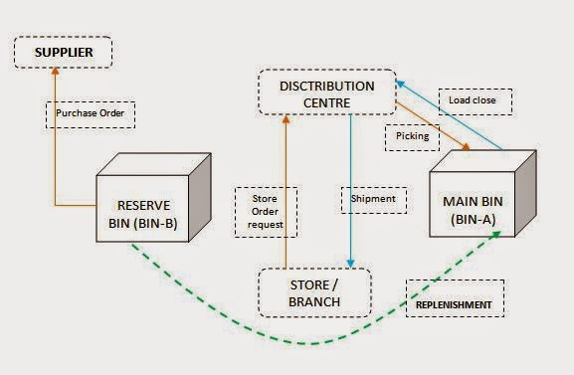

This diagram illustrates the procedures or steps taken when product are returning out from shop or minimum level. The Store/Branch put in a request to the distribution centres which then makes a shipment to the store, where replenishment are made to reserve bin to the supplier of the product.

Student Statement:

By submitting this assignment, I confirm that this is my own work.

Student Signature |  | Date | 05/04/2017

For Tutor / Assessor Use Only
Total Marks
Marks Obtained
Percentage / Grade

