
Assignment Cover Sheet

Student Name: | Lucy Ann Wallace
Student Number: | 33119
Course: | International Diploma in Project Management
Assignment NO: | Project Time Management

Marking Criteria:
We expect the learners to write minimum one well-expressed point in three lines against each allocated mark. This means one needs to write 15 lines with five well expressed points to get high grades for a 5 marks question.
For high grades use examples and illustrations where appropriate.
Project Time Management

Questions

- Give short answers for the following questions:

- What is the input for creating activity lists?
The activity list is a documented formulation of actions needing to be completed, as they are the project deliverables. An activity list is used to ensure that no extra work (which is not required) is included throughout the project. Extra work will result in extra costs, time and money - this defeats the objectives set throughout the project scope. The activities list will comprise all of the work required to create the components within the WBS.

The supporting detail of the activity list must be documented, organized for quick reference, and accessible throughout the project implementation. The supporting detail allows the project team, the project manager, and other interested parties, to reference the activity lists definition process and recall why decisions were made, and how the activity list was created. The supporting detail will includes:

- Constraints
- Reasoning behind identified work package
- Information specific to the industry within which the project is operating
- Assumptions

Creating the activity list relies on several completed documents, knowledge, and actions. The creation of the activity list uses the following as inputs to the process:

- WBS serves as a major input in the creation of the activity list. The WBS is a deliverables orientated collection of project components. This is not a collection of activities to create the deliverables.
- Scope statement is a description of the work required, and only the work required, to complete the project.
- Historical information is proven information in which the project manager can rely to create activity lists.
- Expert judgement allows experts to influence decisions concerning the required work packages.
- Assumptions have to be identified for the project works. For example, considering availability of resources, weather conditions, and time allocations for completion of the project.
- Constraints. What restrictions are imposed on the project manager and the project team? For example, is there a deadline for the project?

- What is the Arrow Diagramming Method and how does it work?

The arrow diagramming method (ADM) refers to a schedule network diagramming technique in which the schedule activities within a given project are represented by the use of arrows. The beginning of the scheduled activity is represented by the tail, or base, of the arrow. The pointed end of the arrow represents the endpoint of a specific scheduled activity, and the length of the arrow can loosely represent the time in between (however, the length should not be interpreted as a literal measure as to the time expected for the scheduled activity to take to complete, as often these arrows are scaled to fit in the presentation of chart that is being populated). The points at which these scheduled activities are connected are referred to as nodes. The connection of these scheduled activities is done to demonstrate the sequence or order in which these activities should take place and this connect point, or node, is usually represented by a small circle or sphere.

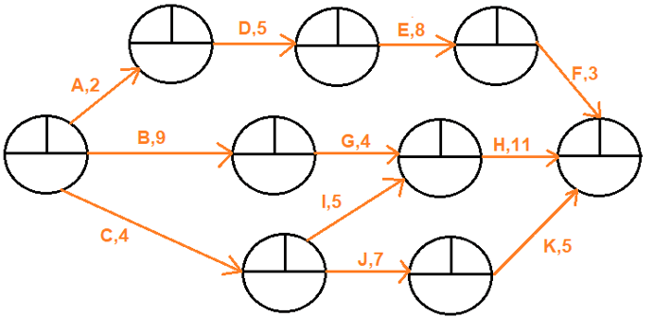

Note: Assume all durations are in days A,1 = means Activity A has a duration of 1 day.

Fig: 1.0

- How does Project Network Diagramming help in creating a flow of project work?

Network diagrams enable us to visualize the required project work. A network diagram shows us how the work will progress from start to completion of the project, and the relationships between the work activities. Like everything in life, network diagrams can be extremely complex or easy/straightforward to create and configure. Most network diagrams in project management environment use an approach called “activity on- node” to illustrate the activities and the relationships between activities. Older network diagramming methods used “activity-on-arrows” to represent the activities and their relationships.

The Project Network Diagramming (PND) helps to create a flow in project works as the diagrams enable staff to visualize the activity list once it has been put into order. A PND illustrates the relationship between the work packages and the flow of the project work; this in turn will also help the flow of project works. Assumptions about the activity sequence may reveal missing activities in the activity list during the creation of the network diagram. Just as the creation of the activity list may prompt the project team and the project manager to update the WBS, the creation of the network diagram may prompt the project team to update the activity lists. Although it may seem redundant to update the activities list illustrated in the project network diagram, it is essential documentation.

The activity list, a reflection of the WBS, and the network diagram should support the project scope. A key stakeholder should be able to follow the logic of the WBS to the activity list, and from the activity list find all of the activities mapped in order.

- What does the term ‘decomposition’ mean? Why are project activities decomposed?
Decomposition is the process of breaking down the major project deliverables into smaller, manageable components. This will be beneficial for everyone involved in the process as it will be easier to understand, more detailed and simple to follow. The decomposition of the project deliverables is done in the following way:
- The major deliverables of the project are identified, including the project management activities. A logical approach includes identifying the phases of the project life cycle or the major deliverables of the project.
- Determine whether adequate cost and time estimates can be applied to the lowest level of the decomposed work. The definition of ‘adequate’ is subject to the demands of the project work. Deliverables that will not be realized until later portions of the projects are achieved may be difficult to decompose since there are many variables between the present and when the deliverable will be created.
- Identifying the deliverables constituent components. This means asking whether the project deliverable can be measured at this particular point of decomposition. For example, a decomposition of a book may have the constituent components of assembling the book, confirming that the book is complete, shrink-wrapping the book, and shipping to the customer. Each component of the work can be measured and may take varying amounts of time to complete, however it must all be done to complete the requirement.
- Verify the decomposition. The lower-level items must be evaluated to ensure they are completely accurate. Each item within the decomposition must be clearly defined and deliverable-orientated. Finally, each item should be composed to the point where it can be scheduled, budgeter, and assigned to a resource.
- Other approaches include breaking it down by geography or functional areas, or even breaking the work down by in-house and contracted work.
Project decomposition is a technique used to break deliverables progressively into smaller and smaller components. The WBS is the top layer encompassing the decomposition. Each layer provides a further breakdown of the layer above. WBS is “a hierarchical decomposition of the total scope of work to be carried out by the project team to accomplish the project objectives and create the required deliverables”. The work breakdown allows you to identify tasks in their granular form. When the work packages are clearly identified, they allow you to:
- Produce more accurate time and cost estimates
- Clarify the scope
- Help to identify and contain risks
- Have more control when executing the project
- Create a more accurate plan
- Have a better understanding of the impact when there is a change in scope
- Utilize cost estimates for future projects
- Influence future WBS

- How does a project manager decompose project components?

The project manager will begin the decomposition of the project components by breaking up the WBS into manageable work elements. Specifically, the work packages within the WBS. The elements within the WBS are classified as deliverables, these deliverables are part of a process that is concerned with the actions needed to create the deliverables.

A project manager might decide to use a template from a previous project for their decomposition, or they may start from scratch. A template can include several elements to make a project manager’s life easier and the new project more successful. The following elements may come in handy from previous project templates:

- Required resources and skills
- Required actions to complete the project scope
- Known risks
- Outputs of the work
- Required hours for activities
- Supporting details
- Descriptions of work packages
The decomposition of the project deliverables is done in the following way:
- The major deliverables of the project are identified, including the project management activities. A logical approach includes identifying the phases of the project life cycle or the major deliverables of the project.
- Determine whether adequate cost and time estimates can be applied to the lowest level of the decomposed work. The definition of ‘adequate’ is subject to the demands of the project work. Deliverables that will not be realized until later portions of the projects are achieved may be difficult to decompose since there are many variables between the present and when the deliverable will be created.
- Identifying the deliverables constituent components. This means asking whether the project deliverable can be measured at this particular point of decomposition. For example, a decomposition of a book may have the constituent components of assembling the book, confirming that the book is complete, shrink-wrapping the book, and shipping to the customer. Each component of the work can be measured and may take varying amounts of time to complete, however it must all be done to complete the requirement.
- Verify the decomposition. The lower-level items must be evaluated to ensure they are completely accurate. Each item within the decomposition must be clearly defined and deliverable-orientated. Finally, each item should be composed to the point where it can be scheduled, budgeter, and assigned to a resource.
- Other approaches include breaking it down by geography or functional areas, or even breaking the work down by in-house and contracted work.
- Outline the factors that can affect a projects length.

Adequate time for planning is required to achieve effective project management. Based on the results of planning, adequate time is required for the implementation of those plans. Poor estimates and poor planning can lead to the project length being extended for longer than originally suggested.

Creating honest estimates based on all the information provided is the best a project manager can do. No one will know the duration of the project until the schedule is finalized. The tasks are first identified, their duration is estimated, and then the sequencing of the activities takes place. These three activities are iterated as more information becomes available, and they are required to complete the project schedule and the estimated project duration. The project can move forward if the proposed schedule is acceptable. If the proposed schedule takes too long, the scheduler might use various strategies to compress the project. Activity duration estimates, like the activity list and the WBS, do not come from the project manager, they come from the people completing the work. Activity duration estimates may undergo progressive elaboration.

Accurate estimates are incredibly important. The activity estimates will be used to create the project schedule and predict when the project should end. Inaccurate estimates could cost the performing organization thousands of dollars in fines, loss of customers, lost opportunities, or worse. To create accurate estimates, the project manager and the project team will rely on several inputs:

- Activity lists are the work elements necessary to create the deliverables.
- An identification of the assumptions is needed since work estimates may be influenced by the assumptions. For example, the team may be operating under an assumption that the project must be completed within one calendar year
- An identification of the project constraints is needed since they may influence the
- estimates. A deadline is an example of a constraint.
- Activity durations may change based on the number of resources assigned to the activity. For example, Task A may take eight hours with one person assigned to the work, but Task A may be completed in four hours with two team members assigned. Some activities will take the same amount of time regardless of how many resources are assigned, for example installing a computer operating system. Project managers must also take care not to overload resources in an effort to complete a task, since too many resources can be counterproductive.
- The abilities of the project team members must be taken into consideration. Consider a task in an architectural firm. Reason dictates that if a senior architect is assigned to the task, he/she will be able to complete it faster than a junior architect would be capable of doing. Also consider how material resources may influence activity time. Consider predrilled cabinets versus cabinets that require the carpenter to drill each cabinet as it is installed. The pre-drilled cabinets allow the job to be completed faster.
- Duration & Effort. Duration refers to how long the task is expected to take with the given amount of labor. Effort is the amount of labor that is applied to a task. For example, the task of unloading a freight truck may take eight hours with two people assigned to the task. If the effort is increased by adding more labor to the task (in this instance, more people), then the duration of the task is decreased. Some activities, however, have a fixed duration and are not affected by the amount of labor assigned to the task. For example, installing a piece of software on a computer will take the same amount of time regardless of whether one or two computer administrators is/are attending to the task.
- Historical information is always an excellent source of information on activity duration estimates. Historical information can come from several sources.

All of these above factors will also equally effect the project length.

- Define the term ‘activity sequencing’. What are the inputs for activity sequencing?

Activity sequencing can be defined as a specific process of the identification of dependencies among a series of scheduled activities. It also involves the documentation of the said series of dependencies among those schedule activities.

There are many approaches to completing the activity sequencing. The project manager must rely on the project team and the inputs to activity sequencing:

- The activity list is the list of actions needed to complete the project deliverables.
- The product description is required since it may influence the sequence of events. For example, in construction, technology, or community planning (among other project types), the product description may include requirements that will logically affect the planning of activity sequencing.
- Mandatory dependencies, these dependencies are the natural order of activities. These relationships are called hard logic.
- External dependencies are dependencies beyond the projects control.
- Discretionary dependencies are the preferred order of activities. Discretionary dependencies allow activities to take place in a preferred order because of best practices, conditions unique to the project work, or external events. Project managers should use these relationships at their “discretion” and document the logic behind the decision. For example, a painting project typically allows the primer and the paint to be applied within hours of each other. Due to the expected high humidity during the project, however, the entire building will be completely primed before the paint can be applied. These relationships are also known as soft logic, preferred logic, or preferential logic.
- Milestones must be considered and evaluated when sequencing events to ensure that all of the work needed to complete the milestones is included.

- Apart from the duration of activities, which other factors can affect a projects time.

It is fairly common to experience delays during construction projects. Delays are not always a result of one single catastrophic event. Delays can be caused by substantial damages. Because of these facts, contract provisions and project processes to anticipate, manage and compensate for such delays are normally put into place. Most of the common construction delay factors are attributed to design faults, incompetent contractor, lack of team accountability, weather, and financials. To minimize or eliminate the delay we have to follow the recognized fundamental principles of management such as: cost-time relationship, time priority, accountability, rewards, knowledge, efficiency, innovative thinking etc.

Deadlines are one of the key aspects that determine how a project is managed. Missing a deadline creates a bad impression for all involved. However, completing a project to a deadline does not mean that you should compromise on quality. A project manager needs to be both alert about time and have a keen eye on quality. If the project has narrow deadlines with strict clients or stakeholders, project manager need to be alert to all possible hindrances from before and take appropriate precautions, so that on-time delivery of quality products or services can be ensured. Not only should the manager be on their toes but also they should install the same kind of attitude among the team members. Team members should flag issues, problems and hindrances the moment being faced so that solutions can be looked out for immediately. Project management techniques will also be determined by the challenges faced by a project manager, which, in turn, depends on the kind of team he or she is handling. If the project is handled poorly, not well organized and badly put together – it is less likely that the project will hit its deadlines and targets.

Budgets are another critical factor that determines a project’s progress, length and management. If the budget is high, then the number of days for completion of the project is also more likely to be, and so is the number of resources allocated to it. However, if the budget is less you have to adjust with limitations such as unavailability of resources, lack of time, and money. However, you cannot compromise on quality, which means the stress level of you and your team increases.

Another factor in which will drastically affect a constructions project time is the weather. Poor weather can result in site abandonment, less productive work, or no work at all. Snow, rain, storms, and heatwaves are all weather conditions that will affect a projects ability to keep working. These weather conditions can cause dangerous working environments, which will slow works down or stop them altogether. Injuries & working environments are also factors in which can hold up a project from works or completion. If an accident was to occur and someone got seriously injured, 9 times out of 10 the site would be closed, assessed and not opened until that risk was cleared. This again to affect the timings of events within a project.

- What time-related risks could be involved in a project?

There are many risks in which can be effected, or effect, the time involved for a project. Some examples are:

- Cost risks. Typically, escalation of project costs due to poor cost estimations, accuracy and scope. This can be affected by the time required to do a project running over, or spending more money to try to complete it on time to the deadlines.
- Schedule risks. The risk that activities will take longer than expected. Slippages in schedules typically increase costs, and delay the receipt of project benefits, with a possible loss of competitive advantages.
- Performance risk. The risk that the project will fail to produce results consistent with project specifications due to a lack of time.

Some other examples of risks are:
- Governance risk
- Strategic risk
- Operational risk
- Market risk
- Legal risk
- And risks associated with external hazards.

The risks associated with each activity should be identified, analyzed, and then predicted in terms of their probability and impact. If risk mitigation tasks are added to the schedule, their durations will need to be estimated before they are sequenced into the schedule in the proper order.

- You are the project manager for a large construction project. The project objectives is to construct a set of outbuildings to house the Olympic support team that will be arriving in your city 15 months from the projects start date. You’ve been given a budget of $18 million to complete this project. Resources are easily attained.

Which of the triple constraints is the primary constraint for this project?

A – Time, because the date cannot be moved.

- Explain Precedence Diagramming Methods of arranging project work.

The most common method of arranging project work visually is the Precedence Diagramming Method (PDM). PDM puts individual activities into their own boxes, called nodes, and connects the boxes with arrows. The arrows represent the relationships between each node, and the dependencies of the work packages.

Figure 2.0 shows a simple network diagram using PDM.

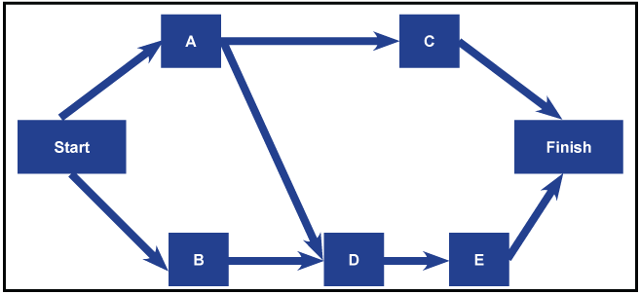
Fig: 2.0

The most significant advantage of using the Precedence Diagramming Method is that it quickly allows the project team to understand all the scheduled activities and its affiliation with one another.

To create a PDM the preliminary step in planning is to work on the WBS. The entire project will become more comfortable/manageable when you break down the tasks to perform the activities. It is important that you know the fundamental capacities to finish the project on time, likewise the project manager will need to know what order the project should be completed. To do this, a Precedence Diagram needs to be created.

Here are a few steps to creating the Precedence Diagram:
- Put the top deliverable from your work breakdown structure on to the right-hand side
- Take each of the lowest level and post-it from your breakdown structure and arrange them in the order in which they need to happen.
- Work from the left until you have the dependencies between the tasks and you have a sequence of functions running from left to right.
- A project manager will need to ensure that emphasis is on the project sequence. Going through the activities, you may come across additional tasks that have to be performed, and henceforth you can incorporate the equivalent in the precedence diagram and to the work breakdown structure.
- Finally, draw arrows between the assignments that connect up, and ensure that there aren't any tasks sitting isolated.
Below is an example of a PDM a construction project might use:
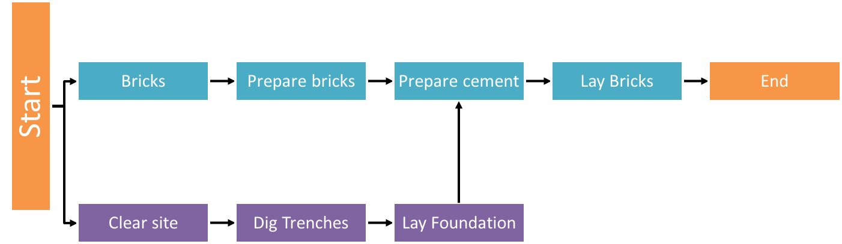

The significant output in the Sequence Activities process is the Network Diagram. The activities that are explained in the define activities process are sequenced as specific activities that rely upon another. While the network diagram shows the project activities and presents the interrelationships of activities, the Precedence Diagramming Method (PDM) is the most widely recognized strategy to draw network diagrams. Therefore, it is normal for certain affiliates and dependencies between the activities in Precedence Diagramming Method.

With the precedence diagramming method, four types of relationships are used in the activities to complete the network diagram of a project. These are:

- Start-to-start (SS): This relationship means that Task A must start before Task B can start. This relationship allows both activities to occur in tandem. For example, a crew of painters are painting a house. Task A is to scrape the flacking paint off the house and Task B is to prime the house. The workers scraping the house must start before the other workers can begin priming the house.
- Finish-to-start (FS): This relationship means that Task A must be completed before Task B can begin. This is the most common relationship. For example, the foundation must be set before the framing can begin.
- Finish-to-finish (FF): This relationship means that Task A must be completed before Task B is completed. Although this is not always the case, ideally, two tasks must finish at exactly the same time. For example, two teams of electricians may be working together to install new telephone cables throughout a building by Monday morning. Team A is pulling the cables to each office. Team B is connecting the cables to wall jacks and connecting the telephones. Team A must pull the cables to the office in order that Team B might complete their activities. The activities need to be completed at nearly the same time, by Monday morning, to ensure that the new phones are functional.
- Start-to-finish (SF):This relationship is also known as just-in-time (JIT) scheduling. It is unusual and is rarely used. It requires that Task A be started in order that Task B might finish. Such relationships may be encountered in construction and manufacturing. An example is the construction of a shoe store. The end of the construction is imminent, but the exact date is not known. The owner of the shoe store does not want to order the shoe inventory until the construction is nearly complete. The start of the construction tasks dictates when the shoe inventory is ordered.

There are four types of dependencies in PDM. These include mandatory dependency, discretionary dependency, external dependency and internal dependency.

Mandatory Dependency is known as hard logic is an integral part of the work. For instance, if you’re working on a project, you cannot test a screen that is yet to be developed entirely in the project. Consequently, in this case, there is a mandatory dependency between the development and testing of the screen.

Discretionary Dependency also referred to as preferential or soft logic is controlled by the project team and can be changed to abbreviate the project. In this technique, activities stay the same, yet, the order changes.

External Dependency comes from outside of the project — for instance, a government regulation expected to finish before proceeding with the outstanding of the project activities.
Internal dependency is a method that involves a precedence relationship between project activities. For instance, if there are activities appointed to a member of the project team, he cannot begin to work on that until the previous project finishes even though there is not a mandatory dependency.

Examples of PDM
A visual representation technique, which is used to prepare the project schedule network diagrams here, is a Precedence Diagramming Method Example that analyses the basic.

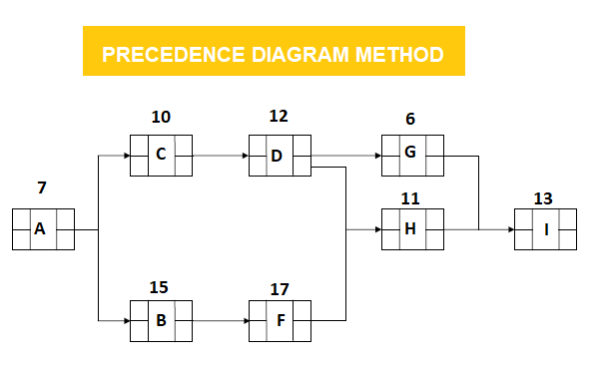
In the example mentioned above, activities are indicated as A, B, C, D, F, G, H, I. Durations are the numbers mentioned above the boxes. Activity B is a predecessor activity that logically comes before a dependent activity F in this network system. Activity F is a successor activity a dependent activity that inevitably occurs after the Activity F. There is an F-S Relationship between activity B and F.

Step 1: PDM Forward Pass Calculation specify the minimum dates at which each activity can be performed and, ultimately, the minimum duration of a project.

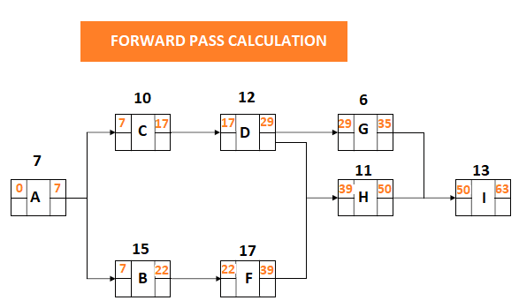
Step 2: PDM Backward Pass Calculation determine the latest dates by which each activity can be performed without increasing the projects minimum duration.
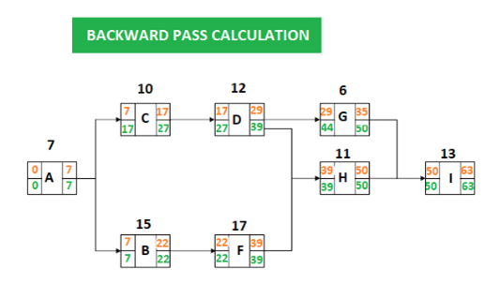

Step 3: PDM Float Calculation for Each Activity
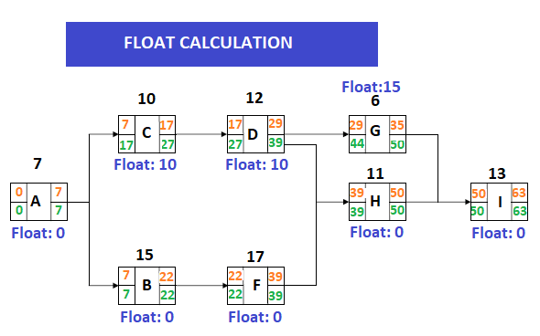
Total float is the amount of time that an activity can be delayed without delaying the project completion date. Total float is 0 on the critical path.
Total Float: LS – ES = 17-7 = 10
Total Float: LF – EF = 27-17 = 10
The total float can be calculated by subtracting the Early Start date of activity from its Late Start date or Early Finish date from its Late Finish date.

Step 4: PDM Identifying the Critical Path
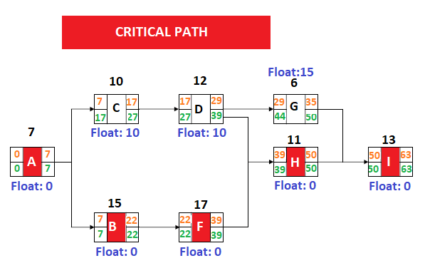

The Precedence Diagramming Method, with its activity-on-node network and additional precedence relationships, offers a simpler and increasingly adaptable system way to deal with demonstrating large projects. While PDM enhances the project planner's ability to deliver precisely demonstrate large projects, clients ought to know about and ready to adequately manage its highlights.

Student Statement:

By submitting this assignment, I confirm that this is my own work.

Student Signature | Lucy Ann Wallace | Date | 04/06/2019

For Tutor / Assessor Use Only
Total Marks
Marks Obtained
Percentage / Grade

