
Assignment Cover Sheet

Student Name: | Allan Geyser
Student Number: | 9345
Course: | Diploma in Construction Management Level 4
Assignment NO: | The importance of estimation in construction work #3

Marking Criteria:
We expect the learners to write minimum one well expressed point in three lines against each allocated mark. This means one needs to write 15 lines with 5 well expressed points to get high grades for a 5 marks question.
For high grades use examples and illustrations where appropriate.
1.
i. Estimating is the process of determining the approximate quantities of resources required to accomplish the project objectives. These resources include materials, labour, equipment and time.

Estimates are necessary as it informs the client when to provide the necessary funds and to enable them to organize all future necessary resources to complete the project. Phased estimates enable the client to ensure resources are available for each phase of the project.

Another reason for estimating is to provide the most realistic prediction possible of time and cost at any given time in a project.

ii. A bill of quantities is a document which lists the items, the amount of items and the unit of measurement for those items. A bill of quantities together with a specification list aids in the planning, scheduling and execution processes.
A bill of quantities is used in the tendering process in which materials, labour and equipment are itemized. It allows multiple tenderers to prepare a price for carrying out the works from one standard document. It also details the terms and conditions of the construction contract.

iii. An approximate estimate, also referred to as a feasibility estimate, is a process performed at the early stage of the project and within a short period of time. It is a process to determine whether the costs are reasonable and what economic alternatives are available, early on.

Approximate estimates are not useful during the actual execution of the project.

There are two steps required to quickly determine an approximate estimate:
1. Determine the total units for constructing the structure based on the physical dimensions such as area, volume or length.
2. Multiply the figure obtained in step 1 by the cost of structure per unit.

iv. A project budget is a financial plan for a project which serves as the benchmark for comparison against the actual cost during the course of the project.

There are certain steps required to prepare a project budget, namely:
1. Refer to the high level project estimates and refine.
2. Refer to budget information of similar projects.
3. Identify the detailed material costs.
4. Identify the detailed labour costs.
5. Identify the detailed equipment costs.
6. Identify any other specific costs
7. Build in a contingency.
8. Compile all information in a report and present to stakeholders for approval.
v. There are two types of project approvals that have to be secured for construction projects namely, administrative approval and technical sanction:

Example taken from Brentwood, (2017):

- Administrative approval
- Technical sanction

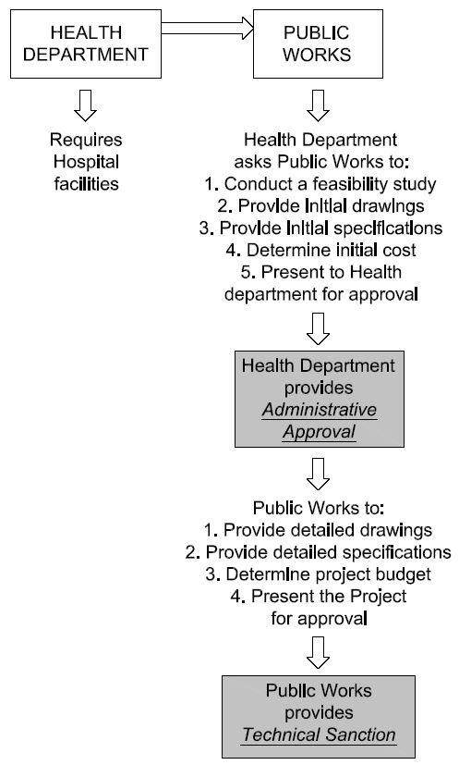
2.
a. Material Rate: For material rates, suppliers should provide quotations as prices can fluctuate but also because of transporting rates to various sites, the size of the loads, loading and unloading, and the handling of the materials on site.

Contractors are encouraged to check whether the materials comply with the specification, whether there is a cost involved for samples of certain materials and whether allowance has been made for damage in the off-loading and handling stages.

b. Labour Rate: Labour rates are calculated by keeping records of skilled, semi-skilled and unskilled worker times for a period of time.

Contractors are encouraged to calculate labour rates on an annual basis rather than on a weekly basis. The reason for this is to include the effect of annual and public holidays on the numbers of hours for payment. Overtime work often depends on the proportion of summer and winter work, because longer working hours are available and used in the summer period.

According to the Brook, M, (2004), a method for estimating labour rate is:
‘Hourly rate = annual cost of employing an operative / actual hours worked’

c. Equipment Rate: Equipment rates are calculated using the quantity of item and the output of the equipment. It is calculated based on the total hours the equipment can be put to work or the required unit output expected of each item.

Cost of fuel and lubricants, repairs and maintenance, allowance for potential idle times and insurance need to be considered when determining equipment rate.
3.
The tasks undertaken in the estimating procedure are items and units, taking off the dimensions, determine rates, project approval and estimate report:

- Items and Units: the estimator creates a list of activities that need to be performed in conjunction with the drawings and specifications. This list can be incorporated in the bill of quantities and be used for tender purposes.
Activities that can be undertaken include lineout and excavation.

The units of measurement are determined based on physical dimensions of the various components.

- Taking off the dimensions: the items listed above will require suitable dimensions being taken off the various components and the drawings completed in appropriate units for each item, including allowances made for portions of the items which are not required to be removed before construction starts.

The lineout and execution procedures should result in a list consisting of items, their quantities and matching units. All items are priced per unit, taking into consideration the resource input cost associated with each item.

Each construction item requires material, labour and equipment rates.

- Determine rates: Material, Labour and equipment rates need to be determined.

- Project approval: There are two types of project approval that have to be secured for construction projects namely, administrative approval and technical sanction.

- Estimate report: regardless of how an estimate is prepared, the estimate report should be presented in a clear, concise, complete and correct manner.

List of sources consulted

Burke, R, 2014. Fundamentals of Project Management. 3rd ed. Southampton: Burke Publishing.

Brentwood, 2017, Unit 3 The Importance of Estimation in Construction Work, lecture notes distributed in Construction Management Level 4 at Brentwood.

Brook, M, 2004. Estimating and Tendering for Construction Work. 3rd ed. Routledge.

Michael, D, Detailed Cost Estimating. Excerpt from the Architect’s Handbook of Professional Practice. Updated 2003.

Student Statement:

By submitting this assignment, I confirm that this is my own work.

Student Signature |  | Date | 2017/10/16

For Tutor / Assessor Use Only
Total Marks
Marks Obtained
Percentage / Grade

