
Assignment Cover Sheet

Student Name: | Deanna Starckey
Student Number: | 23957
Course: | Diploma in Accounting and Finance
Assignment NO: | 04

Marking Criteria:
We expect the learners to write minimum one well expressed point in three lines against each allocated mark. This means one needs to write 15 lines with 5 well expressed points to get high grades for a 5 marks question.
For high grades use examples and illustrations where appropriate.
Please insert your completed assignment (in word format) here:

1) Give short answers for the following questions:
- What do you understand by 'Subsidiary books'?
A subsidiary book is books of original entry in which other transactions of a similar nature are recorded in chronological order. Recording all transactions into one book without being categorized would become very difficult and hard to understand, splitting them into different categories would make it easier to understand and search in the future. A journal is split into different categories which are also known as sub-divisions. Each different category is a specific book of original entry. The original journal entry does not exist when they are entered into these types of books. In the entry system, transactions are recorded in particular journals. These entries of transactions are also entered in ledgers accounts. Whilst working within these sub-categorized journals and creating new entries, we also follow the double entry system rules and principles of accounting although the normal entries are not entered into the sub-categorized journals.

- What is journal?
A journal is a book in which all businesses will hold, containing al information of transactions in chronological order. Whenever any transaction is made, the first thing to do would be to record it in the journal. This is why a journal is also known as a book of original entry as this is where it begins. When transactions have been recorded correctly in the journal, these will then be posted to ledgers accounts.

- What is petty cash book?
A petty cash book is a system that fund and tracks small purchases. These small purchases could be a parking ticket, a jar of coffee, or simply just some milk. These types of purchases are too small for credit card or cheque payments. Usually, a petty cash book is actually used in a book form rather than a computer record. There will be a specific person who is in charge of the petty cash book to save accountants who are occupied with maintaining the main cashbook.
Please see below example of how a petty cash book should look like;
Date | Purchase/Receipt | Amount | Balance
4/01/xx | Opening balance | £250.00 | £250.00
4/05/xx | Toilet Supplies | -£52.80 | £197.20
4/08/xx | Birthday cake | -£24.15 | £173.05
4/11/xx | Take-away lunch | -£81.62 | £91.43
4/14/xx | Parking Metre | -£10.00 | £81.43
4/23/xx | Kitchen supplies | -£42.00 | £39.43

A petty cashier will calculate how much they estimate to be spent on expenses in a certain period. This money is then disbursed at a certain period which could be every 15 days or the start of every month. If the petty cashier needs more money for expenses, a request will be made and passed to the chief cashier and they will go through the petty cash entries that have been made and will then disburse the required amount of money to the petty cashier.

- What are the different kinds of Subsidiary books?
The different types of subsidiary books are;
- Purchases books – This book contains the records of the credit purchases made by a business.
- Sales books – This book contains the records of all credit sales made by businesses.
- Purchase returns books – This book contains a record of all goods returns that are returned to suppliers.
- Cash book – The cash book records all transactions made in cash, which will hold receipts and invoices for these purchases.
- Journal proper – All transactions that do not have a place in any other subsidiary book are entered into the journal proper.
- Sales returns books – This book contains the goods returns by customers.
- Bills payable books – Bills payable book contains records of bills accepted by businesses and are drawn by its creditors.
- Bills receivable books – This book contains the bills that are received from customers by businesses.

- What do you mean by Cash book?
Cash book records transactions which are made in cash. A cash book is a subsidiary category of a journal. This book works as a book of original entry as well as a ledger account. The entries that are made by receipt and payments in cash are then posted to the relevant ledger account.

- Define trade discount and cash discounts
Trade Discount - A seller will usually allow a trade discount to a regular customer or to a customer that buys products in bulk. The discount given to these customers is usually 5% or 10%, according to the retailers’ policy. The cost after the discount has been applied is then known as the trade discount.
Cash Discount – A cash discount is an incentive given by the seller to the customer for settling a bill within a certain amount of time. The discount is usually calculated based on the cost of the bill.

- What is the difference between trade discount and cash discount?
Please see below table describing the difference between trade and cash discount.
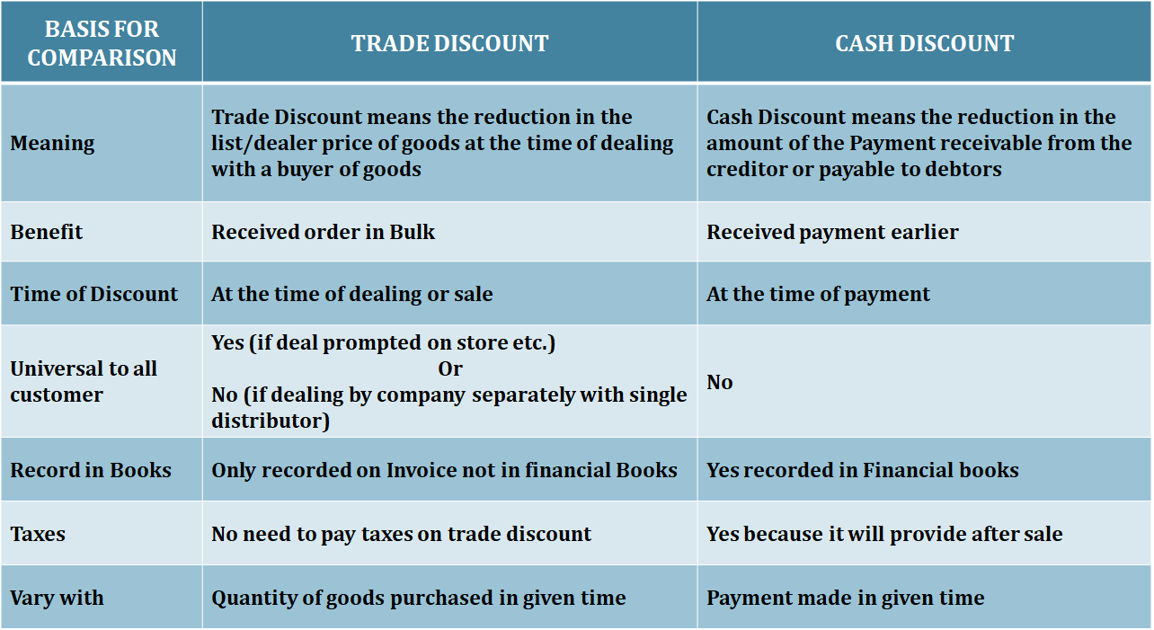

https://tutorstips.com/difference-between-trade-discount-and-cash-discount/

2) What is ledger account? Explain using illustrations.
A ledger contains several different accounts. A journal is a collection of all business transactions recorded in chronological order. This can be very difficult to understand if all transactions are placed in just one book. Ledger provides the chance to sort the transactions out and place them in different sub-headings making it easier to record transactions. A ledger can also be known as a summary of all transactions relating to assets, expense, profit and loss and income etc. When a transaction is posted to a ledger, this means that after this information is passed to the ledger they are then sorted into the correct heading. A ledger is a book where the final entries are recorded.
Below there are some illustrations of transactions being journalized and posted to the cash ledger account.

Illustration 1 – Original transactions
2013  June 1 | Karen commenced business with £ 20, 000.
June 2 | Paid into bank £ 5,000.
June 3 | Purchased Plant worth £ 10,000 from Hammer & Co.
June 4 | Purchased goods worth £ 5,000 form Harold.
June 6 | Goods worth £ 4,000 sold to Alan
June 8 | Sold goods worth £ 2,000 for cash.
June 10 | Goods returned by Alan £ 50.
June 15 | Paid rent £ 250
June 18 | Withdrawn from bank for office use £ 2,500.
June 20 | Paid Salaries £ 1,800.
June 25 | Withdrawn for personal use £ 250
June 26 | Goods returned to Harold £ 100.
June 27 | Paid for office furniture £ 1,500 by cheque.
June 28 | Received £ 3,900 cash from Alan and discount allowed £ 50.
June 29 | Paid Harold on account £ 4,800 and discount allowed by him £ 100.

Illustration 2 – Journalized
Date | Particulars | L.F. | Dr. £ | Cr. £
2013  June 1 | Cash A/c  To Karen’s A/c  (Capital brought into the business by Karen) | Dr. | 20,000 | 20,000
June 2 | Bank A/c  To Cash A/c  (Cash Paid in to bank) | Dr. | 5,000 | 5,000
June 3 | Plant A/c  To Hammer & Co’s A/c  (Plant purchased from Hammer & Co.) | Dr. | 10,000 | 10,000
June 4 | Purchase A/c  To Harold’s A/c  (Goods purchased from Harold) | Dr. | 5,000 | 5,000
June 6 | Alan’s A/c  To Sales A/c  (Goods sold to Alan) | Dr. | 4,000 | 4,000
June 8 | Cash A/c  To Sales A/c  (Goods sold for Cash) | Dr. | 2,000 | 2,000
June 10 | Sales Returns A/c  To Alan’s A/c  (Goods returned by Alan) | Dr. | 50 | 50
June 15 | Rent A/c  Cash A/c  (Rent Paid) | Dr. | 250 | 250
June 18 | Cash A/c  To Bank A/c  (Withdrawn from Bank for office use) | Dr. | 2,500 | 2,500
June 20 | Salaries A/c  To Cash A/c  (Salaries paid) | Dr. | 1,800 | 1,800
June 25 | Drawing A/c  To Cash A/c  (Withdrawn for personal use) | Dr. | 250 | 250
June 26 | Harold’s A/c  To Purchase Returns A/c  (Goods returned to Harold) | Dr. | 100 | 100
June 27 | Furniture A/c  To Bank A/c  (Payment by cheque for office furniture) | Dr. | 1,500 | 1,500
June 28 | Cash A/c  Discount A/c  To Alan’s A/c  (Cash received from Alan and discount allowed £ 50) | Dr. | 3,900 | 3,900
June 29 | Harold’s A/c  To Cash A/c  To Discount A/c  (Cash paid to Harold and discount allowed by him) | Dr. | 4,900 | 4,800  100

Illustration 3 – Ledger Cash Account
Dr.  Date  2013 | Particulars | J.F | £ | Date 2013 | Particulars | J.F | Cr  £
June 1 | To Karen’s Capital A/c |  | 20,000 | June 2 | By Bank A/c |  | 5,000
June 8 | To Sales A/c |  | 2,000 | June 15 | By Rent A/c |  | 250
June 18 | To Bank A/c |  | 2,500 | June 20 | By Salaries A/c |  | 1,800
June 28 | To Alan’s A/c |  | 3,900  28,400 | June 25  June 29  June 30 | By Drawings a/c By Harold’s A/c  By Balance c/d |  | 250  4,800  16,300  28,400

3) Explain the advantages of subsidiary books.
There are many different advantages to subsidiary books, which are listed below;
- Dividing the amount of work – Having different people assigned to the separate books of a subsidiary book means that the work is split between them. The entries in the journals can be divided amongst the team who work independently with these books.
- Time Saving – Finalizing and completing accounting records can take up less time, meaning that other accounting tasks can be performed at the same time.
- Minimum errors and frauds – Maintaining and updating journal and recording transactions on the system can help to avoid any possible errors or fraud.
- Better Information - The journal system does not record certain transactions such as credit sales, credit purchases, returns etc., and so subsidiary books record useful information related to these entries.
- Efficiency – Having clerks that record transactions from day-to-day means that they become experts in what they do. This creates efficiency in the accounting system.
- Better Managements Decisions – The management of a business benefits from a systematic record of transactions which is available in subsidiary books. This makes it easier for management to make better decisions.
- Easy Access – It becomes easy to access the detailed information relating to a particular transaction as the transactions relating to one head are recorded in a separate book.

file:///C:/Users/User/Downloads/1887114756Unit%204%20Journal%20%20and%20%20Subsidiary%20Books.pdf

Student Statement:

By submitting this assignment, I confirm that this is my own work.

Student Signature | D.Starckey | Date | 02/10/2018

For Tutor / Assessor Use Only
Total Marks
Marks Obtained
Percentage / Grade

