
Assignment Cover Sheet

Student Name: | Paula Gabriel
Student Number: | 25976
Course: | Active Listening Online Training Course
Assignment NO: | #1

Marking Criteria:
We expect the learners to write minimum one well expressed point in three lines against each allocated mark. This means one needs to write 15 lines with 5 well expressed points to get high grades for a 5 marks question.
For high grades use examples and illustrations where appropriate.
Q1
(I) Active listening is a communication technique, which requires the listener to fully commit to concentrating and understanding what the other person is saying and being able to respond accordingly. It is also listening to another person in a completely non-biased open way and listening beyond just the words they are speaking by observing other factors such as body language and emotional mood. It involves understanding what the other person is saying from their point of view and not from the listener’s point of view, in order to develop a shared understanding of what is being said and going on in that person’s life. A good active listener watches for clues in the other person’s behavior to ease any tension in a situation and maintain the best possible open climate to enable the person to say what they want to say and feel at ease.

(II) The Physical Indicators in active listening are;
- Showing positive body language such as positive open relaxed posture and smiling, nodding the head in acknowledgement of understanding and listening, not being distracted by fidgeting or looking at a watch. Leaning into the conversation to show interest.
- Making and maintaining eye contact showing encouragement
- Making positive reinforcement statements such as ‘I see’ or ‘carry on’ etc…
- Summarising what has just been said at certain points in the conversation to demonstrate attention to detail and understanding
(III) Various techniques used to demonstrate in active listening are:
- Concentrating on the person, not being distracted by external factors or internal thoughts, but focusing on what is being said whilst listening around the words, observing things such as mood, emotional response and body language. These factors can clarify the intent behind what the person is actually saying and can add a different dimension to a conversation and can quite often complete the message the other person is trying to convey.
- Listening without interruption, letting the person finish their own thought processing and take their time to say what they want to say without you hurrying them.
- Listening in a positive non-judgemental way by creating the correct mind set and suspending your own frame of reference. It is only then that we can truly understand what the other person is trying to relay to us and gain a shared understanding of their point of view.
- Being empathetic and sympathetic to show the other person that you understand and can identify with what they are saying. Also being respectful as well as diplomatic and truthful in your responses.
- Providing feedback and clarification by saying things such as ‘Sounds like what you are saying is that ….’ or ‘what do you mean when you say …..’ This helps you reflect on what is being said as a listener and ensure you are understanding correctly
(IV) Albert Mehrabian conducted a study in the 1960’s which looked at the importance of non-verbal communication. He believed that there are three elements in effective face-to-face conversation; the spoken word, non-verbal behavior (such as facial expressions and mood) and tone of voice of the speaker. He believed that these 3 factors determined how we conveyed liking or disliking of a person (The Mehrabian Myth 2008). The study concluded that when a person is speaking only 7% of the intent of what is being communicated is picked up from the words alone, the other 93% is picked up from their tone of voice and their body language. From his study he formulated the 7-38-55% (respectively) communication rule
(V) a. Frame of reference: our own perspective – how we would see and judge a situation based on our own beliefs, thoughts, biases and values and also our mood at that given time.
b. Positive intent: listening to others by suspending your own judgement and responding to them with their best interests at the front of what you are saying.
c. Reframing the situation: halting your own perspective and looking at the situation with a non-biased, open non-judgmental frame of mind so that you can understand better where the other person is coming from and how what they are saying is impacting on them

Q2
Attitude is key to active listening. If someone comes to speak to you or confide in you, the last thing that person wants is to speak with someone that is going to judge them, patronise them or not be interested/understand what they are saying, as this may make them feel worthless and discourage them from continuing. It is important for the listener to demonstrate they have empathy and understanding as well as sympathy for the person’s situation, as this can encourage the other person to carry on talking and make them feel at ease. Empathy and understanding can also validate what the person is saying in that the listener appreciates their circumstances and has projected themselves into the other person’s personality and situation to fully understand that person and what is going on. Sympathy is also needed as it demonstrates showing compassion for the other person’s hardships however it can sometimes be more of an emotional response than empathy and when showing sympathy the listener must be careful not to show pity which can be condescending. Both empathy and sympathy are forms of showing concern for another person’s wellbeing or situation and in my opinion go hand in hand.
Q3
The tips for becoming a better listener can be summarised as:
- Commitment – committing yourself to listening to that person, closing your mind to distractions and internal thought noise and giving the other person your undivided attention without interrupting them whilst they are talking. Maintaining eye contact and showing that you are listening to them by nodding your head and validating what they are saying by using open questions like ‘how did that make you feel’ or ‘I can totally understand why you reacted like that’. Do not try to mind read – ask for clarification if necessary so you can be sure you understand correctly.
- Listening fairly – listen to the other person fairly and non-judgmentally by re-framing the situation and suspending your own frame of reference and not reacting to them emotionally or making assumptions. Be mindful and respectful of the fact that every person has a different viewpoint and is individual; you cannot judge everyone by your own rules. Be clear and impartial on your advice.
- Support – support the person fully in what they are saying by encouraging them with things like ‘Yes I see’ or ‘Carry on’ and display positive body language such as leaning in to them to show interest or nodding your head to show understanding and then ask the person what they would like you to do in order to support them.
- Listen behind the words – remember to look behind the words for things such as mood, emotional responses and body language as these things often give a fuller picture of what is going on with the person and the impact the situation is having, even if the person is not actually telling you those things with the words.

Student Statement:

By submitting this assignment, I confirm that this is my own work.

Student Signature | 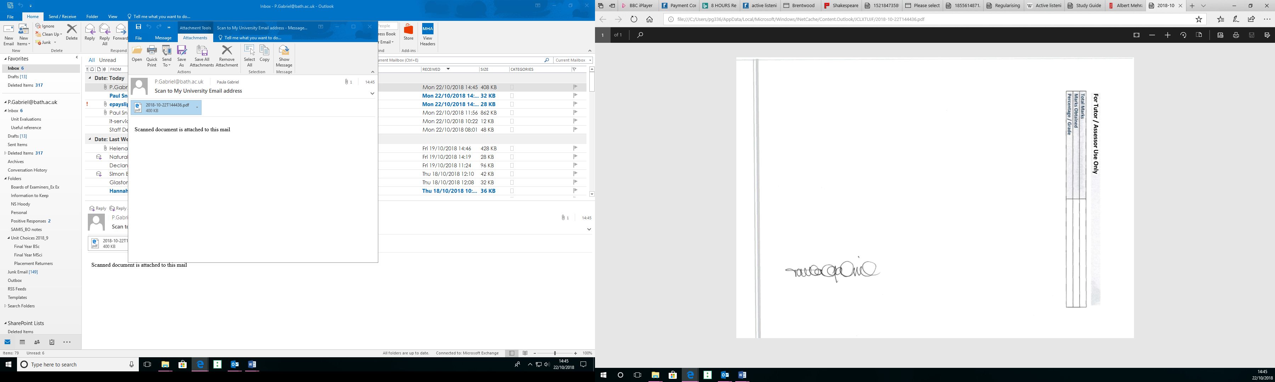 | Date | 22.10.18

For Tutor / Assessor Use Only
Total Marks
Marks Obtained
Percentage / Grade

