
Assignment Cover Sheet

Student Name: | Lydia Johnson
Student Number: | 4996
Course: | Level 4 travel and tourism
Assignment NO: | 6

Marking Criteria:
We expect the learners to write minimum one well expressed point in three lines against each allocated mark. This means one needs to write 15 lines with 5 well expressed points to get high grades for a 5 marks question.
For high grades use examples and illustrations where appropriate.
Please insert your completed assignment ( in word format) here:
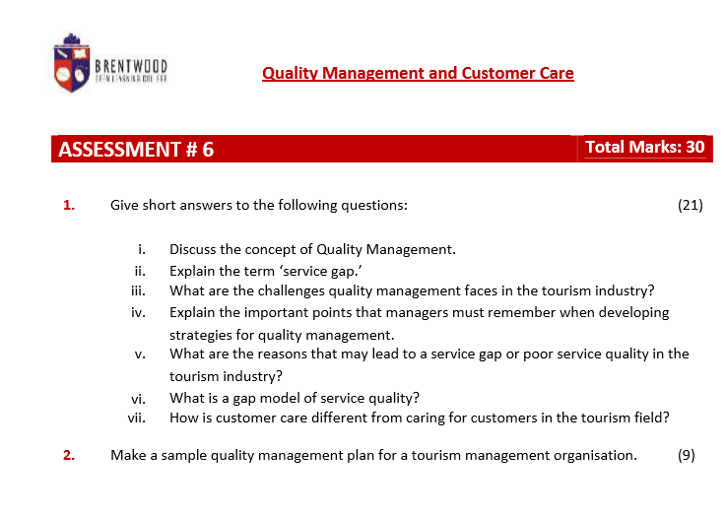
- Discuss the concept of Quality management
The concept of Quality management in services as defined by Nightingale (1985) by two strands. One strand is the service offering as intended by the provider and their perception by the consumer. Parashraman et al (1985) identified five inconsistencies that could hinder the service experience. These are: positioning, specifications, delivery, communication, and perception. Brown et al. (1990) identified the variations between the providers and the consumer’s assessment of service quality. These include: professional and skills, attitudes and behaviours, access and flexibility, reliability and trustworthiness, recovery and reputation and credibility.
One of the essential quality management factors in tourism is that not all tourists are the same. These includes key elements the quality of the product and services and the quality of the user. Since the 1990s the consumer is an inseparable part of the organisation’s aims.
The key elements of quality management are Service quality, which includes the intended market, the power of tourist to purchase. Quality operations focus on the guiding principles of tourism of the location and contentment of tourists and hosts as well.
The key factors that a manager needs to consider in the quality management process are: hold long term obligation to non-stop improvement, adapt a culture of ‘right first time’, train employees to comprehend customer -supplier relationships, the total cost and quality needs to be considered, perfection in delivery system should be practiced, new training and supervision methods should be implemented, team work and good communication, systematic methods to ensure implementation.
The results of a good quality management program will: enhance customer service provider relations, improved management procedures, transformation in organisational culture and employee commitment. Finally, it is essential that a durable management information system is utilised to add customer feedback and front-line employees.
- Explain the term ‘service gap’
Products that do not offer good quality customer service that meets the expectations of consumers are difficult to sustain in a competitive market. The service quality gap is a gap method in service quality measurement, a tool that can be used by Product manager across all industries. The aim of this model is to: identify the gaps between customer expectation and the actual services provided at different stages of service delivery, close the gap, and improve the customer service.
To ensure that quality is delivered in tourism operations the service provider must ensure that all the gaps are filled. Some of these gaps include: when erroneous priorities are assigned, middle management and front line staff are not given the power to make decisions, no encouragement, improvement, or originality are encouraged within the organisation, if higher management loses control in delivery or communication.

- What are the challenges quality management faces in the tourism industry?
The challenges quality management faces in tourism industry is that not all tourists are the same. They differ in origin, length of stay, travel purpose and activities. There are some countries e.g. America are known for spending big which could be good for the tourism industry. However, the challenge is that the resources and infrastructure may affect the locality greatly.
- Explain the important points that managers must remember when developing strategies for quality management
The main points that managers need to remember when developing strategies for quality management are: the top management need to assigns employees priorities, the middle management and front line employees are given the power to make suitable remedial decisions on the spot, upper management do not appear or come across too smug, higher management need to ensure good control of delivery and communication; this in turn will promote a positive company image, expected service quality, good standard of company image, a high standards of service delivered.
- What are the reasons that may lead to a service gap or poor service quality in the tourism industry?
The main reasons that may lead to a service gap or poor service quality in the tourism industry are six areas (according to Brown et al 1990) professional and skills, attitudes and behaviour, access and flexibility, reliability and trustworthiness, recovery and reputation and credibility. In more details, there are: Professionalism and skills – problems are solved in a professional way and they are knowledgeable. Attitude and behaviours – the customer’s problems are addressed in a friendly and professional manner. Access and flexibility – all the customers’ needs and requirements are addressed. Reliability and trustworthiness – the provider ensures that the costumer act in their best interest. Recovery – if anything goes wrong the costumer knows that it is corrected quickly. Reputation and credibility – the aims and mission statement of the company are achieved and have a good reputation in the tourism industry.
- What is a gap model of service quality?
A gap model of service quality highlights the inconsistencies or gaps that could show up in the service supply process and hinder the service experience.
- How is customer care different from caring for customers in the tourism field?
Customer care focuses on the company approach in winning and maintaining customers. It ensures that quality service is offered to the customers.

Caring for the customer focuses on how a company deals with its clients e.g. individual issues, problems, and requirements. The tourist company can determine whether the customers achieves their dreams or has a nightmare experience. This factor should consider going the extra mile to cater for the customer needs and expects.

2. Make a sample quality management plan for a tourism management organisation.
Department responsible | Key quality management feature | Details of the key quality management feature | Customer focus feature | Example of tourism management organisation
Top management | Establish clear mission statement and the expected quality service for the company | Ensure this is communicated and understood by all employees | Reputation and credibility | e.g. Thomas cook values are ‘Put our heart into it’, ‘wear their flip flops’, we’re one Thomas cook.’
Top management | Produce promotional material | Assign employees priorities | Professional and skills | Brochures, website
Top management | Planning implementation and control | Ensure that clear time lines, all departments of the organisation have clear objectives to implementation the company mission statement. | Professional and skills | The customer know that all departments will work together to achieve their dream holiday
Middle management | Ensure that the expected quality service is delivered | Middle management and front line employees are given the power to address customer concerns and issues | Attitudes and behaviour | Customers are listened to and solved when arise.
Middle management | Service quality specification | Ensure that the service receives meets clear quality specification. This can also include meeting individual customer needs. | Access and flexibility | Clear guidelines on how to address visa requirements
Front line staff | Receive professional development | Management give them encouragement and opportunities | Professional and skills | Local knowledge
Front line staff | Systems are set up to receive customer feedback | This will ensure the public image of the company is understood and addressed if this is not positive. | Recovery | Inadequate hotel or transport
 | Implement service quality specifications | As directed from middle management | Access and flexibility | Met individual needs e.g. disability requirements

Each of these departments have clear areas that they are responsible for. However, it is essential that is an ongoing communication and flexibility are in place to achieve high quality results. In addition, each stage need to be reviewed regularly to ensure that customers’ needs and requirements are being meet and the company is keeping up to date with the ongoing change in technology and the tourism industry.

Student Statement:

By submitting this assignment, I confirm that this is my own work.

Student Signature | L.Johnson (e-signature) | Date | 23/4/17

For Tutor / Assessor Use Only
Total Marks
Marks Obtained
Percentage / Grade

