
Assignment Cover Sheet

Student Name: | ASLIHAN MANAS
Student Number: | 20696
Course: | EVENT MANAGEMENT LEVEL 4
Assignment NO: | 9

Marking Criteria:
We expect the learners to write minimum one well expressed point in three lines against each allocated mark. This means one needs to write 15 lines with 5 well expressed points to get high grades for a 5 marks question.
For high grades use examples and illustrations where appropriate.
Starting and Running the Business
ASSESSMENT # 9 Total Marks: 30
1. Write a business plan for your business, which you have started with an investment of £30,000. Your company deals with the management of medium - sized social events,
i.e., weddings, birthday parties, etc. (15)
The business plan must include:

Business name

MANAS CHARM WEDDINGS & CELEBRATIONS
b) Complete business description for your business

At Manas Charm we plan, design and manage exceptional celebrations throughout the world. From small intimate gatherings to large and lavish affairs, our weddings and parties are memorable, magical experiences, perfectly planned and beautifully executed.

Luxury Weddings
We are the Luxury Wedding and Party Planners for clients demanding first class service and world-class events. From princesses to pop stars and from celebrations in Turkey, London and the UK to destination weddings and social events in Europe and beyond, we plan elegant, stylish, glamorous and fun celebrations.

Exclusive Events
We are proud of our international reputation for creating exclusive events and delivering first-class service with discretion. From our Turkey headquarters we enjoy working with diverse clients from across the globe. Our bespoke international service is tailored to their individual needs.

Global Reputation
Our discerning, international clientele include aristocrats, people of note, high net-worth individuals and families seeking unique and meaningful celebrations. We strive to be the best at what we do - and several prestigious international publications have been kind enough to state that we are.

c) Description of the services you offer

Divine Details
THE COMPLETE WEDDING PLANNER EXPERIENCE
Our signature service. We take the stress out of the planning and bring in the fun process of venue selection to vendor selection and every detail in between, facilitating all information and communications with you.
With our experience and knowledge of the Los Cabos area and Mexico, you will feel reassured that every detail will be accounted for. This full event planning service will let you continue with your schedule back home without any added stress. We work on planning your entire wedding weekend, helping you complete every event function we have planned.
EVENT FUNCTIONS
- Welcome Party
- Wedding Rehearsal
- Rehearsal Dinner
- Wedding Day
- Fairwell Brunch
EVENT PHASES
- Venue Selection
- Event Planning
- Event Styling
- Event Management
- Event Operation
Stylish details
- EVENT STYLING + DAY OF SERVICE
For those brides that are DYI or have a family member putting it all together for you, but in the actual wedding day you want to enjoy every minute of it, then this is the service best fitted for you.
We help you complete your initial time-line, so you know what times your vendors should be booked and everything works according to the event hours you have for your big day! Then we start with Event Style right away and 30 days before the big day we start working on those loose ends in your time-line and reconfirm all services.
EVENT FUNCTIONS
- Wedding Rehearsal
- Wedding Day
EVENT PHASES
- Initial Time-line
- Event Styling
- Partial Planning 30 days before
- Event Operation
Wedding Resort or Venue Selection
- scouting locations
- site inspections
- booking location
- Not sure you are ready to make a commitment afar? You want to make sure you are making the correct choice? or you are planning a visit to Los Cabos to check out locations... We can help you with preparing and facilitating all the information for potential wedding venues or resorts that will accommodate your event size, style and targeted budget.

d) Complete primary and secondary analysis of the industry, market
The wedding industry is composed of a variety of sub-group service establishments that work cooperatively to create a wedding event. These wedding industry sub-groups may include: wedding invitations, bakeries for the wedding cake, jewelers for wedding rings, event transportation, event photography and/or videography, wedding planning services, formal wedding attire, wedding locations, banquet/reception locations, catering, and the securing of those individuals qualified to preside over wedding ceremonies.

The wedding industry is globally diverse, and there are a variety of types and traditions that are involved in ceremonies between ethnic groups, countries, and cultures.

These traditions are based on both religion and the personal preferences of the parties involved. Most wedding ceremonies involve the couple reciting and/or exchanging vows. Though traditional vows have been customary, recently couples have more often been choosing to create their own vows. There is also typically a giving of a symbol between both parties; this symbol may be rings, flowers, money, or other symbolic offerings; in addition, the master of ceremonies involved in the wedding will usually issue statement proclaiming the parties to be legally married. Celebrations frequently follow the wedding ceremony.

The demand for wedding services is dependent upon the personal income of the consumer and/or their families, as well as consumer preferences for their wedding ceremony. As there are so many different organizations that must coordinate to create a wedding, competition is often steep within this industry. Some businesses offer more than one wedding service in order to generate increased revenue, while others specialize in one sector of the wedding industry and focus on supremely efficient and effective in that unique area.

e) Trends, market demands, and competition.
The average cost of a wedding reached an all-time high of $32,329, according to The Knot 2016 Real Weddings Study, which surveyed 13,000 brides and grooms across the United States.) Marketing plan including advertisement methods for your business.
Thanks to a stronger economy and higher discretionary incomes, the U.S. wedding industry edged higher to hit $72 billion in revenue in 2016, according to a report by IBISWorld.

However, the wedding industry hasn’t always had a bright outlook. In the last five years, wedding service providers have grappled with a unique mix of limitations. Wedding budgets dropped due to the high unemployment rates that lingered after the recession. At the same time, many people returned to school and postponed their weddings.

Not only that, more and more couples are waiting longer to get married and are choosing to live together before marriage — factors that drive down the overall marriage rate. In 1960, 72 percent of all adults 18 and older were married. In 2012, the marriage rate was just 51 percent, U.S. News and World Report found. With fewer couples getting married, wedding vendors have a smaller pool of customers to draw from.

The DIY Wedding Trend
Wedding planners, in particular, have faced declining demand, as more couples embraced a do-it-yourself approach. However, a stronger economic environment will help counterbalance this decrease to a certain extent. IBISWorld estimates that revenue for wedding planners “will decline at a slower rate over the five years to 2021.”

Although rustic weddings held in barns and other DIY settings have been popular, consumer preferences may swing back to a more formal approach. “Brides are starting to say, ‘my friend, cousin and big sister did that, I am going to do something different,” notes Anne Chertoff, a trend expert at WeddingWire, in an article on CNN Money.

g) Details of your business legal requirements

Business License
In most cases, the owner is required to apply for a business license to open and operate a business. A business license obtained by contacting our local city hall or courthouse.

Building Permit and Certificate of Occupancy
Before opening our business, we must acquire a permit from our local city government that allows us to operate out of a particular building or space. This ensures that the building has been cleared for the type of functions that will be held.

Food Handler's Permit
We plan to open a full-service reception hall, a food handler's permit is required to serve food. We will apply for this type of permit by contacting your local public health department.

Alcohol / Liquor License
A liquor license is required to serve alcoholic beverages. We will not be able to provide alcohol or have any wedding guests consuming alcohol on the premises without a liquor license. Apply for a liquor license by contacting our state's liquor commission.

Insurance
Purchasing insurance is a vital step in the success of our wedding and reception business. Insurance will cover the cost of equipment repairs and protect you against liability if a wedding guest or employee is injured during a function. Additionally, insurance will cover the cost of rebuilding if the building is damaged or destroyed by fire, flood, or another type of natural disaster. Companies offering this type of insurance can be found online.

h) Projected profit and loss forecast for the next 12 months.

We expect losses in the first year, because it will take time for the store to build momentum and generate traffic. However, once sales increase, the results are positive because many of the other expenses will remain fixed. In fact, we expect that sample inventory costs will actually go down in years to come.

The cash flow of MANAS CHARM WEDDINGS & CELEBRATIONS is somewhat unique. For organizations that are sold off the floor, the cash flow and revenue recognition is traditional, in that full payment is received at the time of the sale, and the customer takes possession of the item at that time. This is how most of the shoe sales will take place, as well as some of the other accessory purchases.

However, most of the other items in the store have a different flow. Let's use a wedding organization as an example. The customer will meet up with our design team in the store, and when she decides to organize the wedding, she will most likely have to order it in her theme and colors of her choosing. For this process to begin, the customer must provide a deposit of at least 50% of the total price of the organization (note: while some customers may choose to pay the full amount). The remaining balance will be due within thirty days of when the wedding is due.

This timing issue has also been taken into consideration for the costs of goods to be sold. The store will be billed for items when the items are shipped, thus cash outflow for the cost of the item will closely match the cash inflow of the customer paying the balance on the item.

2. (15)
a) Prepare an event management plan for a sports event being held at the stadium. Some 20,000 people are expected to attend.

Name of Event: | FETSIVAL OF SPORTS
Location of Event: | ISTANBUL INONU STADIUM
Address: | Vişnezade Mahallesi, Vişnezade Mah., Dolmabahçe Cad., 34357 Beşiktaş/İstanbul
Venue Owner: | Besiktas Football Club
Venue Contact | Vişnezade Neighborhood, Dolmabahçe Street, 34357 Besiktas/Istanbul
Provide a description of the nature of the event including the type of activities and entertainment:
This festival will get all types sports together. Each type of sport will have their own challenge.
Festival is aiming to teach about different types of sports.
Date of event: | 23-24 June 2018
Event start time: | 08:00 | Event finish time: | 00:00
What date/time will set up commence: | 20 June 2018 10:00
What date/time will clean up finish: | 26 June 2018 5:00
Estimated number of attendees: | 20,000

Event Management Staff
The Event Coordinator is responsible for the coordination of the overall event. The Event Coordinator should be an individual who is contactable at all times whilst the event is in progress.
Event Coordinator: | Aslıhan Manas
Organisation or Group: | MANAS CHARM WEDDINGS & CELEBRATIONS
Address: | MANAS CHARM WEDDINGS & CELEBRATIONS HQ / Istanbul
Phone: | 05 - - -

Position / Organisation | Contact | Phone
Event Coordinator | Aslıhan Manas | 05 - - -
Event Safety Officer | X X | 05 - - -
Chief Warden | X X | 05 - - -
Edendale Contact | X X | 05 - - -
Istanbul Police Station | X X | 155
Ambulance | X X | 112
First Aid | X X | 05 - - -
Taxi | Basiktas Taxi Company | 05 - - -
Security | X X | 05 - - -
Other | Special Sports Doctor for injuries during the events. X X | 05 - - -

Vendor/Performer Contact List
Name | Contact | Phone | Activity
Nike | X X | 05 - - - | Advertising own products
Sport Drinks CO. | X X | 05 - - - | Advertising own products
Healty Way CO. | X X | 05 - - - | Advertising own products

- Produce a site design showing temporary site entrances and exits, parking, food stalls (adjutant to the stadium), information centre, first aid posts, and toilets for the above event.
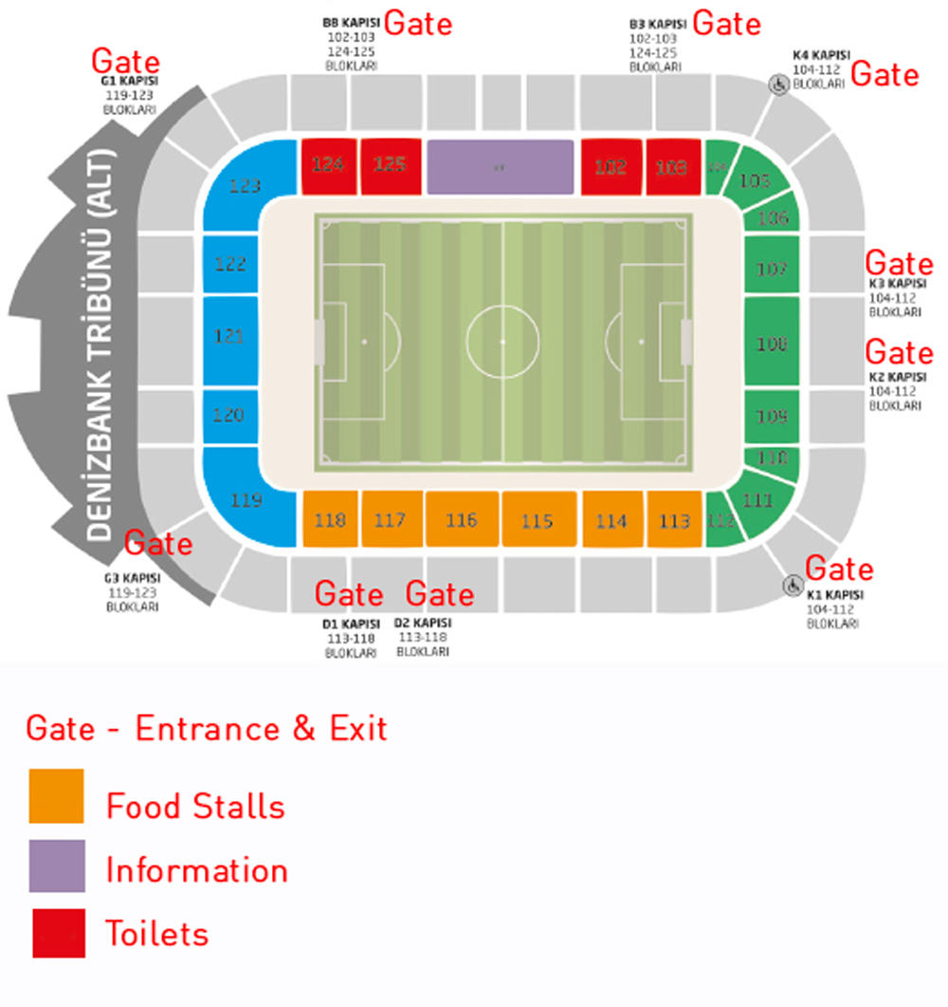

Student Statement:

By submitting this assignment, I confirm that this is my own work.

Student Signature | Aslihan MANAS | Date | 5.6.2018

For Tutor / Assessor Use Only
Total Marks
Marks Obtained
Percentage / Grade

