
Assignment Cover Sheet

Student Name: | Peter Gisbey
Student Number: | 17065
Course: | Environmental Management
Assignment NO: | 3

Marking Criteria:
We expect the learners to write minimum one well expressed point in three lines against each allocated mark. This means one needs to write 15 lines with 5 well expressed points to get high grades for a 5 marks question.
For high grades use examples and illustrations where appropriate.
1. What is environmental management? What are various benefits associated with the
effective management of environmental issues? (10)

Firstly, based on the course notes, environmental management in layman's language is the process by which environmental health is regulated.

Human beings cannot aspire to manage the environment itself, so perforce environmental management is the process of taking steps and behaviours to have a positive effect on the environment (at the same time minimising any negative effect on the environment).

Environmental management involves the wise use of activity and resources to impact the world. Specifically, many leading organisations have developed a management plan or system to implement, manage and maintain environmental goals (e.g. Coca-Cola).

Management plans for the environment are conceptualised by many companies and
organisations, because taking care of the planet has become the prime responsibility of everybody in every type of profession. Successful companies today are not only measured by how much profitable their products are but also how well they respond to the call to protect the natural environment.

Indeed, global companies are increasingly recognising that green products do not necessarily cost more but serve to provide market niches that could help the company thrive. For example, the success stories of Kodak single-use camera and Xerox re-manufacturing programmes have made businesses rethink (and indeed re-imagine!) their strategies and pay attention to environmental management.

Environmental management is therefore a process concerned with human–environment interactions, which seeks to identify:

- what is environmentally desirable;
- what are the physical, economic, social and technological constraints to achieving that; and
- what are the most feasible options.

As such, environmental management displays the following characteristics:

- it supports sustainable development;
- it is often used as a generic term;
- it deals with a world affected by humans

It follows that effective environmental management must do three things:

- Identify goals;
- Establish whether these can be met;
- Develop and implement the means to do what it deems possible.

Secondly, again based on the course notes, there are many benefits associated with the effective management of environmental issues, including reduced risk, improved utilisation of resources and employees, better management of regulatory compliance, reduced costs, increased revenue and improved public reputation.

Incidentally, Huang and Shih (2009) stresses the helpful connection between environmental management and knowledge management. Indeed, it is noted that: “…Environmental knowledge management, which combines the strengths of environmental management and knowledge management, will become a popular tool for businesses in the near future” (p. 35).
Many organisations have significantly improved their profits and turnover through improving materials utilisation rates, reducing energy consumption, manufacturing green products and reducing pollution and waste.

On the other side of the equation, it is only necessary to look at accidents such as the Bhopal incident (Union Carbide) and the Exxon Valdez oil spill, and latterly the Piper Alpha and Deepwater Horizon tragedies.

Such events caused significant harm to human health and/or the environment, also costing many millions of dollars in clean-up costs, compensation and legal fees (incidentally, the cost of cleaning up the oil spill resulting from the Deepwater Horizon oil rig explosion is generally estimated to be around US$3 billion).

The importance of the environment to overall business success is widely recognised. Indeed, it is almost a mantra among business and government leaders that the environment is not a fringe issue but, rather, is a mainstream business issue and an integral part of business excellence and total quality management.

International organisations such as the World Business Council for Sustainable Development and the International Chamber of Commerce have developed environmental guidelines and standards and have promoted environmental issues among their members.

Both public and private sector organisations have responded to environmental pressures and opportunities by integrating environmental issues into their business practices through cleaner production, life cycle analysis, environmental impact assessment and public reporting.

Today, companies are adapting their strategies in response to environmental concerns. World communities have reacted by adopting international and national laws to ensure compliance to environmental standards.

It is also clear that green products may in fact, provide competitive advantage. Recently, there has been significant growth in the development of such products since the 1990s.

The energy industry has also reacted to green power which has been defined by the National Association of Attorney Generals [NAAG] as the use of replenishable or sustainable fuel sources in the generation and transmission of electricity and the disposal of spent fuels. Such releases into the environment would not create harmful substances and would pose no significant concern to the ecosystem and to land use. The focus is on renewable energy supply.

The trend toward green is on the rise in every sector of the economy. According to a study by Yanklovich Clancy Schulman, 78% of people are “influenced greatly” to buy products that make environmental claims. The Organic Trading Association notes that products with the word “organic” have 34% sellthrough rate compared to conventional products. Furthermore, the rate of growth of natural or organic food has been steady at 18-25% while conventional foods remain flat at 3-4%. The demand for organic products has also affected the clothing industry where the current trend calls for the use of organic cotton.

There is also a growing demand for hybrid vehicles. Companies like Toyota and Honda that were among the first to manufacture hybrid cars that combine gas engines with battery-powered electric motors have witnessed surge in demand. These products are not only environmentally friendly but are also economical.

The aforementioned points serve to illustrate that environmental management does not necessarily focus on regulatory compliance in general. As Delmas and Toffel (2004) comment: “…some firms adopt environmental management practices beyond regulatory compliance” (p. 209).
It is worth also bearing in mind that SOAS (2018) indicates, inter alia, that environmental management is concerned with “…concerned with the understanding of the structure and function of the earth system, as well as of the ways in which humans relate to their environment”. This suggests that environment management is about decision-making, with ultimate regard to natural resources.

Having said this, it is important to qualify the preceding point by noting that, as already indicated, environmental management generally focuses more on the management of human activities than on the management of the natural environment itself. Regarding the management of the natural environment, this is an infinitely more formidable and obviously impossible task, given the sheer scale, breadth and depth of Planet Earth’s resources, both animate and inanimate.

Moreover, SOAS (2018) notes elsewhere that environmental management is “…concerned with meeting and improving provision for human needs and demands on a sustainable basis with minimal damage to natural habits and ecosystems.” This points out that a crucial aspect of the role of environmental managers is to influence the course of development in a way that is both fair and just, to both present and future generations (not just of human life but of all species) and to the planet itself.
In closing, and in agreement with SOAS (2018), Brown et al. (1987) similarly contend that: “Sustainability is increasingly viewed as a desired goal of …..environmental management” (p. 713).

2. What is a typical scheme of practice adopted for environmental management? (10)

As suggested by the relevant course notes, the following sequence of steps is generally appropriate for environmental management:

- Identify need(s)/goal(s)
- Define Problem
- Determine Appropriate Action (likely to involve impact, hazard and risk assessment)
- Draw Up Plan
- Implementation (Evaluate Success)
- Develop Ongoing Management
- Evaluate And Adjust Management
- Future Environmental Management

It is important to note that increasingly, stages 1, 2 and 3 are influenced by broad strategic policies, and are accountable to public scrutiny (as is stage 5).

Ideally, lessons learned at every stage should be passed on to improve future environmental management – the evaluation of stages 4 and 5 (and 6!), as indicated by stage 7, is especially useful in future environmental management (stage 8). At stage 1, the public or a developer may not have a clear idea of needs or goals, so the environmental manager may need to establish these.

Moreover, step 8 can then directly link back to step 1 to create an environmental management practice cycle. This fits neatly with the popular view of environmental management being understood as an ongoing activity with successive iterations over time (especially key segments of long duration such as 10-15 years).

3. Draw and explain (an) environmental management system’s Continuous Improvement
Cycle? (10)

Again, as indicated by the course notes, an Environmental Management System (EMS):

  - Serves as a tool to improve environmental performance
  - Provides a systematic methodology for managing an organization’s environmental behaviour
  - Is that aspect of the organization’s overall management structure that addresses immediate and future impacts of its products, services and processes on the environment
  - Gives order and consistency for organizations to address environmental concerns through the allocation of resources, assignment of responsibility and consistent evaluation of practices, procedures and processes
  - Focuses on continuous improvement of the system
An EMS (Environmental Management System) therefore follows a Plan-Do-Check-Act cycle (PDCA). Diagrams 1 and 2 below show the three-fold process of developing an environmental policy, planning the EMS and then implementing it.

The process also entails checking the system and acting on the findings. The model is continuous because an EMS is a process of continual improvement in which an organization is reviewing and revising the system on a continual basis (Welford, 1993).

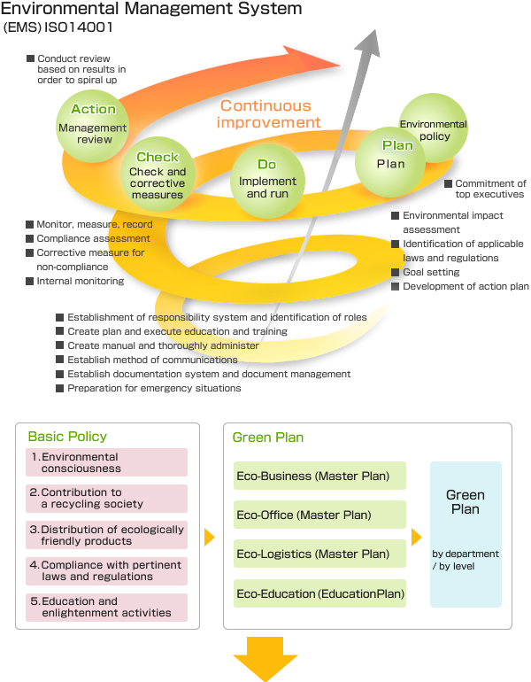
Diagram 1: EMS (Yamazen, 2018)
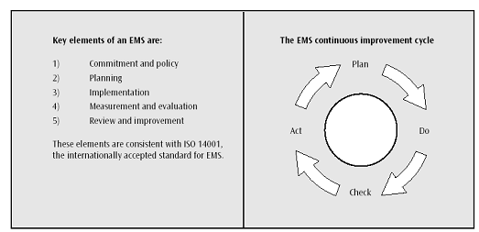

Diagram 2: EMS (Regional Institute, 2018)

As for what are some key elements of an EMS, the following points (again suggested by the course notes, but very much in line with environmental best practice) serve as a good guide:

  - Policy Statement: a statement of the organization’s commitment to the environment
  - Identification of significant environmental impacts: environmental attributes of products, activities and services and their effects on the environment
  - Development of objectives and targets: environmental goals for the organization
  - Implementation: plans to meet objectives and targets
  - Training: instructions to ensure employees are aware and capable of fulfilling their environmental responsibilities
  - Management review

Crucially, SNH (2018) notes, inter alia, that: “Environmental Management Systems (EMS) aim to manage the environmental impacts of an organisation and to ensure that corporate environmental policy and environmental legislation are complied with.“

Additionally, SNH (2018) also suggests that:
“Environmental Management Systems (EMS) are designed to enable organisations to target, achieve and demonstrate continuous improvement in environmental performance as one integrated management process”.

It follows from the preceding two points that an EMS needs to provide clear environmental objectives and targets, along with suitably comprehensive and thoughtful procedures and practice, along with unambiguous roles and responsibilities.

Furthermore, Environmental Management System (2018) points out that:

“An environmental management system provides structure to environmental management and covers areas such as training, record management, inspections, objectives and policies”. In other words, an EMS helps businesses to control their environmental impacts and improve associated environmental performance.

References

Brown, B.J., Hanson, M.E., Liverman, D.M. and Merideth, R.W., 1987. Global sustainability: toward definition. Environmental management, 11(6), pp.713-719.

Delmas, M. and Toffel, M.W., 2004. Stakeholders and environmental management practices: an institutional framework. Business strategy and the Environment, 13(4), pp.209-222.

Environmental Management System (2018). What Is An Environmental Management System? Retrieved Wednesday 7th February 2018:
http://www.environmentalmanagementsystem.com.au/what-is-an-environmental-management-system.html

Huang, P.S. and Shih, L.H., 2009. Effective environmental management through environmental knowledge management. International Journal of Environmental Science & Technology, 6(1), pp.35-50.

Regional Institute (2018). Environmental Management System. Retrieved Wednesday 7th February 2018: http://www.regional.org.au/au/aanrm/pubs/ems-2.gif

SNH (2018). Introduction to Environmental Management Systems and related Standards. Retrieved Friday 9th February 2018:
http://www.snh.org.uk/publications/on-line/advisorynotes/46/46.htm

SOAS (2018). What is environmental management? Retrieved Wednesday 7th February 2018:
https://www.soas.ac.uk/cedep-demos/000_P500_ESM_K3736-Demo/unit1/page_10.htm

Welford, P.R., 1993. Breaking the link between quality and the environment: auditing for sustainability and life cycle assessment. Business Strategy and the Environment, 2(4), pp.25-33.

Yamazen Corporation (2018). Environmental Management System. Retrieved Wednesday 7th February 2018: http://www.yamazen.co.jp/var/ezwebin_site/storage/images/node_1209/csr/kankyo/management/index/pdca_e/43880-1-jpn-JP/PDCA_e.jpg

Student Statement:

By submitting this assignment, I confirm that this is my own work.

Student Signature | P. Gisbey | Date | 09/02/2018

For Tutor / Assessor Use Only
Total Marks
Marks Obtained
Percentage / Grade

