
Assignment Cover Sheet

Student Name: | Farhana Mobeen Nazir
Student Number: | 23220
Course: | Travel & Tourism - Level 4
Assignment NO: | 1

Marking Criteria:
We expect the learners to write minimum one well expressed point in three lines against each allocated mark. This means one needs to write 15 lines with 5 well expressed points to get high grades for a 5 marks question.
For high grades use examples and illustrations where appropriate
- GIVE BRIEF ANSWERS TO THE FOLLOWING QUESTIONS
i) What is sports Tourism?
Sports Tourism is where the main purpose of booking a holiday, be it a long holiday or a short break, it could be to either take part or to be a spectator in a sporting event, which could be anywhere in the world it could be a team you either follow, someone you support e.g.: family or friend it could also be a one day tournament or could go on for a week or so.
A few of the major sports with which Sports Tourism is related include:
Rugby Tours/Cricket/Football/Athletics/Motor Racing and Tennis.

The following is an example of the sports tourism statistics.
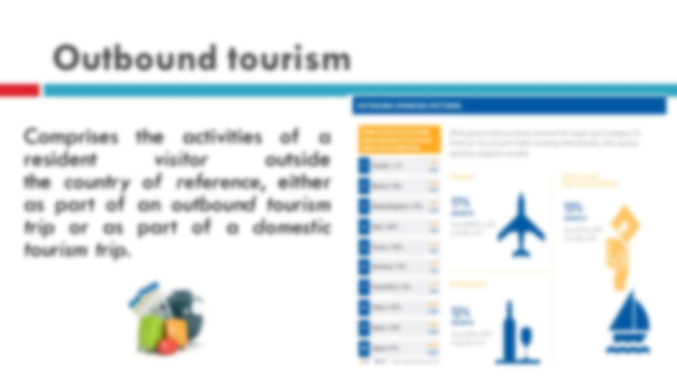
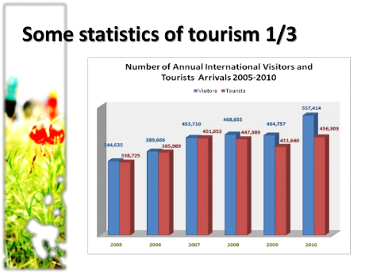

ii.) What is the difference between Outbound/Inbound tourism?
The difference is as follows tourists who leave their country of residency are classed as outbound, because they are leaving their country of origin.

Outbound Tourism means traveling away from rather than towards a place.
Inbound Tourism.
When a country attracts a lot of inbound tourism, the tourists spend money on hotels, dining, attractions, souvenirs and other amenities. This creates jobs, and through consumption taxes, it adds additional money to that country's coffers.

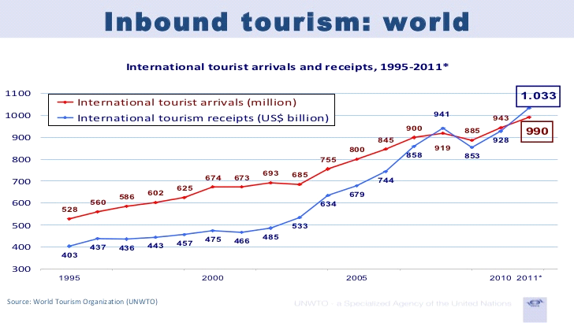
As the inbound tourism increases, so does the job market in that country to cope with the increased traffic. New hotels are needed to accommodate the influx of tourists, new attractions spring up to offer something enticing for visitors, the need for taxis and hired cars increases and so on.
In the simplest terms, inbound tourism occurs when a foreigner or non-resident visits a country, and outbound tourism occurs when a resident of a country leaves it to visit another one.
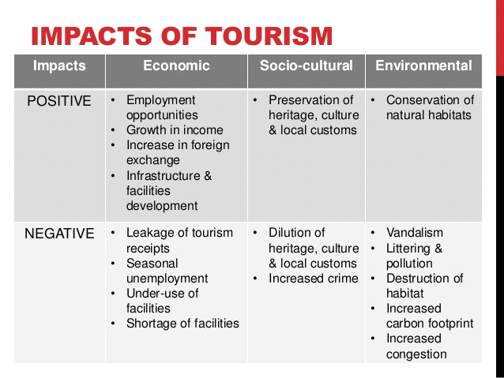
Below is an example of the Impacts of Sports Tourism.

iii.) Make a list of motivation factors of tourism.
- Motivating Factors in tourism can be split

- Motivate a person to take holiday

- Motivate person to take a specific holiday to a particular time

It can also be called Pull or Push, and tourist motivators can be placed in both pull and push.
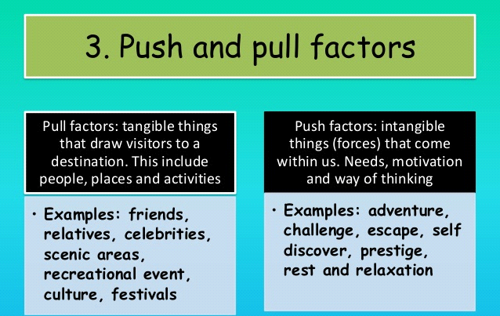
If you look at the next picture.

So now you have a little knowledge of motivation tourism you will now be able to see a list of a few motivation factors you may come across.
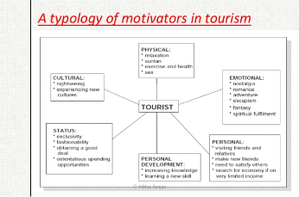

iv.) Define tourism. How is it different from travel?
Travel – Meaning and Usage
Travel means: To make a journey.
It simply refers to an individual’s movement from point A to point B. Traveling usually refers to a long journey. For example, if you are going to the market to buy some vegetables, you don’t call it traveling. But, if you are going on a two-week business conference to Hong Kong, you can say that you are traveling.
An individual can travel to places for different purposes. As mentioned above, a person can travel to another country or city for work related purpose. There are also some people who would travel to visit their friends and relatives. Facilities like education, healthcare are some other reasons that prompt people to travel to another location. We sometimes travel to places for none of the above-discussed reasons. This is when we simply want to spend our days in leisure and enjoy a new place. This is called tourism – a person who is traveling for pleasure is called a tourist.
An individual can travel to places for different purposes. As mentioned above, a person can travel to another country or city for work related purpose. There are also some people who would travel to visit their friends and relatives. Facilities like education, healthcare are some other reasons that prompt people to travel to another location.

TYPES OF TOURISM
Tourism can be put into three main sections:
1. Domestic tourism- this is where U.K residence take trips or holidays in the U.K. Most tourism in the U.K and around the world is in fact domestic - people traveling in their own country.
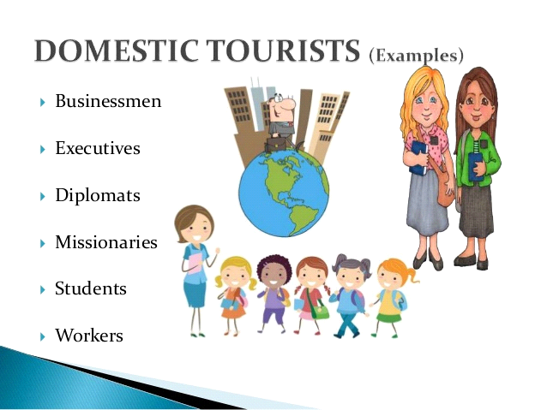
2. In bound tourism- this is where overseas visitors travel into the U.K. these are very important to the U.K economy. Incoming tourists bring lots of money to our economy and provide jobs. Travel and tourism do not just cover holidays. People all over the world travel.
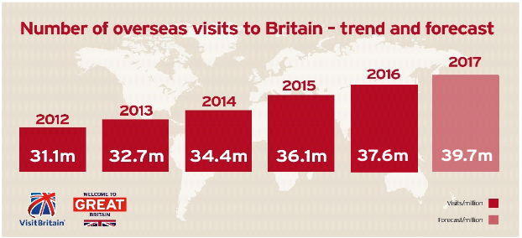
Tourism also brings large amounts of income into a local economy in the form of payment for goods and services
3. Outbound tourism- this type of tourism is when U.K residence travel outside of the U.K on holiday.
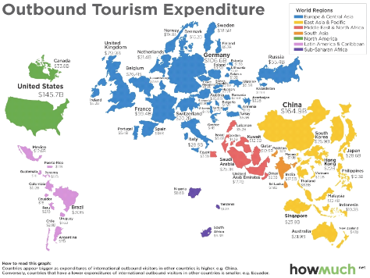

v.) What is the difference between packaged and self - packaged ` holiday.
A packaged holiday is a break where all 3 elements of your holiday is provided by the same tour operator and is sold as 1! So, you will fly with Thomson, your transfers are with Thomson and your hotel is with Thomson. You will have a Thomson Rep and they are responsible for your holiday. They often can provide extras such as car hire and excursions.
A self - packaged holiday is a package created by the tourist flights accommodation and car hire would probably booked separately possible shopping around for better deals,
An Independent holiday or referred to as Tailor made or Dynamically Packaged holidays, are where you organize all the elements yourself with different companies. The benefits often include a wider range of destinations and sometimes the price can be lower. You flight may be with Jet2 your transfers with A2B Transfers and your accommodation with beds online.
vi.) How do changes in lifestyle affect tourism? However, this increase in private transport has a decrease in public transport. This means that domestic holidays which involved transport such as trains/coaches have been affected negatively. Although they are not completely unused they are used a lot less which has meant services have been cut and train lines and coach companies have had to change their business style to promote and keep their services. The increase in car ownership worldwide has encouraged people to tour domestically for either short stays or full holidays.

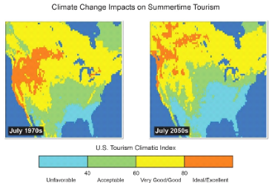People had more freedom with their own car and used this freedom wisely in their spare time to travel around their own country for all different reasons. “The number of private cars on the roads of Britain rose steeply from 2.3 million in 1950 to 11 million in 1970. In 2002 the ﬁgure exceeded 22 million vehicles and by 2005 had risen to 33 million. Current (2009) ﬁgures show a slight fall to 31 million.” This huge increase shows the amount of people able to travel around to different places freely and easily in the comfort of private travel where they do not feel uncomfortable in the public.
As it becomes more and more common for women to have jobs, families are making a lot more money. This increase in their money will influence them to spend it on themselves which usually includes holidays for them to relax after working so hard. This has a positive effect on outbound tourism as with all this extra money families travel further afield and to more adventurous places.

Impact of climate change
- Mountain and snow tourism
- Forest and lake
- Biodiversity and agriculture
- Cities and urban
- Beach and costal
- Ocean and sea

viii.) Describe the main types of leisure tourism
Leisure Tourism and the types of leisure.
The tourism & travel sector includes everything related to leisure travel and vacations. Today, the tourism industry is one of the largest in the world with estimated annual contributions of almost seven trillion U.S. dollars worldwide. Vast improvements in technology and living conditions over the past century have led to the development and strong growth of tourism including phenomena such as mass tourism.
1. Leisure- this is the most important of the three categories and includes all recreational travel.
2. Business- this includes all travel for business reasons. This may be a meeting a conference or even a trade fair. The traveler does not normally pay for their own travel arrangements when traveling on business- the company covers this.
3. Visiting friends and relatives (V.F.R)-This accounts for many of the tourist trips within the U.K. Examples includes a visit to your grandparents for a day or staying with a friend for a week.
Leisure tourism is also called pleasure tourism or holiday tourism. It is a type of tourism when a person goes on holiday and does not travel on business. Thus, the purpose of tourism in this case is recreation.
Leisure travelers look for sun, sea and sand. They want to go sunbathing, swimming and diving. So, this kind of travelers go to sea resorts or holiday camps and stay at resort hotels.
Holiday-makers normally travel with their families and children. There are other ways to travel for pleasure: cruising and coaching, motoring and hiking.
More and more working people will have longer paid holidays and long weekends in future. More and more people will retire at an earlier age. It means that more and more people will travel for leisure in future.
viii. What is business tourism? Discuss main types
A business trip is a trip undertaken for work or business purposes, as opposed to other types of travel, such as for leisure purposes or regularly commuting between one's home and workplace. The necessity to conduct business travel may have many reasons.
Business tourism is the use of travel services, hotel facilities and other amenities by people who are traveling on business. Business tourism is on the increase, and the tourism industry separates business tourism from leisure tourism to promote the former by offering services for business people.
Business people travel and stay in hotels when attending conferences, meetings and training programs. During their stays, these travelers often visit restaurants, souvenir shops and local tourist spots, meaning they are a source of revenue for the community. The International Trade Centre estimates that business tourism accounts for about 9 percent of all tourism and that business people spend approximately twice as much as leisure tourists. Business tourism or business travel is a more limited and focused subset of regular tourism.
During business tourism, individuals are still working and being paid, but are doing so away from both their workplace and home. Some definitions of tourism tend to exclude business travel.
2. Summaries the advantages and disadvantages of package holidays.
Advantages:
- No stress of organizing everything
- Not as time consuming
- Cheaper
- No hidden cost
- No responsibility
- People around you speak English
- Entertainment provided
- Children activates
- Good holidays as tour operator has been before
- One upfront price
- All inclusive

Disadvantages:
- May have to pay from drinks
- Stuck doing the same thing
- Same menu
- Stuck with same people
- Costs more at peak times
- Negative impacts - crime, poor behavior
- Awareness of skin cancer so people want to avoid the sun
- Destinations become crowded
- Limited choice of flight times
- Extra costs
- People are becoming more confident abroad and don't want a day plan

A quick summary of the disadvantages and disadvantages of package holidays are clearly there it’s a case of being organized knowing the sort of package holiday to suit your lifestyle be it a family holiday single holiday etc. once that has all been applied if the package is booked properly with care then the holiday will be perfectly booked to all your needs yes although you may book a perfect holiday you cannot predict the weather but booking the perfect holiday you won’t need to worry about food accommodation excursions flights transfers etc.
Yes, there are disadvantages and advantages it’s just being prepared and organized making sure you take with you all the possible contacts you need and all the details for your whole holiday for example it’s not just your holiday it’s the car hire foreign currency cash cc emergency contact numbers.
3.) differentiate between different forms of tourism and link them to the impacts on the environment and culture.
If the objective of one’s visit to a place is to get to know its history and culture, then this type of tourism is known as cultural tourism. Tourists may visit different landmarks of a country or they may simply opt to focus on just one area. They may also attend festivals and ceremonies to gain a better understanding of the people, their beliefs and their practices. A basic lack of cultural awareness about the places we go on holiday can lead us to cause inadvertent offence to local people. Topless sunbathing on beaches and scant clothing when visiting religious sites are examples of such violations of cultural norms.
- Socio cultural impacts
- Direct and indirect relations with tourists
- Hosts are weaker party compared to guests and providers
- - influences are difficult to measure and hard to identify

Nature tourism, wildlife tourism, and adventure tourism take place in environments
such as rain forests, high alpine, wilderness, lakes and rivers, coastlines and marine environments, as well as rural villages and coastline resorts. Peoples' desire for more authentic and challenging experiences results in their destinations becoming more remote, to the few remaining pristine and natural environments left on the planet.
The positive impact of this can be an increased awareness of environmental stewardship.

Activity
Choose one country in Asia and research some of the natural and cultural attractions which might appeal visitors from the UK
When visiting Africa for example and you’re travelling with teens they are at a different age range and may not understand the culture so it’s always good to plan a cultural holiday as family understanding the knowledge and understanding and respecting them.

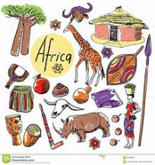
There are lots of reasons why tourists from all over the world find Africa’s cultural and natural attractions appealing especially the UK population is because there is much to do and see especially if your wanting to explore other cultures, however you do have to learn and respect the culture to you understand they types of cultures there are.
There is so much to see on the cultural side of Africa that caters for all ages and are very people friendly and there are also lots of natural attractions in Africa you have the safari experiencing he real African wild life which is always properly organized with gamers and highly qualified people making the tours enjoyable for all, mount Kilimanjaro is a place to visit if you adventurous you can bike ride walk camp near by lots of family outdoor attractions, Victoria falls beautiful falls water and beautiful sceneries and again organized tours to cater for all ages.

Encounters with the Big Five — lion, leopard, rhino, elephant and buffalo — are enough to get many visitors hooked. But there’s also great joy in having an expert guide introduce you to the minutiae of the insect world or in sleeping under the stars at a bush camp.
Beyond the plains, Africa’s shifting scenery can take you to jungles, white-sand beaches, coral reefs, or snow-capped mountain ranges. Having tried and tested each country, we can help you decide where to go and what to do on your Africa holiday.

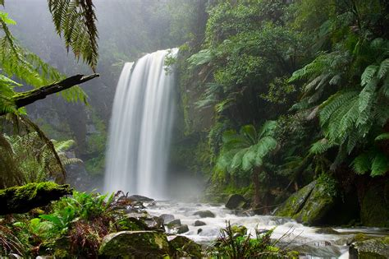
Famous Waterfalls of South Africa. Famous South African Waterfalls…. The Tugela Falls. Located in the Drakensberg, and part of the Tugela River, the Tugela falls are the world’s second highest waterfall and drop a total of 950 meters in five cascades (also making the Tugela Falls the highest cascade of falls in the world).

Masai Mara

Student Statement:

By submitting this assignment, I confirm that this is my own work.

Student Signature | FARHANA MOBEEN NAZIR | Date | 03/08/2018

For Tutor / Assessor Use Only
Total Marks
Marks Obtained
Percentage / Grade

