
Assignment Cover Sheet

Student Name: | Brenda Melo De Paula
Student Number: | 18099
Course: | Travel and Tourism (Level 3)
Assignment NO: | 7

Marking Criteria:
We expect the learners to write minimum one well expressed point inthree lines against each allocated mark. This means one needs to write 15 lines with 5 well expressed points to get high grades for a 5 marks question.
For high grades use examples and illustrations where appropriate.
Please insert your completed assignment ( in word format) here:

- Discuss the concept of quality management.

According to Will Kenton, quality management is the act of guiding all projects and tasks required to preserve a suitable level of success. This covers an implementation of quality policy, planning and assurance. It is also known as Total Quality Management (TQM). In word, quality management should focus on long term goals thought the execution of short-term actions. As its base, quality management is a business philosophy that supports the idea that the long term success of a company resides on the customer satisfaction. Quality management demands that all participants in a company work together to improve processes, products, services and the culture of the company itself.

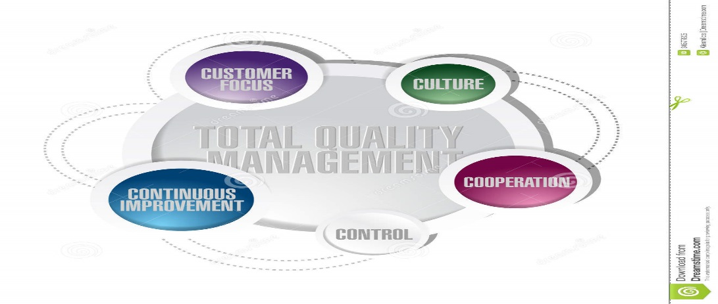
Image 1 (Reference).

- Explain the term service gap.

According to BrainMates website, ‘’todays costumer has become increasingly demanding’’. They expect high quality products as well as exceptional quality customer service. From a customer’s point of view, produced items such as phones, cars, furniture, computers alone are not enough to give a company competitive advantage against another. Costumers consider the experience that they go through while buying an item as part of the product itself.
To provide superior value to a costumer is a constant concern of Product Managers. This is not only about the product itself but the costumer service provided as well. Companies that do not provide exceptional customer service that buyers expect to receive are hard to endure in a fierce market. The Service Gap model is a gap procedure in service quality measurement. This tool can be used beyond all industries and companies interested in having a wide range of clients.
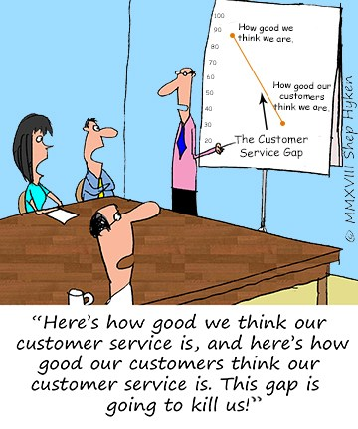
Image 2 (Reference).

- What are the challengers faced by quality managers in tourism industry.

According to John Dudoviskiy one of the challenges faced by the quality mangers in travel and tourism industry have to do with the level of qualification of the people that work for said industry. Many employees have no post-school qualification or with short and highly focused vocational qualification witch can cause a negative effect on quality management.
Another big challenge that tourism organizations have to deal with is external factors like weather, transportation, traffic jams, disruption of transportation etc. The tourism industry is also extremely reactive to a big range of external disturbances such as economic crises, viruses and illnesses, terrorist attacks and so on. Any of the previously mentioned or similar external shocks are going to negatively influence the quality in managing travel and tourism industries.

- Make a sample quality plan for a tourism management organization.

Quality policy Plan
Company Travel Plus Limited was established in 2019 to provide affordable plain tickets, sightseeing tours, accommodation and transport to the Tourism industry. We are based in Manchester and employ 50 people.
Quality is crucial to our business because we appreciate our customers. We try to supply our customers with products and services which meet and even surpass their expectations.
We are Devoted to continuous development and have established a Quality Management System which provides a framework for measuring and better our performance.
We have the following systems and methods in place to carry us in our aim of total customer satisfaction and constant improvement throughout our business:
- - Regular meetings and monitoring of customer feedback
- - A customer complaints book
- - Training and development for our employees
- - Regular audit of our internal processes
- - Measurable quality objectives
- - Management reviews of audit results, customer feedback and complaints.

Although the Managing Director has ultimate responsibility for Quality, all employees have a responsibility within their own areas of work to help ensure that Quality is embedded within the whole of the company.

BIOGRAPHY

Websites

Will Kenton for Investopedia, Quality Manegement (nov 20,2017)https://www.investopedia.com/terms/q/quality-management.aspAccessed on 03/01/2019

BrainMates, The Customer Service Gap Model https://brainmates.com.au/brainrants/the-customer-service-gap-model/ Accessed on 09/01/2019

Recearch methosology, Issues of Quality in Managing a Tourism Organization
https://research-methodology.net/issues-of-quality-in-managing-a-tourism-organisation/ Accessed on 02/02/2019

Images

https://www.dreamstime.com/royalty-free-stock-photo-total-quality-management-cycle-diagram-concept-illustration-design-image34577805Accessed on 03/01/2019

http://locallytargetedmarketing.com/the-customer-service-gap/Accessed on 09/01/2019

Student Statement:

By submitting this assignment, I confirm that this is my own work.

Student Signature | Brenda Melo | Date | 02/02/2019

For Tutor / Assessor Use Only
Total Marks
Marks Obtained
Percentage / Grade

