
Assignment Cover Sheet

Student Name: | Julia Virgoe
Student Number: | 15402
Course: | Diploma in Forensic Accounting
Assignment NO: | 9
Marking Criteria:
We expect the learners to write minimum one well expressed point in three lines against each allocated mark. This means one needs to write 15 lines with 5 well expressed points to get high grades for a 5 marks question.
For high grades use examples and illustrations where appropriate.
Please insert your completed assignment ( in word format) here:

1. Short Questions:

- Outline the factors on which fraud risk assessment depends.

The course material states that Fraud risk assessment depends on the investigator’s knowledge of fraud concepts, such as the fraud triangle, fraud indicators, fraud schemes and accounting information systems, and an understanding of the fraud environment, which includes timeframe, entity, efficacy of internal controls, etc. It reminds me that effective risk management is a continuous process

Probability (the likelihood of an event occurring) and impact (the magnitude of the event) form the foundation of risk assessment.

The unit goes on to mention that Risk assessment factors can be considered on different levels such as entity, behavioural, products and services, geography, divisions, accounting and business processes, controls, computerized systems, etc.

Usually, factors are initially considered at the entity level because fraud, embezzlement or theft can only be successful with the combination of executive and employee personalities, working environment, organizational culture and internal controls. After the process is initiated, different perspectives, such as
the ability of management to incorporate risk management practices, should also be examined.

I found the section discussing industries really interesting and the fact that some industries and organizations are more vulnerable to theft, fraud and embezzlement than others.

A factor to consider while conducting risk assessment is whether the entities working in industries that have a higher susceptibility to fraud are at a greater risk
of fraud as well.

The Organization for Economic Co-operation and Development (OECD) analyzed 427 cases of bribery in international business which Ivana Kottasova refers to in her article “World's most corrupt industries”. Two-thirds of the cases occurred in just four industries, extractive (19%); construction (15%); transportation and storage (15%); and information and communication (10%).
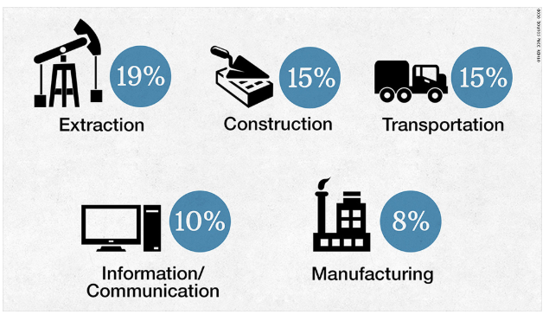
Senior executives were involved in more than half the cases, with chief executives playing an active role in 12%. They either paid the bribes themselves, or authorized them, the OECD found.

I found it really interesting to note in her report that nearly a third were brought to the attention of the authorities by companies that often uncovered bribes during internal audits or when combing through accounts before a merger or acquisition.

It does strengthen the idea that if you review material with the healthy level of professional skepticism discussed in unit 8 the probability of identifying fraudulent activity increases.

My interest in combating fraud has been the basis for my career path, having managed finance departments in the above industries, with the exception of Oil. I deliberately went into Construction to test the robustness of the policies, procedures, governance and controls I implemented and didn’t have to wait long before I experienced my first fraudulent act in the company. Fake purchase orders, stolen cheques, phishing emails, personal expenses being claimed as business and false phone calls kept my team on their toes.

Economy is another factor to consider during risk assessment. People steal in good times, and in bad times they steal even more!

Jim Marasco writes in his article “Economic Hard Times: The Impact on Fraud” that “as the economy continues to falter, your organization, like many others, may find itself more susceptible to fraud. It is estimated that U.S. organizations lose approximately 7 percent of their revenues to fraud, according to the Association of Certified Fraud Examiners recently released 2008 Report to the Nation on Occupational Fraud and Abuse. In recessionary times, this figure may increase and organizations in specific industries may become more vulnerable.”

He goes on to link factors that create a perfect storm, referencing the factors in the fraud triangle, stating that collective economic pressures are one of the key reasons for how and why fraud thrives.

Unemployment, rising wholesale prices, increasing costs of fuel, utilities and food, interest rates forcing higher than expected mortgage payments. These factors contribute to a perfect storm of pressures. Because of the nature of the problems people are facing, they may find it easier to justify their fraudulent actions. They may rationalize that stealing from their employer is justified when it comes to feeding their family or keeping a roof over their head.

He mentions internal risks when organizations have to downsize and that their work force may be left with disgruntled employees and corresponding low morale. These employees are more inclined to steal the cash, inventory and fixed assets of the company.

- What are the main concepts about risk assessment?

Risk assessment is a continuous process requiring central position holders to constantly monitor and adapt to the fraud environment and refresh the process and plan for response regularly.

- Does the organization have an adequate level of fraud awareness and are there appropriate policies to minimize fraud risk?
- Does the organization have an adequate internal control mechanism?
- Has the organization addressed the following fraud prevention issues?

Lowers & Associates summarise the principles of fraud risk management in their blog with the statement that “Fraud risk management needs to be embedded in an organization’s DNA in the form of written policies, defined responsibilities, and on-going procedures that implement an effective program….. The tone from the top will be reflected in the perception of fraud prevention and detection throughout the organization.”

The blog goes on to suggest that it is important to have a responsible person with adequate resources and access to top management running the program. This person should be charged with designing and evaluating the program, and for communicating it throughout the organization as appropriate.

I do like what Lowers say is the foundation for the prevention and detection of fraud - a structured risk assessment. One that addresses the actual risks faced by the organization as determined by its purpose, industry (products or services), complexity, scale, and exposure to network risks.
The goal of the assessment is to determine the type, likelihood, and potential cost of risks in a traditional expected value framework. This allows the organization to tailor program efforts toward cost effective mitigation, which may include a greater or lesser toleration of a specific risk.

They conclude under the risk assessment heading that assessing fraud risks necessarily involves looking at how employees—including top management—interact with the resources of the organization.

Their incentives and opportunities compose one of the legs of the Fraud Triangle that is mostly determined by the organization itself. As such, the risk assessment effort has to be very clear and detailed about how controls, policies, and procedures interact with specific roles.

It is important to note that the sources of these risks may be external as well as internal, especially in highly networked and data dependent operations.

- What are the internal factors that should be considered for fraud risk assessment?

Internal factors that contribute to the increased probability of fraud and embezzlement are lack of monitoring activities and inadequate controls such as:

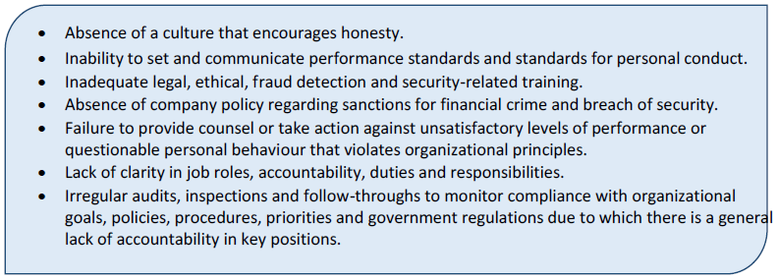
Risk assessment should also consider fraud schemes that have the probability of occurring while guiding the anti-fraud program. For example, in financial statement fraud, executives have a higher probability of being involved, and in asset misappropriation and corruption a trusted employee is more likely to be involved.

- What is ‘inherent risk’?

The course material states that Inherent risk associated with a fraud scheme is determined by the team for the entity or a particular business process. It can be expressed in percentage form or simply as high, medium or low risk. A number of factors need to be considered while measuring this risk including industry, strategy, organizational structure and market volatility.

I didn’t quite understand this risk and the following one so I did some research to find examples of these and how they can be measures and I found a police fraud report that helped.

North Yorkshire Police Commission regularly issues Fraud Risk Assessment Reports. The assessment involved examining multiple business systems and processes throughout the Organisation for risks of potential fraud and scoring the risk according to the Organisation’s risk appetite criteria.

The criteria included likelihood of occurrence and the legal, financial, reputational and operational implications. The fraud risks have been scored both inherently
and residually.

The Yorkshire Police define Inherent Risk as the risk that a fraud scheme would pose if no controls or other mitigating factors were in place. Essentially risk before controls. This made more sense to me.

In appendix 4 of their report they give an example of the Scoring Methodology they use when assessing the payroll system and ghost employees:

Inherent Risk
This is the risk that the Organisation is exposed to when compensating controls or other factors are not considered e.g.:
- No vetting of personnel,
- Unrestricted access to the payroll system,
- No verification of employee setups for legitimacy,
- No exception reporting to identify all new employee set-ups
- No budget and transaction monitoring,
- No limitations on transaction value.

In order to obtain the Risk Score two factors are considered, these are Likelihood and Impact.

- Inherent Likelihood - In the absence of controls or compensating factors it was assessed as probable that employees within the force would utilise the ghost employee scheme in order to obtain undue payment.
- Inherent Impact - In the absence of controls or compensating factors the impact was assessed as being significant

The Risk Score is the multiplication of the Impact by the Likelihood. The category of risk that the score then relates to i.e. High, Medium or Low is determined by the Force risk appetite.
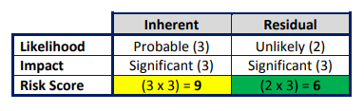

- Define the term ‘residual risk’.

The unit defines Residual risk as a simple calculation - subtracting the level of internal controls being used to mitigate risk from the inherent risk. There are two possible responses to residual risk: no response, as it is accepted; or action to take further preventive measures (such as purchasing insurance) in order to mitigate residual risk. In either case, the response should be documented and tracked in order to determine the organization’s ability to measure and manage risk.

The Police report mentioned above defines residual risk as the risk that remains after controls are taken into account and gives an example of their calculations in the box above.

The residual risks are noted in their report as below:

Residual Likelihood (2)
The actual controls reduce the likelihood of this risk occurring to unlikely from probable, however, due to the weaknesses identified in the actual controls the likelihood cannot be reduced further as there a couple of vulnerabilities in the process.
Residual Impact (3)
The financial impact is likely to reduce from significant to negligible or at most minor, however, the reputational impact remains significant, so there is no change in the impact level.
Residual Risk Score
The score was assessed as 2 x 3 = 6, which using the force risk appetite criteria works out as a low risk.

2. Prepare a fraud - risk assessment check list for any business of your choice.

In my career I have witnessed a number of fraudulent activities in organisations and the most common places are in the Procure to Pay process and Staff expense claims so I would like to explore these areas in particular in response to question 2.

Also I want to get some ideas on good practice, the approaches organisations take to these checklists and how to score them, so I have researched some risk assessment check lists online and below are extracts of a couple I really like.

The American Institute of Certified Public Accountants issued a fraud - risk assessment check list in their March 2013 journal, where a running total is calculated based on the responses to each question.

Score greater than 50: The company has strong controls, and fraud risk is reduced
Score is between 40 and 10: Controls can be improved
Score is less than 9 or negative: Fraud risk is high. Inventory and cash could be at risk for theft.
Below are a couple of sections from the checklist that I would use in my current company:

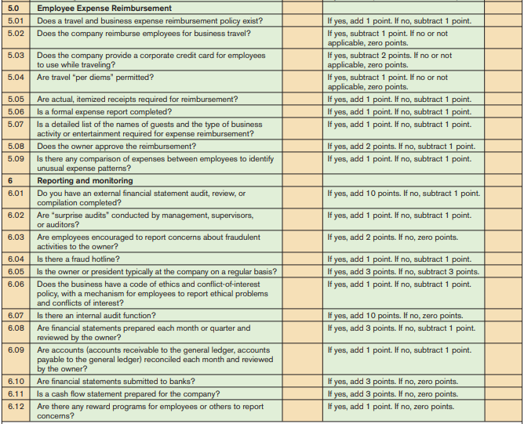

In an organisation I worked for there wasn’t a travel and expense reimbursement policy and yet we did reimburse employees for business travel. Unfortunately I also found examples of claims being submitted for personal costs marked as business. There was also an incident of a company credit card linked to an employee’s Amazon account and used for personal purchases, that were claimed as business.

We provided corporate credit cards to staff and our expense process was completely paper based. Although managers approved the claims it was apparent that they simply signed the form without validating claims and receipts.

I particularly like the idea of comparing staff in similar roles to see if there are any unusual expense patterns. Using this approach I found 2 staff claiming hotel costs for stays just down the road from the office who were having an illicit affair.

Section 6 I also found interesting. Our organisation does not have an internal audit function and there are no formal processes for month end balance sheet reconciliations. I have found a number of unreconciled bank items in my initial review and the cashflow for the company is under strain.

During my research I wanted to find out where the majority of employee fraud takes place to ensure any checklist created is built covering queries in the major areas of concern.

I came across an article on CFO.com stating that the majority of asset misappropriation occurs in the procurement, payment and expense areas. They listed the five areas in which employee fraud commonly occurs as:

Purchase-to-Pay
Potential fraud risks include (a) an employee initiating purchase orders (P.O.) for goods and services that are diverted for personal use and (b) an employee setting up a “phantom” vendor account, through which fraudulent invoices are processed and payments are made to the employee.

In these situations, fraud tests can detect if the same individual both enters and approves a P.O. or if an individual enters or approves multiple “split” P.O.’s, just under an authorized limit.

Corporate Credit Cards
A common fraud risk is an employee using a corporate credit card for personal gain instead of legitimate corporate purchases or travel and entertainment expenses.

Fraud tests can detect purchasing cards (P-Cards) being used to acquire goods and services from vendors with suspect merchant codes (e.g., home supplies, personal entertainment, etc.) and corporate cards being used by employees on weekends or while the employee is on vacation.

Payroll
Payroll fraud can consist of (a) “phantom” employees being set up on payroll systems; (b) excessive overtime payments; and (c) employees remaining on the payroll after death or termination.

Tests can detect if there is more than one employee with the same bank account details or the same address. In addition, they can find invalid address information for employees, invalid social security numbers, unusually high overtime amounts, and payroll payments made to employees who were terminated or deceased according to HR records.

Sales and receivables
Some potential frauds include (a) employee collusion with vendors and (b) sales representatives inflating sales to achieve higher commissions and bonuses.

Fraud tests can detect customer accounts with exceptional credit terms; customer accounts that have unusually large or frequent credit memos; customers receiving unusually large discounts; customers returning goods without corresponding adjustments to sales representatives’ commissions; and sales shipment addresses that are the same as an employee’s address.

Information systems and critical data
This kind of fraud includes (a) employee theft of critical data and (b) employees providing corporate data to external individuals.

The right tests can discover databases accessed by individuals without appropriate authorities and reports generated by individuals without appropriate authorization.

Creating these checklists may not always catch the fraudulent act but the knowledge that they exist in an organisation and periodic checks on transactions take place must reduce the volume of activity as it changes the perception around the fraud triangle, specifically the opportunity to get away with it.

References:

Kottasova I, Dec 2014, CNNMoney (London), “World's most corrupt industries”, electronic journal article, Available at https://money.cnn.com/2014/12/02/news/bribery-foreign-corruption/index.html [Accessed 2 March 2019]

Marasco J, Fall 2008, Stonebridge Business Partners, “Economic Hard Times: The Impact on Fraud”, electronic journal article, Available at https://stonebridgebp.com/library/uncategorized/economic-hard-times-the-impact-on-fraud/ [Accessed 2 March 2019]

Lowers & Associates, Nov 2015, The Risk Management Blog, “5 Principles of Effective Fraud Risk Management”, electronic journal article, Available at https://blog.lowersrisk.com/fraud-risk-management/ [Accessed 2 March 2019]

Gibson A & Collins A, Jun 2015, North Yorkshire Police Commission, “Fraud Risk Assessment - Final Report”, electronic journal article, Available at https://www.northyorkshire-pfcc.gov.uk/content/uploads/2016/10/9c-Fraud-Risk-Assessment-Final-Report.pdf [Accessed 2 March 2019]

Journal of Accountancy, Mar 2013, American Institute of Certified Public Accountants, Inc , “Fraud Risk Self-Assessment Tool”, electronic journal article, Available at https://m.acc.com/chapters/wpenn/upload/ACFE-Fraud-Self-Assessment-Tool.pdf [Accessed 3 March 2019]

Verver J, Nov 2013, CFO.com, “The Top Five Areas to Monitor for Employee Fraud”, electronic journal article, Available at http://www.cfo.com/accounting-tax/2013/11/top-five-areas-monitor-employee-fraud/ [Accessed 3 March 2019]

Student Statement:

By submitting this assignment, I confirm that this is my own work.

Student Signature | Julia Virgoe | Date | 3rd March 2019
For Tutor / Assessor Use Only
Total Marks
Marks Obtained
Percentage / Grade

