
Assignment Cover Sheet

Student Name: | Anouska Hinder
Student Number: | 23837
Course: | Customer Service : Advanced Diploma - Level 5
Assignment NO: | Unit 8 Building long term customer relations

Marking Criteria:
We expect the learners to write minimum one well expressed point in three lines against each allocated mark. This means one needs to write 15 lines with 5 well expressed points to get high grades for a 5 marks question.
For high grades use examples and illustrations where appropriate.
Please insert your completed assignment ( in word format) here:

Student Statement:
By submitting this assignment, I confirm that this is my own work.

Student Signature | A Hinder | Date | 17/10/2018

For Tutor / Assessor Use Only
Total Marks
Marks Obtained
Percentage / Grade

Assessment 8
BUILDING LONG TERM CUSTOMER RELATIONS

Give short answers to the following questions:
- Discuss pros and cons of loyalty scheme.

There are many reasons companies should use a loyalty scheme, one is to retain valued custom. By retaining valued customers, it can give a company and idea/project/planning for future business.

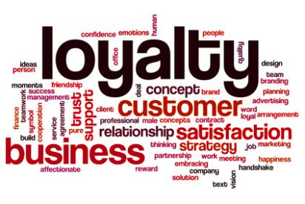
The pros of a loyal scheme are simple, in that it gives the customer an incentive to continue to purchase/use your service and continue in increase sales thus profiting the business. It can also create a foundation for additional offers to consumers, very good in retaining of customers.

Then there are the cons, by creating incentives may result in enticing the wrong “type” of customer, will they stay loyal? Will they give a bad review/feedback? If no further offers are given or not one that is perhaps of use or requirement to them. By continuing with the competitive rates to customers, may not be sufficient enough to motivate long term loyalties.

- What is SWOT analysis? How it is performed?

SWOT analysis:

Strengths What does the company excel in, in what areas are their specific strengths.

Weaknesses Which department or area within the business requires improvement, where is the weakness.

Opportunities Other opportunities, are there any other consumers/businesses that might benefit from the service/product.
Threats Are there other companies out there with the same/similar product at a more competitive rate, or good after service.

By running this analysis in any business can show how they are performing within their industry. Showing strengths and weakness in different departments, action can be immediately taken.

- What is strategic CRM?

CRM stands for Customer Relationship Management.

In principal the more information a company has regarding its customers the better. Breaking down a simple CRM Strategy is a process to identify the desirable customer segments, or individual customers, sell & service.

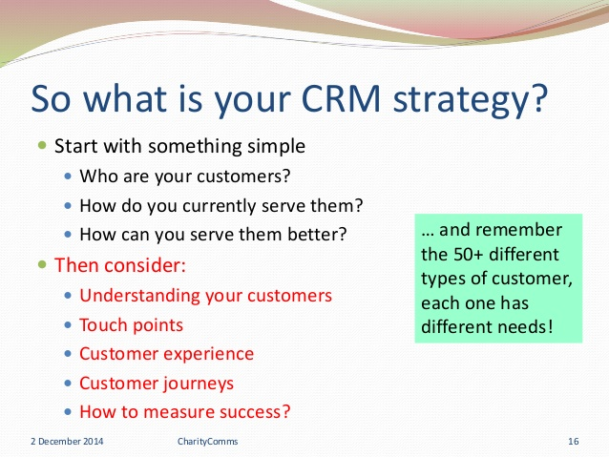

CRM focuses on the development of customer centric business culture. This culture are committed to enticing and gaining new customers by ensuring they stand out from the crowd and their competitors.

- Define customer satisfaction.

A customer expectation is a level of standard requirement where quality of product, services and value for money is decided. When the standard of service is high the consumer is happy and will lead to using the business again in the future.
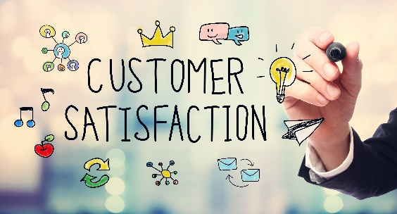

Aftercare is top priority for customers, first time satisfaction every time. Timescale of deliveries/service, personal touches, helpfulness and politeness all contribute to a customer’s satisfaction.

If the expectation is set too high, by the business to deliver, then the services will not succeed and thus loosing valued customers to other competitors in the market.

- How would you differentiate between ‘supplier loyalty’ and ‘De- Loyalty?’

Some customers are creatures of habit, they are loyal to the product and the business, not wanting to stray elsewhere for fear of disappointment. These consumers are known as the supplier loyalty customers.

A De Loyalty is a customer who moves from being a loyal customer following perhaps a bad experience with a company, let down with delivery or just not happy with the aftercare. These customers have been loyal from many years and one bad experience has made them move to another product/service. It is not to be confused with disloyalty.

- Why companies want long term relationships with customers?


Companies who build a long term relationship with their customers, pride themselves with a good reputation and ensuring the business succeeds for many years in the future. By retaining their most profitable customers, its guarantees are regular income/turnover.

By retaining customers it reduces the budget cost for marketing and putting that money into loyalty schemes as a thank you for their custom.

Building a strong relationship with your customers can gain recommendations for your product/services, encouraging new customers to the business and thus boosting profits.

- What is customer loyalty?

Customer loyalty is a client who is loyal to a business for their product/services and keeps on retaining their business with the same company.

They are resistant to change or switch product/supplier for fear of being disappointed. Loyalty to the product/service as in some cases it’s easier for the customer and their lifestyle.

Customers who are loyal to a product/service can sometimes be a creature of habit, it maybe that their parents used the same product/service, tried and tested reluctant to change.

- What is behavioral loyalty?

This is measured by customer repetition of purchase/use of a business. This will indicate a consistent preference for a brand or service over time.

The behaviour definition of loyalty focuses on a customer’s demeanour, irrespective of attitudes or preferences that lie beneath the conduct.

2. What is a seven stage customer journey from suspect status to advocate status?

Suspect Does the customer fit the marketing profile?
Prospect If the customer fits the profile then approach for the first time
First time customer the customer makes the purchase
Repeat customer the customer likes the product and returns for additional purchases
Majority customer the customer selects a certain company for as supplier choice
Loyal customer Resistant to switch product/service for fear of disappointment, loyal to the company
Advocate A customer who supports/recommends

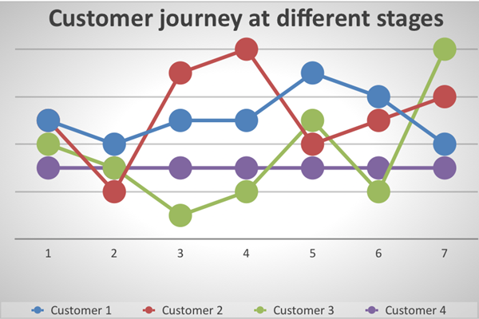

The CRM has ability to see where a customer is within their journey, allowing them to add resources where required. Building a strong customer focus and relationships to entice new and retain loyal customers to the business.

Marketing for new customers to the business, what’s their requirements, does the company meet their expectations for the product/service that’s being marketed.

This strategy, not only benefits the customers, but the business too, as they have an insight and knowledge of the customers wants and needs. The CRM will then be able to action a plan of certain weak areas to ensure a smooth running of the business and implement new procedures for employees to follow to gain the highest level of customer satisfaction.

Looking at the loyal customers and what the business can do to thank them for their continued support and custom and monitor the levels of the repeat business.

Continual monitor of the customer feedback/recommendations, carry out surveys and look for areas of improvement.

- How an ongoing business relationship can be developed with the customers?

The role of a customer care manager, is to develop a good business relationship with their customers. To ensure this relationship continues with the client, is to be an excellent communicator, tell the client the correct and precise information and do not pretend and hide, perhaps a fault that has occurred. Keeping to your word and promise promotes trust with your customers.

The customer wants to be happy with the product/service and that the aftercare have the knowledge and skills to assist and be on hand for any queries and advice.

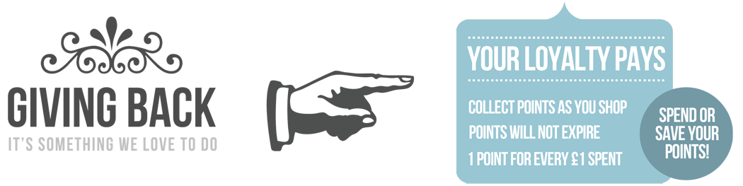
Loyalty schemes are a good way of retaining customers. Perhaps a discount next time the customer purchases the product/service or a voucher for recommending friends and family. Appreciate the customer’s loyalty, make them feel valued .

Implementing new policies and procedures for area of improvement when a complaint is made. Showing the customer that, even though that had a bad experience this time, steps are being put in place so that it doesn’t happen again.

Keep the customer well informed of new products/services and adapt to changes within the current market.

