
Assignment Cover Sheet

Student Name: | Qurrat Ul Islam Ilsa
Student Number: | 10604
Course: | Diploma in Diet and Nutrition
Assignment NO: | 5 &6

Marking Criteria:
We expect the learners to write minimum one well expressed point in three lines against each allocated mark. This means one needs to write 15 lines with 5 well expressed points to get high grades for a 5 marks question.
For high grades use examples and illustrations where appropriate.
Assessment 6 and 7

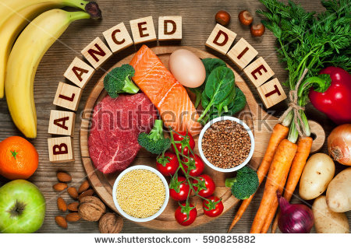
Question;1
Multiple Choice Questions;
Question;1 | A
Question;2 | B
Question;3 | A
Question;4 | A
Questionl;5 | C
Question;6 | A
Question;7 | A
Question;8 | C

Question;9 | B
Question;10 | C
Question;2
Short Questions
1;What are trace minerals? Why they are called trace minerals?
There are two types of minerals in our body. Major minerals and trace minerals.
Trace minerals;
Micro-minerals are often referred to as trace minerals which means they are present at low levels in the body or required in small amounts in diet. Our body needs only very small amount of trace minerals for normal functions, without trace minerals our body cells would be unable to carry oxygen throughout the body in order to keep your body cells alive.
Trace minerals include calcium, Iron, copper, zinc, manganese, fluoride, selenium and cobalt.
2; Why should we prefer whole grain foods over refined foods?
Whole grain food contains tons of vitamins and minerals like antioxidants and other vitamins in their bran, Vitamins B and healthy fats in their germ .On the other hand refined grains include white flour , white rice and white bread. Many breads, cereals, crackers, desserts and pastries are made with refined grains. Most refined grains are enriched , and many enriched grains also are fortified with other vitamins and minerals such as folic acid and iron.
3;What are two different types of sugar?
There are two main types of sugar.
1.Monosaccharides 2.Disaccharides
Monosaccharides are simple sugar .They are the common base unit of all carbohydrate molecules. They are soluble in water and their sweetness varies with individual monosaccharides.
Disaccharides consists of molecules which form is that of two monosaccharides molecules joined together.
It can also soluble in water .It must be broken down into monosaccharides before they can be absorbed into the body.
4;Describe methods for healthy preparation for fruits and vegetables?


Followings are the methods to cook healthiest fruits and vegetables;
To retain these vitamins , cook vegetables in as little water as possible for a minimal amount of time (unless you’re planning to consume the water , as in a soup)
Use steaming, microwaving, stir fry, grill, Blanch, gridding, baking and roasting. These methods will use little water will give you the same results as boiling or balancing but with less nutrient loss.
Try dried foods .Even though eating fresh fruits will give your body more nutrients with less processed sugar. You can enjoy a small amount of dried fruit as a snack or salad topper and get almost as many vitamins and minerals as are in fresh kind.
5;What is importance of adequate fluid intake?
Adequate fluid intake is very important to help prevent constipation and helps to regulate body temperature. The recommended intake of fluid is 6-10 glasses or cups of non sugar drinks, this includes water, soup, juice, tea and coffee but the best choice is water. Our body uses water in all its cells, organs and tissues to help regulate its temperature and maintain other bodily functions its because our body loses water through breathing ,sweating and digestion, It’s important to rehydrate by drinking fluids and eating food that contains water.
6;What is energy density?
Energy density is the amount of energy (or calories) per gram of food .Lower energy density foods provide fewer calories per gram of food .This means that you can have satisfying portions of these foods with a relatively low calorie content.
7;Describe the best sources of dietary fibre. How does it benefit our health?
Followings are the best sources of dietary fibres;
Beans
Brown rice
Whole grains
Popcorns
Baked potatoes with skin
Berries
Bran cereals and Nuts (almonds, pecans, and walnuts)
Benefits of dietary fibers;
A high fiber diet has many benefits which includes normalizes bowet movements. Dietary fiber increases the weight and size of your stool and softens it.
It helps to maintain bowel health and also helpful in lowering your cholesterol level and blood sugar levels. Furthermore dietary fiber also helps to aid in achieving healthy weight.
8;What is glycaemic index (GI)?
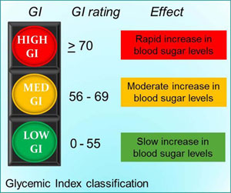
The GI is a relative ranking of carbohydrates in food according to how they affect blood glucose levels. Carbohydrates with a low GI value (5s) or less are more slowly digested; absorbed and metabolized and cause a lower and slower rise in blood glucose and therefore insulin levels.
Some examples of the GI rating of various carbohydrates include low GI( less than 55)-soy products, beans, fruit , milk, pasta, grainy bread, porridge, and lentils .medium GI (55-70)-orange juice, honey, basmati rice and wholemeal bread, high GI (greater than 70)-potatoes, white bread and short grain rice.
3;Why is calcium important especially for children? And what are calcium alternatives for those who exclude milk and dairy products from their diets?
Calcium is a must have nutrient in kids’ diets because it’s a key building block for strong healthy bones and teeth. Bones are the framework of your child’s growing body- living tissues that changes constantly with bits of old bone being removed and replaced by a new bone, Without this repair and reinforcement of even minor weak spots, we would break bones on a regular basis.
Building bone mass is not only calcium” role in the body. Calcium is also important for other bodily functions , including muscle contraction and relaxation, the secretion of hormones and enzymes, and the nervous system. Furthermore Calcium is one of the most vital minerals for optimal functioning of the entire body. While the body needs calcium at any age ,consuming calcium is particularly important during childhood and adotescence. Many parents are aware of this, yet surprisingly 70% of children are not meeting their recommended daily intake for calcium.
The recommended daily intake (RDI) varies according to age and provides a good guideline to help you ensure your child receives the correct amount of calcium needed each day. The recommended calcium requirements for children are;
1-3 years , 500mg/day
4-8 years , 700mg/day
9-11 years, 1000mg/day
12-18 years,1300mg/day
Calcium is predominantly found in milk and milk based food products with smaller amounts found in bony fish such as tuna, salmon, green leafy vegetables , some nuts and calcium fortified products .It is important to familiarize yourself with calcium rich foods and how much calcium each source supplies. There are the non-dairy products which are still rich with calcium for example oranges, almonds, broccoli, kale, sardines and figs. On the other hand deficiency of calcium leads you to osteoporosis, loss of height , severe back pain, muscle weaknesses, hormone disorder hypoparathyroidism, and hypocalcemia..


Student Statement:

By submitting this assignment, I confirm that this is my own work.

Student Signature | Qurrat Ul Islam Ilsa | Date | 06-10-2017

For Tutor / Assessor Use Only
Total Marks
Marks Obtained
Percentage / Grade

