
Assignment Cover Sheet

Student Name: | Samuel Haworth
Student Number: | 33538
Course: | Certificate in Accounting and Finance – Level 1
Assignment NO: | 1

Marking Criteria:
We expect the learners to write minimum one well expressed point in three lines against each allocated mark. This means one needs to write 15 lines with 5 well expressed points to get high grades for a 5 marks question.
For high grades use examples and illustrations where appropriate.

1i) Accounting is the mass recording, analysing, reviewing and reporting of financial documents and transactions that have been made by business and non-business organisations such as manufacturers for business, and hospitals for non-businesses.
ii) The first objective of accounting is to keep records of financial activities in an organised and methodical way, this needs to be kept in order of when the transaction took place, and this should be kept in the accounts of a book.
The next objective is to analyse the results of the transaction that took place, doing this will help the company find out what was earned and/or lost when buying or selling stock. A calculation will be made to see if this was beneficial or harmful to the company’s capital.
After that, we have to analyse the financial wellbeing of the organisation as a whole. To do this we will have to look at how much money they have; capital which is the company owner’s investment; liabilities which are the company’s obligations which is money that might have to be paid elsewhere or another service which must be met; And finally the company’s assets which is something that belongs to your company that will bring in net gain in the future.
Continuing on from that, we need to show where we are in terms of liquidity, Companies need access to quick cash for services such as paying debts, and paying for goods and services, without this a company will not be strong or stable.
Following on, we need to make sure the businesses belongings are safe and not in jeopardy from indefensible use of what the company needs.
Afterwards, we need to look at the decision making that was made and how it can be more effective. We can analyse all the transactions that have been made and that will teach us what we should do and maybe should avoid for future deals.
Finally, we have to make sure that we have followed all the laws when we have been making transactions. Laws such as the Companies Act have to be followed thoroughly to make sure the business doesn’t get into trouble.
iii) There are many limitations to accounting as Iedunote (2017) says “Despite accounting’s huge advantages, there are limitations of accounting that every accountant … must be aware of.”
Record keeping only talks about financial gains and losses but doesn’t take into account things that indirectly affect the business such as management therefore being not as useful as once thought.
Another limitation as mentioned by Iedunote (2017) is that when in accounting we can record events of past events but these do not always foreshadow what will happen in the future so it can be a waste of time in some circumstances such as trading as values of items and money can fluctuate quite highly.
Finally, The precision of information made isn’t always 100% as liabilities, assets and revenues are sometimes estimated whilst analysing accounts and this can mean the price of stock can vary based on who estimates how much they are worth.
iv) Data evaluation is one of, if not the most important activities for accounting in a business as it has key points that make it this way. One of them is budgetary control, managers will set a budget with performance goals over a period and when the period is finished, they’ll compare the results by analysing performance and make changes where necessary.
After this financial statements such as transcripts and balance sheets will be analysed as well as cash flows. A cash flow statement is made and this shows where the money has gone and what assets you have gained or lost because of this. Averkamp (2019a) uses a great example saying “When you use cash to buy a book, you now own the book (you've increased your "assets") but you also have less money” thus showing a flow of the funds.
Finally, decision making processes need to be adjusted to make sure a business improves its operations over the next period to come. This could make the company more efficient and effective when it comes to earning money and/or selling stock.
v) Record keeping is used so we can see how well a company has been doing over the past period; accounts are created from balance sheets and transactions so we can see how well we have done in the past and give us ideas for what we could change to improve in the future. Lenders loan money or services and will therefore appear on the records for the better or worse. Employees could be at risk of losing jobs or maybe more jobs will open depending on how well the company is doing according to the records. Customers can see how well the business is doing by having a look at said records and can decide if they want to carry on with business there.
Managerial function is the overall operation of gathering, analysing and sending off various pieces of information such as finances. As Bragg (2018) puts it “managerial accountant’s acts in an advisory role, to warn managers of impending issues” therefore we can analyse that this is an approach to keep safe and maybe earn more profits by staying away from deals that could be deemed dangerous. Lenders don’t really get the reports of finances as they are sent to managers of the business instead. Employees will be examined to see how well they performed over the period to see where they can improve also. Customers will also be examined by margin analysis; this determines how much profit is earned from local regions and/or stores.
Legal requirement states that auditing must take place as auditors will analyse and verify all of the accounts to see if any laws have been broken or fraud has been made. Lenders will have to do everything legally to as if they are fraudulently working the company will be in trouble. Employees are required to give all accounts to auditors for it to be checked as it is legally required to do so. Customers will be able to detect which companies are more ethical and more stable from the audits that have been made.
The language of business is accounting and this shows all finances for a company, this shows if a company is failing or accomplishing at making profits we can observe from accounting if a company will go bankrupt and fail or flourish into a very successful business. Lenders will want to know how well a company is doing if they want to lend, if a company is failing they might want to refrain from lending as this could damage their economy, however if a company is doing well they might want to lend more to help them succeed. Employees can also see how their business is doing by looking at the accounts, they can decide if they want to continue working for a business that is doing well or if the company is falling behind they might choose to leave. Customers are the heart of accounting working well, if there are lots of customers going to a business and purchasing items or services the profit and balance sheet will increase and look great for the company.
Lenders need to analyse accounting reports and see if the company is a risk or not, if the company is doing well then they will carry on lending as it will help them economically in the long term. However, if a company is failing they might want to avoid doing any more business with them as it could be damaging to them. Employees will also need to know how well the company is doing as the business is a way of life for them, if the company is failing then their job could potentially be at risk therefore they need to keep up to date with statements and reports. Customers want to see if a company is doing well so they have the choice to continue using this companies service but they also want to know how well it is doing to assist them in making a choice of whether to invest in the company or whether it’s too risky to do so.
2) Modern Accounting has its roots in 15th century Italy where book-keeping was used by wealthy individuals who hired stewards to oversee and analyse accounts and property. Double entry book keeping was used to keep transactions made, finances owed and money that needs returning. This is called stewardship accounting and this began a wave of accounting.
As businesses grew and joint stock companies (A company that has stock which can be purchased by shareholders) were formed, accountancy changed as people were now able to buy stocks and invest in companies. An example of the first joint stock company would be the Virginia company in 1606, this allowed the public to invest in the business which helped it grow exponentially. Financial accounting assisted potential investors in making decisions of which companies were the best to buy shares in and invest in.
In the industrial era, accounting was changing as people were being more careful when spending money, as Averkamp (2019b) puts it (Cost accounting assists management to plan and control the business through budgeting). The main three things that this accounting teaches us is that we have to keep to a budget and avoid exceeding it or profits will be lost; money on operations must be reduced to help keep profits high; and finally, the company must work as efficient as possible. Cost accounting is still used today in services such as banks.
Management Accounting was formed in the 20th century as this puts the manager thoroughly control of the business. In the past we only observed financial statements but now, we can harness the information and it can help us make decisions for future transactions for example, if a manager analyses the report and figures out how the financial health of his company is doing it allows them to make a variety of choices to make it better. Management reports make the company more efficient and able to reach the goals management has set much easier.
Over the past couple of decades accountancy has been more socially responsible, accounting has to look at the effects it has on society as a whole. Scarce materials such as wood need to be used less often and materials that damage the environment such as plastics need to also be used as a last resort. Management has to work with accounts to earn profits but to be socially respectable too. This doesn’t seem to sound very much like accounting however as Garcia (2019) puts it we need to integrate “nonfinancial measures into financial reporting”
In 1964 Human capital figures were attempted to be included in on transactions and reports however it only really caught on in the 1990’s. Human Resource Accounting portrays to us the employee work that has been done for the company and just how much they are worth to the business. This type of accounting shows us how indispensible human work is for the company, and it tries to show us in figures how much they are needed in the enterprise. Managers will look at these figured to see if they need more workers or if they have too much.
Finally we have inflation accounting, as time goes by some original costs will be worth less than they are now for example £200 50 years ago would be worth over £3000 today. So as you can see if you were to have traded £200 a while ago you will not get the correct money back as inflation hasn’t been adjusted for it and this will be extremely harmful for profits. Therefore, the changes in price must be adjusted according to inflation to create a fair deal.
As you can see accountancy has evolved many times over the centuries all in all to make profits as high as possible and work as efficient as possible in the first stages, but now we have to look after the employees and our society too so these are implemented into accounting to make sure the job has good ethics and morals.
3) The accounting cycle is the revolution all accounts must take in a single period for everything to be accurate and give a precise report of how a company is doing financially.
This is required to give management as much information as possible to display to them how well their company is doing financially in a specified period. Bookkeepers are made to create this so the company can benefit from what they can learn.
Firstly, we start off by looking at transactions, when a company trades one of its assets a transaction has taken place therefore, a sale or trade for money, equipment or services is a transaction,
Following on from this we make a journal entry. Transactions are reported in a journal in order of the time they took place, the journal will contain the date of transaction; what was sold or bought; and the amount of money that was used or made at this purchase. After this it is then posted to accounts.
A report of all credit and debt (Trail Balance) is made in accounts is created at the businesses specified end of period.
Trial balances are often inaccurate sometimes due to a mathematics error therefore the debit side and the credit side of the trial balance become unstable and corrections must be made to make them balanced and this takes place in the worksheets.
Once the worksheet has recovered from the mistakes and everything is balanced, the fixes will be made into an adjusted journal entry which is basically a refined and galvanised trial balance.
Financial statements that portray how much profit was made and how many losses have incurred are created with the adjusted documents of information. After management has seen these the current accounts are closed and as a new period begins the cycle begins anew.
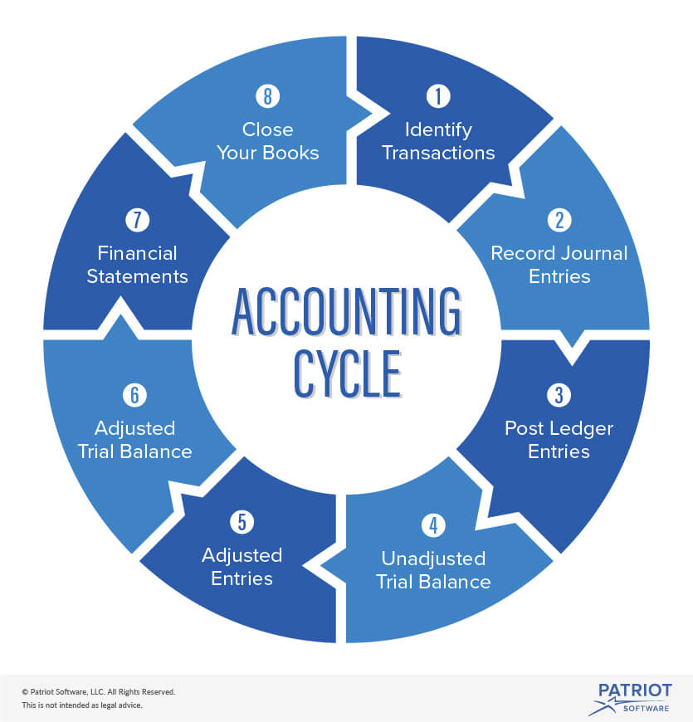
This illustration shows the order and routine an accountant must take in order for them to complete the cycle efficiently and post haste.

Activity)
The first step in the accounting process is to detect all transactions that have been made, this has to be done because we will need to gather all financial information for the later processes where we will analyse and order it. These are then measured and sorted to see which involve finances as the ones that involve money will be recognised in our final statement for the period.
After we have looked at and ordered our financial transactions, we will record them in a new entry called a journal entry these are ordered chronologically to make sure it’s easy to read and the information isn’t all over the place. This has to be done to guarantee our transactions that we’ve identified are in a nice report.
Following on from this all the information is classified and refined to make a ledger entry which is then sent to accounts with all the business and financial information inside.
After we have completed our ledger entry we will synopsise all the information into a trial balance form. This is done to see both sides: debit and credit sides, these must always equal the same amount. If they are unequal a mistake might have been made and will need to be fixed.
Next, all the information we have gathered will have to be analysed to make sense of all the transactions that have occurred over the period. This has to be done so management has a clear and concise view on how their company is doing. They will want to know if their company is growing or declining by looking at the profits and losses.
Finally reports of this information will be made and sent to users of the company. Reports of how well the company is doing will be made so employees will acquire knowledge of any profits or losses. Also, management may create a report to send to employees to give other information such as work efficiency and how well they think he’s doing.

References
Averkamp, H (2019a) Cash Flow Statement (Explanation) Retrieved from https://www.accountingcoach.com/cash-flow-statement/explanation
Averkamp, H (2019b) What is cost accounting? Retrieved from https://www.accountingcoach.com/blog/what-is-cost-accounting
Bragg, S (2018) The functions of managerial accounting Retrieved from https://www.accountingtools.com/articles/what-are-the-functions-of-managerial-accounting.html
Garcia, M (2019) What is Social Responsibility Accounting? Retrieved from https://bizfluent.com/info-7904492-social-responsibility-accounting.html
Iedunote (2017) 9 practical limitations of Accounting Principles Retrieved from https://iedunote.com/accounting-limitations

Student Statement:

By submitting this assignment, I confirm that this is my own work.

Student Signature | Samuel Haworth | Date | 31/05/2019

For Tutor / Assessor Use Only
Total Marks
Marks Obtained
Percentage / Grade

