
Assignment Cover Sheet

Student Name: | Jessica Kenny
Student Number: | 28560
Course: | Advanced Diploma in Interior Design Level 5
Assignment NO: | Unit 5 – Room By Room Designing

Marking Criteria:
We expect the learners to write minimum one well expressed point in three lines against each allocated mark. This means one needs to write 15 lines with 5 well expressed points to get high grades for a 5 marks question.
For high grades use examples and illustrations where appropriate.
How important is it for a designer to know about the function of a room before decorating it? What questions would you ask your client to establish the purpose of the living room before decorating it?

Every family will have different needs so it is important that a room is specifically designed to suit their requirements in order for the design to be successful. The biggest priority of a design project is to understand the function of a room to ensure it is safe, practical and comfortable to use. Once the function of the room has been established the designer can then recognise any existing space and function deficiencies that can then be rectified during the designing process. As soon as the function of the room is identified the space planning stage can begin and allows for all circulation routes to be mapped out.

The living room is often the most versatile room within the house so it is important that all the activities to be carried out in this space is identified. There are important questions a designer should ask in order to establish the living rooms purpose such as:

- How big is your family?
- Do you have any children?
- Do you have any pets?
- Do you have any hobbies?
- What is your profession? / Do you work from home?
- Is the space mostly used at certain points of the day?
- Do you use this space for dining?
- Do you have guests that stay overnight?
- What is your daily routine?
- What is the age of the property?
- How would you describe your lifestyle?

Once these key questions have been answered the designer can then begin considering the layout, materials and furniture. For example, a family with a young baby should have a living area that is durable and safe, therefore furniture should be fixed to the walls and any wires should be secured away. For a family that frequently have overnight guests should consider a sofa bed with plenty of cushions and black out window treatments.

How can a focal point be created in a room by using a mirror?

Mirrors can make excellent focal points in a room, particularly if they are used routinely as our eyes are naturally drawn to the light and the views they reflect. They also have similar qualities to windows as they add depth to the room and accentuate different hues of colour – this could be taken advantage of to enhance a decorative feature that automatically draws attention. Furthermore, the mirror doesn’t have to act as the focal point alone and can be used to enhance an existing one such as a window, fireplace or a piece of artwork.

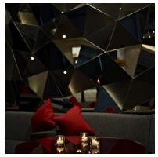
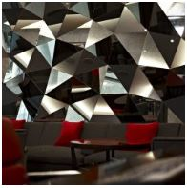
There are many other ways in which a mirror can be used to create an interesting focal point such as using a large mirror with a decorative frame to work as a stand-alone piece of art to make a statement, or by grouping a collection of smaller mirrors in an interesting arrangement. Mirrors can also be used to create a piece of artwork which works as the focal point – for example ‘Daedalian Glass Studios’ have previously created a geometric mirror feature for a hotel which adds a contemporary modern day feel and has created an open and light space to welcome guests during the day (see image 1). As the day progresses the mood and lightning changes meaning that the appearance of the mirror feature also changes, which is interesting to observe at different points of the day (see image 2).
Image 2
Image 1

Which type of cushions should be used within a child’s room?

As children grow up quickly and their interests soon change it is important to have a scheme that is able to evolve with time, so it is a good idea to keep the space simple. Furthermore, brightly coloured cushions are a popular choice as they can be used for all ages as they don’t just suit a single interest, meaning they can be used as they grow. In order to keep the child interested dress the space imaginatively – an easy way to do this is through carefully considering the cushions and arranging them in an intriguing way.

The aesthetics of any design are important, however if the space is not practical or safe then the design will not be successful. A child's bed should be comfortable therefore it is a good idea to invest in high quality cushion pads which can accommodate changeable covers, allowing them to be altered as tastes and interests change. For cushions used on the bed, the size of them is important to avoid the child from feeling overcrowded and uncomfortable. The material used for the cushion covers are also an important consideration as they need to be easily cleaned, therefore the best materials to use in a child's room would be linen or cotton. These materials are light and breathable meaning that at night time the cushions in the bed won’t cause the child to overheat. There are other places within the child's bedroom where cushions can also be used alongside the ones arrange on the bed – for example you could create a cosy corner using large oversized square cushions for the base and then feature more decorative and contrasting cushions on top to create a comforting area for activities such as reading or watching television.

Why is it important to draw a floor plan for a room before buying furniture?

A floorplan is drawn to scale by the designer to help them visualize what space is available. The space planning stage is fundamental for ensuring that a space is functional and comfortable to use. The process allows analysis of how the space will be used, the various different zones required and the required circulation routes to allow for free movement. Furthermore, the space planning stage also allows the designer to see the space required to open doors and windows fully. Once each zone has been mapped out and its use has been determined the designer can begin to figure out what furniture is required to create a practical space.

A floorplan drawing gives the designer an idea on furniture dimensions required so that it is in proportion with the space available whilst also giving the opportunity for the designer to create the best possible layout. This step prevents time and the available budget from being wasted as all of the furniture has been carefully considered and positioned in a scaled diagram – without this step the space may not function as well as it should. For example, a sofa that is purchased without space planning runs the risk of being too large for the space which will reduce circulation routes and potentially make the space uncomfortable to use.
As a result, drawing a floor plan is essential to any design to ensure the best layout is found and the furniture is proportionate to the rest of the room.

When two people have to share a room and they have different tastes how would you solve the problem relating to colour, pattern etc.

The most common group of people that are required to share a bedroom and will often disagree on different design schemes are siblings because of their separate personalities and styles. A popular way to overcome this problem is to create a room divider to give each sibling their privacy and the ability to design their own section of the room. A room divider could be created by using a large bookcase that provides storage space and gives each sibling some space for their chosen decorative accessories.

Another way to overcome this problem is to have high sleeper beds with an enclosed area below for each child - this is ideal for younger children of a similar age. The area beneath can be stylized to suit the child's personality and include space for their favorite activities such as a desk for drawing or a cosy area for reading. The rest of the space could be designed to feature neutral walls and flooring to avoid it from being favored towards one of the styles.

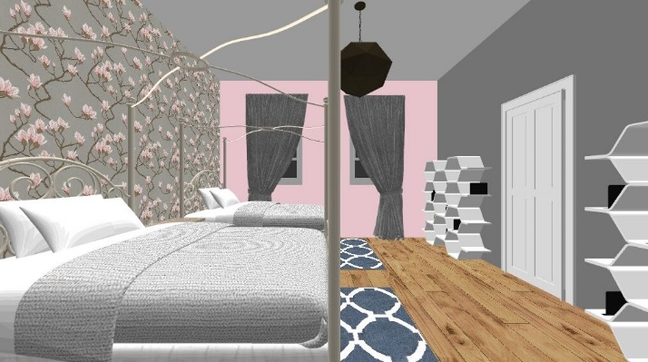
For older siblings you could feature four post beds with a beautiful material of their choice draped across to create a private space and then allow for each sibling to have their own have a feature wall that incorporates storage to suit their needs with pale accent colours on the adjacent walls.

Another way to overcome this problem is to establish a middle ground between the two siblings for the design. For example, two sisters share a room however they both have different tastes. One of the siblings like floral feminine styles whereas the other sibling like minimalist and geometric styles. In order to compromise with these demands I would feature pink floral wallpaper on a grey background and use the colours found within the wallpaper on the adjacent walls (see image 3). As the walls have dominating proportions that satisfies mostly with the first sibling, I would then pull in geometric shaped accessories such as hexagonal storage units and ceiling light to compromise with the second sibling.
Image 3

How important is it for an en-suite bathroom scheme to relate to an adjoining room?

An en-suite is generally designed based on its sole use from the adjacent bedrooms’ occupants, therefore it should be tailor made to their needs. It is extremely important that the scheme between the bedroom and bathroom is related to prevent them from feeling disconnect and to help it look and feel as though they belong together. The two different spaces should be visioned as one to ensure the scheme flows nicely whilst also remembering that they shouldn’t be identical. The key elements to remember is repetition of colour, pattern and texture.

Often white sanitaryware works best in compact spaces such as an en-suite as it helps to open the space, so ideally it is a good idea to feature white furniture in the bedroom so a cohesive look can be achieved. The overall style needs to continue throughout both spaces, for example a modern style bedroom should flow into a modern style bathroom or a vintage styled bedroom should flow into a vintage styled bathroom.

I have created two mood boards for a bedroom and an en-suite shower room to visualize how the two spaces can be connected by using a few of the elements. I have chosen a grey carpet which will then lead on to the grey wood effect laminate flooring in the bathroom whilst also transitioning the calming blue scheme from the bedroom to tiling in the bathroom which would feature within the shower cubicle. As the sanitaryware is white, I have decided to feature white bedroom furniture in the bedroom and have taken elements of this into the bathroom – for example the bed frames wooden paneling is repeated on the bathroom walls along with the light pastel colour also repeated across the two rooms. Within the accessories for the bedroom I have decided to feature chrome effect items which are seen on the shower cubicle, tap and toilet handle.

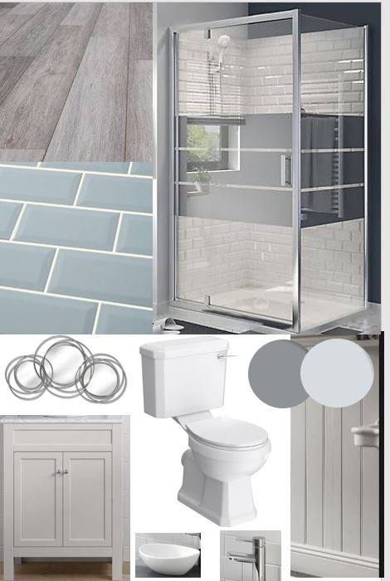
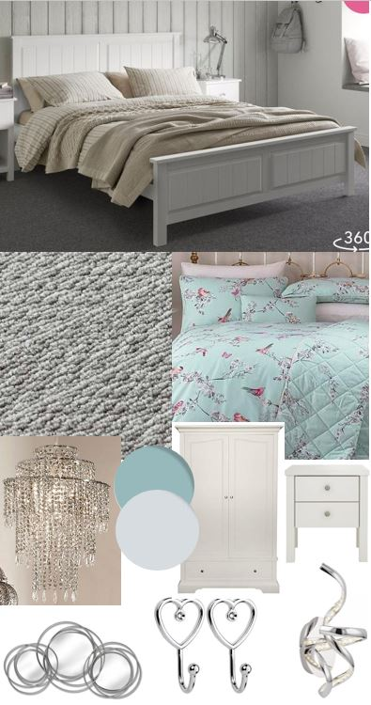

Activity

Items within my bedroom:
- Double Bed with duvet, pillows and bed spread
- Two chests of drawers
- Two bedside table
- Two bedside lamps
- Mirror
- Television
- Alcove with clothing rail and shelving
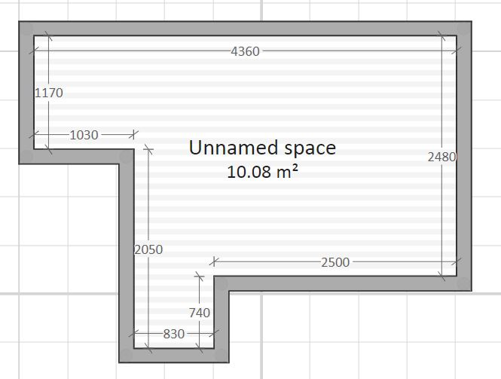

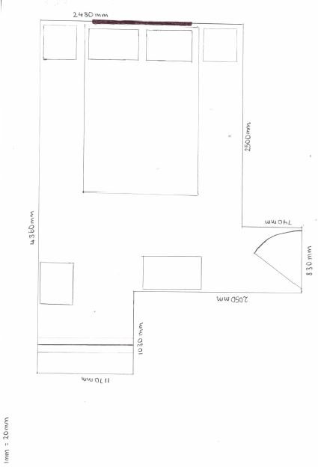
Bedroom measurements.

Bedroom floorplan drawn to scale.

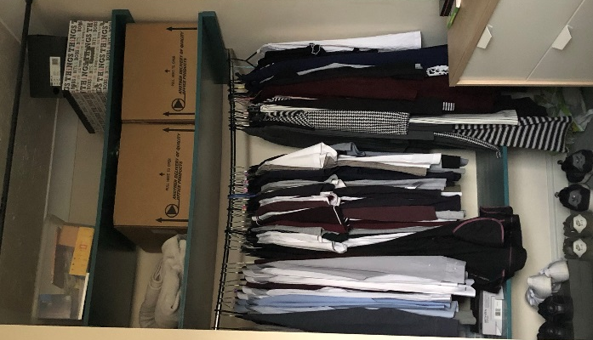
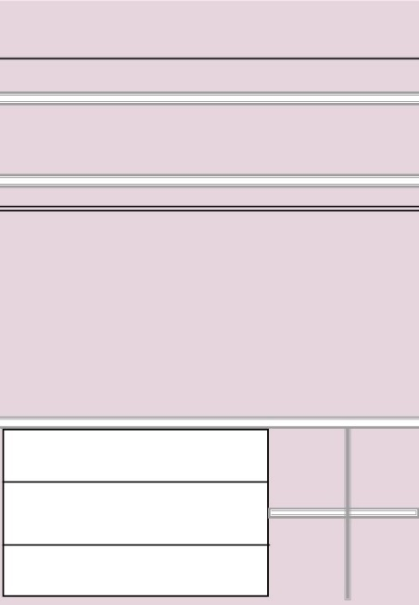
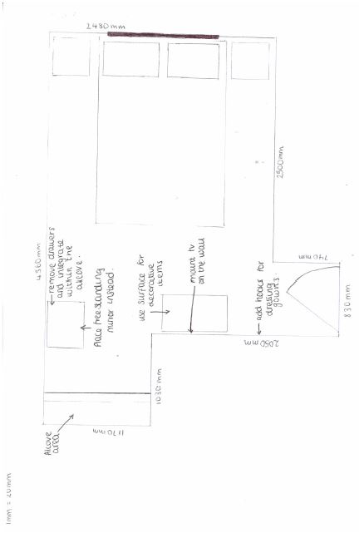
I share my bedroom with my partner, and we have discovered there isn’t as much storage as we would like. As it is a rental property, we are limited to the changes we can make however I have included ideas that I would incorporate into the space if the property was my own. There is an existing alcove with built in shelving and clothing rail (see image 4), however it could be re-configured to suit our needs. We would like to be able to raise the bottom shelf so one of the sets of drawers could be placed underneath for better utilsation of the current space. For the remaining space under the bottom shelf I would create cubes for extra shoe storage within our home (see image 5). On the top two shelves I would store the rest of our things in simple storage boxes and then hide the all of this away using the top rail and hang a beautiful curtain that works with the rest of the scheme. In order to further increase our storage space, I would mount the television on the wall and use the surface of the existing drawers to display decorative items. I would also fit hooks to the same wall as the television so we can hang up our dressing gowns (see floorplan 2).
Image 4
Image 5

Floorplan 2

Resources

Image 1 & 2 - https://www.daedalianglassstudios.com/glass-design/mirror-interior-design/
Image 3, 4 & 5 – Primary Sources.

http://www.interior-dsgn.com/mirror-as-focal-point/

Mood Board –

https://www.dreams.co.uk/woodbridge-wooden-bed-frame/p/235-00203?gclid=Cj0KCQjwvo_qBRDQARIsAE-bsH8xlTqzGHLN2jEQGi0bUUiYtND8lAEK2T4p50M46mJ9bDQHdtb5ES0aAsv5EALw_wcB

https://www.dreams.co.uk/sloane-2-drawer-bedside-chest---champagne/p/810-00099

https://www.flooringsuperstore.com/highlands-medway.html

https://www.dunelm.com/product/duck-egg-beautiful-birds-bed-linen-collection-b02342

https://www.lookagain.co.uk/products/3-tier-beaded-pendant/_/A-71X065_?utm_source=GoogleProductList&utm_medium=PLA&utm_campaign=Lighting&utm_content=71X065_&ns_campaign=Lighting&ns_mchannel=PLA&ns_source=GoogleProductList&ns_linkname=71X065_&ns_fee=0&ordermedia=L0637&name=LookAgain25Percent&orderoffercode=R47P&entry=3

https://www.pagazzi.com/twirls-led-wall-light.html?gclid=Cj0KCQjwvo_qBRDQARIsAE-bsH9Aak_Hgq6aRLUDiAQwMpUspZo0pVtITRNzIL6i19CZ6Ndiix8GtAIaAszOEALw_wcB

https://www.baytree-interiors.co.uk/item/silver-trio-multi-circled-wall-art-mirror/?gclid=Cj0KCQjwvo_qBRDQARIsAE-bsH_RWUSHeB5CERKKvMQ0pfa_kwlHQWzpWhfXUB3Zo7cbO9_Lak9jVi8aAoZxEALw_wcB

https://www.pinterest.co.uk/pin/405112928956330211/?lp=true

https://soak.com/en-gb/furniture/designer-furniture/600mm-melbourne-chalk-stone-countertop-unit-and-camila-basin---floor-standing/103013.html#gclid=Cj0KCQjwvo_qBRDQARIsAE-bsH8LKqEE0m1E-68eBPN9RHJVQ7AH4VN9zs3muaytWxj1krTUt1O_cnsaAiISEALw_wcB&start=21

https://soak.com/en-gb/toilets-and-basins/basins/camila-counter-top-basin/2000717.html#gclid=Cj0KCQjwvo_qBRDQARIsAE-bsH8LKqEE0m1E-68eBPN9RHJVQ7AH4VN9zs3muaytWxj1krTUt1O_cnsaAiISEALw_wcB&start=1

https://www.victorianplumbing.co.uk/premier-carlton-ceramic-wc-pan-cistern-with-seat?campaign=googlebase&pagetype=shopping&gclid=Cj0KCQjwvo_qBRDQARIsAE-bsH_j2LR802SD3HAKNrNz5-skH6ugjBkbLS6AXEcvgruIfEP_YbwHBhoaAlDSEALw_wcB&gclsrc=aw.ds

Student Statement:

By submitting this assignment, I confirm that this is my own work.

Student Signature | Jessica Kenny | Date | 05/08/19

For Tutor / Assessor Use Only
Total Marks
Marks Obtained
Percentage / Grade

