
Assignment Cover Sheet

Student Name: | Mary Allott
Student Number: | 25594
Course: | Certificate in Management Level 1
Assignment NO: | 3

Marking Criteria:
We expect the learners to write minimum one well expressed point in three lines against each allocated mark. This means one needs to write 15 lines with 5 well expressed points to get high grades for a 5 marks question.
For high grades use examples and illustrations where appropriate.
Please insert your completed assignment ( in word format) here:

Student Statement:

By submitting this assignment, I confirm that this is my own work.

Student Signature | Mary Allott | Date | 02.04.19

For Tutor / Assessor Use Only
Total Marks
Marks Obtained
Percentage / Grade

Q1)
Time management is the process of conscious control over the amount of time spent on individual activities throughout each day, week or month. This can be done through a range of methods and techniques, such as goal setting, usually in a hierarchical manor for most important. Job (or individuals) performance is the most important factor for any organisation to focus on; poor or fantastic performances each have their own impact on the running of a business.
Therefore the relationship between time management and the performance of individuals, although moderate, it is a significant one. If an individual has bad time management, they will undoubtedly struggle to keep up with their workload within the working day, resulting in the workload going home and impeding on their home life and relationships. Should a group of individuals have poor time management skills, and are badly managed, the running’s of an organisation will not run smoothly, and constantly overrun deadlines which in turn would impact costs to the business.
For example a construction company are issued with a contract to get the workload carried out within a timeframe. Well managed, this time frame will allow for interruptions such as weather, on the other hand, badly managed, they will continue to pass deadlines, houses or roadworks will not be carried out on time and the company will have to continue to pay numerous workers for weeks or months longer than initially contracted, which then eats into their profits and future project management.
Many employees for all companies undergo the training for time management, however, feel it is ironically wasting time by going through the training, because they as individuals, believe they have no issue handling time. What they need to take into consideration is the bigger picture, and how another team member or even their manager having bad time management will impede on their own working time. At the end of the day the organisation has a job to do well, and all work must be finished by the working day, no matter who has to carry it out to ensure it is completed.
Reflecting on the bad time management, If operations are running smoothly it allows each individual to reach their own individual targets, resulting in each person experiencing a higher level of happiness through positive reward which produces lower level of stress.
A good leader will be able to ensure these operations are run smoothly and with a strongly built relationship, this will also impact performances. Should every individual feel praised and needed for their work, they are highly likely to give the job everything they have which in turn will not only give the company a good reputation for how they treat members, but will also produce better quality products or services.

In today’s technological state, there plenty of software or apps to choose from that will work well for a company and to allow all members to visualise the workload and deadlines. Following Carrie Green Female Entrepreneur, she regularly speaks to fellow entrepreneurs and how they manage their time, many of which mention software such as Meet Edgar and Asana [pictured below] These sites allow businesses to post the same post across numerous platforms in one go, thus saving precious time to carry out other activities.
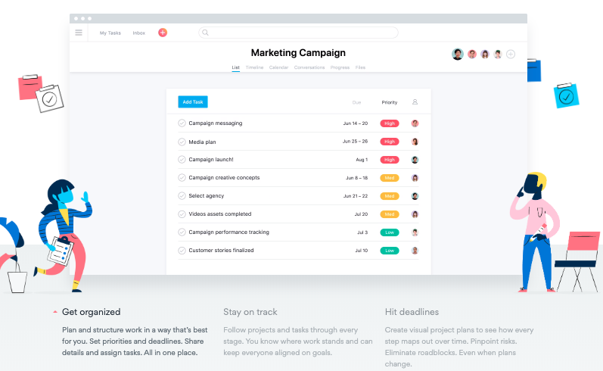

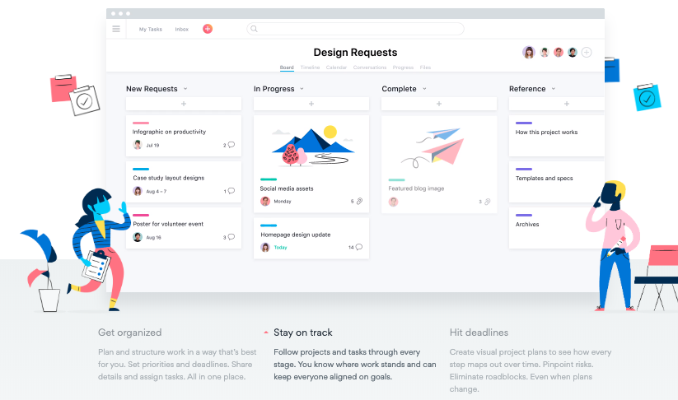
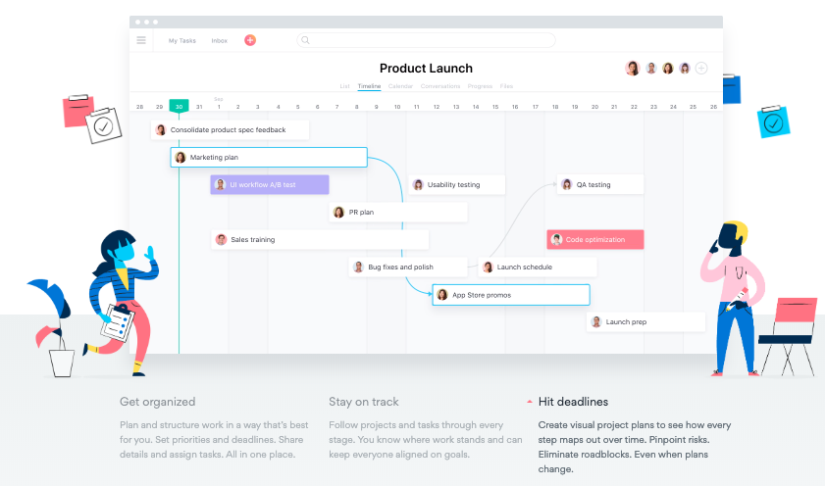

A severe implication of bad time management, creates a poor training scheme, and exaggerating this issue to the event of a crisis; should the team members and managers not know how to correctly handle a crisis within a time frame can greatly impact the workings of a business. This type of crisis could be thought of as the ramifications of bad press by the media, if not handled correctly and within the exceptionally tight deadline the media allows, it can harm an individuals or an organisations image for the World to see.
Overcome by Employing tactics of stress management – each individual handles stress uniquely. Pressures in work or personal can cause employee to skip work, slack off, perform poorly.

Q2) Each organisation comes with its conflicts, a strong manager, whose job it is to reinforce the companies values, will be able to resolve these issues professionally, optimistically but brutally honest - without creating further conflict.
Time Management.
To make sure the organisation stands the best chance against any interruption, managers will have strong time management skills and not just to make sure they turn up to work on time, but to ensure all their diary schedules and workload is carried out in a timely and effective manor, including allowing for “white space” such as travelling time, interruptions or last minute appointments. With an organised manager, it allows the rest of the organisation to keep the working cogs rotating smoothly and with efficiency, reducing risk of additional costs to the business.
Through strong communication, a manager will keep the workforce up to date with the ins and outs of the business, where they fair strongest and where they need to improve to stay ahead of the competition, and to help visualise the end goal.
A good manager will have built up trusting relationships with the organisations workforce Should a conflict arise, a manager will know how to keep the working environment calm and clear minded, resulting in a stronger performance to overcome any such issues.
With the use of goal setting techniques, it keeps the team members and themselves focused on the task at hand, these goals’ rewards could be varied from company to company, but with a reward scheme it may alleviate the stress by encouraging a positive work environment.
Stress and Crisis Management
In the event of a crisis, a manager will also take psychological and cultural actions such as providing the training or support services regarding the human emotions of a crisis. Commonly this is a support available, throughout training, to workers in high risk positions such as Fire Fighters, Military, MOD/ Police.

Prevention  Well-laid-out plans help the management of the company to minimise any damage that may happen.  Although it is hoped they won’t be needed, foreseeing these events, allows to reduce risks that both may create a crisis and in the event of a crisis. | Preparedness  Mock drills and practice allows for the continuing readiness in the event of a crisis and keeps it fresh in the mind.  Annual reviews should be carried out and updated accordingly
Response  Having a dedicated crisis management plan/team allows the company to handle it quickly and in a calm manor– in turn this reduces a greater amount of stress for all involved.  Each member of this crisis team will have their own individual duties to contend to, and be trained in. i.e First Aider, Fire Marshall. | Recovery  Sufficient funding to allow for damage control will help rebuild a business or its reputation.  With effective crisis management, this stage could be carried out efficiently and allow the business to get back to normal in as short a time as possible.
An example of a crisis management plan being used on a regular basis, is within the Royal Navy, or Military as a whole. During the build of a new ship for example; training is completed to prevent fire and floods with extensive training exercises, and daily briefings and official policies keeps it clear in the minds of all on board ship.
Although any company will not want a crisis to actually happen; in light of a crisis, new strategies, competitive advantages and positive changes can emerge for a company. An exaggerated example of this would be to reference the Industrial Revolution during WW1, the emergent need for new, better and duplicated equipment within a short turn around revolutionised the way we are today.

Q3) A well-managed, planned and organised diary is a positive step to reduce stress and support effective time management. A well-organised diary allows the flow of work to continue, everything happens at the right time and in the correct order.
For example within a manufacturing company, an efficient diary would allow the employees to manage their production, orders and deliveries to and from suppliers and ensure they are all scheduled to the companies production timeline. Quite often, within manufacturing, this diary is in the form of a critical path.
Being organised both in business and in personal life will only aid a calmer lifestyle, improve quality of life and preparedness for any level of implications or crisis.
Entrepreneurs and successful people will owe their success to being organised and effective diary management. By selecting a period of time per day or week to organise their schedules with a time plan, allowing time for interruptions, travelling or mishaps. They will plan their desired result for each day, meeting or phone call and prioritise their work around this goal.
A strong diary manager will think outside the box, not only will they be able to schedule events within the near future, but will also foresee potential issues and create secondary and even tertiary schedules around it.
For example within a studio environment publishing catalogues, they will schedule photoshoots by booking models, samples and creatives. Within the publications department there will be a critical path to follow which would consider the following: failure of attendance of a creative or model, weather implications, permit rejection, missing samples and will have other options set in place as backup, which in turn would ensure publications are still finished to deadlines, no loss of money for missed photoshoots or delays within publication.
With today’s technology it is increasingly more efficient, cleaner and leaner for a business’s day to day processes, such as diary management. Computing has allowed to automate tasks that were once time consuming, and money wasted activities. It is efficient on the input of appointments and events, particularly with any that are recurring.
Once the right platform, based on the number of access points, networking and its general versatility has been chosen, it is then in the interest of the manager or director to engage and inform all its employees of what the diary does and the expectations of how they will all utilise it to its best ability.
Solely informing employees of the diary system won’t be strong enough, it is crucial to enforce the importance of the diary, emphasising on how the diary is a key tool to the backbone of the businesses productivity and success. On the contrary, having all employees able to add data to the diary could be catastrophic and confusing, so to overcome this issue, having a select few who have access to alter the diary then creates a clear chain of command but still allows all employees keep up to date with the events of the business.

Q4) Stress is a feeling of being under abnormal pressure, a physical or psychological stimulus that produce mental tension or physiological reaction. This pressure could arise from situations we create for ourselves when things get complicated or complex, but these underlying issues are usually not that important or worth the time, energy or emotion we spend on it.

It can be built up through a series of minor irritations or major upheavals caused by general day to day lifestyle aspects from work, relationships, bereavement to monetary issues. However without identifying the root of what is causing the stress, an individual or team will not get passed every effort of trial and error, which in turn reduces an effective and efficient working environment and increases poor time management and an unacceptable workload. A business that is severely affected by stress will find an impact on its profits and its efficiency.

- Common Signs and Symptoms of Stress

- Feelings of constant worry or anxiety
- Feelings of being overwhelmed
- Difficulty concentrating
- Mood swings or changes in your mood
- Irritability or having a short temper
- Difficulty relaxing
- Depression
- Low self-esteem
- Eating more or less than usual
- Changes in your sleeping habits
- Using alcohol, tobacco or illegal drugs to relax
- Aches and pains, particularly muscle tension
- Diarrhoea and constipation
- Feelings of nausea or dizziness
- Loss of sex drive
mentalhealth.org.uk

When the body is stressed, it becomes naturally exhausted, which then impedes on the performance of the mind, you begin to lose concentration, become drained and tired which then affects an individuals activity and decisions can become unclear, hasty and emotions hit different temperamental levels.

To try and reduce the impact of stress on the body, mind and business there are steps to take. First: Identify when it is causing a problem by looking out for physical warnings such as headaches or migraines, tense muscles or over-tiredness, and notice its passed general ailments. Connect between the level of pressures to the tired or ill feeling.
The next step would be to identify the underlying causes and ask:
1 - whether there is a practical solution to correct the issue,
2 - is it an issue that will get better given some time,
3 – There is nothing that can be done to fix it.

Finally, a review of lifestyle. Look into how much is actually being taken on and if the load can be split and passed onto someone else. Through re-organisation and prioritisation of the work-home balance, an individual can easily find a more leisurely way of still achieving the desired outcome, but reducing the levels of stress.

Contradictory to the natural negative reaction to the term “stress”; it can also be positively beneficial, even if it is short-lived. An individual, or even team of people working under immense pressure, or a stressful situation have shown they perform better, are more alert and develop stronger character building skills across a multitude of tasks from team work, through to effective time management and ability to perform.

Without dealing with stress, a person, team or company cannot hope to develop or move forward. Stress creates opportune moments to reflect on mistakes and learn from the lesson to progress. Businesses will not progress or beat competition without the drive to take risks or move forward.

Q5) I strongly agree that “time management is a tool for stress reduction”. In today’s busy, hectic world, we rarely find time to spend on the things that matter most to us, such as family life, fun activities or even just switching off, away from technology and the world. The time we do get to enjoy taking part in the aforementioned activities, are extremely limited and can only be enjoyed to the fullest extent if an individual, or group are ‘stress free’.
Time is a fixed point, there is no more or less added to the day: it is simply how we spend it.

With wise time management it allows an individual to complete all tasks given within a timeframe, once these tasks are done we find ourselves “free time” to spend as we wish creating happy endorphins within the body causing a reduction of stress.

A strong leader will encompass such time managing values, by delegating tasks to individuals who capable of managing the workload handed to them in a calm and stress free environment. They will be able to foresee certain events within the companies schedule and know the weight of the workload at particular times in the year, for e.g. when a larger publication is going to print, and what individual jobs need to be completed to allow such a publication to go out on time.

My own personal preferences includes the following weekly activities:
At the start of the month I will list what I plan to achieve within the month; jobs that need doing at work, around the house, a new subject to learn and any pre-booked activities or upcoming birthdays.
Spending just 1 hour a month doing this allows me to not only budget, but also allows me to fill my time wisely and buy any presents needed without rushing round last minute on Amazon Prime – although Prime is an integral element to a busy schedule. I also ensure I make time once a week to spend watching a new-to-me movie and social time with friends.
On a Sunday, I will spend an hour creating meal plans, daily schedule for the week ahead. Each day’s activities are listed to a hierarchy of importance, including emails or phone calls I need to make and what I wish to achieve from the calls.
Without managing my time as I do, I would miss jobs out, feel stressed with the piling high list of things to get done and wouldn’t enjoy the little things in the day.

An individual who applies a goal-setting tool to their personal and work life are an asset to any company. They value both their own time and the companies. By achieving goals no matter how small, a sense of pride and achievement is created within, which releases those happy endorphins and by consistently reaching these goals it allows both a business and individual develop strongly.

As a business owner myself, I find following the SMART analysis per goal, to be helpful and instructive when it comes to planning my time.

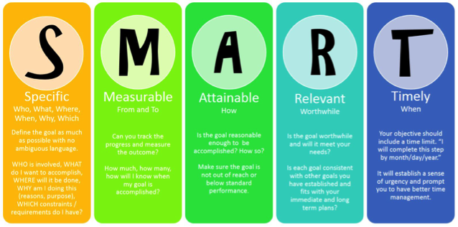

Applying the SMART analysis alongside Pareto’s Principle – the 80/20 rule really grinds into maintaining achievable results. Most high achievers are great at prioritising tasks, but are not so good at letting the smaller tasks go uncompleted. They generally whizz through the most important jobs first, but then spend hours trying to complete the smaller lower priority tasks in order to “finish their workload”. What they don’t comprehend, is there is always a job to be done – without their workload they are considered to be “out of a job” and by attempting to complete all tasks within the working day, they compromise their quality of work.
The 80/20 rule – 80% outcomes from 20% inputs. This translates to only 20% of the work is actually important, and worth your time and efforts. It also suggests that the other 80% of time and effort put in will only get you your 20% of the outcomes you are working to.

In conclusion, there is no argument that time management is in fact a way to relieve stress. Being organised, with the capability of foreseeing issues there is no reason why each individual can manage their time efficiently. It is a transferable skill that can be utilised throughout all aspects of life, it creates balance and by following the SMART analysis, 80/20 rule or even using the latest software available, there is only a positive outcome that can be achieved for both businesses and individuals.

