- Benefits of supply chains:

Supply chains are developed to beat the gaps, in between the producers and end users. The majority of the products are produced by many more countries around the world but at the same time all the products are transferred to the end users by the means of suitable transportation methods. Example coffee beans are cultivated in South America but at the same time the product users are in Europe and North America, so the real benefits of supply chains are providing the materials or products from the producers to the end users by organized transport methods and also using the place like super markets.

If the products like vegetables are plenty then it can be stored in the depot and then delivered to the destination by suitable transportation method. If the products are in demand in particular area in the town, then it is very easy to supply there by supply chain. The real benefits of supply chains are explained by simple method of diagram as follows

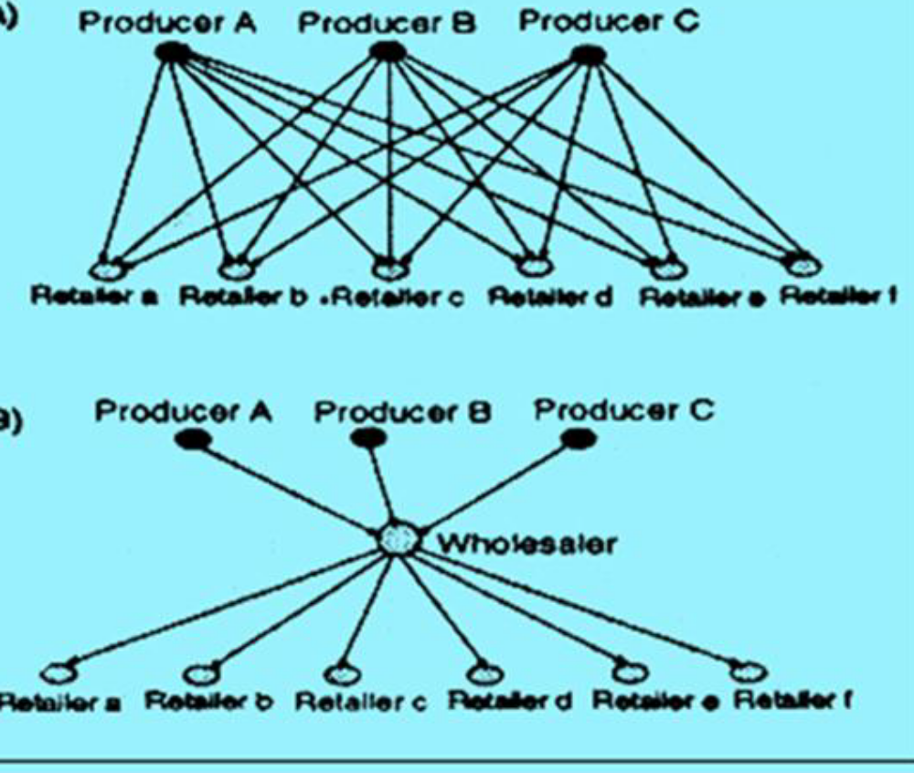

- Business in supply chain must take decisions individually or jointly concerning their action in the following five areas, they are
Production: What are the products needed by the market and what will be the demand what is the quantity and which of the products are manufactured and when it will be ready. So the activity comprises of the production schedule it consider plant capacity, quality control, workload balancing and equipment.

Inventory: Inventory is one of the main aspects in supply chains, because it should be placed in stock at every phase in the supply chain. How much stock need to be maintained as raw materials, semi finished, or finished goods.

Location: It is also one of the main aspects in the supply chains like production facility and inventory storage space, we also consider inexpensive storage location and can use the existing facility . So once the decision is made then finally decide the potential paths which are accessible for products to flow through for delivery to the final or end customer.

Transportation: The required stock need to move from one place to another by means of arranged transportation. Air freight and truck are widely used for fast and consistent, again it is more costly . Shipping by sea or railway is much less costly but need more time to deliver.

Information: It is one of more vital role in the supply chains, because gathering accurate information and data, which are timely shard to required department in order to coordinate better delivery system. If the company want to establish in the market it is very important to maintain good customer service and also fulfill customer’s expectation.

- What is inventory management
Inventory Management is a collection of techniques that are applied to supervise the inventory levels within dissimilar companies in a supply chain. The objective is to decrease the cost of stock as much as possible while still maintaining the levels of service that customers need. Inventory management takes its main inputs from the demand predictions for products and the prices of the products.

- Write short notes on following topics

Producers: Producers are the organizations that make a product. This includes businesses that are producers of raw materials and finished goods. The producers of raw materials are business that drill for oil and gas, mine for minerals. It also include that raise the animals, farm the land, and catch the seafood. So producers are make products that are not like music, software, design and entertainment.

Distributors: SUPPLY CHAIN MANAGEMENT
Distributors are businesses that take inventory in mass from producers and supply a bundle of associated product lines to the consumers. Distributors are may called as wholesalers too. The wholesales are to sell products in big quantities than a individual customer would generally buy.
A distributor is normally a business that takes possession of important inventories of products purchase from producers and sell to customers. In addition to product advertising and sales, other
functions the distributor carries out are inventory administration, warehouse operations, and product transportation along with customer support and post sales service. A distributor may also called as a brokers a product between the manufacturer and the consumer, also never take possession of the product. The distributor is the mediator that repeatedly tracks consumer needs and aligns them with the products available.

Retailer: Retailers stock inventory and sell in lesser quantities to the common public. This business also closely track the demand and preference of the consumer that it sell to. Discount department stores draw customers using extensive product selection. Fast food hotels use ease and low prices as their draw.

