
Assignment Cover Sheet

Student Name: | Desislava Marinova Mavrogeorgi
Student Number: | 21762
Course: | Diploma in Logistics & Supply Chain Management (Level 4)
Assignment NO: | 5

Marking Criteria:
We expect the learners to write minimum one well expressed point in three lines against each allocated mark. This means one needs to write 15 lines with 5 well expressed points to get high grades for a 5 marks question.
For high grades use examples and illustrations where appropriate.
What is purchasing?

Purchasing usually starts with the buyer recognizing the need for a product and preparing the specifications. Market sourcing, through the selection or tendering process, assists identification of a suitable product and supplier. Thereafter, buyer and seller negotiate the terms and conditions of sale for the goods being purchased, i.e. how and when they are to be shipped and insured, and how and when payment is to be effected. Once agreement is reached, the buyer issues a purchase order, an accepted pro-forma invoice or a contract. The buyer may place this against a framework agreement already established with preselected suppliers. Transport of the goods is arranged according to the delivery terms stated in the sales contract. Upon acceptance of delivery (or as otherwise arranged to facilitate the transaction, e.g. through advanced billing), the seller prepares a commercial invoice for payment. The buyer processes the payment according to the contract.
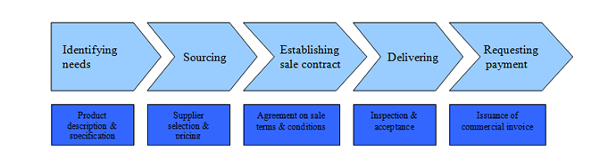

Purchasing involves two primary parties: buyer and supplier or seller. Other entities may become part of the process as intermediaries. They are secondary stakeholders, for example, agents for purchasing, trade and credit. Purchasing agents, acting on behalf of the buyer (and sometimes the seller as well), are used especially by small and medium enterprises (SMEs) for tendering, offering, evaluation, invoicing and payment procedures, which may be combined with other responsibilities, such as packing, marking, shipment, export licensing and Customs tracking.

Purchasing is the organized acquisition of goods and services on behalf of the buying entity. Purchasing activities are needed to ensure that needed items are obtained in a timely manner and at a reasonable cost. A purchasing department is especially necessary in a manufacturing business, where large amounts of raw materials and components must be obtained on a recurring basis.

The purchasing department's primary goals are as follows:
To locate suppliers that can provide goods and services in accordance with the buyer's requirements.
To buy items that meet the quality specifications of the buyer.
To create a stream of deliveries into the buyer's premises that minimize the raw materials inventory investment while still ensuring that goods are available as needed.
Common purchasing activities are as follows:
Receive and verify purchase requisitions from around the company.
Search for qualified suppliers that can fulfill the buyer's needs.
Prepare and issue request for proposal (RFP) documents to qualified suppliers.
Evaluate supplier responses to RFPs, select a winner, and negotiate a contract.
Issue purchase orders to suppliers that authorize purchases. A master purchase order may be issued when there are a number of deliveries contemplated under a purchasing arrangement.
Administer contracts that have a longer duration.
Review open purchase orders to see if any should be closed.
There is a tendency for the purchasing function to be bogged down in paperwork, which is related to the excessive use of bidding procedures and the issuance of purchase orders. The function can be streamlined by replacing bidding with sole source arrangements for most purchases. Also, lower-cost purchases are now made with procurement cards, thereby avoiding the use of purchase orders.
The purchasing department may operate a freestanding purchasing software package, though the system is more effective if integrated into the software of the receiving and accounts payable functions.
Steven Bragg (2018)

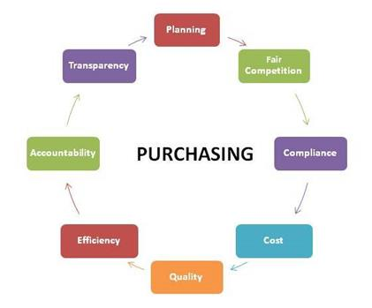

Define the term ‘procurement.’

Procurement has become a very effective tool for companies of all sizes to cut costs and improve customer's satisfaction. However, this term has a different meaning for different people. Anyway, procurement can be defined as below:
“Procurement refers to the participation in the development of requirements and their specifications; managing value analysis activities; conducting supply market research; managing supplier negotiations; conducting traditional buying activities; administering purchase contracts; managing supplier quality; buying inbound transportation”
Donald Dobler (2018)

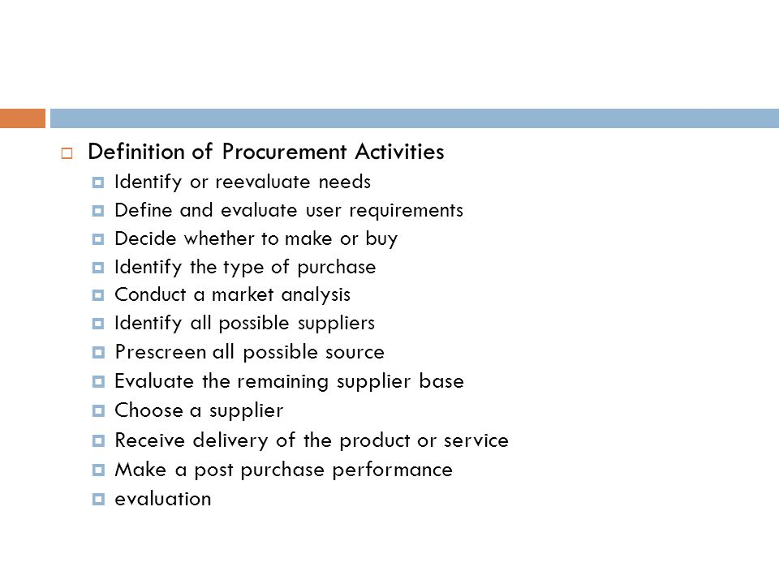
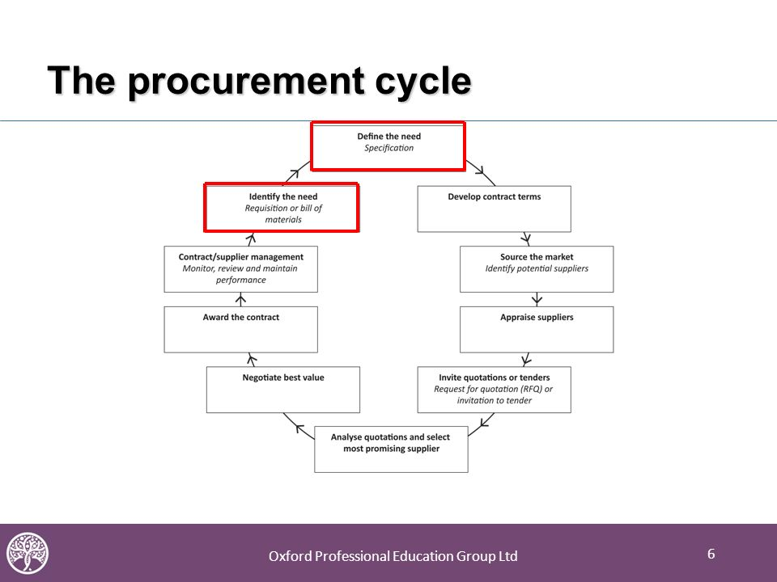

The procurement cycle The diagram above shows a generic procurement cycle.It is important to ensure that business needs are considered at each and every stage of the cycle.The earliest points at which a business case can be prepared are identification and definition stages.Therefore the focus of this unit is firmly on the identification, definition and communication of requirements.So rather than discuss all of the various stages of the procurement cycle we will focus on identifying and defining needs.

What is the importance of procurement in a supply chain

Reasons Why Procurement and Supply Chain Functions Are Important
More than ever before, the success of any business today is more dependent on the performance of its supply chain. For you to see why it is fast becoming important to embrace a more supply chain focused business model, here are a couple of reasons for you to consider.
The failure of a supply chain, or the lack thereof, could visibly impact a business’ market valuation
When a business’ supply chain fails or is non-existent, this could considerably impact the business’ market valuation negatively. Any company’s failure to connect its objectives and outcomes to its realistic supply chain capability could be catastrophic, and the resulting market movements could lead to its value depreciating.
For the corporate suite, predictability is priceless
Reliability is a key determinant of a company’s or corporation’s valuation. However, reliability is more than just getting a product delivered to a specific point by a specific time or having a service or services performed whenever needed and as needed. Reliability also means being predictable. Considering that the customers expect the right quality and the right quantity delivered at the right time every time, it is important that the business stays predictable. As such, it is important that it delivers on all its promises – both externally and internally. Virtually all of a company’s internal functions – manufacturing, sales, procurement, finance, etc. – will perform more efficiently and capably when all variances are minimized. The absence of predictability will ultimately lead to costs multiplying as unpredictability and uncertainty are the major contributors to rising costs within a supply chain.
Global growth requires a globalized and reliable supply chain
Most of today’s supply chains are more globally-focused, technologically-infused, interactive and collaborative. For any business to grow out of its cocoon and address a more global audience, it will have to improve its procurement and supply chain to ensure that its services and products reach more people. As such, it is crucial to focus on a creating a supply chain that is intelligent, well-defined and well-informed. As such, you should be able to make all the right decisions concerning the most influential business aspects and developing a chain that exudes interconnectivity, flexibility, end-to-end transparency, customer-centricity and any other additional attribute that is appropriate for your customer base, business strategy or specific industry
Raf Verheyden (2026)

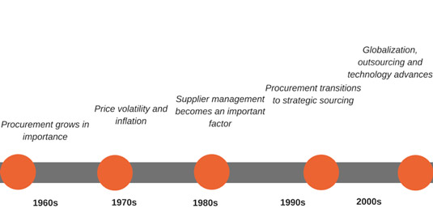

Who are qualified suppliers?

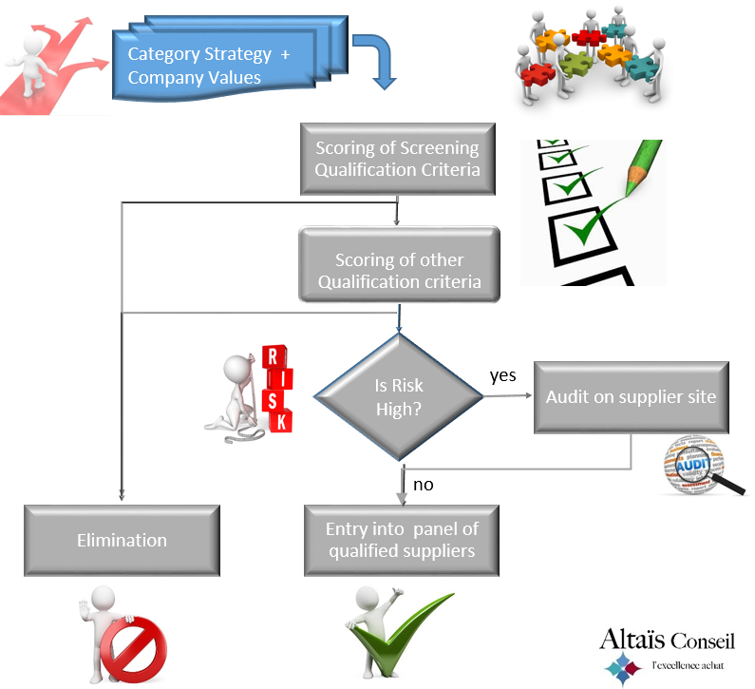

Supplier identification and qualification are the first two steps in the supplier management process within procurement. Companies define their unique supplier identification and qualification criteria needed for each supplier to become a supply partner. World-class supply chains must continuously identify and qualify suppliers to maintain a healthy supply base to account for normal and unforeseen exists of preferred suppliers. High growth technology companies often find they must identify and qualify new suppliers in order to meet the needs of new technology components. Established companies with preferred supplier lists often find that continuous maintenance, removing under preforming suppliers and added new suppliers is a key enabler for maintaining their supply base. Software tools today are allowing supply chain professionals to automate the process of identifying and qualifying suppliers to free up time to focus on engaging suppliers. Below is a step-by-step plan for identifying, qualifying, and engaging world class supply partners.
Solutions
Step 1) Identifying supply partners that are the right strategic fit
Step 2) Qualifying supply partners efficiently and effectively
Step 3) Engaging supply partners to quickly build credibility
Industry star (20116)

What is e - procurement?
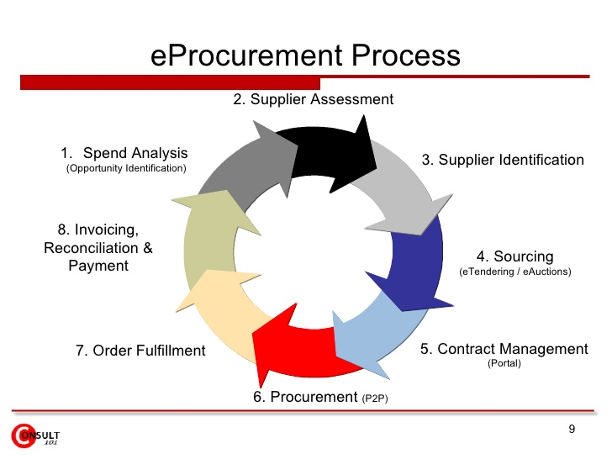
Electronic procurement, usually simply referred to as “e-procurement”, is a term used in professional purchasing and e-commerce for B2B transactions – that is to say business to business. It is not about ordering goods from individual customers, but rather communication between businesses. E-procurement is not targeted at private customers shopping in a web shop, but instead at companies using a digital solution to regulate purchases between one another. There are several advantages to using this modern purchasing solution, with the automation of several parts of the process saving a considerable amount of time for the companies involved.
In the course of digitization, many areas within companies have changed. Back office processes in particular can be carried out more efficiently with digital solutions. This also includes purchasing. The fact that e-procurement plays an increasingly important role is also because some goods and services, such as software or web services, can only be purchased digitally anyway.
In most cases, electronic procurement is based on so-called ERP systems. Enterprise resource planning systems are software solutions specially designed for companies, which support business processes and simplify merchandise management.

In principle, e-procurement is the digital process of procurement. This means that paper order forms, catalogs, and paper price lists are not needed, and communication with the supplier is predominantly digital. When it comes to e-procurement, companies rely on software designed to make their purchasing processes more efficient.
It is crucial for e-procurement that the purchasing process is perfectly integrated. Ideally, the systems of both businesses would work together seamlessly – the company can then immediately see whether the supplier has the required item in stock, and whether the order has been received.
Both parties now mostly rely on the internet for communication purposes. Due to the need to keep data secure, some companies also prefer networking via their own extranet. Business partners can then access each other’s intranet via a VPN connection, for example. The data is transmitted via a secure IP tunnel.
Digital Guide (2018)

Outline the main aims of procurement.

Procurement Objectives for 2020
 | Present | Future
Value Drivers | Cost Savings and Risk Mitigation | Execution Speed and Business Insight
Procurement’s Role | Sourcing Executor | Sourcing Advisor
Business Role | Procurement Customer | Disciplined Sourcing Agent
Delivery Model | Standalone Corporate Function | Hybrid Center of Excellence (COE)
Resources | Execution Staff and Core Technology | Professional Advisory Staff and  Customer-Oriented Technology

Linda Ashok ( 2019)

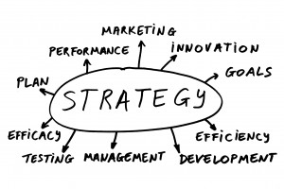
Outline some common manufacturing strategies.

Lean manufacturing strategies, also known as just-in-time manufacturing, aims to make the manufacturing process as efficient as possible by eliminating inventories and streamlining the manufacturing process to reduce wasted labor and materials
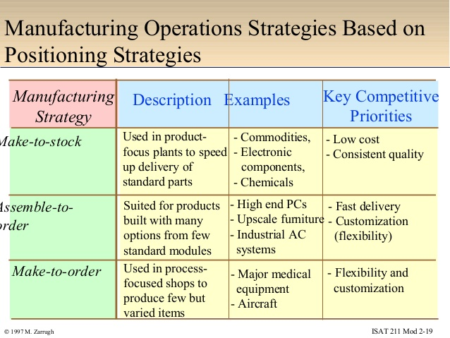

Describe the procurement cycle in details
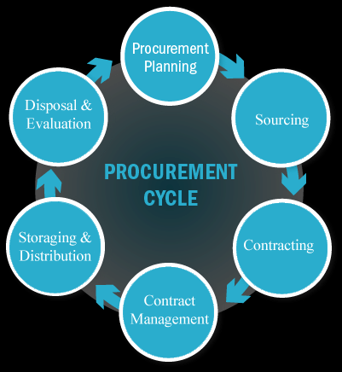
Procurement cycle is the series of steps that are taken to purchase any product a business might require. For an uninitiated businessperson, the process might appear to be a very simple procedure. But this whole process (Procurement cycle) has many stages involved in it from Identifying a product to the Payment settlement. Everyone has different opinions on each step of this process, But following steps of a standard procurement cycle can support you through the procurement journey.
Abbu Gopi (2018)
Which approaches are used to monitor the performance of suppliers?
There are a number of key factors which can be used to assess supplier performance and which can be used as a yardstick for determining whether good practice is being achieved in specific situations. Some examples of these 'hard' issue key performance indicators (together with their sub-categories) are:
• Product quality • MTBF (Mean Time Between Failure) • Percentage of incoming rejects (delivery accuracy) • Warranty claims • Service Quality (against agreed SLAs) • Call-out time • Customer service response time • On time delivery performance against agreed delivery lead times • Relationship/Account Management • Accessibility and responsiveness of account management • Costs are maintained or reduce• Payment terms
CIPS 2018
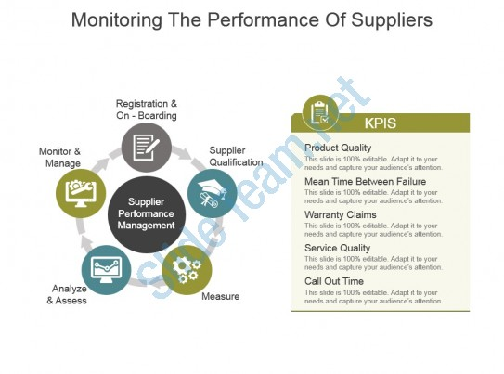

Student Statement:
By submitting this assignment, I confirm that this is my own work.

Student Signature | Desislava Marinova Mavrogeorgi | Date | 19/05/2019

For Tutor / Assessor Use Only
Total Marks
Marks Obtained
Percentage / Grade

