
Assignment Cover Sheet

Student Name: | Preethi Kulkarni
Student Number: | 9225
Course: | Certificate in Fashion Design Level 1
Assignment NO: | 2

Marking Criteria:
We expect the learners to write minimum one well expressed point in three lines against each allocated mark. This means one needs to write 15 lines with 5 well expressed points to get high grades for a 5 marks question.
For high grades use examples and illustrations where appropriate.
Please insert your completed assignment ( in word format) here:

Assignment 2#

Question 1: What is the relationship between principles and elements in a design?

Please note all the answers are taken directly, entirely copy pasted and edited from the content of the course provided, Unit 2 – Elements and principles of design.

Also please note all the images are copy pasted from various websites on the Internet.

Answer -

The following are the different Elements of Design:

• Line - According to the type, lines can be divided into three types - straight, curved, and jagged lines, Lines are incorporated into clothing in the two basic ways - structural and decorative.

• Form

• Shape - Basic Shapes, In dress designing there are seven basic shapes – Triangle, Inverted Triangle, Oval, Square, Round, Hourglass and Combinations.

• Texture and

• Colour - Starting with a given design theme the first thing which comes to mind is the color and texture of the fabric. Every season, now and then a color emerges in the fashion scene which is decided by the leading manufacturers, exporters and textile experts of the fashion world. Also while choosing a color one must be utmost careful as color creates the first impression and hence can glorify or destroy ones appearance. Even simple silhouette may be enhanced by using effective color schemes. As texture is the feel, drape and degree of stiffens and softness of the fabric, it also creates a visual effect upon the wearer.
These elements are considered as “Plastics” in art language as they can be manipulated or arranged by the designer to create desired illusions.

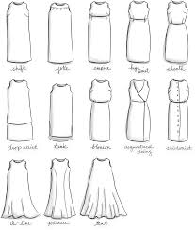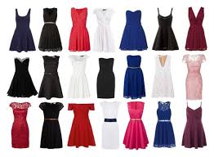

Following are the Principles of design.

Balance - Balance implies pose, equilibrium, stability and security.

Emphasis - Emphasis is concentration of interest in one area of a design that acts as the center of attention.

Harmony - Harmony is also called unity in design or in other terms, harmony is pleasing visual unity.

Proportion - Proportion is simply the pleasing interrelationship of the size of all parts of the garment. Generally, unequal proportion is more interesting than equal.

- A design can be defined as an arrangement of lines, shape, colours and texture that create a visual image, elements are therefore the raw materials that must be combined successfully and the principles of design are the rates that govern how elements are combined and are guidelines for the use of the elements of design. The elements and principles of design are flexible and should be interpreted within the context of current fashion. They are used for creating, discussing and evaluating garment designs, in order to arrange the elements of design well, application of principles like balance, proportion, emphasis and unity/harmony are essential. These are specific guides that help to create attractive garments. The principles of design are useful in creating different forms of expression in an artistic manner, which are pleasing and attractive to the eye.

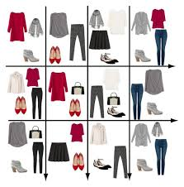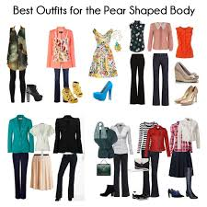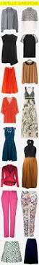

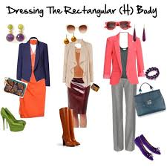

Question 2: Describe at least three ways for creating rhythm in dress designing?

Please note all the answers are taken directly, entirely copy pasted and edited from the content of the course provided, Unit 2 – Elements and principles of design.

Also please note all the images are copy pasted from various websites on the Internet.

Answer –

Rhythm is the pleasing arrangement of design elements so the eye moves easily over the apparel, rhythm results from a regular or a gradual change giving the feeling of continuity throughout the design. Rhythmic effect becomes stronger when a pattern is repeated, but repetition is not very essential always, rhythm is used most effectively with line, shape and space and also by changing the value and intensity of colour.

Rhythm can be created garments with repetition, gradation, transition, opposition or radial arrangement of various parts of design and fabric design. This is achieved in garment construction by the following combination of lines, shapes, colours, and textures.

Rhythm through Repetition - Rhythm is achieved by repetition or regular repeats of motifs of design, shapes, buttons, tucks, pleats, laces, edgings, colour, textures, fabric designs etc. It can be done with all parts having the same shaped edges; they might be squared, rounded, or scalloped. Repetition of colours can create good effect, especially if the colours are distributed in an interesting way. A rhythm created by smooth lines reminds us of gentle wave which imparts a calming effect. Lines which have sharp points and jagged when repeated gives an exciting rhythm which is more suitable for a dramatic evening wear. One should be cautious about this type of rhythm as it may disturb a garment design. Pleats, tucks, stitching folds create abrupt rhythm; trimmings like beads, buttons, laces etc. create a variety of rhythmic effects in a garment, so such trims are to be added for creating variety in a rhythmic way.

Rhythm through Progression - Rhythm is also created by progression or by gradation, gradation is a gradual increase or decrease of similar design elements. Colours can go from light to dark or textures from fine to coarse or vice versa, shapes may range from small to large, and lines may range from thin to thick. The gradual changes provide continuity while giving a feeling of movement. A systematic sequence of gradually increasing or decreasing changes in sizes of motifs buttons, trims, flowers, ruffles, intensity, fabric design also create rhythm.

Rhythm through Radiation- Rhythm by radiation creates a feeling of movement in different directions; this organized movement originates from a central point of gathers, folds, tucks, darts, pleats and lines. Direction of radiation may be in a similar or one direction, opposing direction or both the directions, several directions and all directions.

Rhythm by Continuous line Movement - This type of rhythm is obtained by flowing lines of trims, bands of colour, fabric designs etc., which make the eye move in a continuous line. This movement also unifies the garment design bringing about harmony. Rhythm is broken when lines, trimmings, or fabric designs are not matched at the seams or at other construction points, fabric designs with widely placed motifs may lack rhythm, often the garment design will interrupt this type of fabric designs and produce strange effects when worn on the body. So care needs to be exercised while using such fabric design in a dress.

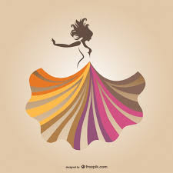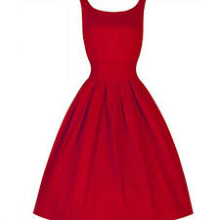

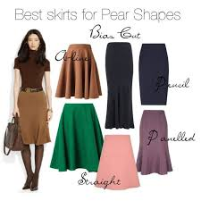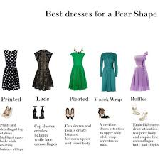

Question 3: What are the principles of design? How do they help a designer analyze the effectiveness of a design?

Please note all the answers are taken directly, entirely copy pasted and edited from the content of the course provided, Unit 2 – Elements and principles of design.

Also please note all the images are copy pasted from various websites on the Internet.

Answer –

Principles of design are guidelines for the use of the elements of design. They are used for creating, discussing and evaluating garment designs on the individual. In order to arrange the elements of design well, application of principles like balance, proportion, emphasis and harmony are essential. These are specific guides that help to create attractive garments. The principles of design are useful in creating different forms of expression in an artistic manner, which are pleasing and attractive to the eye.

Following are the principles of designing.
a. Balance
b. Emphasis
c. Harmony
d. Proportion

Balance - Balance implies pose, equilibrium, stability and security. The average human body is visually symmetrical which mean that the body seems to be same on each side of a central line. When important details or decorations are designed for a dress, they should be grouped in such a way that there seems to be equal interest or weight on each side of an imaginary center. When the design elements are in balance, a pleasing harmony is established. Balance in garments is produced by structural parts and by added decoration.

Formal Balance - It is also called symmetrical balance. It is easier to create but may not be as interesting as informal balance. This occurs when identical objects are equidistant from a center point or otherwise called as the exact mirror image of the other half. In dress design the feeling of dignity or formality is created by formal balance. The upper and lower portions of the design are arranged, as to give an effect of balance. There should not be the effect of too much of weight at the bottom or a heavy appearance. For Example, dark coloured shirt over lighter shade of pants make a short person shorter.

Informal Balance - Informal balance occurs when objects appear to equalise each other but not through repetition and the arrangement. It is in a haphazard manner. Here design of different sizes and shapes and of different attraction are arranged. The larger and more attractive designs are kept far away from the centre. If used correctly, informal designs can be effective in being attractive. A good example of informal balance may be seen when both sides of the dress are different. The large sash placed near the centre lines is balanced by the small ornament on the shoulder which is placed as far as possible from the centre line. On the other hand, a poor example of informal balance is all the weight being on one side of the dress, thereby making the dress very one-sided.

Informal balance can be used to correct the appearance of body irregularities. This is because the observers will not asses or compares one side of the body with the other. Informal balance may create illusions that will make the body appear symmetrical. This is because the right and left sides of the garment are cut and handled differently. Assembling this type of garment is more time consuming, which adds to the cost of manufacturing.

Radial Balance - Radial balance occurs when the major parts of the design radiate from a central point. Pleats, seams, gathers, darts, or motifs radiate from the focal point creating a sunburst effect. This type of balance is found frequently in necklines. Because of intricate feature involved in this type of construction, it is found only in expensive clothing

Emphasis - Emphasis is concentration of interest in one area of a design that acts as the center of attention. This creates more eye arresting area than any other part. It is the center of attention of an outfit. All areas may be interesting, but all areas should not have equal strength of interest. This implies that some areas require subordination in order to emphasize some areas. Without any such center of interest, an outfit looks unplanned and monotonous too. On the other hand, there should never be more than one main center of interest. Two or more would compete confusingly with each other. Spotty use of details-especially those of equal importance, such as pockets-is distracting. Such distractions should be removed and the dominant design feature strengthened. Care should be taken not to emphasize awkward parts of the body. Above all, the wearer should be the center of attraction. Lines leading to the face are particularly effective. Light colors around the face also help direct interest to the wearer. This is one reason why contrasting collars are common. A black dress with white collar and cuffs will direct the eye to the face and hands.
A satisfactory example of emphasis is the bow at the neckline emphasizes this part of the dress; thereby the attention is attracted to the head where the center of interest should be. By contrast, a very bad example of emphasis is the large, curved, meaningless design on the dress does not go well with a long V-shaped neck. It would be better to do away with this design entirely or at least substitute one, which should not emphasize the center portion of the dress to such an excessive extent. Instead should move interest to the wearers head. Placement of emphasis should not be placed in any area where the individual wishes to minimize. The face or personality area is more important and should be emphasized most often. This is the part of the person that is most unique and individualistic and so one should make use of this area. Emphasis at this personality area may be achieved by color and texture contrasts, necklines, jewellery, scarves, hats, hairstyles, and makeup. Care is exercised to see that only one area is emphasized as discussed earlier. Hands are emphasized by long sleeves, especially when cuffs are linked, by bracelets and rings and even by well-manicured nails. Hands that are dirty or with chewed nails can bring negative emphasis to this area. Similarly, legs and feet are made dominated by unusual hem lengths, design details at the hem, textured or colored hosiery and even elaborate footwear. Parts of the torso, such as the waist and hips become areas of interest when garments lines or ornamentation fall at these areas.

Creating Emphasis in Garments

a) Emphasis may be achieved by grouping rows of stripes, tucks, gathers, ruffles, buttons or trim in one area, or by concentration of Jewellery such as rows of beads, chains or pins.
b) Unusual lines and shapes by virtue of their individuality are eye arresting. Unusual shapes of collars, sleeves, pockets, Jewellery, outsized buttons, belts and trims can be used to create local interest. Texture and fabric designs that are unusual and different from the ordinary may attract focus of attention. Elaborate, complex or eye arresting fabric design is displayed at its best by simple garment design, so that the fabric and garment design do not compete with each other for attention.
c) The placement of decoration on a plain, contrasting background permits the decoration to be dominated. Trims, embroidery appliqué, Jewellery, buttons and belt, buckles when used on a contrasting background are emphasized and become areas of interest.
d) Contrasts of color, line, shape, and texture will create emphasis. Some related factor must be used to connect these contrasts or else it results in confusion. Using contrasts too many times often lose their impact in the design.
e) Contrasts of shape in designs are more strongly emphasized when their intensity, value or hue differs from that of the background. Yokes, collars, cuffs and shapes will be more noticeable when their edges are outlined in a contrasting trim.
f) Texture contrasts also provide a means of emphasis. Whereas the use of all textures that are shiny, dull or all heavy in the same garment produces monotony.
g) Emphasis can also be achieved by progression in ruffles, contrasting bands, buttons and other trims.

Harmony / Unity - Harmony is also called unity in design or in other terms, harmony is pleasing visual unity. It is the relationship among all parts within a whole. This is created when all parts of the design are related, in a regular and orderly manner. When a design has unity, it gives an overall impression that attracts and holds the attention of the observer and gives a feeling of belongingness to the composition. This effect is created when the elements of design are used effectively according to the design principles.

Unity in Clothing Design - Harmony between shape and form is necessary for good design. Functional aspects of harmony imply that a garment is comfortable, moves easily and breathes with body, performs any specialized duties effectively and fits well. In physical effects of harmony, garment parts are in scale; their combined proportions seem to belong with each other and the figure. Advancing qualities harmonize with receding qualities and every part bends consistently with every other part giving a total look. The term total look has been coined to describe this unity in dress. A total look is achieved when each part of the design, including garments accessories, Jewellery, hairstyle and facial ornamentation, expresses a single theme that is dependable with the personality of the wearer and with the place where it is to be worn. Shapes and spaces created by pockets, collars, cuffs, sleeves etc. will harmonize if they are soft curved or straight and angular in accordance with the major forms of garment. By using monochromatic and analogous color schemes one can achieve harmony of color in a dress. Textures, which gently move from clinging to fluid folds, introduce harmony of texture. In order to achieve harmony in any garment, the three aspects of design- function, structure and decoration must be in accordance with each other. This means that occasion, climate, size, gender, age, personal coloring, life style and personality of the wearer should be considered while designing the garments. However complete identicalness in a garment, be it color, texture, shape or space may create boredom.
To avoid this monotony a small area in contrast color or a garment part cut in contrast of texture can often add interesting element in the design.

Proportion - Proportion or Scale Proportion is simply the pleasing interrelationship of the size of all parts of the garment. Generally, unequal proportion is more interesting than equal. When we see an outfit in the mirror, on someone else, or in a pattern catalogue, our eye automatically compares the smaller part of the outfit with the larger one. This comparison is called proportion. When the parts of an outfit are divided equally, the garment seems shorter and wider. A good example of even proportions is a Chanel-style suit, with a hip-length jacket and knee-length skirt. Uneven proportions keep the eye moving and give it interesting things to look at. The height and width of all parts of a design must be compared. Individual sections of a garment, such as sleeves, pockets, and collar, must all relate in size to each other as well as to the total silhouette.

Styles with proportions of two-thirds to one-third make the person look taller and slimmer, such as a fingertip-length jacket over a short skirt or a knee-length tunic over pants. Proportions of one-third to two- thirds are also pleasing, such as an Empire-waist dress or a waist-length jacket with a long flared Skirt. Width above and/ or below an area makes that area seem smaller, For example, a flared skirt can make hips look less wide and shoulder pads with extended shoulders make the lower torso look narrower by comparison.
The spacing of trimmings, pleats, and tucks must have meaning in relation to the total design. Trimmings must not be too heavy or too light, too large or too small to harmonize with the space around them as well as with the feeling of the garment.

Proportion and Body Conformation - The human body size can be divided into three general categories- small, medium and large. The body size should be identified for using it as a guide in selecting all clothing and accessories. The small person should limit himself or herself to items that are of small or medium scale. The middle or medium sized person may select from the small, medium or large scale. The large person should be limited to the large or medium scale. Parts of apparel, such as yokes, collars, and pockets, must be the right size for the total design and for the wearer. A tiny pocket would look out of proportion on a large, heavy overcoat.
Similarly, details such as buttons and trimmings should also be related to the overall size of the garment. When a person wears clothing that is too large in fit, texture and fabric design and also selects accessories that are too large, the relationship of size becomes out of proportion as the large build individual is visualized in contrast to the small scale of the clothing and accessories. A person of medium size has more freedom to select clothing and accessories in a wider scale range. In considering the proportions of an outfit, one should therefore always use the body as the guide for clothing purpose. It is most pleasing to divide a garment or outfit at natural body division such as the chest, waist or hips than at any other area.

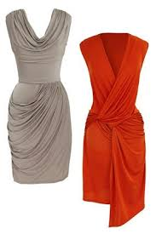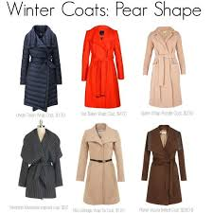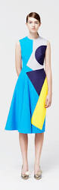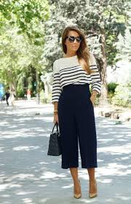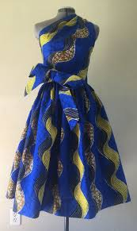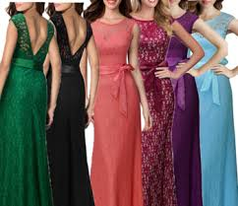

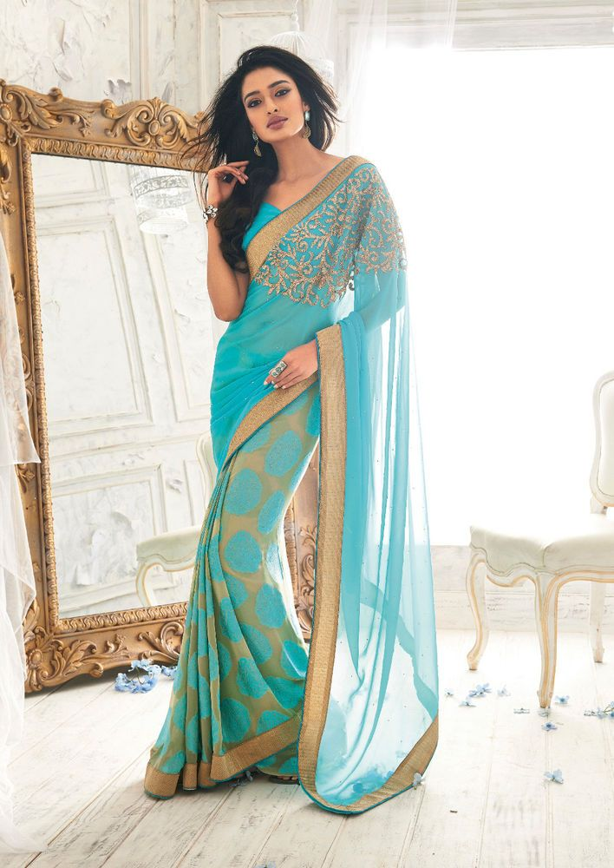

Project

Please note all the images are copy pasted from various websites on the Internet, also the design I have tried to make is directly and entirely taken from google images.

The origin of Anarkali suits dates back to the Mughal Era, an Anarkali Shalwar suit is a form of women's dress. The anarkali suit is made up of a long, frock-style top and features a slim fitted bottom. The anarkali is an extremely elegant style that is worn by women in India, Pakistan and other countries in South Asia. The anarkali suit varies in many different lengths and embroideries including floor length anarkali styles.
Anarkali suits owe their name to the fictional Anarkali, a courtesan in the court of Mughal emperor Akbar who was legendarily murdered for her illicit relationship with the Crown Prince Salim, who would later become the Emperor Jahangir.
The word Anarkali literally means the ‘delicate bud of the pomegranate flower/ tree’. This name signifies the qualities of softness, vulnerability, innocence and beauty, associated with the women who wore Anarkalis.
The majestic Anarkali suit ensemble is quite popular in India and many other South East Asian communities. It generally consists of 3 separates – a fitted till waist and then flared long kurta/ top-wear, a churidaar (fitted) bottom and a dupatta/ stole. The graceful Anarakali suit finds its roots in the Mughal and Persian cultures. The various forms of regal Anarakali silhouette are also related to the Indian culture in many ways.

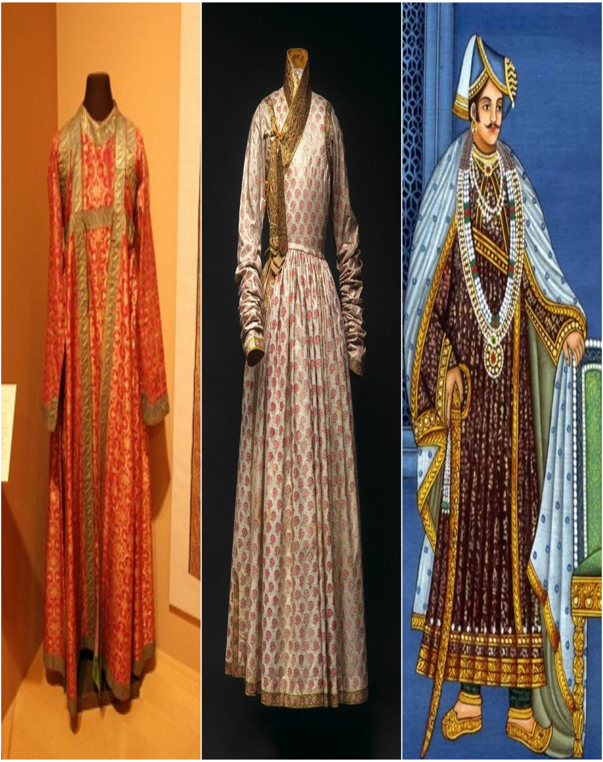

It came into fashion some years ago in India, not sure if it is in the current fashion in India as of now.

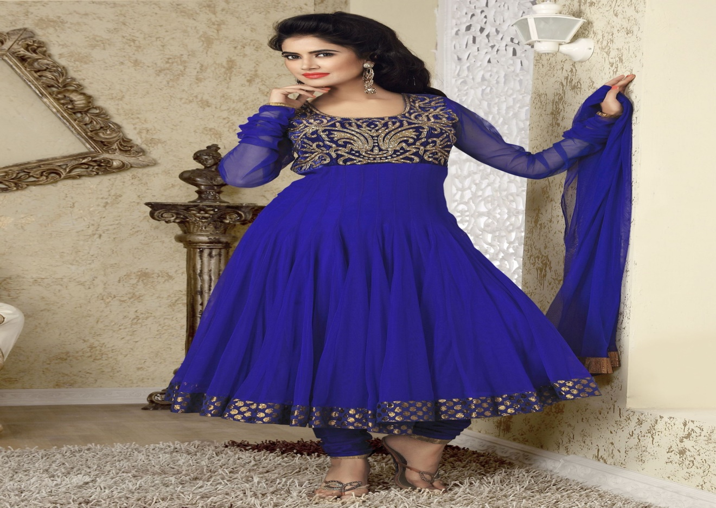

My design

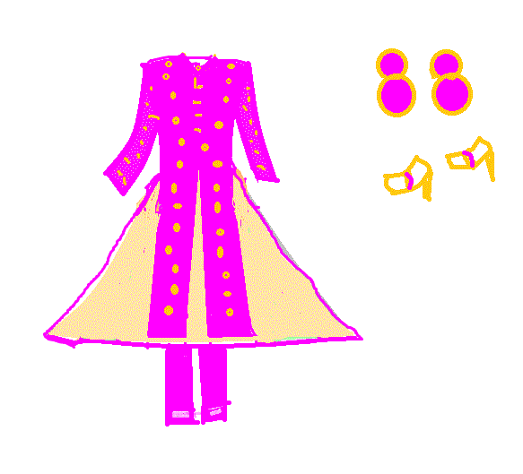

I have tried to design an Indian Anarkali suit with pink silk brocade fabric, curved lines on the sides until the waist and overall a triangle shape of frockstyle with padded shoulders, front slit gold buttons, small collars right up to the neck, three fourth sleeves and long light cream coloured diamond tissue fabric frockstyle with light cream satin lining for the frock which is a sleeveless frock with a zip fitted behind and is hidden underneath the long waistcoat, so the waistcoat covers the top of the dress, maintaining a symmetrical formal balance of the suit on both sides of the center and the emphasis is on the pink brocade long waistcoat , also by using the light cream diamond tissue fabric frock as a background with dark pink silk brocade waistcoat over it trying to maintain harmony with colors and rhythm with the lines and shape of the waistcoat and the frock, a slim fitted dark pink plain silk bottom with multiple crease fitting near the feet, circular pink and gold earrings and costume gold heel footwear.

Student Statement:

By submitting this assignment, I confirm that this is my own work.

Student Signature | Preethi | Date | 22-Sep-2017

For Tutor / Assessor Use Only
Total Marks
Marks Obtained
Percentage / Grade

