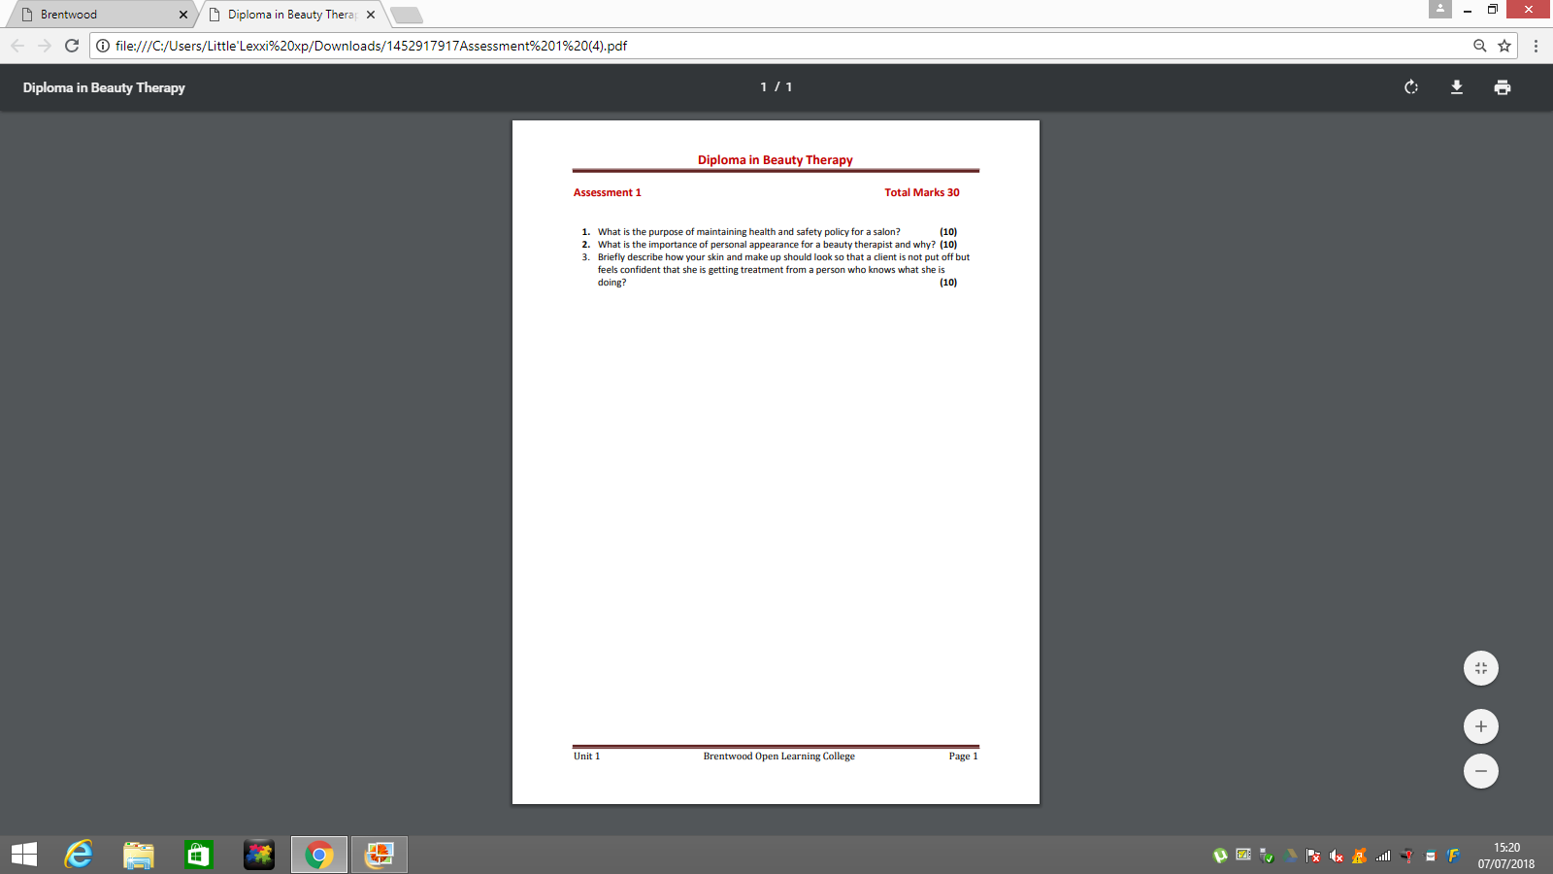
Working in a Salon
What is the purpose of maintaining health and safety policy for a salon?
The purpose of maintaining health and safety policy for a salon is so that both employers and clients can remain safe within the premises at all times. A health and safety policy ensures that the employer complies with the occupational safety, health act and relevant state legislation, it provides guidelines for establishing and implementing programs that with reduce workplace hazards such as chemicals, protect the lives of those who work at the salon and the clients who come in for treatments plus to promote employee health.
Employers are responsible for keeping the workplace safe, under the occupational safety and health act employers must inform employees of:
- safety standards
- provide training
- eliminate or reduce hazards
- supply protective equipment
Employers must perform tests in the workplace and maintain accurate records. Employees must take an active part in keeping the salon safe by complying with safety standards, rules and regulations.
What is the importance of personal appearance for a beauty therapist and why?
In an industry built upon making people look and feel good, it is very important that you maintain a presentable client facing appearance whilst taking care of the overall upkeep and aesthetics of a salon. How the salon and staff are perceived is extremely important and will correlate to how loyal your clients are and ultimately how profitable you will be as a business overall. For example if a client was to come into a salon and employees within that business didn’t have their uniform on, have good body language or have an extreme amount of makeup on that client will not be wanting to receive their treatment of that beauty therapist in particular, this could lead to the business losing business as well as a returning client.
Uniform is extremely practical within a salon workplace, a smart uniform makes you look incredibly presentable as a beauty therapist, so clients will not be afraid to present you when entering the salon or throughout, if a employee was to wear normal clothes this could also give clients the impression that you don’t care on what treatments your about to deliver on them if you’re not willing to be a part of a business and wear the exact uniform. A uniform also helps to keep you identifiable within your salon if any clients need assistance and don’t ask someone who is also another clients, this would look like the salon is not in order and is not very well organised.
Part of maintaining a positive appearance is all down to the body language that you use. When communicating with clients, be aware of what it is that you are saying by thinking before you speak, the tone of voice you are using and your non-verbal body language such as posture. These are all attributes in what defines good and bad customer service. Making regular eye contact, respecting your clients’ personal space and being aware of body language. If a client feels that they have received the right amount of personal attention, they are much more likely to want to return to the salon in comparison to a blasé and uninterested experience with their therapist.

Briefly describe how your skin and make up should look so that a client is not put off but feels confident that she is getting treatment from a person who knows what she is doing?
Wearing an extreme amount of makeup could be very off putting for clients, if a client was to walk into the salon and an employee has extreme makeup on, the client will not take interest in getting the treatment at all, will be off put and will want to leave the salon. When a beauty therapist is first seen by a client once entering the salon their face is the first thing the client will look at, the client is purposely coming into the salon for a makeup over if your makeup isn’t toned down clients are not going to want you as their beauty therapist and are not going to want you to present the treatment to them as they will think automatically you don’t know what you’re doing, if your own makeup isn’t presentable they will think you can’t do what they are about to ask you to do for them and the client will be left disappointment. This also goes for skin care if a client was to come into a salon and an employee had greasing, unkept looking skin the client isn’t going to want a treatment presented by you as they will think if you cannot look after your own skin what you about to do to theirs are. This could put not just yourself but the business under a bad reputation as clients are not going to want to return to the salon at all.

