
Assignment Cover Sheet

Student Name: | Milica Dubovina
Student Number: | 12417
Course: | International Diploma in Project Management
Assignment NO: | 7

Marking Criteria:
We expect the learners to write minimum one well expressed point in three lines against each allocated mark. This means one needs to write 15 lines with 5 well expressed points to get high grades for a 5 marks question.
For high grades use examples and illustrations where appropriate.
1.i. Main processes in Quality management: Quality Planning (planning phase), Quality Assurance (executing phase) and Quality Control (controlling phase).

1.ii. Main characteristics of Quality management:
- customers satisfaction
- prevention of the mistakes before they happen (quality is planned, not inspected)
- management responsibility for providing resources
- plan-do-check-act
- Kaizen technology – constantly making small improvements can improve overall results (reduce costs and improve performance)
- Marginal analysis – small incremental investments in improvements can bring more earning revenue in the future

1.iii. Benefits/costs analysis is determining pros and cons for every process, project, activity or product.
Benefits are determined by work done correctly, which saves time for redoing and saves additional funds that would be invested. Cost means that performing quality work would cost more money.
Both should be calculated and presented in order to better understand and apply corrective actions.

1.iv. Benchmarking is comparing current project with any other project, and based on results of comparison, apply corrective actions.

1.v. Flow chart is a diagram that shows relationships in between components.
Cause-and-effect diagrams (Ishikawa diagrams, fishbone diagrams) show relationship in between variables within the process, and how those relationships may contribute to inadequate quality.
On the image below you can see one sample of how cause-and-effect diagrams are looking.
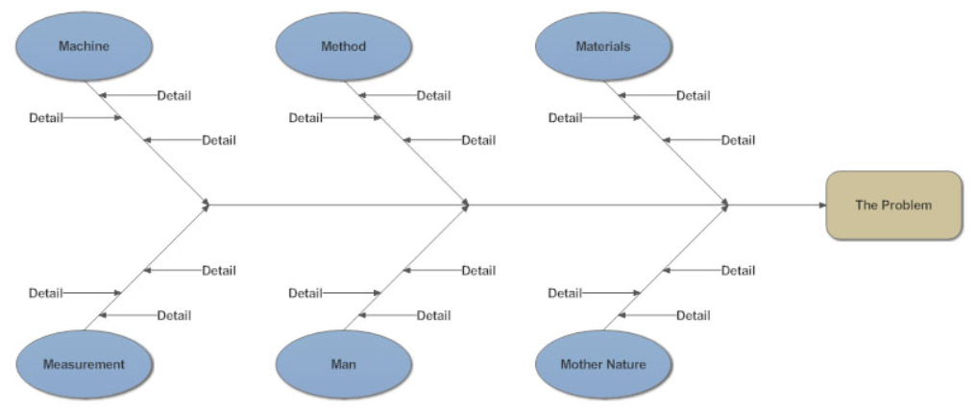

2. Quality management plan describes how quality policy is fulfilled by project team and project manager. It addresses quality assurance (described below), quality control (monitoring of work results, analyzing to find a cause of poor performance) and quality improvements (corrective actions applied to improve quality of product or project).
Quality assurance is focused on finding defects and fixing the problems and issues, and it represent sum of planning’s and implementing those plans by PM and other team members with a goal of reaching certain level of quality. Quality assurance happens during the entire project. In order to complete Quality assurance activities, we should use 3 inputs:
- Quality management plan (plan how Project team will meet Quality policy)
- Results of quality control measurement (quantified results from quality control test)
- Operational definitions (the metrics that define the project processes, their attributes, and units of measure are necessary for QA)
In order to implement quality plan, we can use same tools as in Project planning (Flowcharts, Design of experiments, Cost of quality, Benefit-cost analysis, Benchmarking or others)

Student Statement:

By submitting this assignment, I confirm that this is my own work.

Student Signature | Dubovina Milica | Date | 28.11.

For Tutor / Assessor Use Only
Total Marks
Marks Obtained
Percentage / Grade

