
a
Assignment Cover Sheet

Student Name: | Alica Schmidtova
Student Number: | 11878
Course: | Hospitality management level1
Assignment NO: | 3

Marking Criteria:
We expect the learners to write minimum one well expressed point in three lines against each allocated mark. This means one needs to write 15 lines with 5 well expressed points to get high grades for a 5 marks question.
For high grades use examples and illustrations where appropriate.
Please insert your completed assignment ( in word format) here:

1.Outline the main duties and responsibilities of House-keeping Manager
1.1.Analyse
Housekeeping activities are linked with maintenance of hotel establishment, the main duties of housekeeping department is to cleanliness of the hotel, including back-of-the-house and front-of-the-house hotel areas.
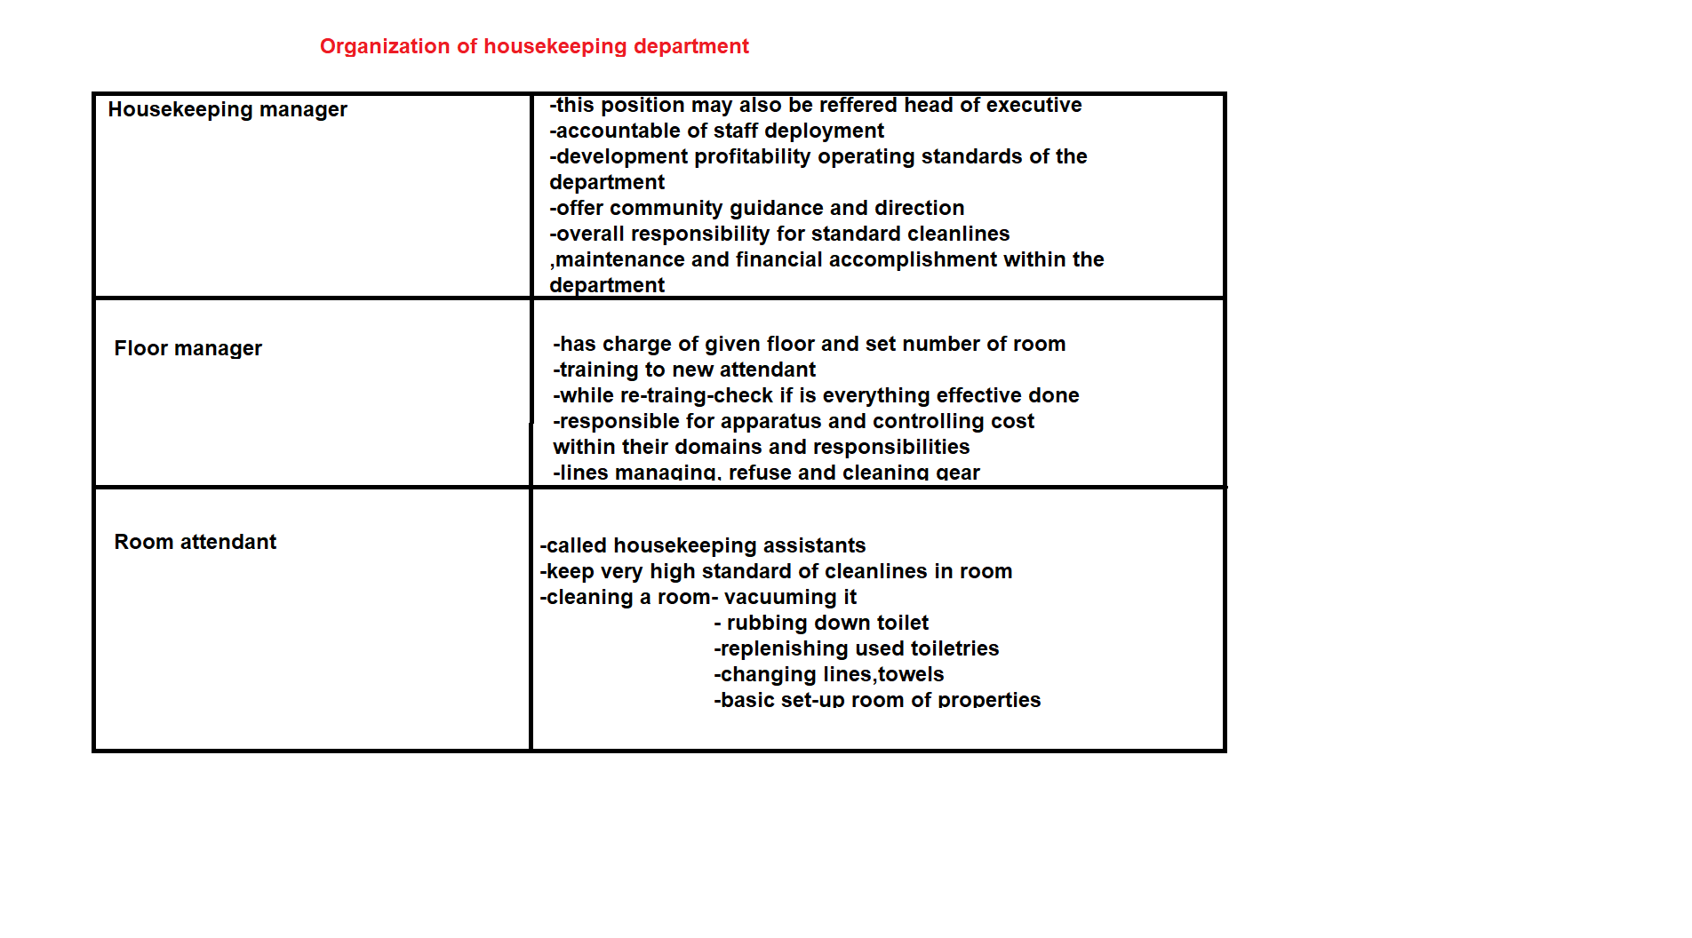
Function of housekeeping department
- Lost and found department-something lost or find in hotel
- First aids-first aids kit
- Floral arrangement-arrange flower or etc.
- Laundry service-what everything need wash- pillow case, duvet case, towels, kitchen towels, uniforms, clothes
- Purchasing-1. Bedroom supplies-laundry bags ,breakfast ,cards ,shoeshine,
2. Bathroom supplies- toiletries
3. Lines-bed sheet, toweling
4. Tea and coffee making facilities-tea, coffee, sugar, biscuit
5. Cleaning supplies- air freshener , bleach
6. Working replacement- glassware, curtains, vacuum
7. Uniform
8. Executive housekeeper- the supplies this consumption are monitored -consumable-b. s, cleaning supplies, tcmf
-assests-uniforms, lines
,,Efficiently managed housekeeping department ensure the cleanliness maintenance and aesthetic appeal of lodging properties the housekeeping department not only prepared clean guest rooms on a time basic for arriving guest , it also cleans and main everything in the hotel. Kappa, Nitchke and Schappert.
1.2 Define
Arrangement-
noun
1.
the act of arranging or being arranged
2.
the form in which things are arranged: he altered the arrangement of furniture in the room
3.
a thing composed of various ordered parts; the result of arranging: a flower arrangement
4.
(often pl) a preparatory measure taken or plan made; preparation
5.
an agreement or settlement; understanding
6.
an adaptation of a piece of music for performance in a different way, esp on different instruments from those for which it was originally composed
7.
an adaptation (of a play, etc) for broadcasting
Collins English Dictionary - Complete & Unabridged 2012 Digital Edition
© William Collins Sons & Co. Ltd. 1979, 1986 © HarperCollins
Publishers 1998, 2000, 2003, 2005, 2006, 2007, 2009, 201
Word Origin and History for arrangement Expand
n.
1727, from French arrangement, from arranger "arrange" (see arrange ).

Supplies-
verb (used with object), supplied, supplying.
1.
to furnish or provide (a person, establishment, place, etc.) with what is lacking or requisite:
to supply someone clothing; to supply a community with electricity.
2.
to furnish or provide (something wanting or requisite):
to supply electricity to a community.
3.
to make up, compensate for, or satisfy (a deficiency, loss, need, etc.):
The TVA supplied the need for cheap electricity.
to fill or occupy as a substitute, as a vacancy, a pulpit, etc.:
During the summer local clergymen will supply the pulpit.
verb (used without object), supplied, supplying.
5.
to fill the place of another, especially the pulpit of a church, temporarily or as a substitute:
Who will supply until the new minister arrives?
noun, plural supplies.
6.
the act of supplying, furnishing, providing, satisfying, etc.:
to begin the supply of household help.
7.
something that is supplied:
The storm cut off our water supply.
8.
a quantity of something on hand or available, as for use; a stock or store:
Did you see our new supply of shirts?
9.
Usually, supplies. a provision, stock, or store of food or other things necessary for maintenance:
to lay in supplies for the winter.
10.
Economics. the quantity of a commodity that is in the market and available for purchase or that is available for purchase at a particular price.
11.
supplies, Military.
- all items necessary for the equipment, maintenance, and operation of a military command, including food, clothing, arms, ammunition, fuel, materials, and machinery.
- procurement, distribution, maintenance, and salvage of supplies.
12.
a person who fills a vacancy or takes the place of another, especially temporarily.
13.
supplies, Obsolete.
14.
Obsolete.
Origin of supply¹ Expand
Middle English
Middle French
Latin
1325-75; (v.) Middle English sup(p)lien < Middle French souplier, variant of soupleer ≪ Latin supplēre to fill up, equivalent to sup- sup- + plēre to fill (see full¹); (noun) late Middle English: aid, succor, derivative of the v.
Related forms Expand
supplier, noun
unsupplied, adjective
well-supplied, adjective

Replacement-
noun
1.
the act or process of replacing
2.
a person or thing that replaces another
3.
(geology) the growth of a mineral within another of different chemical composition by gradual simultaneous deposition and removal
4.
a process of fossilization by gradual substitution of mineral matter for the original organic matter Also called petrification
Collins English Dictionary - Complete & Unabridged 2012 Digital Edition
© William Collins Sons & Co. Ltd. 1979, 1986 © HarperCollins
Publishers 1998, 2000, 2003, 2005, 2006, 2007, 2009, 2012
Cite This Source
Word Origin and History for replacement Expand
n.
"act or fact of being replaced," 1790, from replace (v.) + -ment. Meaning "something that replaces another" is attested from 1894.

Department-noun
1.
a distinct part of anything arranged in divisions; a division of acomplex whole or organized system.
2.
one of the principal branches of a governmental organization:
the sanitation department.
3.
(initial capital letter) one of the principal divisions of the U.S. federalgovernment, headed by a secretary who is a member of thepresident's cabinet.
4.
a division of a business enterprise dealing with a particular area ofactivity:
the personnel department.
5.
a section of a retail store selling a particular class or kind of goods:
the sportswear department.
6.
one of the sections of a school or college dealing with a particularfield of knowledge:
the English department.
7.
one of the large districts into which certain countries, as France, aredivided for administrative purposes.
Origin of department Expand
French
1730-1735
department
/dɪˈpɑːtmənt/
noun
1.
a specialized division of a large concern, such as a business, store, oruniversity: the geography department
2.
a major subdivision or branch of the administration of a government
3.
a branch or subdivision of learning: physics is a department of science
4.
a territorial and administrative division in several countries, such asFrance
5.
(informal) a specialized sphere of knowledge, skill, or activity: wine-making is my wife's department
Derived Forms
departmental (ˌdiːpɑːtˈmɛntə l) adjective
departmentally, adverb
Word Origin
C18: from French département, from départir to divide; see depart
Collins English Dictionary - Complete & Unabridged 2012 Digital Edition
© William Collins Sons & Co. Ltd. 1979, 1986 © HarperCollins
Publishers 1998, 2000, 2003, 2005, 2006, 2007, 2009, 2012
Cite This Source
Word Origin and History for department
n.
mid-15c., "a going away, act of leaving," from Old French departement(12c.) "division, sharing out; divorce, parting," from Late Latin departire(see depart ). French department meant "group of people" (as well as"departure"), from which English borrowed the sense of "separate division, separate business assigned to someone in a larger organization" (c.1735).Meaning "separate division of a government" is from 1769. As anadministrative district in France, from 1792.

Consumable-

[kuh n-soo-muh-buh l]
- Word Origin
1.
able or meant to be consumed, as by eating, drinking, or using:
consumable goods.
2.
liable to be used up or depleted:
comsumable resources.
noun
3.
Usually, consumables. something that is produced to be consumed, as processed food or fuel.
Origin of consumable Expand
1635-1645
First recorded in 1635-45; consume + -able
1.3 Describe and drawing
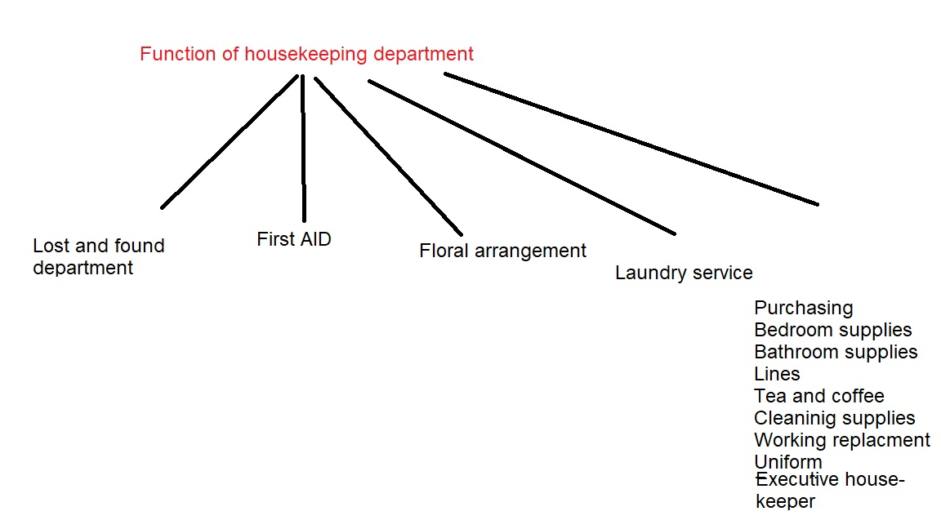

1.4. Citation

http://www.dictionary.com/browse/arrangement?s=t
http://www.dictionary.com/browse/supplies?s=t
http://www.dictionary.com/browse/replacement?s=t
http://www.dictionary.com/browse/department?s=t
http://www.dictionary.com/browse/consumable?s=t
1.5 State of responsibilities Housekeeping Manager
1. Housekeeping Manager-
Floor Manager- responsibilities
Room attendant-
2.Function of housekeeping department…

2.How does House-keeping department manage the amenities?
Manage of hotel amenities is very important for housekeepers and main work for Housekeeper Manager, show how does amenities manage in :

A)600 Room Deluxe Class
Hotel, City Centre location,
Mainly Business Bookings :
Entrance “Do Not Disturb” card
Desk Top Telephone directory
Fire escape plan
Typhoon safety regulations
IDD booklet
Guidebook
Breakfast menu
Sewing kit
Ball pen
Food and beverage information
Desk-top Folder Letter paper/envelopes
Telex/Fax forms
Thank you and postcards
Cable Television guide
Blotting paper
Limousine service
Health spa information
Closet Laundry bags and list
Dry cleaning bag and list
Leather shoehorn
Leather clothes brush
Shoe shine kit
Shoehorn
Hangers Laundry bags and list
Shopping bag
Wooden hangers
Mini Bar Services Glasses and ice bucket
Bottle opener
Water (mineral/distilled)
Coasters
Mini bar on request Ice bucket
Sitting Area Television set
Remote control
Magazines/Newspapers
Flowers
Bedside Table Int’l direct a dialling telephone
Control panel/switches
Radio channels
Bathroom Bath towels – 2
Hand towels – 2
Face towels – 2
Tissue box and tissues
Tumblers with coaster
Soap dish with soap
Foam bath and shampoo
Rubbish bin
Sanitary bag
Shoe shine mitt
Shaving socket
Bathrobes
Slippers
Glass jar and cotton buds
Bath salts
Bottle opener
Vase (bud)
Emery board
Mild clothes detergent
Shower cap
Hair dryer
Upon Request Swimming goggles
Adaptors/Transformers
Heaters
Iron (with board)
Baby supplies/crib
Extension cord
Clothes rack
Luggage rack
Comb
Disposable razor
Shaving cream
B)800 Room Medium Class
Hotel, Bub-Urban location,
Mainly Group Bookings:
Entrance- “Do Not Disturb” card
Breakfast menu
Fire escape plan
Desk Top- Guest directory
Guidebook
Tent card promotion
Ashtray
Match box
Folder with standard stationeries
Closet- Laundry bags and list
Shopping bag
Wooden hangers
Mini Bar Services-Ice bucket
Opener
Glasses with coaster
Red wine glasses – 2
on request Champagne glasses – 2
304 glasses – 2
306 glasses – 2
Tumbler – 1
Napkins – 2
Stirrers – 2
Drink voucher
Rattan basket with liquor
Bedside Table-Int’l direct dialling telephone
Control panel/switches
Radio channels

Sitting Area -Television set
Remote control
Magazines/Newspapers
Flowers
Bathroom- Bath towels – 2
Hand towels – 2
Face towels – 2
Tissue box and tissues
Tumblers with coaster
Soap dish with soap
Foam bath and shampoo
Rubbish bin
Sanitary bag
Shoe shine mitt
Shaving socket
Plant
Upon Request- Adaptors
Heaters
Iron (with board)
Baby supplies/crib

Housekeeper and housekeeping manager use a very simple and systematic method of delivering standardized service is to make use of a checklist.
Room Status Codes
Sleep-out- SO The guest is supposed to be staying in the room
but the bed has no signs of being used

Check-out- CO The guest has paid the bill and checked out his/

Expected Departure- ED It is the same as ‘due-out’ which means the guest
would depart prior to the check-out time of the
following day

Inspected Clean-IC The room is double checked by the floor
supervisor after the cleaning of room

Did Not Check-DNCO The guest has paid or made payment arrangement but has not completed the check-
out processes or informed the front desk while Out
Late Check-out LC/O The guest has requested and is approved to check
out later than the standard check-out time

Skipper / The guest has not paid and left without informing
the front desk

Complimentary/ The room is occupied for free

Stay-over/ The guest is not checking out today and will
remain at least one more night

Lock-out/ The occupied room has been locked which
disallows the guest to re-enter until he/she
comes into contact with hotel staff to clarify
his/her status
2.4. Define
Complimentary

[kom-pluh-men-tuh-ree, -tree]
adjective
1.
of the nature of, conveying, or expressing a compliment, often one that is politely flattering:
a complimentary remark.
2.
given free as a gift or courtesy:
a complimentary ticket.
noun, plural complimentaries .
3.
something given or supplied without charge, as lodging, transportation, or meals, especially as an inducement to prospective customers.
Origin of complimentary
1620-1630
First recorded in 1620-30; compliment + -ary
Related forms
complimentarily, adverb
complimentariness, noun
intercomplimentary, adjective
quasi-complimentary, adjective
uncomplimentary, adjective
Synonyms
1. commendatory, praising, laudatory.
complimentary
/ˌkɒmplɪˈmɛntərɪ; -trɪ/
adjective
1.
conveying, containing, or resembling a compliment
2.
expressing praise; flattering
3.
given free, esp as a courtesy or for publicity purposes
Derived Forms
complimentarily, adverb
Collins English Dictionary - Complete & Unabridged 2012 Digital Edition
© William Collins Sons & Co. Ltd. 1979, 1986 © HarperCollins
Publishers 1998, 2000, 2003, 2005, 2006, 2007, 2009, 2012
Cite This Source
Word Origin and History for complimentary
Expand
adj.
1620s, "conveying a compliment," from compliment (n.) + -ary. In later use loosely meaning "free of charge."

Skipper- noun
1.
the master or captain of a vessel, especially of a small trading or fishing vessel.
2.
a captain or leader, as of a team.
verb (used with object)
3.
to act as skipper of.

2.3. Describe and drawing

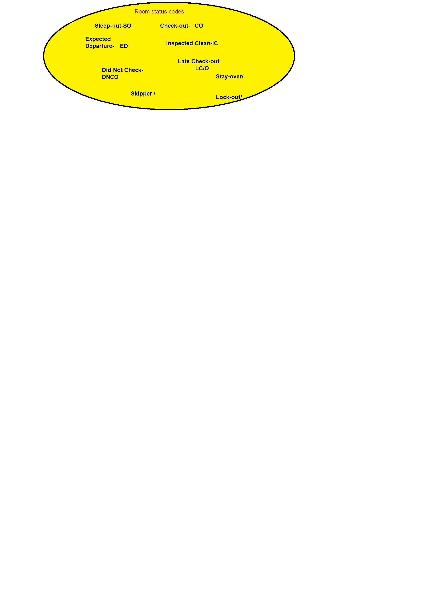2.4. Illustrate
BATHROOM
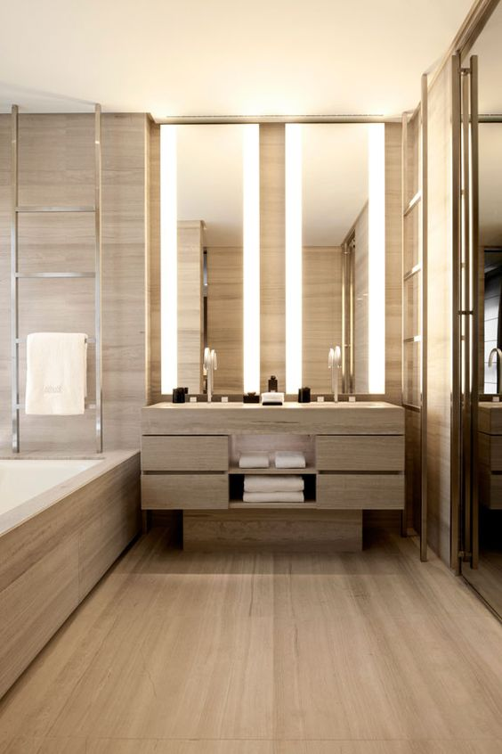
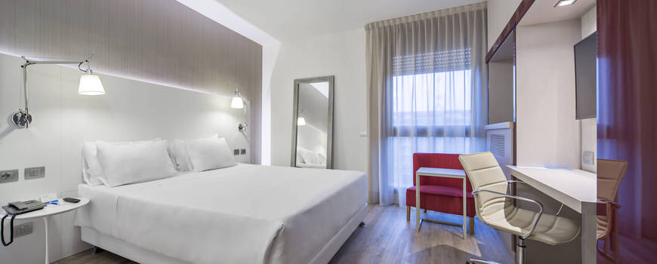
BEDROOM

2.5. Citation
http://www.dictionary.com/browse/complimentary?s=t
http://www.dictionary.com/browse/skipper?s=t
2.6. States of House-keeping department manage the amenities
1A)600 Room Deluxe Class
Hotel, City Centre location,
Mainly Business Bookings : Entrance, Desk top, Desk top folder, Closet, Minibar services, Bedside table, Sitting area, Bathroom, Upon request

B)800 Room Medium Class
Hotel, Bub-Urban location,
Mainly Group Bookings: Entrance, Desk top, Closet, Minibar services, Bedside table, Sitting area, Bathroom, Upon request

2.Room status codes

3. What is the importance of hygiene for restaurant
3.1.Analyse of the importance of hygiene for restaurant

The hospitality industry has two separate segments of accommodation and Food and Beverages (F&B) ,describe:

1) COMMERCIAL (Public & Private ownership)

2) GENERAL MARKET
a) Restaurants and snack
b) Food and take-away

3) SUBSIDISED OR WELFARE
(Public or private ownership)
(Catering main or secondary activity)
A) Institutional catering
a) Schools
b) Universities and colleges
c) Hospitals

B) Restricting market
a) Transport Catering
b) Clubs
c) Some Institutional and Hotels
C) Fast-Fig: 3.3 - The Main Sectors of the Hospitality Industry. (Source: Davis and Stone, 1991)
Food and beverage operations designed to meet the demand of the consumers. People eating out reasons for eating out are:
• to celebrate a special occasion or treat,
• meeting friends,
• just for a change from home, and
• at times a necessity, e.g., eating out while travelling.

Fig: 3.4-The Catering Cycle (Source: Cracknell et al., 1983)
Catering cycle is not only operations but it is also a dynamic model in any one problem in one section will be difficulties for other elements of the cycle. For example, problem in the purchase section will also affect production and service, while improper utilisation of raw materials during production would also affect control system and so on an ideal food and drink service would be one which:
• provides food and drink on demand;
• has optimum utilisation of labour and skill, raw materials and equipments ;
• has quick and simple methods of operational design; and
• has flexible system design allowing ease of adaptation.

Fig: 3.5
The raw materials, processing involving the cooking and preparation of food and output is to serve the prepared food to the guests. The process of the food production traditionally followed is depicted in Figure 3.6.

Fig: 3.6 - Flow diagram of traditional foodservice delivery systems.
(Source: Adapted from Alan Huelin and Peter Jones, Food Service Systems: Generic Types,
Alternative Technology and Infinite Variation, Journal Of Foodservice Systems, 5(4), p. 303, 1990)
Fig 3.6 shows the eight distinct stages of the traditional food service delivery system. These stages are:
1. Storage – refrigerated or ambient storage of material
2. Preparation – activities such as peeling, cutting and so forth
3. Production (cooking) – methods such as frying, roasting and so forth
4. Holding – storage between production and consumption
5. Service – style of delivering dishes/meals to consumers
6. Dining – consumption of meal by consumer in setting
7. Clearing – removal of equipment/food debris
8. Dish wash – cleansing of soiled equipment
3.2 Define
Occasion
[uh-key-zhuh n]
noun
1.
a particular time, especially as marked by certain circumstances or occurrences:
They met on three occasions.
2.
a special or important time, event, ceremony, celebration, etc.:
His birthday will be quite an occasion.
3.
a convenient or favorable time, opportunity, or juncture:
This slack period would be a good occasion to take inventory.
4.
the immediate or incidental cause or reason for some action or result:
What is the occasion for this uproar?
5.
(in the philosophy of Alfred North Whitehead) the coincidence of the eternal objects forming a specific point-event.
6.
occasions, Obsolete.
needs or necessities.
necessary business matters:
to go about one's lawful occasions.
verb (used with object)
7.
to give occasion or cause for; bring about.
Idioms
8.
on occasion, now and then; from time to time; occasionally:
She visits New York on occasion.
Improper-
[im-prop-er]
adjective
1.
not proper; not strictly belonging, applicable, correct, etc.; erroneous:
He drew improper conclusions from the scant evidence.
2.
not in accordance with propriety of behavior, manners, etc.:
improper conduct at a funeral.
3.
unsuitable or inappropriate, as for the purpose or occasion:
improper attire for a formal dance.
4.
abnormal or irregular:
improper functioning of the speech mechanism.

Utilisation-
n.
chiefly British English spelling of utilization (q.v.). For spelling, see -ize.

Historical Examples
Its utilisation for other practical purposes was then suggested.

Inventions in the Century
William Henry Doolittle
It is to be presumed that elephants are preserved with a view to their utilisation.

Natural History of the Mammalia of India and Ceylon
Robert A. Sterndale
Hardness and toughness are actual drawbacks in the utilisation of rubber which is required for vulcanising.

The Preparation of Plantation Rubber
Sidney Morgan
Mr Hickey proposed the utilisation of the ammoniacal products resulting from his process.

Cooley's Practical Receipts, Volume II
Arnold Cooley
An interesting new industry for utilisation of old tins (waste) has arisen in connection with Central Hall, Manchester.

Glimpses into the Abyss
Mary Higgs
The utilisation of these aeroplanes obviates the necessity to throw out ballast to rise, or to let out gas for a descent.

The Romance of Modern Invention
Archibald Williams
With me it had always been more the adventure than the story; my writing was a by-product, a utilisation of what life offered me.

The Mystery
Stewart Edward White and Samuel Hopkins Adams
I realise that the particular solution of the Irish Question which is about to be unfolded is the utilisation of our bogs.

Ireland In The New Century
Horace Plunkett
A much more difficult problem is sure to arise, sooner or later, in connection with the utilisation of efficients.

Cambridge Essays on Education
Various
Apart from navigation on rivers, the question of the utilisation of the flow of rivers is of importance.

International Law. A Treatise. Volume I (of 2)
Lassa Francis Oppenheim
Ambient-
[am-bee-uh nt]
adjective
1.
of the surrounding area or environment:
The tape recorder picked up too many ambient noises. The temperature in the display case was 20° lower than the ambient temperature.
2.
completely surrounding; encompassing:
the ambient air.
3.
creating a certain reaction or mood, often a subconscious one, by being wherever people tend to be:
ambient advertising on a shopping cart.
4.
pertaining to or noting sounds that create a peaceful and relaxed atmosphere.
5.
pertaining to or noting close and constant social contact and communication fostered by the Internet or the use of digital devices:
social media sites that enable ambient intimacy and awareness.
noun
6.
ambient music (def 1).

3.3 Drawing
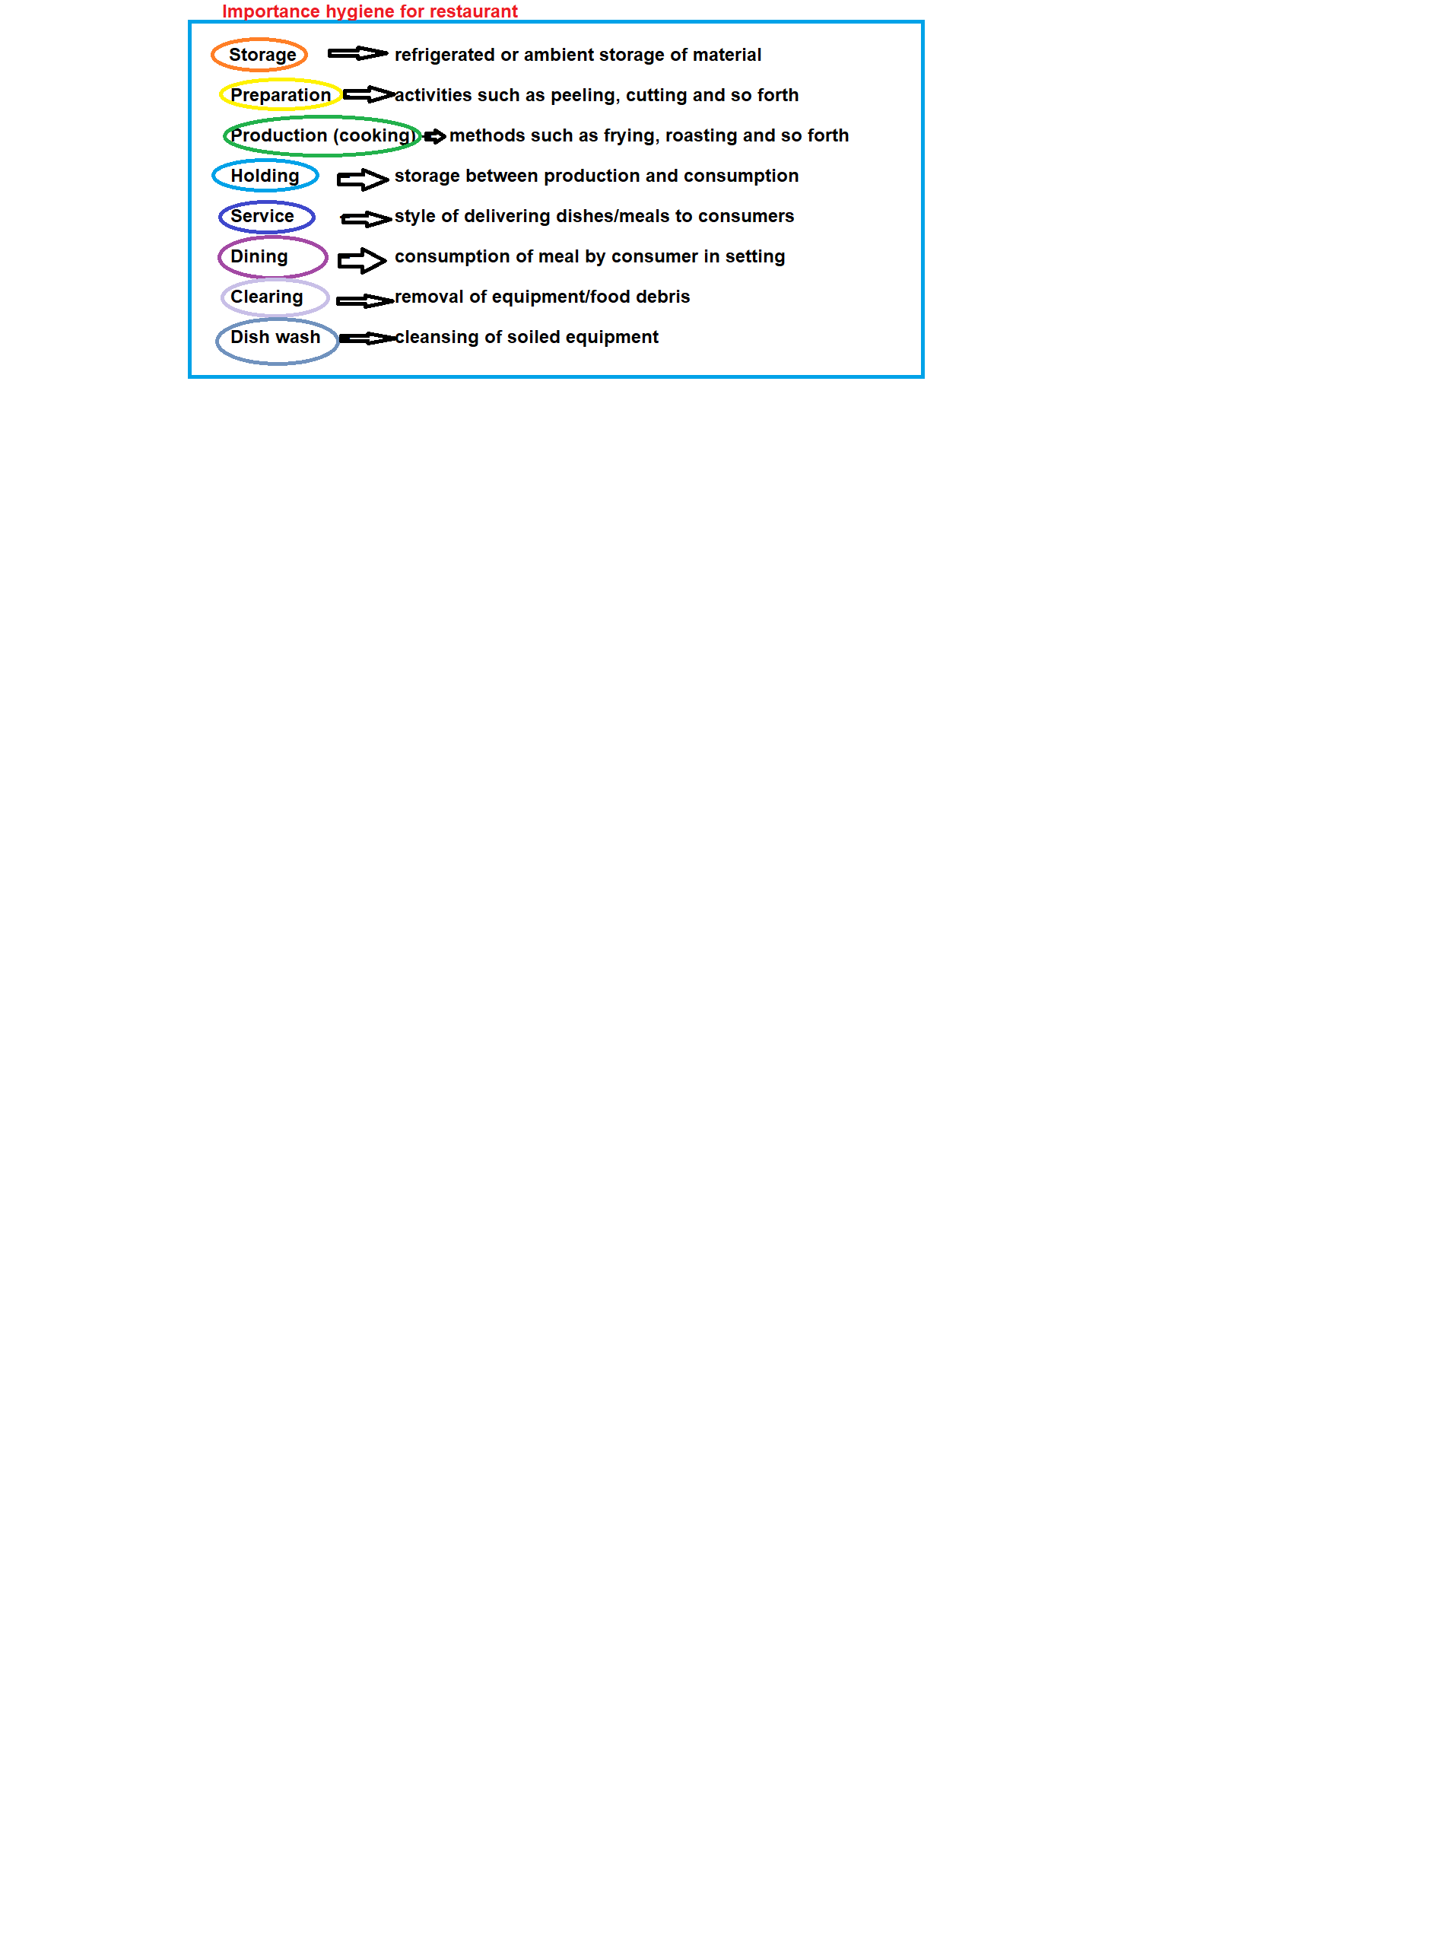

3.4. Citation
http://www.dictionary.com/browse/occasion?s=t
http://www.dictionary.com/browse/improper?s=t
http://www.dictionary.com/browse/utilisation?s=t
http://www.dictionary.com/browse/ambient?s=t
3.5. State
1. Describe food and beverage segment
2. fig. 3.3.-3.6.

4.What is various aspects of the managing food service operations

Various modern food service outlets do not always follow the traditional system in it’s true form, for example, a la carte restaurant in a five star hotel would use fresh ingredients and stage 4, wherein prepared foods are kept on hold is not necessary. Same is the case when in speciality restaurant the different courses are prepared right in front of the guest.
The designing of the sitting area of restaurant depends on the type of restaurant,for example, if the restaurant is only for breakfast buffet, then the sitting arrangements needs to be centred around or near the buffet table for easy access by the customers. While designing the guest sitting area needs the correct furnishing and furniture. The guest sitting area should provide some form of privacy to each guest table and at the same time have optimum utilisation of space.
The kitchen can be distinguished as:
a. Storage: where the raw materials are stored. This would mean both dry storage and refrigerated storage area. Storage area is also dependent on the type of restaurant. For example, a speciality restaurant may require some special storage facilities for the ingredients.
b. Pre-preparation Area: Kitchen usually has a specified area for cleaning, peeling, chopping,mixing and combining ingredients.
c. Production Areas: The production areas or food preparation area is best situated. The production area has hot food and cold food area wherein main courses, soups and salads and other refrigerated food is prepared, respectively.
d. Bakery: If the manager decides on providing baked food, a separate bakery is useful.
e. Holding and Service: An area for holding the food prior to service is very essential.
f. Ware Washing: The washing area is usually near to the dining area but also close to the main production area.
g. Pot and Pan Area: A pot and pan area would enable the storing of the utensils when they are not in use. The restaurant design must have an Office Area and Employees Area. The office area would be used to keep the record of various transactions both with the suppliers and the consumers.
The employees need an area to change into work clothes and also an area to rest during breaks. It’s the manager’s duty to check the viability of a restaurant’s final design and work out the viability of the plan.
Equipments
The general points to be considered when purchasing equipment for a food and beverage service area are:
• Flexibility of use;
• Type of service being offered;
• Type of customer;
• Design;
• Colour;
• Durability;
• Ease of maintenance;
• Stakability;
• Costs and funds available;
• Availability in the future – replacements;
• Storage;
• Rate of breakage, e.g., for China;
• Shape;
• Psychological effect on guests; and • Delivery time.
(

Fig: 3.7 Factors affecting food habits, acceptance and preferences
following factors:
• Age, sex, physiological and psychological influence affect of the food a consumer chooses,
• Factors like appetite, personality, mood and emotions and also the influence of other people, • Advertising and environmental situations prevalent even before the guest enters the restaurant,
• Economic conditions and social or prestige issue of the guest,
• The appearance, texture, quality, odour and flavour of the prepared food, and
• Finally, religious and cultural constraints as many people don’t try some food due to their set views.
Menu planning is extremely important since it involves selection of food and beverages acceptable to both to the consumers and to the management and following aspects:
• The type of food service outlet and the budget available with the organisation for the outlet;
• The consumer food habits;
• The availability of the raw materials is also important. Many food items are seasonal and procuring of exotic ingredients can prove to be difficult. The viability of the menu depends on the available ingredients; and
• The physical facilities and equipments also dictate menu planning. Both the type and number of equipments available play an important role in the selection of menu items.
Once the factors affecting menu planning are understood, menu is decided upon. Essentially menus can be of three types:
a. Static or fixed menu where the same menu items are offered repeatedly.
b. Cycle menu refers to menus, offering different items for a pre-determined time period.
c. Finally, Single Use Menus which are planned only for special days or occasions and are not repeated.
Various aspects of managing food service operations involves:
a) Food Purchasing:
According to John Stefanelli the food service purchasing involves:
• developing specifications;
• preparing an approved suppliers list;
• determining the appropriate order size; and
• establishing appropriate receiving and storage procedures.
b) Managing Food Production Systems:
Menu classification starts the food production system Table 3.3 describes the three different types of menus :
No Choice
Limited Choice
Choice Fixed (static)
Quick-service restaurant
Full service restaurant
Cafeteria
Cycle Airline
Nursing home
School food-service
Single-use
Banquet
Catered luncheon
Buffet
Table 3.3: Menu classification
Although menu forms the core of food service industry, the ingredients form the magic part of the food produced. Herein, comes the usefulness of recipe standardisations. The most important available to control costs and ensure product consistency and quality.
Table 3.4 is a format used for standardization of recipe:
Date
Meal
Unit
Item/Recipe
Quantity Needed
Actual Produced
Time
Leftover
Comments

Additional instructions
Table 3.4 : Sample production schedule format
As a manager, you shall ensure that standardisation of a recipe is achieved so as to control quantity and quality along with the costs involved in running an eating joint.
c) Food Service Hygiene:
Hygiene is very important for any eating joint. Here the employees are in constant contact with food and preparation equipment. Major of contamination of food from human contact from elements like skin, fingernails, hair, jewellery, mouth, nose and respiratory tract and eyes. Employees, therefore, should be trained to ensure that they maintain personal hygiene.
The cleaning area should be clean so as to ensure food service hygiene. The sink and work surfaces should be cleaned before and after every use. The equipments should be sanitised and sterilised after every cleaning. These sterilized equipments need to be protection from splash, dust and contact with food and various sanitation methods like thermal and chemical sanitation methods should be used.

Beverages
Beverages or drinks can be alcoholic or non-alcoholic, Non-alcoholic beverages include tea, coffee, juices, shakes, aerated drinks and of course mineral water. Alcohol beverage need:
• special permit or licence is required to serve alcohol at the premises,
• usually specific hours are maintained, and
• age of the consumer needs to be checked so as to ensure the legal age of buying an alcoholic drink.
Types of Wine and Drinks List
The wine and drink contents of a list may include (Source: Food and Beverage Management by Cousins, Foskett and Shortt):
• non-alcoholic drinks including natural spring and mineral waters, aerated waters, squashes, juices and syrups.
• cocktails including non-alcoholic cocktails,
• bitters as aperitifs and for mixed drinks and cocktails,
• wines including still wine, sparkling wines, alcohol-free, de-alcoholised and low-alcohol wines, fortified wines and aromatised wines,
• spirits,
• liqueurs,
• beers including draught and packaged beers and reduced alcohol beers, and cider & perry.

The order of wines and drinks on a list under types of wine or drink.
• Cocktails,
• Aperitifs,
• Cups,
• Wines,
• Liqueurs, and
• Beers, minerals and squashes.
After-Meal Drinks List
• often combined with the wine list
• The list should offer a range of liqueurs together with possibly a specialist range of brandies and/or a specialist range of malt whiskies. Vintage and LBV port may also be offered here, and
• A range of speciality liqueur/spirit coffees might also be included.
Banqueting Wine Lists
• The length is generally according to size and style of operation,
• In most instances there is a selection of popular wine names/styles on offer,
• There would be a range of prices from house wines to some fine wines to suit all customer preferences, and
• In some instances the banqueting wine will draw wines from the restaurant wine list.
Room Service Drinks List
• There may be a mini-bar or choice from a standard bar list, and • They usually offer a limited range of wines.
Purchasing and Pricing
Purchasing the right amount of stock is the main objective of a beverage manager. A formula which can also be useful is:
M = W (T + L) + S
(Source: Food and Beverage Management by Cousins, Foskett and Shortt)
Where
M is the maximum stock,
W is the average usage rate,
T is the review period,
L is the lead time,
S is the safety stock (buffer or minimum).
An example of using this formula could be
W = 24 bottles per week
T = 4 weeks
L = 1 week
S = 1 week’s usage, i.e., 24 bottles.
Therefore,
M = 24 (4 + 1) + 24 = 144 bottles
ROL (Reorder Level) may also be calculated as:
(W × L) + S = (24 × 1) + 24 = 48 bottles
The Pricing is based on three basic methods:
1) Cost Plus Pricing: The selling price is determined by the addition of specific percentage, of the cost price, to the cost of the drink (Gross profit = sales less the cost of sales).
2) Rate of Return: The total costs of the business are determined for a given business level and from this the percentage of the cost price required to be added to the cost is determined in order to ensure that business will be viable.
3) Market Oriented: Selling price is determined by considering both what the customer is likely to pay as well as what others in similar operations, locally, are charging.
4.2. Define and describe of
Durability-
[doo r-uh-buh l, dyoo r-]
adjective
1.
able to resist wear, decay, etc., well; lasting; enduring.
noun
2.
durables, durable goods.
Contemporary Examples
One way of measuring the durability of an airplane is to check how many of those built are still flying.
Stackability- stackable
[stak-uh-buh l]
adjective
1.capable of being stacked, especially easily:
stackable chairs.
Origin of stackable Expand
1960-1965First recorded in 1960-65; stack + -able
Related forms Expand
stackability, noun

4.3 Citation
http://www.dictionary.com/browse/durability?s=t
http://www.dictionary.com/browse/stackability?s=t
4.4. State

- Various food
- DESINING SITTING AREA IN RESTAURANT
- Distinguished the kitchen
- The employees
- Equipment
- Fig.3.7
- Various aspect of managing food operation
- Menu classification food of production
- Beverages

Student Statement:

By submitting this assignment, I confirm that this is my own work.

Student Signature | Alica Schmidtova | Date

For Tutor / Assessor Use Only
Total Marks
Marks Obtained
Percentage / Grade

