L
INTRODUCTION TO BUSINESS MANAGEMENT
JOSEPHINE DUROSINMI-ETTI

February 13, 2019
DIPLOMA
ETTI@DUBLIN.COM

Task 1
- A sole proprietorship is an unincorporated business owned by one individual, making it the form of business to start and operate and they make all business decisions, They are not a legal entity and personally responsible for its debts. (Comlaw.gov.au2011)

- Partnership, in general, is a legal form of business operation between two or more individuals who share management and profits. The government recognises several types of partnerships. The two most common are general and limited partnerships. ... One of the significant advantages of a partnership is the tax treatment it enjoys, although some partners accept more risk than others. (Feely and Harzing 2003).

- A corporation is a Firm that meets specific legal requirements for its existence, as an entity separate and distinct from its owners. Corporations are owned by their stockholders (shareholders) who share in profits and losses generated through the firm's operations and have three different characteristics: Legal Existence, Limited liabilities and Continuity of existence. (Feely and Harzing 2003).

- Joint venture also known as (JV) is when a New firm formed to achieve specific objectives of a partnership like a temporary arrangement between two or more firms. It is advantageous as a risk-reducing mechanism in market penetration, and pooling of resource for large projects. Although, they can present unique problems in equity ownership, operational control, and distribution of profits (or losses). (Feely and Harzing 2003).
Task 2:
Difference between a business owner and entrepreneur

Business Owner
Any person, firm, or corporation is holding legal title to both intangible and tangible property of a corporation. Ownership is the power to control and use for one’s purposes exclusively.
A business owner is a boss within a clearly defined business. The owner is the one who makes the decisions, and the company is probably going to end with him or her (or be inherited their family members). An independent builder who hires two or more people to help him on his projects is a business owner. (Mitchell and Weinstein 2015)

Entrepreneur
an entrepreneur is someone with the foresight, drive and ambition to take a risk and solve business or consumer problems, generally observed as a higher risk than your run of the proprietor/business owner. They handle testing circumstances and take care of issues that are part artistry and part science. What they do will entirely overlap with a proprietor, right from the beginning in the business. The entrepreneur is a business visionary and will contribute cash that they assemble from their very own assets, financial specialists, the bank, and wherever they can discover the people that they need.
Some of the critical characteristics a successful entrepreneur requires include:
- Passion
- Innovative
- Persistent – doesn’t take no for an answer
- Resourceful
- Risk-taker
- Discipline

Difference Between Entrepreneurs & Business owners?
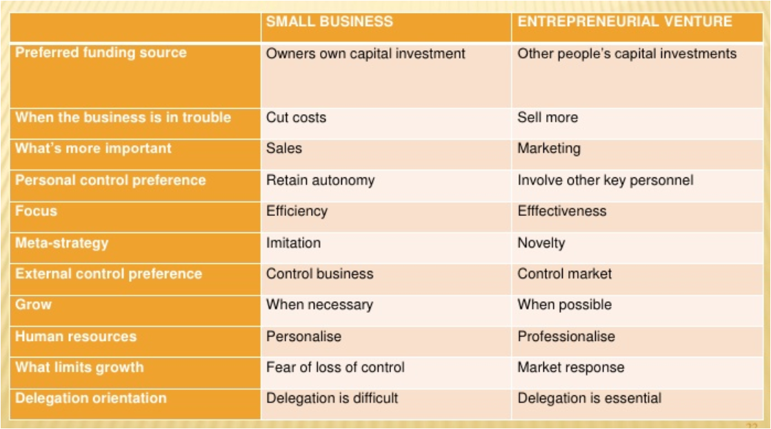

To the entrepreneurial novice, being an entrepreneur or a business owner is interchangeable. However, they are not the same. Sure, they are both self-employed, and need to make money (regardless of how they spend it). However, there are a few differences:
- Entrepreneurs rarely want things to stay as they are. They are looking to change things, develop ideas, create more energy. Small business owners are often happy with how things are, content to carry on (if successful).
- Entrepreneurs invent things, look to do things in different ways and are often technically minded. Small business owners are more likely to do something others are doing, such as opening a shop.
- Entrepreneurs are often looking for the next big thing, ready to move on once their company is good enough. Small business owners are often more sentimental, and see their business as part of the community and region of the family.
- Entrepreneurs will do things more often than not because of passion or opportunity rather than strictly profit or a means of making a living.
- Entrepreneurs want to change the world. Small business owners want to make a living and often serve their local community first and foremost. (Mitchell and Weinstein 2015)
Task 3
What are the different organisational structure options available for a small business
A small business can use one of three primary organisation structure options:

- Functional: Functional organisational structure groups together employees who work toward a common goal. For example, all of your marketing employees would be in the same group.
- Divisional: Divisional organisational structures decentralise the functional organisational structure because the roles of the employees are divided by product or region, rather than function, within your business. For example, you could split the United Kingdom into four divisions: north, east, south and west. Each division would then have its employees.

- Matrix: The matrix organisational structure has the most decentralisation, which means it can confuse employees about who is in charge. The matrix organisational structure is appropriate if your business operates on an international level, or serves different geographic regions.

The organisational is a hierarchical structure that makes a business order to expand the productivity and viability of the business activities. Distinctive independent companies work in various routes, so there is no one-fits-all arrangement each private company ought to decide for a hierarchical structure. You can be that as it may, figure out which of the most widely recognised structures works for your business. (Laurette2017)

Task 4:
What is the role of stakeholders in a business?

Stakeholders are individuals or groups that have an interest in the success and progression of a company. Internal stakeholders include silent partners, staff, shareholders and investors. External stakeholder groups might consist of neighbouring businesses, strategic partners or community bodies such as schools. The role of the stakeholder varies depending on the organisation and the particular project being developed or decided upon.

Decision Making
The most common gathering of stakeholders in a publicly traded company is the board of directors, comprised of high-ranking executives and occasional outsiders who hold large amounts of equity in the company.

Direct Management
While the board of directors is a more "hands-off" approach to controlling a company, some stakeholders prefer the "hands-on" approach by directly assuming management positions.

Investors
Stakeholders are regarded as large investors, who will either increase or decrease their stakes in your company according to your financial performance. Ideally, they act as guardian angels for everyday investors, poring over financial reports and pressuring management to change tactics if necessary.

Corporate Conscience
Large stakeholders are generally high profile investors and would like to steer clear of companies that trample human rights and environmental laws. They monitor your company's outsourcing activities and globalization initiatives and may vote against your business decisions if they are deemed harmful to the company's long-term goals.

Other Responsibilities
Of course, this is only a broad description of stakeholder responsibilities. Ideally, you'll have stakeholders who care about these four issues, but more often than not, short-term profits take precedence over long-term sustainability. (Sun 2018)

List and roles of stakeholders
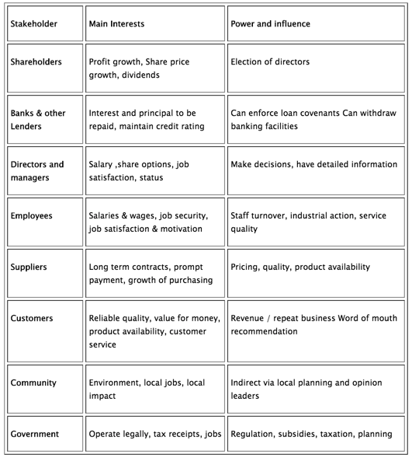

TASK 5:

Discuss in detail, the role of CEO
A (CEO) chief executive officer is the highest-ranking executive in a company. Also, their essential obligations incorporate making major corporate decisions, managing overall activities and assets of an organisation, acting as the primary concern of correspondence between the board of directors and corporate administrations, and being the face of the organisation. A CEO has a position on the board; now and again, they are even the chairman.

There are different titles for CEOs, including overseeing directors, president, executives, and official. The job of a CEO changes starting with one organisation then onto the next relying upon the organization's size and general structure. In moderately little organizations, the CEO regularly has a substantially more hands-on role in the organization, settling on a large portion of the business decisions, including lower-level ones, for example, the employment of staff. Be that as it may, in more prominent organisations, the CEO regularly manages just the more elevated amount organisation procedure and coordinating its general development, as most different assignments are designated to different directors or different offices. (Kenton 2019)

Bibliography
Feely, A. and Harzing, A. (2003). Language management in multinational companies. Cross-Cultural Management: An International Journal, 10(2), pp.37-52. [Accessed 13 Feb. 2019].

Comlaw.gov.au. (2011). Business Names Registration Act 2011. [online] Available at: http://www.comlaw.gov.au/Details/C2011A00126/Html/Text#_Toc306370998 [Accessed 13 Feb. 2019].

Eleanor Mitchell, Sarah Barbara Watstein, (2015) "Entrepreneurship and more!", Reference Services Review, Vol. 43 Issue: 3,

Lorette, K. (2017). Typical Organizational Structure of a Small Business. Available: https://smallbusiness.chron.com/typical-organizational-structure-small-business-4895.html. Last accessed 13th Feb 2019.

Sun, L. (2018). The Role of Stakeholders in Your Business. Available: http://www.businessdictionary.com/article/601/the-role-of-stakeholders-in-your-business/. Last accessed 13th Feb 2019.

Kenton, W. (2019). The Role of Chief Executive Officer CEO.Available: https://www.investopedia.com/terms/c/ceo.asp. Last accessed 13th Feb 2019.

