
Assignment Cover Sheet

Student Name: | Mrs Helen Fursdon
Student Number: | 24314
Course: | Project Management Level 1
Assignment NO: | Two

Marking Criteria:
We expect the learners to write minimum one well expressed point in three lines against each allocated mark. This means one needs to write 15 lines with 5 well expressed points to get high grades for a 5 marks question.
For high grades use examples and illustrations where appropriate.
Assignment 2 Total Marks: 20
Project Management Level1 Brentwood Open Learning College
Selling a Project

Questions: 1. What are priority quadrants? How do these matrix help in selecting projects?

The Priority Matrix is a visual reference which will demonstrate priorities criteria for projects.
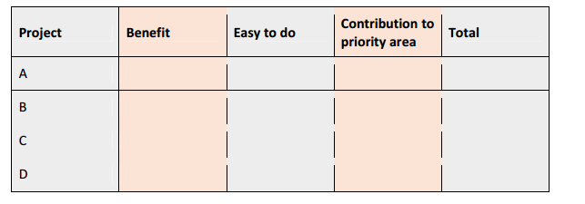
One method is to assign a points system.
A scale of 1-10 are awarded for benefit rates, easy to do rates and contribution to priority areas. If 2 projects are being compared then a numerical score will compare the projects.
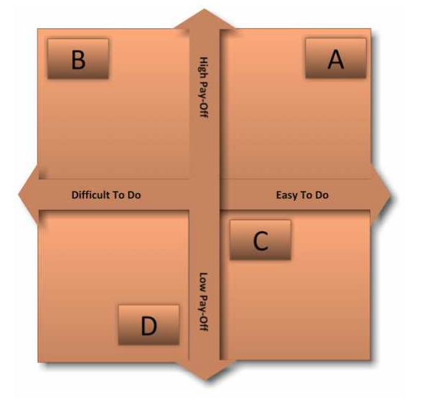
Priority Quadrants are bisecting lines. They compare high pay offs against low pay offs . This then bisects the lines with difficulty against ease of doing a project.
As shown in the diagram above, A would be the best project, as it has a high pay off, though is easy to do.
D on the other hand has a low pay off and is more difficult to do.

2. What is SPIRIT? How it is used for setting goals?

All projects must have Goals and Objectives in the creation of a project. Outcomes, deliverables, benefits to stakeholders and end users must be clearly described.
All goals need to be agreed upon and must come with clear responsibility.
These goals need to be “Specific” with a clearly outlined criteria. These can be used to evaluate the success of the project, to include measuring time, costs and resources.
“Prizes” can be used to celebrate accomplishments throughout or at the end of a project.
“Individuals” are all members of a team. They must be involved in goal setting to allow motivation and ownership of a project.
A “Review” of project goals should be made throughout the project.
“Inspire” goals, which should be high but achievable.
“Time-bound” goals allow a dead line and timescale to be clear.

Student Statement:

By submitting this assignment, I confirm that this is my own work.

Student Signature | Mrs Helen Fursdon | Date | 1-11-18

For Tutor / Assessor Use Only
Total Marks
Marks Obtained
Percentage / Grade

