Question 1
What are priority quadrants? How do these matrix help in selecting projects?

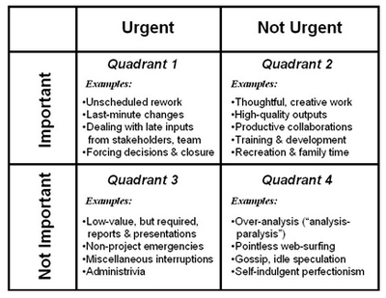
Four-Quadrant Matrix Applied to Project Teams
Here’s an overview of how this grid might be applied to projects
- First, you begin by asking two questions of any activity your team is performing or is planning to perform:
  - Is it important?
  - Is it urgent?
- Next, based on your answer to this question, you log the activity in the appropriate grid square.
- Finally, you can analyse the overall grid to determine if your team is making the most of their time and effort. Specifically, you look inside each grid square and really think about what’s going on there and whether you want to continue spending so much time in that quadrant. There are no right or wrong answers here. You simply apply your judgment and your deep knowledge of your organization, your market, your competitive environment, or other strategic issues that matter to your project stakeholders. Then you figure out if you want to continue spending time as it’s charted in the grid or if you want to make some changes. In broad terms, here are the issues to think about:
  - Quadrant 1 activities (Urgent and Important) often take the form of surprises: You may need to rework (revise) something that wasn’t planned. Or you may need to deal with last-minute changes based on late inputs from stakeholders. Or you find yourself dealing with someone who’s refusing to make a decision that is holding up the entire project.
  - Quadrant 2 activities (Not Urgent, but Important) are the kinds of things you and your team should spend most of your time doing. These include engaging in thoughtful, creative work to develop high-quality project deliverables. And these include productive collaborations with project stakeholders. Finally, they include the personal growth and renewal that comes from training and development activities or simply spending time in recreation and with family.
  - Quadrant 3 activities (Urgent, but Not Important) are the kinds of things of things that typically are imposed from someone outside the project. These include unnecessary “dog and pony show” presentations, dealing with excessive demands for reports, organizational emergencies outside the project, and all manner of administrative and interruptions.
  - Quadrant 4 activities (Not urgent and Not Important) are simply anything that wastes time and produce nothing of value. Over-analysis (leading to “analysis paralysis”) and self-indulgent perfectionism (going above and beyond project specifications) are typical Quadrant 4 activities that can suck time from overly-conscientious professionals in any field. And all of us can fall victim to such time wasters as pointless web surfing, gossip, or idle speculations and rumours.
The object of the game: Help your project team spend as much time as possible in Quadrant 2 – Important, but Not Urgent. These activities lead to great project outcomes and happier, more successful team members.
Greer’s Challenges…
Reflections
Reflect on these questions:
- Does our project team always seem to be in a rush, scrambling to get things done?
- Do we spend enough time in Quadrant 2 (Important, but Not Urgent)?
- If I could change something about the way my team spends time, what would it be?
Team Challenges
ask your team:
- Keep a diary of how you spend your time, in 15 minute increments, for one week.
- Review and analyse your time diary: Take each item and assign it to one of Covey’s Quadrants.
- What changes do we need to make, as a project team, to enable us to spend more time in Quadrant 2?
- How can our organization (or our supervisors) help us spend more time in Quadrant 2?
Project Manager Challenges
- Guide your team through the team challenges named above.
- Debrief with them and really listen, with an open heart and mind, to the changes they would like to make.
- Follow through with changes they need to make within the project to support better time management… and more time spent Quadrant 2, with less time in the other Quadrants.
- Do the hard work of fighting for your project team to make changes in your organization’s behaviours or the behaviour of your supervisors or customers that support better time management.

