
Assignment Cover Sheet

Student Name: | Sally Tomlin
Student Number: | 18902
Course: | Diploma in Construction Management
Assignment NO: | Unit 2

Marking Criteria:
We expect the learners to write minimum one well expressed point in three lines against each allocated mark. This means one needs to write 15 lines with 5 well expressed points to get high grades for a 5 marks question.
For high grades use examples and illustrations where appropriate.
1i. Materials Management is defined by many sources as a joint action of various materials activities directed towards a common goal and that is to achieve an integrated management approach to planning, acquiring, processing and distributing production materials from the raw material state to the finished product state. In other words it is the co-ordination of planning, sourcing, purchasing, moving , storing and controlling materials in a most favourable manner so as to provide service to a customer at a pre-decided level at minimum cost.
The scope includes emphasis on the acquisition aspect, inventory control, stores management, material logistics, movement control and handling aspect. The purchasing, supply, transportation, materials handling, supply and logistic management and all the associated activities concerned with materials.

ii. Materials Management is the grouping of management functions supporting the complete cycle of material flow, from the purchase and internal control of production materials to the planning and control of work in process to the warehousing, shipping and distribution of the finished product. Thomas F. Wallace & John R. Dougherty.
The objectives and functions of Materials Management is to buy at the lowest price (up to the desired quality and service), to maintain a high inventory turnover to reduce excess storage/carrying costs and losses due to deterioration, obsolescence and pilfering, to maintain continuity of supply, preventing the interruption of the flow of materials and services to users, to maintain specified material quality levels and a consistency of quality which permits efficient and effective operation. To develop reliable alternative sources of supply to promote a competitive atmosphere in performance and pricing. To minimize the overall costs of acquisition by improving the efficiency of operations and procedures. To hire, develop, motivate and train personnel and provide a reservoir of talent. To develop and maintain good supplier relationships in order to create a supplier attitude and desire to furnish the organization with new ideas, products and better price and service. To achieve a high degree of co-operation and co-ordination with user departments. To maintain good records and controls that provide an audit trail and ensure efficiency and honesty. Finally to participate in make or buy decisions.

AA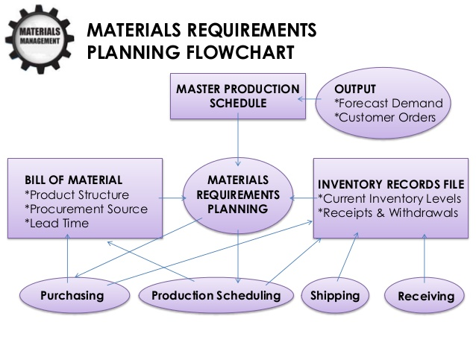

Above is a flow chart from Christian James Mingoy and below is a procurement flow chart from Saiprasad Bhavsar.
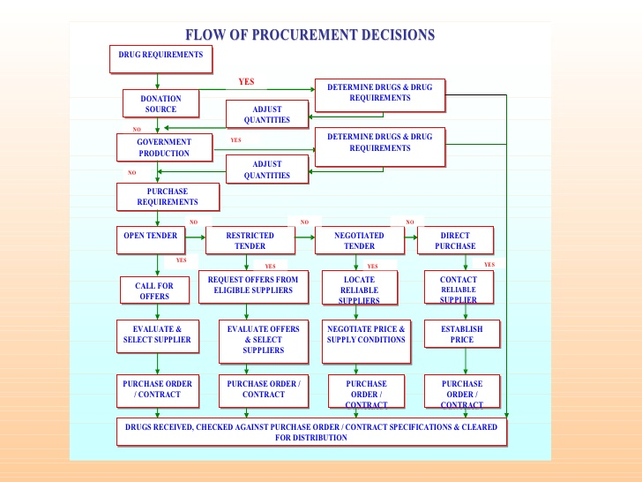

iii. An organization should rate its vendors for a number of reasons for the benefit of not only the buyer, but also for the vendor. The vendor will get the feedback based on objective evaluation and can compare its own performance with that of competitors, they can also get to know their shortcomings and improve upon them.
The advantages for the buyer are that they can assess how the vendor is performing against Key Performance Indicators and Service Level Agreements in the contract, how have they complied to the contract. The buyer will be able to identify areas where the vendor is not performing to expectations and subsequently partner with the vendor to resolve problems. The buyer will be able to compare the vendor against similar ones. The buyer will also be able to assess performance trends and resolve problems prior to them impacting on productivity. Finally the buyer will be able to see if they are engaged with and utilizing the full services of the vendor.
Dennis Wright, a management consultant from the SCORE Orange County Office says “Successful companies embrace their suppliers and vendors viewing them as partners in helping to grow the business. Making sure that this is a mutually beneficial partnership will impact the price you are negotiating today and the quality you get in the future”.
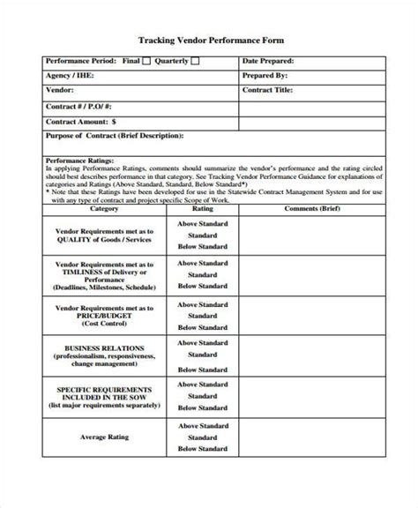
Image by howtheygotthere.us

Vendors should be rated on pricing, quality, delivery and service, although criteria may be adjusted for individual vendors, for example Honda of America adjusts its performance criteria to account for the impact of supplier problems on consumer satisfaction or safety. A supplier of brakes would be held to a stricter standard than a supplier of radio knobs.
A 2001 article in Supply Management says it should be based on the 7 C’s
Competency, Capacity, Commitment, Control, Cash Resources, Cost and Consistency.

2. The “integrated materials management approach” is not perfect and certainly not for every company, although for the companies that do use it the benefits outweigh the disadvantages. There are arguably 4 main advantages and many miscellaneous. The first being better accountability for materials and material concerned costs, by practical centralization of responsibility and authority for all the material activity, a clear cut responsibility is established, this helps in assessing the performance of materials management in an unbiased manner. Secondly, better co-ordination within the materials functions. When the Materials Manager is responsible for all functions it results in better support and co-operation in the accomplishment of the materials function. Better co-ordination creates an atmosphere of trust and better relationships between departments and the materials management department, not least because all problems are dealt with centrally. Thirdly there is better performance and effectiveness, as all the associated functions are integrated organizationally, better performance and effectiveness is achieved. The need for materials is promptly brought to the notice by materials planning and purchasing department is supplied with stock levels and orders status by the stores department. Communication is fast and speed is necessary to reduce costs, stocks and lead times.
The last main advantage is the adaptability to data processing systems, the centralization of materials functions has made it possible to design data processing systems. The integrated materials management approach aids the collection, process and analysis of data, leading to better decisions. Computerization can be cheaply introduced under an integrated system, including advanced and efficient electronic data processing (EDP).
The miscellaneous advantages vary depending on what you read or who you speak to, but they include, but are not limited to, procurement at the right time, improved inventory control, increased productivity, control of prices, less dead stock, effective classification and codification, assurance of verifying right materials, better focus on urgent materials, quick return of defective materials, better use of storage space, reduced paperwork, reduced correspondence and ease for the accounting department.

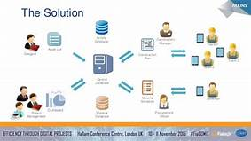

3. Poor materials management can often affect the overall construction time, quality and budget. It is important for planning and control of materials to ensure that the correct quality and quantity of materials, installed equipment, labour and fuel are appropriately specified in a timely manner, obtained at a reasonable cost and are available when needed. An example of bad materials management was a cost-cutting exercise using an unsuitable combustible cladding on the outside of a high rise in London which resulted in a major fire and the loss of 72 lives, I am talking of course about Grenfell Towers, when reporting on the quality of the cladding one presenter on the BBC compared it to “putting lipstick on a pig”.
Research has shown that construction materials and equipment may constitute more than 70% of the total cost for a typical construction project, therefore the proper management of this single largest component can improve the productivity and cost efficiency of a project and help ensure its timely completion.
Planning and purchasing are vitally important processes in material management, which can increase the productivity, profit and assist on time lines. Planning obviously involves measuring (plus use of blueprints, plans and diagrams), scheduling, because construction normally works through phases different components will be needed at different times and ordering. Purchasing is a number of different tasks including vendor enquiries, vendor comparisons, vendor selection and negotiating, purchase order and vendor evaluation.
When goods are delivered on site the quantity and quality must be checked. Production parts and materials are checked against blueprints and specifications, when they have been checked and as ordered the goods will be accepted.
The problems of Materials Management in construction sites can occur when there is a lack of communication between different departments including the estimating department, R&D, purchasing and plant & machine department. An undefined scope, incomplete drawings and plans, a lack of conformance to requirements, non-standard specifications not commonly used, pointless and ineffective meetings and differences between plans and specifications.
Other problems can occur at the procurement stage due to lack of availability of materials (including quantity), unreliable deliveries (late or wrong), unrealistic delivery dates, double handling of goods, insufficient storage areas, theft and handling errors resulting in waste and loss of goods.
Good planning of material management can help avoid any delays of works on site and reduce any extra costs for a project, it is important to manage all materials and inventory throughout construction activity and processes. It is essential in the construction project in order to provide better handling of materials to provide an overall performance of construction projects in terms of time, budget and quality.
With the correct material management a reduction of waste of materials will increase the profits of the company.

Student Statement:

By submitting this assignment, I confirm that this is my own work.

Student Signature | S J Tomlin | Date | 9/6/18

For Tutor / Assessor Use Only
Total Marks
Marks Obtained
Percentage / Grade

