
Assignment Cover Sheet

Student Name: | Tamrat Mebrahtu Gebreyohanes
Student Number: | 5016
Course: | Diploma Logistics and supply chain management level 4
Assignment NO: | 10

Marking Criteria:
We expect the learners to write minimum one well expressed point in three lines against each allocated mark. This means one needs to write 15 lines with 5 well expressed points to get high grades for a 5 marks question.
For high grades use examples and illustrations where appropriate.
Unit 10
warehousing and material handling

1. give short answers for the following questions .
i. what are the aims and functions of ware house ?
- Examine the logistics policy- setting the context and deciding what the ware houses has attain.
- Examine existing operations-to observe the failings and how those can be conquered.
- Design the out line structure –finding the best major location and number of sub-depots …..
- Get closing approval –submitting the plans to superior manager to concure the funding
- Finalise building design –purchasing and choosing contractors and building.
- Finalise equipment design –choosing equipment ,supplier ,and purchasing.
- Finalise system design –design the ordering , inventory control, billing, goods location ,monitoring ,and all other systems needed.
- Fit out installing all equipment , system, staff and setting.
- Open and obtain stock – to test all system , finish training , and begin operations.
- Sort out teething problems- to get things running smoothly.
- Monitor and control – ensuring that everything works as planned ,measuring performance , and revising incentive schemes, etc.
ii. what is the difference between public and private ware house ?
- Private ware houses are owned by business as part of its own supply chains.
Private ware houses gives greater control over a middle part of logistics and allows incorporation of ware housing with the broader activities of logistics.
- Public ware houses is running as a self governing business , which makes money by charging users a fee.
Main advantages of public ware houses is their flexibility.
Cold store
Bonded ware houses
Bulk storage and
Tankers are some of types of public ware houses.

iii. Explain the advantages of public ware house.
Advantages of public ware houses are as the following:-
- Flexibility to deal with changing demand, possibly due to seasonality;
- Ability to supply skills and knowledge that the business does not have internally;
- Access to the newest equipment and practices;
- Avoiding big capital investment, giving higher return on investment;
- Easy access to a wider geographical regions;
- Allowing immediate tests of working in new areas;
- Use of economies of scale to lessen warehousing costs;
- Consolidating loads with other organisations to decrease transport costs;
- Certain high quality and well-organized service; and
- Flexibility to deal with varying conditions, removing risks from dated practices and technology.

- What are manual warehouses ?
- Manual ware houses are when users are using self serving around and choosing items from the shelves and put them in to some kind of container for movement.
- The items are small and light enough to lift in the manual ware house.
- Shelves must be low enough for them to achieve and close together to decrease the distance walked.

v. What are automated ware house ?
- Automated warehouse requires high investment in materials and a worth wile for extremely big stores for shifting materials and parts of the Automated ware house are as the following :-
- Storage regions that can be accessed by mechanical equipment; these often make use of narrow aisles up to, say, 40 M. tall to get an elevated density of materials and reduce the distances moved.
- Equipment to shift materials around the warehouse; these are typically automated guided vehicles (AGVs)
- Equipment to mechanically choose materials and place them into storage, including high speed stacker cranes that can arrive at any point in the thin aisles very fast.
- Equipment to move materials between the diverse types of equipment; these mechanical loaders and unloaders may include industrial robots.
- A warehouse administration system to record material locations, and manage all movements.

- What are the main materials used for packing ?
- Packing serves are four which is protecting from pollution of each other products such as foodstuffs and chemicals .
- Recognizes the product and gives fundamental information;
- Protects items while they are being shifted through the supply chain;
- Makes treatment easier; and
- Assists in promotion, promoting the product, advertising and giving information to Customers.

2. out line the activities that take place in a warehouse.
We do have alist of warehouse activities as the following :-
- Receiving goods from upstream sellers.
- Identifying the goods, matching them to orders and finding their planned use.
- Unloading materials from delivery vehicles.
- Doing any essential checks on quantity, quality, and state.
- labelling materials (usually with bar codes) so they can be recognized.
- Sporting goods as essential.
- Moving goods to mass storage area.
- Holding them in stock until required.
- When required, moving materials from mass storage to a smaller picking store.
- Picking materials from this store to meet orders.
- Moving the materials to a marshalling area.
- Assembling materials into orders.
- Packing and packaging as necessary.
- loading delivery vehicles and dispatching the order . and
- controlling all communications and connected systems, such as, inventory control and finance.
3. Describe in detail the general lay out of warehouse. Using examples and illustrations.
- In the general layout it must included the need of supportive materials such as :-
- Storage racks
- Loading and unloading areas
- Rooms
- Offices
- Equipment and so on
- In general layout there are necessary elements which is Bay and Dock - they need substantial investment both money and effort, they involve long-standing commitment , they have important impact on the coast and competence of immediate operations.
Below are list of elements
- A storage area, where the goods are kept as stock.
- A departure bay, or dock, where customers’ orders are assembled and sent out.
- A material handling scheme, for moving goods around. And
- An information system, which records the site of all goods, arrivals from suppliers, departures to consumers, and other applicable information

Bellows are an example of general lay out illustration:-

Example 1.

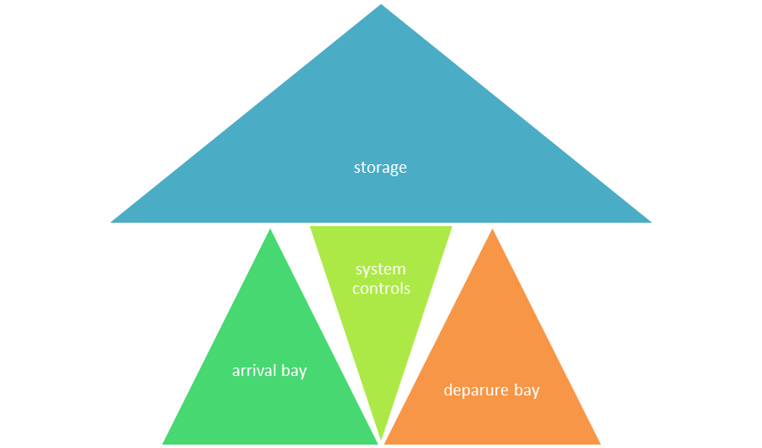

Example 2

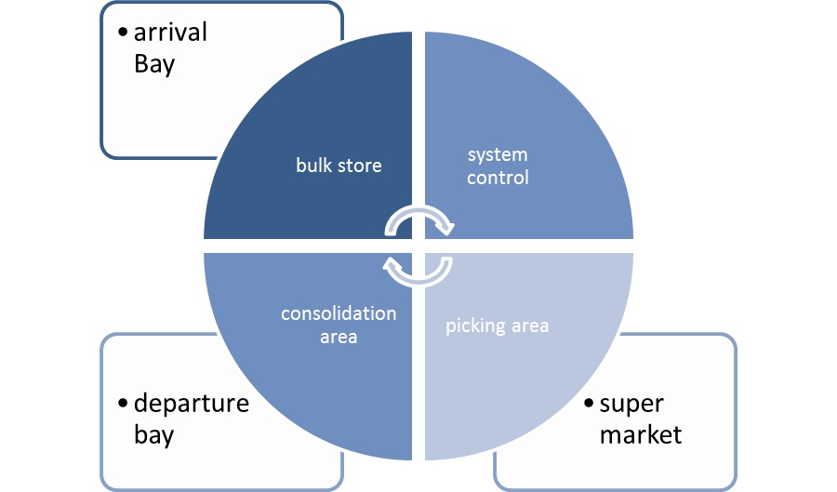

Student Statement:

By submitting this assignment, I confirm that this is my own work.

Student Signature | Tamrat M.Gebreyohanes | Date | 02/05/2017

For Tutor / Assessor Use Only
Total Marks
Marks Obtained
Percentage / Grade

