
Assignment Cover Sheet

Student Name: | FLORENCIA CALCAGNI
Student Number: | 3557
Course: | DIPLOMA IN BUSINESS ADMINISTRATION
Assignment NO: | 2

Marking Criteria:
We expect the learners to write minimum one well expressed point in three lines against each allocated mark. This means one needs to write 15 lines with 5 well expressed points to get high grades for a 5 marks question.
For high grades use examples and illustrations where appropriate.
Florencia Calcagni
Student # 3557
Assignment 2
Page 1

Fundamentals of Administrative Management

Total Marks: 30

Q: 1: Short questions: (15)
- Define the term “Management”.
Management refers to the process of using men, money, machines, material and processes through proper direction, coordination and integration of several activities so as to produce desired results and attain predetermined goals.
In other words, management consists of a series of activities classified into various functions like planning, organising, staffing, directing and controlling.
- List different levels of management.
There are certain levels of management with varying degree of authority and responsibilities. Some managers decide about the objectives of the business as a
Florencia Calcagni
Student # 3557
Assignment 2
Page 2

whole, some managers perform functions to achieve these objectives in different departments, like production, sales, etc., and some of the managers are concerned with the supervision of day-to-day activities of workers. Managers performing different types of duties may, thus, be divided into three categories:
• Top-Level Management
• Middle-Level Management
• Lower-Level Management
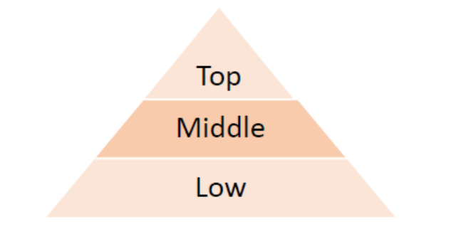
These three levels of management taken together form the “hierarchy of management”.
- Define the term “equity” as a principle of management.
The principle of equity is about motivating workers to perform their duties by maintaining a proper mix of fairness, justice and kindness among each other.
- State the various functions of management.
- Planning requires the ability to see into the future and picture the goals that the organization would like to achieve. Then it is up to the manager to set a specific time frame within which the team would work to accomplish the task, a budget, and determine the amount of resources required and the way to go about achieving these goals.
- Organising is important to stay on track and to avoid mistakes. After determining the objectives, the manager then organizes her team, and distributes the work amongst her men. Then she could control and oversee the work of every member of the team and check if everything is going as per the planning.
Florencia Calcagni
Student # 3557
Assignment 2
Page 3

- Commanding is when the manager communicates his expectations with every subordinate and their involvement in the work. A manager must delegate the work amongst his subordinates and then instruct and inspire them to work to their best of their abilities. It is important for the manager to treat her subordinates with respect and not overburden them with work.
- Coordinating is essential for any organisation. It is the job of a manager to see that two subordinates aren’t working for cross purposes, or that there isn’t a duplication of assigned tasks. Every department should complement each other, and work with harmony to achieve their goals.
- Controlling is an important task in the manager’s workload. She must make sure that the standard of work is up to the standard of the company and that every member of her team is following the policy of work of the company.

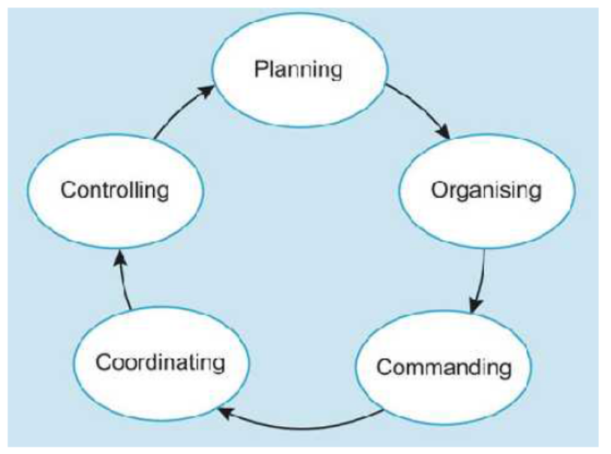

- Match the expression given in column 1 with these given in column 2

Florencia Calcagni
Student # 3557
Assignment 2
Page 4

Column 1 | Column 2
a) Management as a discipline | i) team of managers
b) Management as a process | ii) code of conduct for professionals
c) Management as a group | iii) developed and grown through practice and research
d) Management as a profession | iv) series of inter-related activities

- Management as a discipline is a systematised body of knowledge that has developed and grown through practice and research.
- Management as a process consists of a series of inter-related activities.
- Management as a group refers to a team of managers working in an organisation and performing managerial activities.
- Management as a profession applies a code of conduct for professionals.

i. The following table contains the function, position and different levels of management.

Pick one from each column and make a meaningful combination.

Levels of Management | Position | Functions
(A) Top | a) Departmental Heads and  Managers | (i) Identifying the departmental objectives and guiding lower level towards achievement of those objectives
(B) Middle | b) Board of directors and chief executives | ii) Carrying out the operations and their supervision
(C) Lower | c) Supervisors and Foreman | iii) Defining the objectives and formulating the policies

Florencia Calcagni
Student # 3557
Assignment 2
Page 5

The middle-level management includes Departmental Heads (e.g., production, sales, etc.) and other managers. Sometimes senior departmental heads are included in the top management team.
The objectives of the business as a whole are translated into departmental objectives for the middle level management. By identifying these departmental objectives, the heads of the departments work out their own strategies and guide lower levels towards the achievement of those objectives. Middle-level managers are particularly concerned with the activities of their respective departments.

Q.2. “Planning is looking forward; whereas controlling is looking back”.
Explain the statement. (7)
Planning contributes heavily to success and gives us some control over the future. By planning, we can identify our tasks and deadlines and have a clearer picture of the goals to achieve in the required time frame. We can decide which strategies or guidelines will be more suitable to tackle our goals. It helps us prepare for the future of the organisation and enlarge our mental focus. Just as no two organisations are alike, neither are their plans. It is therefore important to prepare a plan keeping in view the necessities of the enterprise. Planning provides a considered and logical framework within which a business can develop and pursue its strategies. It offers a benchmark against which actual performance can be measured and reviewed.
However, the control process measures progress towards goal attainment. It helps us devise corrective actions, if required. Controlling investigates whether planning was successful. It takes place after other functions have been completed. For this, we need to look back and analyse the performance of our planning, organisation and leadership. This also involves evaluating positive and negative strategies implemented, so that we choose the best for future implementation. We should investigate, analyse and understand to finally confirm on the effectiveness and efficiency of our planning. Control is also part of the present since it helps focusing on the right activities at the right time. It monitors progress of planning process.
Florencia Calcagni
Student # 3557
Assignment 2
Page 6

Planning is the process in which goals are set, strategies are developed and tasks and schedules are made to accomplish these goals: whereas the process of control is related to checking that each and every step is conducted according to schedule.

Case Study (8)
The directors of Vision Tech have reorganized their business. William Davis is now Chairman, Vijhay Singh Finance Manager, and Irene Rogers is the floor in charge (Supervisor).

Keeping in view the above situation answer the following questions:
- What is meant by the hierarchy of management?
Hierarchy of management is a workplace leadership structure in which authority is assigned in ranks. In this organisational structure the staff is ranked, so that everyone -but the topmost- is subordinate to a specified one/s above them.
With this classification we can divide the tasks to be performed by each level and staff within the organisation. This arrangement of individuals within a corporation helps outlining power, status and job function.
The three levels typically found in an organisation are low-level management, middle-level management and top-level management.
Top-level managers, like William Davis, are responsible for controlling and overseeing the entire organisation.
Middle-level managers, like Vijhay Singh, are responsible for executing organisational plans which comply with the company’s policies. They act at an intermediary between top-level management and the low-level one.
Low-level managers, like Irene Rogers, focus on controlling and directing. They serve as role models for the employees they supervise.
- How does William Davis know about any problem on the factory floor?

Florencia Calcagni
Student # 3557
Assignment 2
Page 7

Unless it is not a major problem in which his intervention is required, he can request for a weekly, biweekly, monthly, etc. update to the department manager or floor supervisor so that he is aware of the situation in each area of the company.
- Who determines the objectives for the business?
The objectives of the business are determined by the top-level management, in this case Mr. Davis. Following them, middle-management (Mr. Singh) will execute the plan accordingly in each area to reach those objectives. Low-level management (Ms. Rogers) will control this is done in an effective and timely manner.
Top-level management oversees and control the whole process.
- Who will ensure that the work is carried out properly and on time?
This task will be controlled by low-level management (Ms. Rogers). She will direct and control each step of the process to make the necessary adjustments and work towards the agreed objectives.

Student Statement:

By submitting this assignment, I confirm that this is my own work.

Student Signature | FLORENCIA CALCAGNI | Date | 25/01/2017

For Tutor / Assessor Use Only
Total Marks
Marks Obtained
Percentage / Grade

