
Assignment Cover Sheet

Student Name: | Jernita Esprit
Student Number: | 24204
Course: | Diploma in Travel and Tourism Level 5
Assignment NO: | 03

i. Governed by laws, the main purpose of consumer protection is to safeguard the buyers of goods and services and the public against inappropriate practices within the marketplace. This often derives when companies use unfair strategies in order to gain an advantage over their rivals.

ii. In 1992, a legislative to regulate the travel trace was established as The Packaged Holiday. The organisers within the tourism industry consist of Tour Operators, Travel Agents, Tour Guides and Wholesalers. Each element within the industry works as a chain in the structure of the tourism sector.

iii. The retailers of the tourism industry are the entities who are responsible for selling packages, tickets, car hire and hotel accommodation directly to the consumers.

iv. MICE organisers often refers to a specialised niche market of group tourism which is dedicated to the planning, booking and facilitating of meetings, Incentives, Conferences and events which is a great stimulant towards the growth of the sector. In recent times, there has been a trend in the industry aimed at using the term “meetings industry” in order to avoid confusion from the acronym.

v. The travel trade industry comprises of several industries namely; the hospitality industry which provides services within the food sector and the transportation industry which entails the provision of accessibility via various modes of transportation services such as train, plane and bus.

vi. Over the past few decades, technology has been implanted within the Tourism Industry due to the advancement of new technology. Mobile technology has undoubtedly been integral within the prosperity of the tourism industry. Smart phones possess the ability to perform multifaceted functions such as hotel bookings, flight tickets, car hire, and attractions advertisements; amongst many others. Not only are individuals able to utilise these services at the touch of a button but there is a direct link to the internet which provides great accessibility in one retrieving information about tourism destinations.
In contrary, the technological developments have also impacted the industry negatively. As customers have access to the internet at their fingertips, this means that almost anything can be done online hence the demand for organisers within the industry such as Tour Operators and Travel Agencies will be considerably low. The knock on effect has led to a vast number of agencies and operators re-strategising their tactics or ultimately suffering the consequences of going into administration. Despite the threat posed to the organisers, the positive impacts of technology development far outweigh the negative impacts caused to the tourism industry.

vii. Businesses within the tourism sector are consistently being faced with challenges which may be of great risk to all components within the tourism product. Terrorism, Health, (Richter 2003), War and Political instability, (Sönmez 1999), Crime (Dimanche 1999) and Cultural and language difficulties (Basala 2001) are the five major risks related to tourism.
Should a country have a high crime rate or declared a war zone (Syria and Iran), this will pose great risk for the traveller as their life will be in great danger. The language barrier and a difference in the way of life of a people will create a lot of confusion and misunderstanding in the minds of potential visitors as they may find it difficult adjusting to a culture they are not accustom to. Ones’ health is a major risk which ought to be exercised with great caution. A country with very limited medical facilities i.e. many Caribbean islands could be a huge deterrent for a visitor irrespective of how beautiful a destination is because the value of life is far greater than the value of a holiday.

2. In line with the United Nations World Tourism Organisation, travel legislation aims to provide a regulatory framework in order to better manage and develop the activities within tourism. The technological advances are evolving at a rapid rate and so is the tourism industry. It is therefore crucial for tourism professionals to maintain an extensive knowledge of the ongoing changes by adhering to instructions set out by the main governing bodies.
Airlines in particular should take drastic steps in order to ensure that their employees are adhering to IATA’s code of conduct via means of continuously attending courses in relation to the new policies implemented. For example: it is mandatory that all licensed pilots renew their Civil Aviation Association license annually in order to maintain the validity of their ratings as well as their knowledge. A failure to do so will not only be detrimental to the airline and the individual (most likely to be issued with a hefty fine) but the lives of passengers would be at great risk and this would be deemed as a major breach of security.
The Passenger Bill of Rights aide airlines in ensuring that the safety and security of passengers is at the forefront of policies. There are several frequent travel related issues which are protected by laws and regulations. The issue of lost baggage or damaged goods is a relatively common problem that almost every traveller has experienced. Due to the surge in lost baggage situations, the CAA implemented the ABTA Bonding law which is aimed at protecting travellers who would most likely be susceptible to the lack of financial protection in the event of a lost baggage claim. It is therefore imperative that the inclusion of travel insurance on all packaged tours is implemented by intermediaries. Within the hospitality sector, hotel chains and restaurants ought to maintain a superior knowledge of rules and regulations as it aides in the protection of the business’s reputation.
Food safety and hygiene is vital as such practices will ensure that the environment at hotels and restaurants are kept clean which will lead to the prevention of food poisoning and contamination being spread. Irresponsibility in adhering to such regulations will result in avoidable deaths occurring and further legal action could be taken against tourism professionals.
Environmental tourism thrives off the numerous visitors who have chosen a destination based on its image. If tourism professionals are not knowledgeable on the sudden change in the physical landscape of a destination, this will lead to a misrepresentation of the area from a marketing perspective. In the event of tourists becoming aware of the environmental change upon arrival at the destination, this will most likely have a psychological effect on the visitor. Dissatisfied customers will most likely venture out to another company and the existing company will most likely experience a loss of revenue.
Some of the governing laws within the tourism sector possess a tendency of being non-structural as some countries do not cater for the protection of non citizens and failure to comply with specified laws will be of a major financial liability to the tourism professionals. External bodies such as IATA and the CAA have been very instrumental in ensuring that there are laws implemented which prides itself on protecting the consumers and organisations which will in turn maintain the success of the tourism distribution sector.

3. The distribution system within the tourism sector is currently facing an ongoing transformation and the functions of intermediaries are vital more than ever before. Tourism intermediaries are classified as any dealer or supplier who acts as a link in the chain of distribution between an entity and its customers; i.e. Tour Operators, Wholesalers, Travel Agents and the Internet. The primary role of intermediaries is to merge buyers and sellers in the transformation of goods and services to a level of being purchased. Through intermediaries, producers will benefit from reducing promotional costs as well as sell products in bulk. Consumers will also profit from intermediaries as knowledge is gained from specialists, transactional and search costs are not needed and prices are relatively discounted.
The change in the distribution system derived as a result of airline deregulations and Global Distribution Systems which improved the accessibility and availability of information to airlines have protested for the distribution costs to be minimalists as this has exposed the fragility of the intermediaries due to the direct link between suppliers and consumers. Furthermore, key improvements in technology have given leverage to customers to purchase from travel agents and Tour Operators who act as a third party to external companies. Activities such as the organisation of packaged holidays, flight and hotel bookings and transportation aides in providing the traveller with the ultimate holiday experience for the purpose of leisure or business. Travel insurance and other forms of monetary protection are not within the stipulated guidelines of travel agents and therefore it is the role of intermediaries to keep abreast with the regulations in order to avoid mishaps. Many travellers prefer to utilise the services of an intermediary due to the extensive knowledge they possess of services provided.

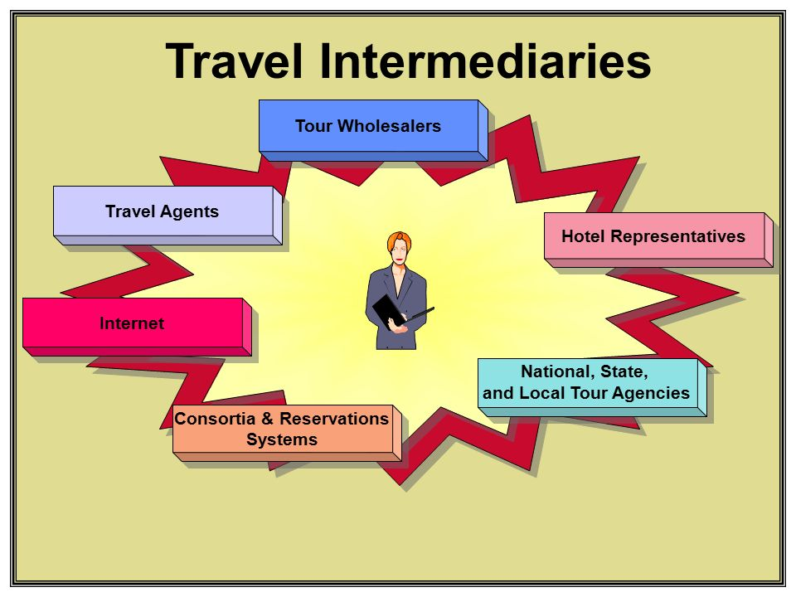
Despite the enhancement of technology being a gateway for independent travellers to act as agents, the role of intermediaries is still needed within the tourism sector as it is a key ingredient in ensuring that the distribution chain is functional and that this sector remains renowned for its booming revenue.

Student Statement:

By submitting this assignment, I confirm that this is my own work.

Student Signature | Jernita Esprit | Date | 31/03/20

For Tutor / Assessor Use Only
Total Marks
Marks Obtained
Percentage / Grade

