
Assignment Cover Sheet

Student Name: | Vicky Groves
Student Number: | 22889
Course: | Diploma in Diet and Nutrition (Level 4)
Assignment NO: | Unit 9 Diet and Disease

Marking Criteria:
We expect the learners to write minimum one well expressed point in three lines against each allocated mark. This means one needs to write 15 lines with 5 well expressed points to get high grades for a 5 marks question.
For high grades use examples and illustrations where appropriate.
Please insert your completed assignment ( in word format) here:

Diet and Disease Unit 9 Brentwood Open Learning College Page 1 Assessment 9 Total Marks 30
Q.1. Multiple Choice Questions: (05)

i. Cardiovascular disease is caused by a build-up of:
a) swollen arteries
b) infection in arteries
c) fatty streaks and cholesterol in blood vessels

ii. How many types of cholesterol are found in blood stream?
a) Two
b) Three
c) Four

iii. The high-density lipoprotein or (HDL) is referred to as:
a) the bad cholesterol
b) the useful cholesterol
c) the good cholesterol

iv. Which type of fat should be avoided in order to reduce the risk of CVD?
a) Trans-fat
b) Monounsaturated fat
c) Omega-3 fats

v. Trans-fatty acids are a particular kind of fat naturally occurring in:
a) eggs and cheese
b) vegetable oils
c) meat and dairy product

vi. The most important risk factor for the lung cancer is smoking, which is thought to be responsible for about:
- 40% cancer deaths Diet and Disease
- 30% cancer deaths
- c) 20% cancer deaths

vii. Type 2 diabetes develops:
a) after the age of 40
b) after the age of 60
- slowly

viii. Glycaemic lead is calculated using which of the following formulas?
a) GL= GI x Net carbohydrates
b) GL= GI net carbs
c) GL = GI x Net Carbohydrates
d) GL = GI x Net carbs/100

ix. 10 % of all cancer deaths among non-smokers are related to:
a) diabetes
b) obesity
c) heart failure

x. Calcium requirement for 7-10-year-old is;
a) 350 mg a day
b) 450 mg a day
c) 550 mg a day

Q.2. Short Questions: (18)

- Describe the risk factors for cardiovascular disease or CVD.

Cardiovascular system consists of the heart and blood vessels. These transfer blood around the body which carrys oxygen, nutrients and glucose.

Cardiovascular disease or CVD includes - High Blood Pressure (Hypertension), Coronary Heart Disease (CHD) and Atherosclerosis. The CVD disease is caused by a build-up of fatty streaks and cholesterol in the blood vessels, leaving the arteries narrower which puts stress on the heart. Heart attacks and strokes happen when the arteries become blocked.

The risk factors are…
- Being overweight/obese
- Having high HDL cholesterol
- Smoking
- High Triglycerides (type of fat lipid found in blood which the liver makes)
- High blood pressure
- Inactive
- Diabetes
- Eating too much salt
- Stress
- Drinking too much alcohol
- Family history of CHD
- High fat diet of Trans fats and saturated fats

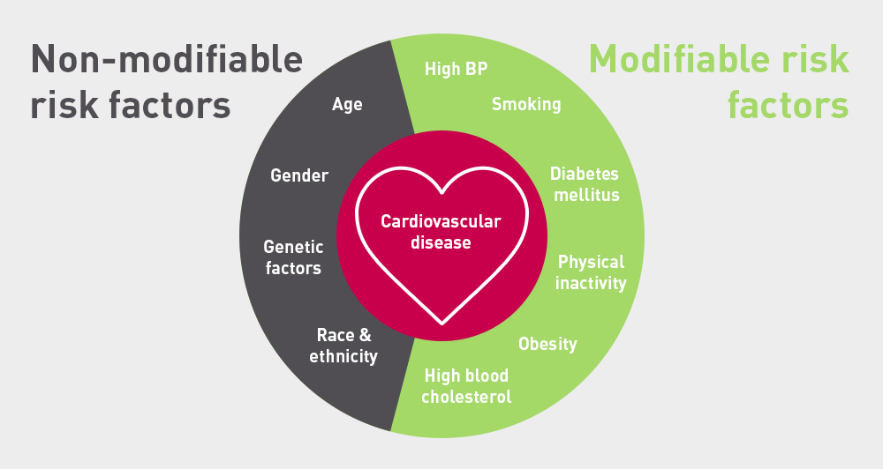
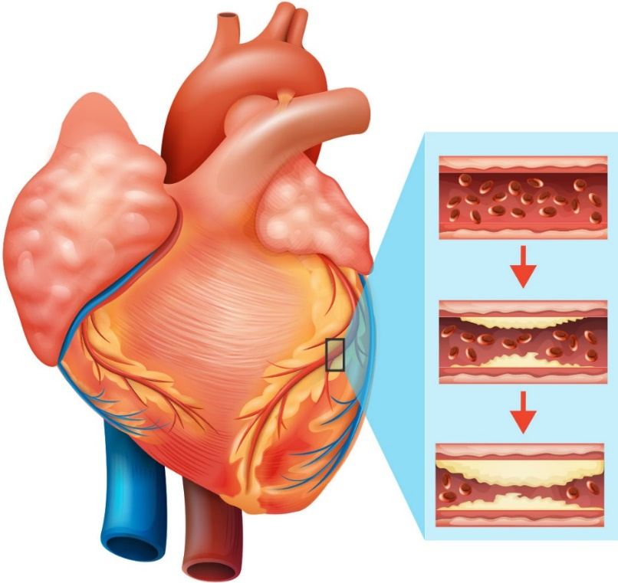

- What is cancer?

Cancer is a disease caused by an uncontrolled division of abnormal cells in a part of the body. These cells grow out of control. Usually it involves damage to the DNA in cells. Gene mutation can be caused by smoking, radiation, some viruses, cancer-causing chemicals (carcinogens), obesity, lack of exercise, hormones, sun, poor diet and chronic inflammation.

Cancer starts with a cell that mutates which divides rapidly. New blood vessels supply the cells with oxygen and nutrients forming an invasive tumor, which can spread via the blood and lymph vessels to other parts of the body.

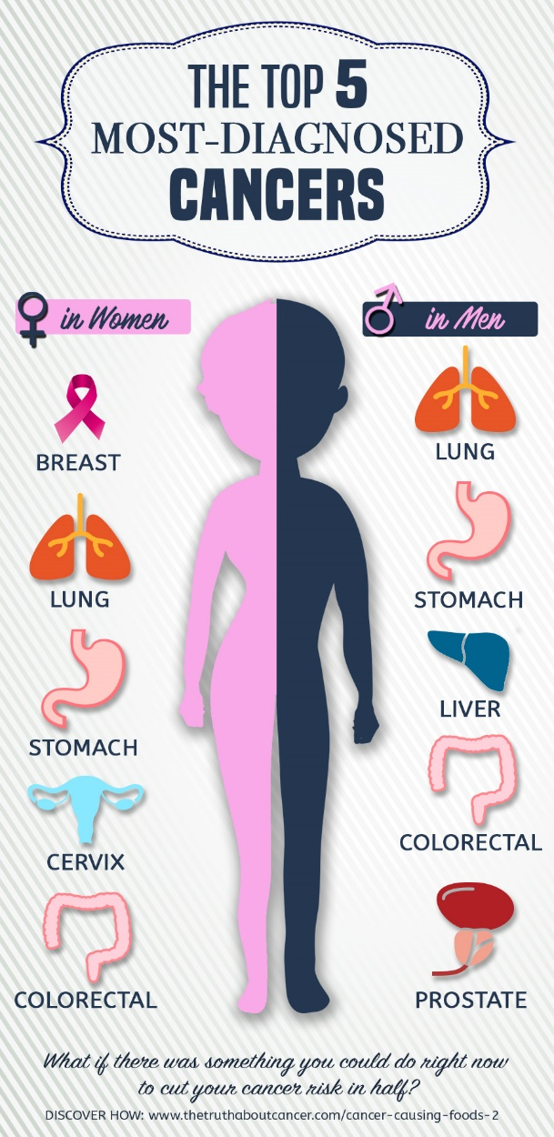
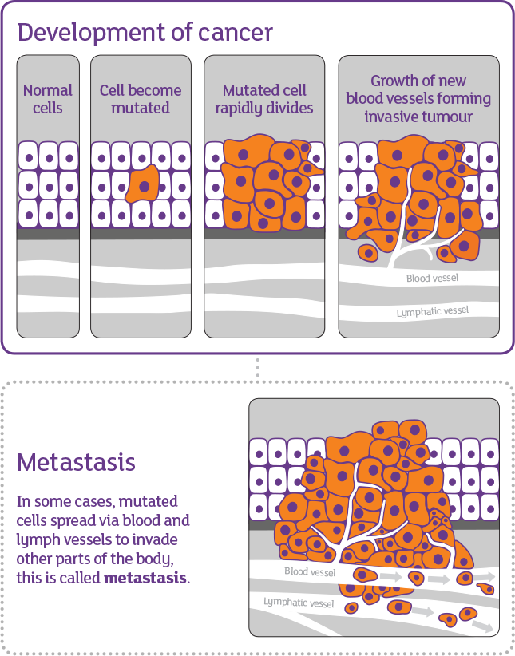
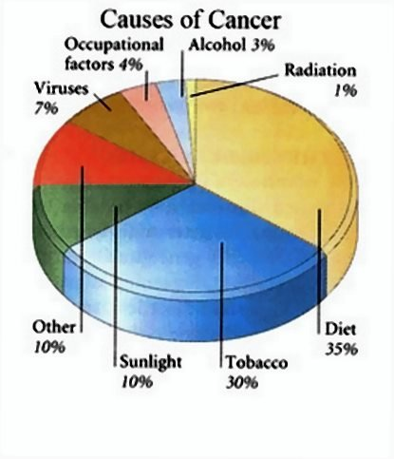

- What is the link between glucose and insulin?

If blood glucose isn’t controlled correctly in the body by insulin and glucagon, which are hormones produced in the pancreas, then a person can develop Diabetes.

Insulin helps the glucose enter the body’s cells. Without insulin the glucose can’t enter, leaving the cells low of energy.

When the blood glucose is too high, the pancreas release insulin and the fat cells take the glucose from the blood to store and use at another time, balancing the blood glucose levels.

If a person has low blood glucose, then the pancreas release glucagon into the liver, which makes the liver releases glucose into the blood, normalising blood glucoses level.

It is said that there are two million people in the UK who have Diabetes and around one million are thought to be undiagnosed with the disease.

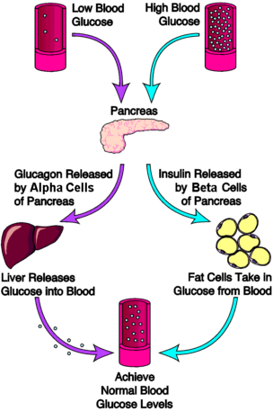

- Why is glycaemic index important?

A person’s body works best when the blood sugar (glucose) maintain a constant normal balance.

Understanding how fast carbohydrates are broken down and used by the body means a person can help control their blood sugar levels. Helping to prevent the blood sugars levels peaking and troughing. If the levels are too high, then insulin is released and if to low glucagon is released from the pancreases.

The GI rating is very important to someone who has diabetes or who is closed to developing the disease, The GI rating can help them to prevent/control the disease by controlling the foods they eat which raises the blood sugar levels too high to quickly. The GI rating of foods is to simply to help minimise insulin related problems by having foods rated according to their effects on a person blood sugar levels.

- What is osteoporosis? What causes this disease?

Osteoporosis is the name given to the condition where the bones become brittle and fragile otherwise known as brittle bone disease.

From birth to adulthood the body absorbs calcium and vitamin D for growth and repair of bones and teeth, as well as to store to be drawn on later in life as the bone cells slow down being replaced as a person ages.

Hormonal changes and deficiency of calcium and vitamin D can cause osteoporosis, as well as, in early menopause or having a hysterectomy, genetics, regular use of steroids, having bowel disease, lack of exercise, coeliac disease, drinking heavily, smoking and obesity.

Being healthy, doing regular exercise and having a healthy balance diet can help prevent osteoporosis especially during childhood and into adolescence.
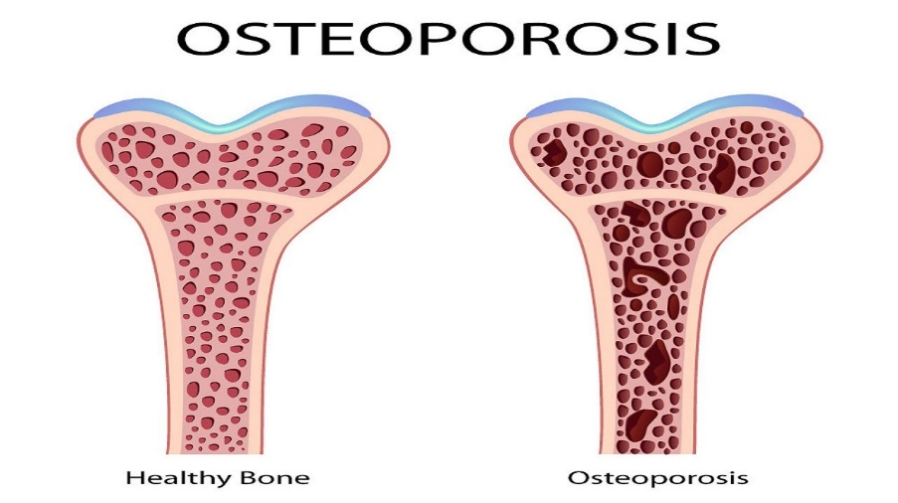

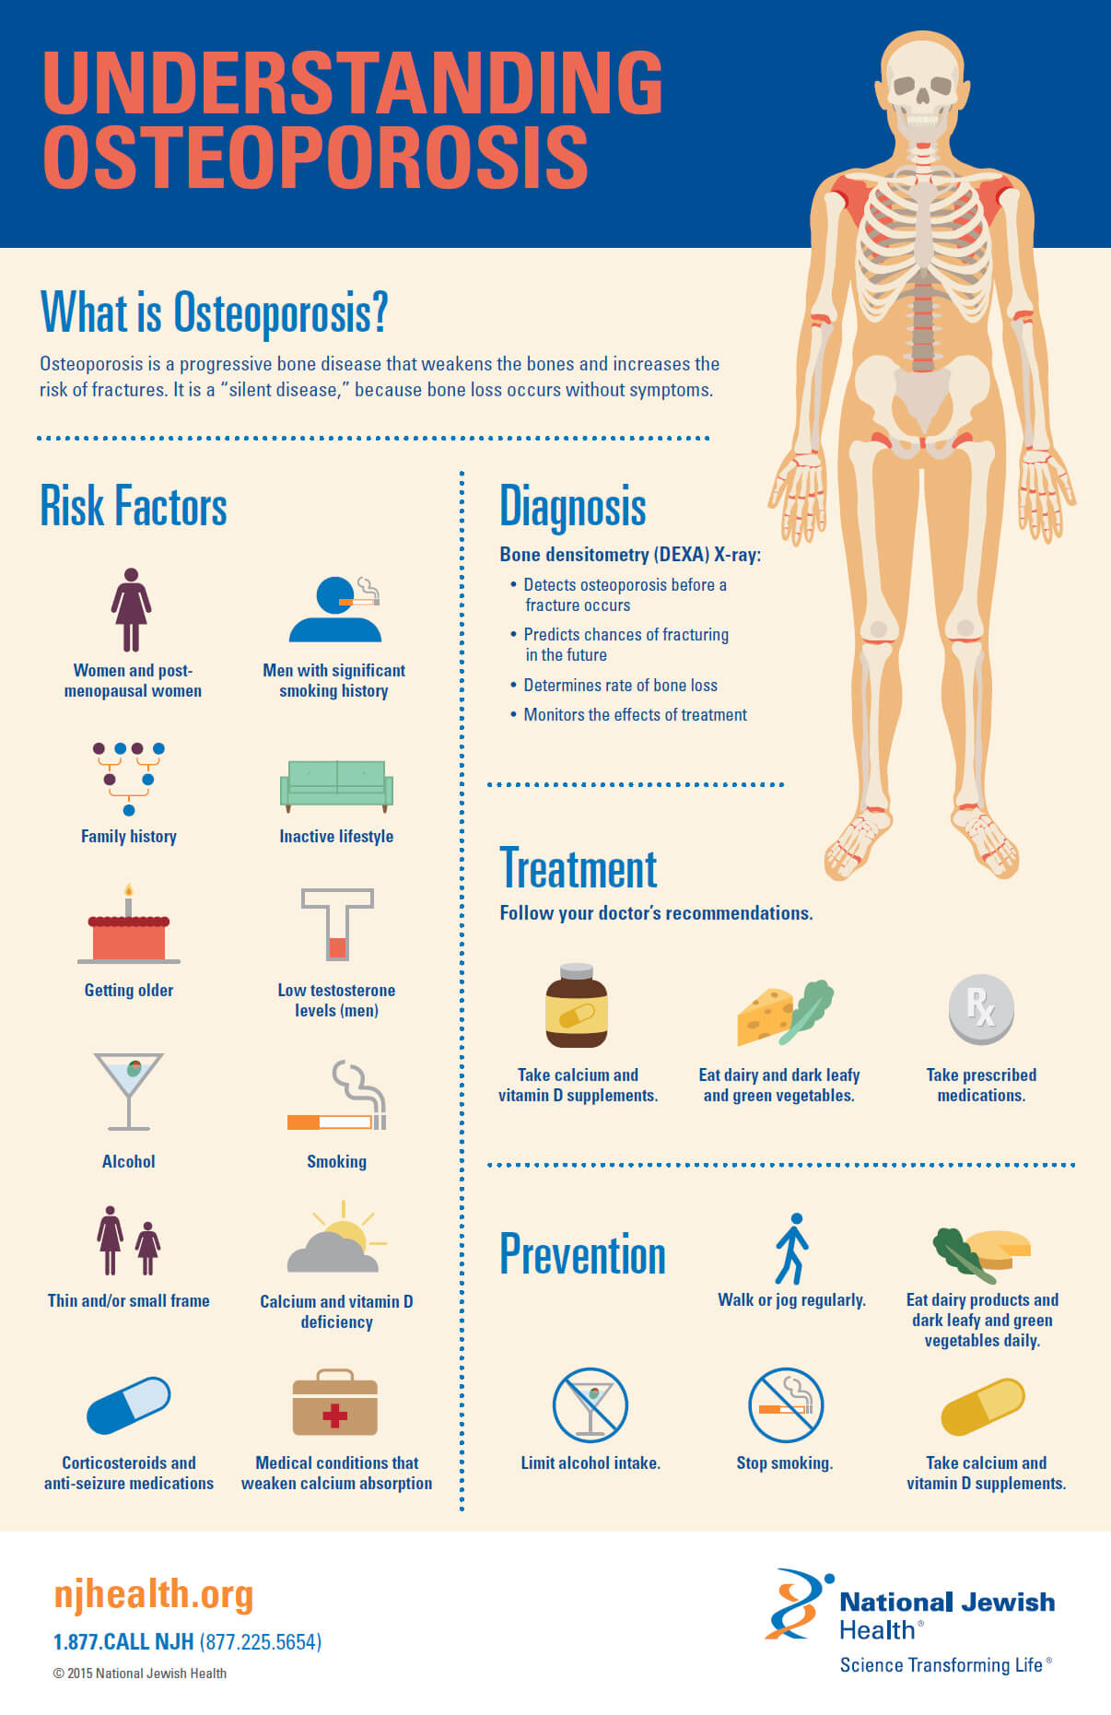

- What are the two types of diabetes?

The two main types of diabetes are..

Type 1 Diabetes – insulin dependent, known as Insulin Dependent Diabetes Mellitus (IDDM)

This is where the body cannot produce the insulin it requires, meaning a person haves to inject insulin to control blood sugar levels when they become too high.

Type 1 diabetes usually starts in childhood. A person can show symptoms of being very thirsty, peeing a lot, being very tired, loss of weight, blurred vision, having cuts that don’t heal. Diabetes complication can be life threating and effect a person’s heart and blood vessels, nerves, kidneys, feet, skin and mouth as well as complication in pregnancy.

If a person’s blood sugars become too low (hypoglycaemia) they will need glucose tablets or sugary drink. If they feel better, then give them more substantial food to help the glucose levels like, bread and jam, biscuits and more sugary drink. However, if after 10 minutes, they don’t improve call 999.

Symptoms of someone having hypoglycaemia are…
- Behaving unusually, anxiety or nervousness
- Being aggressive
- Appear drunk and confused
- Pale, cold, shaky, dizziness and sweaty (clammy)
- Rapid breathing
- Seizure
- Hunger
- Headache

Type 2 Diabetes – known as Non-insulin Dependent Diabetes Mellitus (NIDDM)

A person produces small amount of insulin which can be ineffective on regulating their blood sugar levels. Unlike type 1, type 2 diabetes usually starts in later life and can be controlled by eating the right diet, doing exercise and with medication which activates the pancreas to produce more insulin.

If a person’s blood sugar gets to high (hyperglycaemia), they will need to go straight to hospital as they can go into a diabetes coma.

Symptoms of someone having hyperglycaemia are…
- Extreme tiredness
- Loss of concentration
- Thirst
- Nausea, and vomiting
- Abdominal pain
- Sweet smell on breath
- Headaches
- Blurred vision
- Loss of appetite
- Argumentative behaviour
- Weakness and rapid pulse
- Low blood pressure

Tiggers | Hyperglycaemia | Hypoglycaemia
Food | Too much food | Not enough food
Exercise | Too little activity for the food they have consumed or medication they have taken | Too much activity for the food they have consumed or the medication they have taken
Medication | Too little insulin | Too much insulin

Case Study (7)
Ben, aged 62, has recently been diagnosed with type 2 diabetes. He complains of extreme fatigue. He fell asleep while driving and was so worried for his situation that he consulted the doctor. The doctor recommended that he should reduce his weight. Ben has therefore decreased his fat intake a lot and eats lots of grains, refined carbohydrates and some protein. Two weeks later his problems are still there. He still feels fatigued and lethargic most of the time. He visits a dietitian. Through testing, it is discovered that Ben is gluten intolerant.

i. Which of the followings do you think is the right dietary advice for Ben?
a) Ben should stop eating grains altogether and should use vegetables as his sources of carbohydrates.
b) Ben should eat lots of grains as these are good for diabetics.
c) He should eat all the foods with low GI.

ii. Do you think that Ben should be advised to replace all his refined foods with whole foods?
a) Yes
b) No

iii. How can Ben be advised on his fat intake?
a) He should include healthy fats in his diet.
b) He should stop taking any fats in his diet at all.
c) He should continue his present fat intake.

Student Statement:

By submitting this assignment, I confirm that this is my own work.

Student Signature | Vicky groves | Date | 12/03/19

For Tutor / Assessor Use Only
Total Marks
Marks Obtained
Percentage / Grade

