
Lynn
Assignment Cover Sheet

Student Name: | Linda Coggins
Student Number: | 9050
Course: | Certificate in Travel and Tourism Level 1
Assignment NO: | The Tourism Products and Services

Marking Criteria:
We expect the learners to write minimum one well expressed point in three lines against each allocated mark. This means one needs to write 15 lines with 5 well expressed points to get high grades for a 5 marks question.
For high grades use examples and illustrations where appropriate.
Please find attached my Course work for the Certificate in Travel & Tourism Level 1, Unit 2.

Student Statement:

By submitting this assignment, I confirm that this is my own work.

Student Signature | Linda Coggins | Date | 04/08/2017

For Tutor / Assessor Use Only
Total Marks
Marks Obtained
Percentage / Grade

TANGIBLE & INTANGIBLE SERVICES
Tangible services are things like natural & historic assets in the area together with infrastructure & superstructure, for example:-
Mona Lisa Louvre
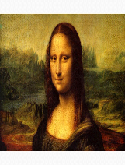
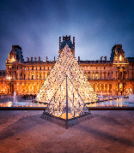
+ One would be nothing without the other!!

Lake Windermere Road Access
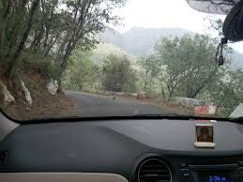
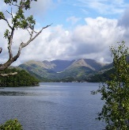
+ Road access to see the stunning views!!

Hotels Energy
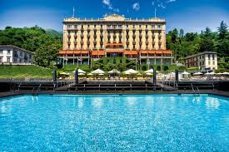
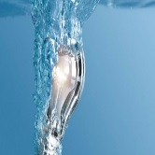
+ Hotels would need Electricity & Water Supply!!

Intangible services are what are created to enhance the location & experience,
for example:-
Welcome Friendliness


+ Creates a long lasting memory!!

Helicopter Grand Canyon
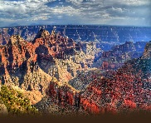
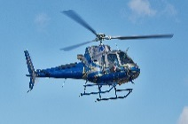
+ Excitement of the ride together with great views!!

THE TOURISM PRODUCT

The end result of the holidaymakers experience would be a combination
of the following:-

Accommodation, Quality & Service
Local Attractions
Natural Assets:- Lakes & Mountains

Special historical locations would have their own cultural value and would never be able to be copied or replaced.

By applying the infrastructure of tourism then its superstructure could be developed naturally.

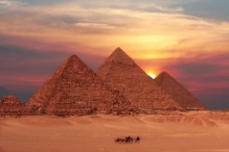
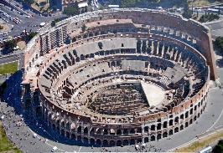
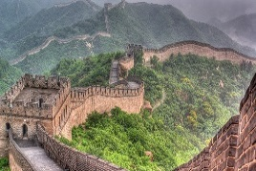
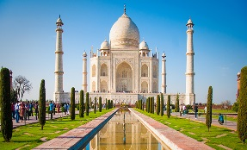

INFRASTRUCTURE & SUPERSTRUCTURE

INFRASTRUCTURE

These would be services which might be used publicly, they would be available to both the local communities and tourists.

Some examples of these are as follows;-

AIRPORTS, ELECTRICITY, ROAD ACCESS, WATER SUPPLY & DRAINAGE

Without the above in place there would not be the opportunity of visiting the country as well as the opportunity of staying at hotels/accommodations or enjoy local places of interest & attractions.

SUPERSTRUCTURE

Includes those facilities that have been developed especially to respond to the demands of visitors.

Examples of these are below;-

HOTELS, RESTAURANTS & RECREATION
The facilities are constructed primarily to support tourism and to enhance the visitor activities. They would be constructed primarily to attract and serve international holidaymakers

CLUSTER CONCEPT IN TOURISM

Tourism has become a very important sector for many countries worldwide. This is due to the ever growing request for tourist products and services.

The modern tourist has become a very demanding customer which has been said by the following:-

TRAVEL AGENTS, ORGANIZERS OF RECREATIONAL EVENTS & OWNERS OF ACCOMODATION FACILITIES

The above has also been confirmed by the authorities of countries/cities for which tourism is their main source of income.

Tourism is a suitable sector for an efficient use of a potential cluster.

The nature of a tourist product would comprise of:-
THE CULTURAL & ENVIRONMENT ATTRACTIVENESS OF THE PLACE
HOTEL SERVICES
ACCESS TO QUALIFIED GUIDES
The above as just 3 examples which combined can enhance the tourists enjoyment.

RESORT COMPLEXES

A resort complex would consist of a concentration of tourists based in one location. They are able to provide accommodation, recreational facilities and entertainment.

As they provide a varied amount of experiences this requires a larger amount of capital investment which has the opportunity of then helping the local economy and creating jobs in the area.

Examples of the main products they would consist of are as follows:-

HOLIDAY ACCOMMODATIONS;-

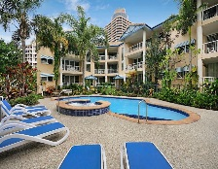
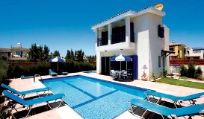
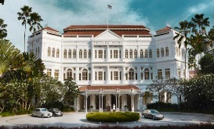
HOTEL VILLA APPARTMENT

RESTAURANTS
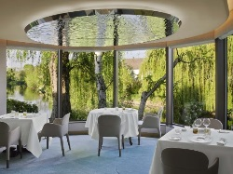
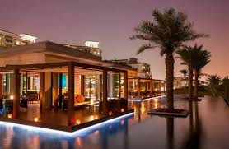


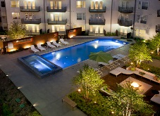
RECREATIONAL FACILITIES;-
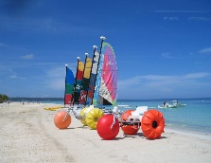
SWIMMING POOL SPA BEACH

The ideal complex for the tourist would be a combination of all the above as well as offering excursions to the local places of interest.

