
Assignment Cover Sheet

Student Name: | Vikum Weerasinghe
Student Number: | 28202
Course: | Level 4 Diploma in Accounts and Finance
Assignment NO: | 06

Marking Criteria:
We expect the learners to write minimum one well expressed point in three lines against each allocated mark. This means one needs to write 15 lines with 5 well expressed points to get high grades for a 5 marks question.
For high grades use examples and illustrations where appropriate.
Answer 1

The Balance Sheet is a statement that gathers most of a component's advantages, liabilities, and esteem beginning at a given point in time. It is conventionally used by advance pros, theorists, and moneylenders to assess the liquidity of a business. The advantage report is one of the records joined into a substance's budgetary announcements. Of the fiscal clarifications, the bookkeeping report is communicated as of the completion of the itemizing time allotment, while the pay declaration and verbalization of cash streams cover the entire reporting time frame.

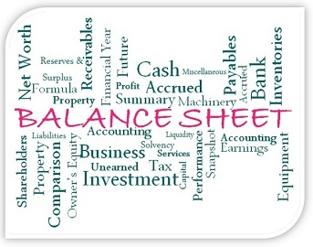

Definition:

A Balance Sheet is a declaration of the cash related position of a business which communicates the favorable circumstances, liabilities, and owners' an incentive at a particular point in time. Toward the day's end, the bookkeeping report demonstrates businesses all out resources.

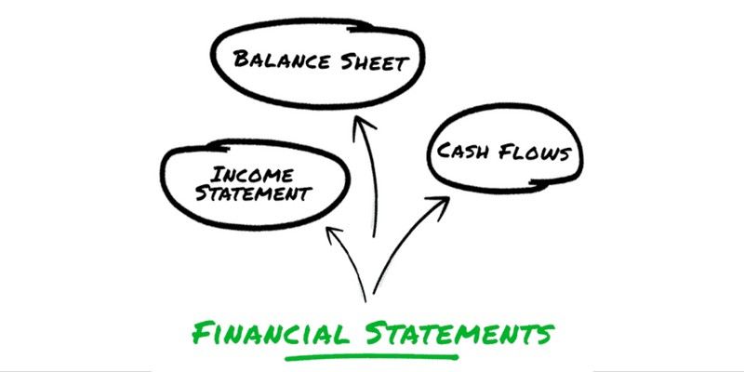

The Balance Sheet is the most basic of the three basic cash related declarations used to demonstrate the budgetary quality of a business. The others are:

The Income Statement, which shows net pay for a specific time span, for instance, a month, quarter, or year. Net pay levels with salary short expenses for the period.

The Cash Flow Statement, which shows the advancements of exchange and cash reciprocals unmitigated of the business. Unending negative salary is symptomatic of irritated associations.

Melded associations are required to join bookkeeping reports, wage verbalizations, and exchange stream clarifications out budgetary reports to financial specialists and charge and managerial specialists. Arranging resource reports is optional for sole ownerships and associations, yet is significant for checking the prosperity of the business.

A true and correct resource report is essential for a business visionary that is scanning for additional commitment or esteem financing or wishes to pitch the business and necessities to choose the sum it is value.

All records in General Ledger are requested as an advantage, a hazard, or esteem. The association between them is imparted in this condition:

Assets = Liabilities + Equity

The things recorded on bookkeeping reports change from business to business dependent upon the business, yet when in doubt the benefit report is isolated into the going with three zones:

Assets



As the accounting report representation showed as pursues, resources are typically dealt with into current resources—those that are cash or can be easily changed over into cash—and settled resources that can't quickly be changed over to cash, for instance, land, structures, and rigging as depicted below:

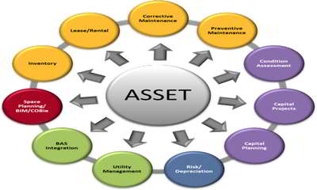

Liabilities

Liabilities are amounts owed by the business, and are isolated into present and long haul groupings. Current liabilities are those due inside one year and joins things, for instance,


Accounts payable

Annuity plan responsibilities

Borrowings portions

Utilities extraordinary

Ephemeral advances, credit augmentations, or overdrafts

Creating commitment

Held assets are utilized to settle responsibility or are all things considered reinvested in the business to abuse headway openings. While a business is in an enhancement sort out, Retained advantages are generally used to help extension instead of pay out as advantages to money related masters.

The explanation behind the advantage report is to reveal the cash related status of a business beginning at a specific point in time. The declaration shows what a component has (assets) and the sum it owes (liabilities), similarly as the whole placed assets into the business (esteem). This information is progressively productive when the bookkeeping reports for a couple of progressive periods are gathered together, with the objective that designs in the unmistakable subtleties can be seen.

There are a couple of subsets of information that can be used to get an understanding of the transient money related status of an affiliation. Exactly when the present assets subtotal is appeared differently in relation to the present liabilities subtotal, one can assess whether a firm methodologies satisfactory resources right now to fulfill its flashing duties.

One can similarly differentiate the total of commitment with the total entirety of significant worth recorded on the advantage answer, to check whether the ensuing commitment/esteem extent exhibits a hazardously anomalous condition of acquiring. This information is especially profitable for moneylenders and leasers, who need to know whether the development of additional credit may result in a horrible commitment.

Theorists like to take a gander at the proportion of cash on the benefit answer to check whether there is adequate open to pay them a benefit. Regardless, this judgment may ought to be adjusted subject to the need to put additional advantages in the business.

A potential acquirer of a business investigates a money related record to check whether there are any advantages that could possibly be stripped away without harming the major business. For example, the acquirer can differentiate the itemized stock balance with arrangements to decide a stock turnover level, which can show the closeness of excess stock. A comparable examination can be associated with obligation claims. Or then again, the settled asset hard and fast can be stood out from arrangements to induce a settled asset turnover measure, which is then diverged from emerge associations in a comparative industry to check whether the settled asset adventure is too much high.

In this way, the explanation behind the financial record is on a very basic level to reveal the cash related status of an affiliation, yet customers may focus on different information inside the declaration, dependent upon their own special prerequisites.

Answer 2

In accounting, we as often as possible experience the term resources, which demonstrates those things or resources asserted by the firm, which should give cash related favorable position in future, as cash streams. Resources are named settled resources and current resources.

The fundamental difference between settled resource and current resource lies in the way that how present the favorable circumstances are, for example in case they can be changed over into cash inside one year, by then they are considered as a present resource while when the preferred standpoint are kept by the firm for more than one accounting year, by then it is known as settled resources. Thus, we should explore the article gave, to have a predominant cognizance on the two.

Definition of Fixed Assets

Settled Assets are the bit of non-current resources, which are asserted by the association with the purpose of valuable use by the firm instead of resale. They are depended upon to give financial points of interest to more than one accounting year and are held by the association for working together tasks. On the money related record, settled resources are represented at their net book regard, for example sticker price less downgrading or amortization everything considered.

It involves unquestionable settled resources, unimportant settled resources, and capital work ahead of time, subtle resources a work in advancement. It fuses arrive and collecting, plant and equipment, PC, vehicles, leasehold property, furniture and establishments, programming, copyright, patent, trademark, and so forth.

Current Assets

Favorable position is said to be a present resource when it is anticipated to be recognized or wanted to be sold or ate up inside one year or the association's conventional working cycle. Associations held the present resource as cash or their change into cash or for using it in the giving items and ventures.

These are picked up with the ultimate objective of being traded. It fuses current theories, stock, without a moment's hesitation credits and advances, trade receivable, cash and cash partners, appealing securities, prepaid expenses, etc.

Key Differences Between Fixed Assets and Current Assets



The refinement between fixed assets and current assets can be drawn clearly on the going with grounds:

The non-current assets which the substance has with the true objective of continuing with use, to make pay, is called settled resource. Current resources are described as the things which are held with the true objective of resale and that too for a most extraordinary time of one year

The change of a fixed assets into cash is unthinkable easily. In reality, current resources are changed over into cash instantly.

Fixed assets are used by the association to convey stock and adventures. Thus they are held for more than one year. Then again, associations kept current resources, in the edge or exchange or out such shape that can be easily changed over into cash. Thus such resources are held for shy of what one year.

Fixed assets are regarded at net book value, for example novel expense of the favorable position less degrading. As against this, the valuation of a present resource is at expense or market esteem whichever is lower.

As the enthusiasm for fixed assets requires huge capital hypothesis, so long haul stores are utilized for its obtainment. Not in the least like current resources, which require without a moment's hesitation financing for its acquirement.

Non current assets can't be pledged while current resources can be guarantee, as certification for giving credits.

The fixed charge is made on fixed assets however current resources are obligated to floating charge.

Right when the association offers current resources, the advantage earned or mishap continued is of pay nature. Of course, offering of fixed assets will achieve capital advantage or disaster to the association.

CURRENT RATIO
The current ratio is a liquidity ratio that measures a company's ability to pay short-term and long-term obligations. To gauge this ability, the current ratio considers the current total assets of a company (both liquid and illiquid) relative to that company’s current total liabilities.
The formula for calculating a company’s current ratio, then, is:
Current Ratio = Current Assets / Current Liabilities
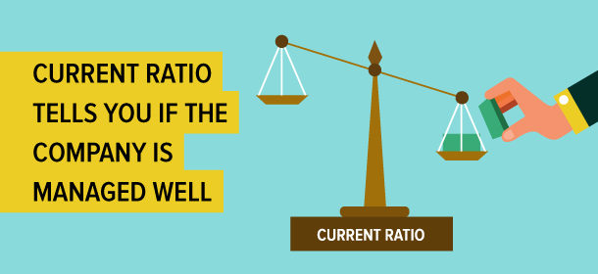
The current ratio incorporates all current assets and liabilities. It is also known as the working capital ratio.

This ratio is mainly used to measure organization's capacity to settle its obligations (debt and accounts payable) with its assets (cash on hand and at bank, marketable securities, inventory and accounts receivable). As such, current ratio can be used to take a rough measurement of a company’s financial health. The higher the current ratio, the more capable the company is of paying its commitments, as it has a larger proportion of asset value relative to the value of its liabilities.
Answer3
Clarification of Financial position together with other money related statements contribute towards a key and refined budgetary examination of the business. It not just gives a depiction of the connection's adaptability, liquidity and use; an examination of cash related records from various bookkeeping periods also permits remaking and fundamental thing expert.
An "all out resources" articulation or "explanation of monetary position" is relied upon to furnish you with a photo of the budgetary soundness of your business at a particular point in time. Indicate resources verbalizations are as frequently as conceivable arranged toward the start and completing of the bookkeeping time allocation (for example January 1), yet should be possible at whatever point.
The statement records the advantages of the business and their respect, and the liabilities or money related assemblages of proof against the business (for example responsibilities). The aggregate by which the estimation of the focal points beats the liabilities is the all out resources (regard) of the business. The all out resources mirror the proportion of obligation with respect to business by the owners. The formula for enrolling all out assets is
Assets - Liabilities = Net Worth
In like way, the going with formula clears up the correspondence of the parts of the declaration.
Assets = Liabilities + Net Worth
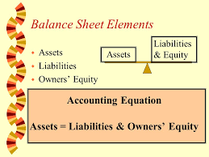

Portrayals of Assets and Liabilities
Resources are much of the time segregated into three game plans; present, transitional and entire arrangement. In a few conditions the broadly engaging and entire arrangement resource classes are converged into one portrayal called "settled resources".
Current resources incorporate money and close money resources. Current resources as a rule contain resources that will be sold and changed over to trade out the middle of the forefront bookkeeping period. Yields and subdued animals held open to be obtained are basic current resources for a property business.
Current resources have an imperative nearness of over one year. Normal bequest focus resources are gadget, gear and duplicating subdued animals.
Long haul resources join entry, for example, land, structures and working environments. These are resources regularly recommended as land.
Liabilities are regularly assembled a practically identical way resources are asked.
Current liabilities contain divides that are ordinary amidst the outstanding bookkeeping time span. This solidifies bank liabilities and premium and pushes divides due amidst the bookkeeping time length.
Coordinate liabilities incorporate significant duty against broadly engaging resources and as frequently as conceivable have a term of three to seven years. Intrigue and essential segments due inside the coming year are combined into current liabilities. Basically the proportion of duty staying after the present year's major bit is deducted is united into generally engaging liabilities.
Long haul liabilities include surprising duty against entire arrangement resources and may have a term of no under twenty years. Intrigue and basic segments due inside the coming year on this responsibility are united into current liabilities. Essentially the proportion of responsibility staying after the present year's fundamental part is deducted is joined into entire arrangement liabilities.
Current resources and current liabilities give a sign of the wage of the business amidst the coming year. Subtracting current liabilities from current resources picks the proportion of working capital in the business. Working capital is the proportion of cash used to empower the tasks of the business.
Disengaging current resources by current liabilities gives a degree showing the proportion of money open per dollar of current liabilities
Assessing Assets Value
Respect is resolved to resources on the day the all out resources statement is made. There are two systems for with respect to resources. The market approach is normally utilized as a bit of a reasonable complete resources articulation for private undertakings. The cost methodology is an increasingly present strategy customarily utilized for wide and complex affiliations. The two frameworks might be utilized as a bit of a tantamount clarification demonstrating two evaluations of all out resources.
Market driven Approach
The market approach fuses in regards to ideal position in context of its present market or course of action respect. For resources with a prepared exhibit the present market cost is utilized. Different resources (for example hardware and land) may must be studied or respected with some other framework. The market approach gives a gage of the estimation of the all out resources if the business is exchanged (resources sold and liabilities paid) on the date of the statement. After some time, the estimation of the absolute resources utilizing this methodology will change in light of changing resource costs and the proportion of points of interest held in the business.
The market approach normally utilizes a "net" showcase estimation of the focal points. For instance, if the offer of good position will trigger pay compel responsibility, the estimation of the preferred standpoint is balanced for the assessment possibility.
An absolute resources proclaim utilizing the market valuation framework measures the "dissolvability" of the business. For whatever time range that complete resources is certain, the business is dissolvable. In the event that liabilities beat resources and the all out resources are negative, the business is "cleared out" and "bankrupt".
Dissolvability can be estimated with the Debt to Asset Ratio. This is figured by confining total liabilities by demonstrate resources. For instance, a degree of .4 proposes that, if the liabilities are paid, it would require the liquidation of 40 percent of the central focuses. The more prominent the degree, the more noteworthy the proportion of favorable circumstances should have been exchanged.
Cost Approach
Another technique for with respect to resources is the cost methodology. It fuses with respect to great position in context of its stand-out buy cost, less breaking down, despite climbs to the preferred standpoint. For instance, device can be respected by subtracting accumulated corrupting from the essential sticker cost of the hardware. Land can be respected in context of the essential obtained expense of the land, less breaking down on structures and working environments, despite any movements to structures and working environments.
The cost methodology gives a right evaluation of the estimation of the all out resources in context of the profitability of the business. In any case, it may not give a correct game plan estimation of the business.
Other Financial Statements
An absolute resources elucidation is just a lone of two or three money related affirmations that can be utilized to gage the budgetary idea of a business. Other conventional elucidations intertwine the Cash Flow Statement and the Income Statement, despite the route that there are two or three different clarifications that might be merged.
These statements fit together to plot a sweeping money related photo of the business. The advantage report or all out resources clarification demonstrates the dissolvability of the business at a particular point in time. Declarations are much of the time planned toward the start and satisfaction of the bookkeeping time distribution (for example January 1).
The Income Statement is a dynamic elucidation that records pay and costs over the bookkeeping time allocation (between the two all out resources declarations). The net wage (difficulty) for the period develops (diminishes) the complete resources of the business (as appeared in the summit accounting report versus the starting money related record).
The Cash Flow Statement is besides a dynamic articulation that records the surge of money into and out of the business. A positive (negative) wage will develop (diminish) the working capital of the business. Working capital is depicted as the proportion of cash used to office business tasks and exchanges. It is figured as present resources (money or close money resources) less present (liabilities due amidst the stand out bookkeeping period - for example year).
A Complete course of action of Financial Statements (Decision Tool), including the start and end mean resources elucidations, the pay proclaim, the compensation articulation, the announcement of owner regard and the budgetary execution measures is accessible to complete a serious money related examination of your business.
To engage you to think about the budgetary success of your business, Financial Performance Measures enables you to give your business an enlistment. Translating Financial Performance Measures urges you to comprehend what these execution estimates mean for your business.
Bookkeeper essentially needs to fuse a large portion of the aggregates recorded under resources, and openly, join the greater part of the sums recorded under liabilities. Over the long haul, the firm should finish up with two numbers: an uncommon aggregate of points of interest and a mind boggling aggregate of liabilities. At last, subtract the complete liabilities from the all out resources - and that is the alliance's absolute resources.
As clear as this figuring may be, convey it with a grain of salt. This single number doesn't paint a right photo of the alliance's entire budgetary condition. In any case, it infers that to perceive money related targets soon, it should work to satisfy those duties rapidly.
On the off chance that the firm is long standing undertaking and stressed over negative absolute resources, it's a mind blowing opportunity to make sense of how to escape responsibility.

Student Statement:

By submitting this assignment, I confirm that this is my own work.

Student Signature | Vikum Weerasinghe | Date | 01/02/2019

For Tutor / Assessor Use Only
Total Marks
Marks Obtained
Percentage / Grade

