
Assignment Cover Sheet

Student Name: | SARA PABLO
Student Number: | 11060
Course: | DIPLOMA IN TRAVEL AND TOURISM
Assignment NO: | 4

Marking Criteria:
We expect the learners to write minimum one well expressed point in three lines against each allocated mark. This means one needs to write 15 lines with 5 well expressed points to get high grades for a 5 marks question.
For high grades use examples and illustrations where appropriate.
Please insert your completed assignment ( in word format) here:

Student Statement:

By submitting this assignment, I confirm that this is my own work.

Student Signature | SARA PABLO ALVES | Date | 20/02/2017

For Tutor / Assessor Use Only
Total Marks
Marks Obtained
Percentage / Grade

Initial Questions

what are the inbound tour operations
Inbound tours involve non-residents traveling to another country.
Tour operators provides tours and holidays in many different languages; for different budgets; for individual travelers, families, people with special interest; people with special needs or anyone who wants to enjoy the freedom of travel at their own pace. This sort of costumers have all the necessary services (treated with great delicacy) to have a satisfactory travel in their desired destination abroad their country.
The product in inbound tour operations is designed in accordance with market, their bases are regulated using the last technology, always having control over possible issues related to vouchers and tickets.
Arrangements for operations such as transfers, hotel check-in, pickup and delivery (carefully planned and prepared), help in emergencies and the fact to make certain of effortless connections for the group by road, rail and air, are some of the needs that a tour operator inbound have to cover.
The staff has to be ready for any kind situation. Make the costumers feel secure and safe to be able to satisfy their physical needs and provide them a feeling of belonging or ensure that their status is recognized are important factors.
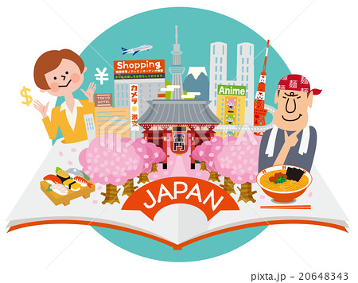

Define outbound tour operations
Outbound tourism comprises the activities of residents from a given country travelling to and staying in places outside their country of residence and outside their usual environment.
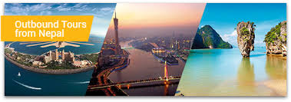
These tours take travelers all over the world. In order to be able to carry out all the facilities for passengers who wants to travel in this way they have several divisions or sections:
- Documentation section
This section take care of the costumers, who have to accomplish different documentation requirements and a complete a set of formalities.
Any holidaymaker have to contact the documentation section of the travel agency or the tour operator division. These professionals should keep informed the costumer about the documentation requirements, advising in case they need a visa or other special document. Depending on the purpose or reason of the visit the necessary documentation can vary.
- Visa section
This division has the responsibility to collect, endorse customer’s passports and return them to the clients in advance of the journey date.
- Reservation section
It is a really important division, because they have the information about airline timetables, hotels, type of tariffs and also the most visited locations at the destination. They are responsible to collect all this information, deliver it together with the travel plan and the designed flight connections, arrivals/departure timings and location of the hotels on a special designed sheet of paper.
Once the previous step is done and the plan is approved, a copy has to be given to each passenger, that’s called the itinerary.
At this point, the reservation division has to contact the airline to request places in the aircrafts according to the itinerary. After the request the airline provide a copy of their itinerary and they attach it to the passenger´s plan.
After all confirmations have been received the airline will inform the reservation section about it. At this time the agent request (once it is all checked and correct) them to issue the tickets for the passengers.
A voucher has to include the next important information:
- Name of the passenger
- Place to be visited
- Flight number
- Date
- Time
- Passport number
- RBI permit number
- Applicable fares
- Agent code number

All this voucher information is sent to the airline, then they proceed to issue the flights. Once this is done, it returns to the agent´s hands to give him/her final approval.
It is really important to keep in mind that the promised services have to be the same sold at the initial point. The tour operator should to be cautious.

Name the principle suppliers involved in the tourism industry
In tourism industry it is very easy for the costumer to know which suppliers are responsible of giving them the necessary services that they need to travel. Operation suppliers such as hotels, airlines, cultural attractions, rents a car, malls and also insurance companies are the managers behind travels, the sources of the suppliers. They play a key role in the success of tour operations.
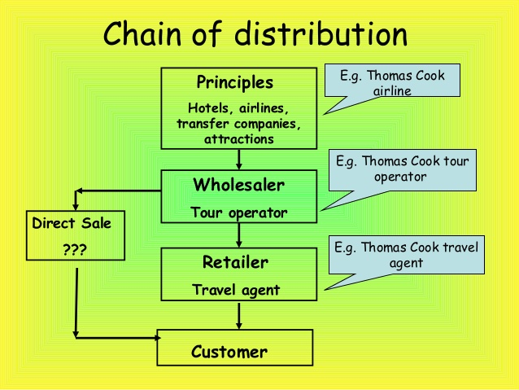

Depending on the kind of travel (inbound or outbound), suppliers are different:
- Inbound: When the product is designed, besides of be aware on what type of travel product exist in markets and at what cost, it is necessary to adapt the products to the appropriate target market and provide a good price.
- Outbound: It should exist connections and keep the contact with suppliers from the country and at abroad destinations to have agreeable conditions for bargain for all parties involved.

Outline the staff requirements for inbound tour operations
When you have created a fantastic touristic product or you are the manager who has to create a professional operational staff, it’s really important to choose the best possible people to work with.
You must establish a good criteria to match the sort of people you want to work with. What kind of skills, the expected behavior and the way they have to deal with clients are really important factors, these vary depending on the product you’re working on. It is not the same a professional who has to work taking care of pick up a transfer, than a person who works constructing rates, their capabilities has to be different.
For inbound tour operations and depending on the job position, the staff needs might include:
- Supervisor transfer and pick up
It is one of the most important roles working in a tour operator. He/ She has to be able to train his/ her staff in procedures and relevant considerations to pick-up people and transfer them to hotels.
- Airport representative
On this type role, managers have to hire professionals to work in a non-conventional hour. They main task is to wait for the groups of people in the airport at any time, either morning, afternoon or night, depending on the scheduled time of the flight arrival.
This person has to be a dedicated worked and if they also can work during the day as office assistant will be more complete.
- Account worker
Professionals working in this area needs to have expert qualifications and experience. Tour operation business is based on credit and all the payments have to be done in the exact moment. Accounts executive are also responsible for vouchers intended for transit transporters as well as for hotels.
- Drivers and chauffeurs
They need to be good communicators, polite people and it is a plus to have a good sense of humor. To have knowledge about the local tourist attractions and sightseeing place is a good skill. Furthermore they would need experience on the best car routes and the signaling patterns.
- Escort and guides
They represent the company, essentially, they are the company´s walking image so they play a critical part in the success of an inbound tour operation.
They are the professional that go with the groups always, guiding and showing to the customer through the final product of the tour operator.

Discuss, in detail, the tasks involved in inbound tour opeartions
An important point is have skilled staff, which involve to train them to make them more empathic, putting themselves in the client´s shoes to try to feel under particular travel situation as a long flight. This is important to have a successful tour, and in order to achieve this, training is a must.
Once the tourist arrive, they usually are exhausted due to the physical effects of the flight. Holidaymakers could be nervous in different environments where people have different culture, the staff have to be able to ensure the tourist´s comforts and safety.
Customers are waiting for a good service staff, they should be able to deliver them everything that the tour operator has promised during the negotiation process. This is the time to live up to the expectations. Costumers are expecting the following points from the professionals working at the tour:
- Make them feel and safe
It is important to make them in this way. They are in a foreign country, but they cannot feel alone, the staff will be there for their necessities in all moment.
- Satisfy their physical needs
As discussed above, after a long flight they may be suffering for instance a physical effect due to the climate changes between home country and the visited place. Staff should be able to provide them food, drinks or any kind of elements that make them easier to accustom to the destiny.

- Ensure that their status is recognized
There could be problems with the immigration department or at the airport with the bureaucracy. Professionals waiting for the tour should help to give a solution of this kind of situations.
- Provide a feeling of belonging
Make the customers comfortable at any moment. This is a great starting point for a quality tour, the staff have to take care of every details to make customers have a pleasant tour.
Particularly in cases where the communication could be an issue, the staff should put especial attention on the group necessities. It is important to understand how to advise them, offering them different possibilities. The product managed from the tour operator have to be always the best. In order to achieve this, the next points should be checked:
- Use for the transport an appropriate vehicle that meets the expectations (conditioned vehicle or a large one with enough capacity to keep their luggage).
- The driver should be informed about where the costumers should go, and he should be able to escort them. He have to be ready for unexpected situations.
- Vouchers should be leased in advance (for transport and hotels), and housekeeping advise about the time of the customer´s arrival to be ready to receive them.
Another important point is to have a good escort. They have to be in possession of the following data:
- Name list
- Flight number
- Transport details and vouchers
- Hotel name
- Address
- List of rooms
- Hotel voucher
- Any special necessity from the group
- Take a placard tourist´s name with all the required information
It could be several escorts for each tour, they have to be well coordinated and all of them have to understand the itinerary. It is important the communication within the group to achieve a successful tour.

In an unlikely situation they have to be prepared. For instance any change on flight´s arrival the staff have to put on advice to be able to reschedule the next services.
Apart from the escorts, the transfer staff should be waiting at the airport before the customer´s arrival. So it would be great to provide them (just if the airport allows it) airside passes, a card or electronic key that allows them to restricted areas on the airport. In case the airport does not allow it, the staff should be waiting in the visitor´s area with a placard with the name of the guest´s group leader´s name.
Their main tasks are:
- Passenger´s identification
At the arrival of the group the airport transport staff welcomes tourists in a warm way and check their tourist list to ensure all their costumers has arrived. If this is not correct they have to go to the airport information service to make an announcement about:
- The missing passenger´s name
- Name of tour group
- Place of group origin
- Easy to identify meeting point.
Obviously the announce should be done in a language that the passenger can understand.
After that, the next step is check with the airline to make sure that the passenger was on that flight or not. If he/ she was, the announcement has to be repeat, and if it doesn’t work, after thirty minutes waiting the staff member has to give instructions at the information desk about the whereabouts of the group. Same happens in case of lost baggage. the staff has to follow the instructions for their recovery. It is responsibility of the airline to find and forward the lost bags or, if it corresponds, provide a compensation.
Once the passenger´s identification is done, the tour can continue, introducing him/herself and proceeding gradually to converse with the travelers in a welcoming tone about their journey etc.
- Departure transfers
This process should start a few days before. All the necessary tickets have to be collected and all the services reconfirmed. The staff will give a copy of this information to each costumer by letter or putting a note on the tour notice board.
On the departure day, the staff using their check list will have to reconfirm all the information in the arrival transfer.
The tasks will be:
- Inform hotel and potters to be prepared.
- Arrive to the hotel before the given time.
- Find out from reception if everyone has made extra payments.
- Have clients assemble in one place and call those who are missing
- Load bags and have each client confirmed
Remind clients to do the following things before departure:
- Pay the extras
- Return keys
- Clear out safe deposits
- Ensure passports and tickets are in hand and luggage is accounted for
- Grouping passengers
- Leave for the airport
On the way, outline the procedures for the airport
- Inform about the facilities that are available
- Drive up as close as possible to check in area
- Help with porters/trolleys
- Assist with check in procedures
- Walk with them to security and passport control
- If there is a delay before the clients have gone to the airside the staff continue being responsible for them
When all have gone to the airside, the staff work is finished.

which marketing strategies are used in inbound and outbound tour operations and how do they differ?
Marketing could be defined as a management function which organizes and directs all those business activities involved in assessing customer needs and converting customer purchasing power into effective demand for a specific product or service to the final consumer or user to achieve the profit target or other objective set by the company or organization.
Following this definition and applied to tourism, marketing is not solely attending travel fairs a marketing brochure, these are just a small part of the field of promotion. It is necessary develop suitable products for the market, price them correctly, promote them effectively, distribute them to the final consumer and evaluate the results of the total program.
Depending on the kind of tourism that the tour operator wants to offer to their costumers (inbound or outbound tours) there are different marketing strategies, these are the following:
- MARKETING INBOUND TOURS
The focus has to be make the product popular in all the countries that we want to sell it in order to draw in tourists.
Usually, tour operators use the Department of Tourism of the country to develop their marketing strategies, it is strange to find any tour operator who has its own office in other countries.
In case a small or medium sized operator want to take part in any international travel exhibition and exposition, the Department of Tourism help them to make their company and the product more visible to the world. When they want to have direct access to the overseas markets this is very advantageous.
The marketing program has to have the principles of “customer care” and “quality”, couple with a good overseas contact and to the idea of being ready to come up on demand with packages according to tourist´s request, is the most effective marketing tool.
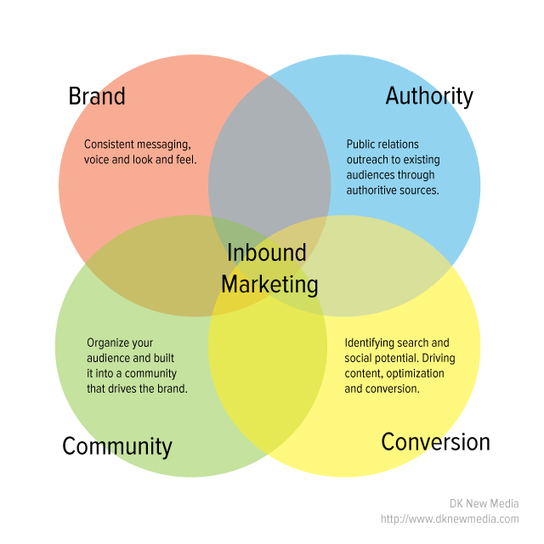
If a tour operator wants to sell a quality product, pricing could be an impediment in the marketing campaign, there are two possible options:
- Tour operators that want to get the business providing cheap rates
- Tour operators that offers quality instead of quantity when they are pricing their products.
Nowadays, the second option is the most used by the players in business. Therefore, and based on these two options, market is divided in two parts:
- To reach a mass consumption.
- To sell quality products to a sector of the population for which the level of the services is more important than the cost.
Usually the quality is able to travel from mouth to mouth, so we can think that today´s tourists are informed about destination either on their own or by asking tourists who have already been. Before to arrive the destination, they have all the information about what can they visit or the hotel where they are going to stay. This is “the power of the word”, a free marketing strategy.
After designing, pricing and promotion of a product, the distribution should be the next step. It can be self-employed of the tour operator or using the resources of another trade players as tourism offices and embassies from the different countries.
- MARKETING OUTBOUND TOURS
As opposed to inbound marketing, one of the most important sales strategies is that you and your marketing staff should be familiar with these locations. Travel to the country that you want to sell, know its appeals, its touristic places and its variety of accommodations, without doubts it is the best way to sell a product.
A good manager could divide the marketing department depending on the destinations that his/her group want to sell. In this way, the staff marketing will specialize only on destinations with which they work.
In the seventies and eighties, the outbound tours were reserves just for rich people, so there were not too much people to be able to travel in this way. A good way to advertise a destination is showing to the public in movies. This practice has its beginning in these two decades, although as shown in the image, is a regular practice nowadays.
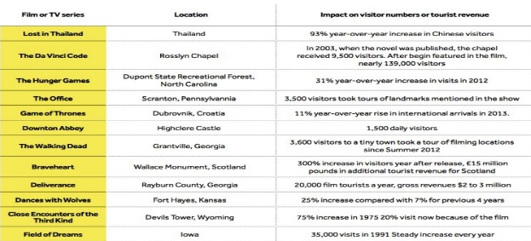
Considering all this information, the focus of marketing inbound guarantees the maximum level of quality, designing, development and delivery based on overseas markets, and on the other side, the outbound market is based on the experiences of the company’s marketing team.

