
Assignment Cover Sheet

Student Name: | Kelly-Marie Wood
Student Number: | 29679
Course: | Diploma in Management Level 4
Assignment NO: | 1

Marking Criteria:
We expect the learners to write minimum one well expressed point in three lines against each allocated mark. This means one needs to write 15 lines with 5 well expressed points to get high grades for a 5 marks question.
For high grades use examples and illustrations where appropriate.
Leadership is an action of leading a group of people or an organisation. There are four types of leadership roles according to the situational leadership model. These are as follows:
- Director - Leaders set out the roles and tasks of the employee and supervise them closely. Decisions are made by the leader and directed out to the employee and communication is mainly one way.
- Coaching - The leader still sets outs the roles and tasks of the employee but allows the employee to share ideas and suggestions. Communication is more two way and the coach is both direct in getting the employee to understand what is expected as well as supportive in guiding the employee to achieve the level they should be working towards.
- Supporting - Leaders support the employee to be more empowered. The leader is there to facilitate and take part in decisions, but most of the control is with the employee. The leader will support the employee to make the right decisions and become more self assured in their role.
- Delegating - This style of leadership takes into account the different skills and abilities of the worker. The leader will delegate certain tasks to individuals that hold high skill sets in different areas to achieve maximum results. There is very little directing or supporting within this style of leadership.

Servant leadership is a leadership philosophy in which the main goal of the leader is to serve, by adopting a set of practices that enriches the lives of individuals, to build better organisations. A servant leader shares power, puts the needs of the employees first and supports them to develop and perform to the best of their ability. This is different from traditional leadership where the leader's main focus is the thriving of their company or organisations

The Five practices which James Kouzes and Barry Posner identified are :
- Model The Way - Leaders who follow this practice show two main behaviours, they clarify their values and set an example. Their actions mirror their values.
- Inspire a Shared Vision - Kouzes and Posner identify "envisioning the way" and "enlisting Others" as two ways leaders can inspire a shared vision. The vision needs to be seen and accepted by others to manifest into a significant change within the organisation.
- Challenge the Process - leaders look to take risks, innovate, and experiment to find new and better ways of doing things.
- Enable Others to Act - Leaders enable others to take ownership. This is accomplished by supporting the employees to feel empowered, competent and connected to take a bigger role and responsibility within their daily working roles.
- Encourage the heart - This is about recognising the contribution others have input into the organisation and celebrating achievements to encourage the employee to feel valued and motivated.

A manager is someone who governs and is responsible for the important aspects of a job, project, or team. A leader is someone who is influential, takes charge, and is an example for others. Managers have particular obligations dependant on what they do and who they are managing. They delegate and implement plans for the team or business. Striving to obtain results by setting rules, remaining in control and reacting to situations they may encounter. They are essential to maintain a true understanding of who is in charge in a setting and tend to manage tasks and projects more than people. Managers do not consider human emotion or desire when making decisions, the preference is for concise, scientific methods of managing a group. They are considered as superior and are seen to have subordinates, which are people that follow and do as instructed. A successful manager should have the characteristics of both a manager and a leader.

A leader sets precedence in guiding others to perform to their greatest ability by leading by example. They tend to deal with the personal issues of a group. A leader will have followers who believe in the vision and work ethics they portray by earning their loyalty, respect and admiration. Goals are achieved through passion, heart and charisma and a great leader will focus on human emotion and desires to accomplish this.
Directional Thinking is a process of thought that produces a vision or establishes a direction. This process consists of two key factors. The first being a direction - setting opportunity, this is an event in a person's life that presents an opportunity to change a course of action. There are two types of direction setting opportunities, those that are outside your control and those that are intentional. The second key factor is a direction - setting decision, this happens when a decision is made to stay on the same path or take a new route and travel in a different direction. The new direction can be made using varying techniques. These are:
- Paradigm Shifts - An example of this is a 25 year old man was sitting on a bus with his father looking out the window saying things like " look dad at those magnificent trees with all their green leaves, and the sheep in the field" Gasping and repeating all the things he could see out the window to his father. This had the other people on the bus pass judgement and one person even told the father he should take his son to hospital to get a diagnosis. The father then replied and said that they are both on the way home from the hospital and that his son had been blind from birth and for the first time is experiencing sight. This made the people on the bus change their initial thought process and become more compassionate towards the father and son and share in the young man's joy of being able to see the world through new eyes.
- Mind Mapping - This is an example of creative or lateral thinking verses linear thinking which is sequential and orderly.
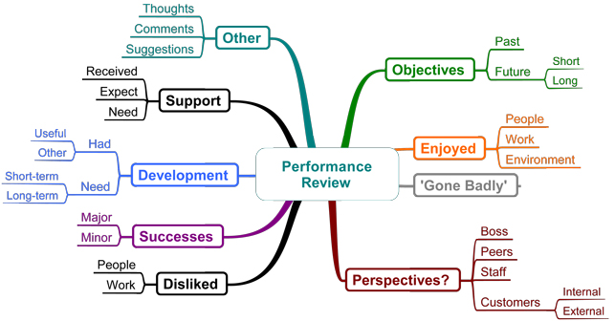
Diagram of a mind map.

- Reframing - This can help us to come up with new insights and ideas by reframing the delivery of a problem can help us change perspective. Examples would include:
She is too impulsive to refrain from using drugs to She's so spontaneous, she can find a better way to cope.
He is too self-involved to get help to his independence will keep him focused on healing.
She is too foolish to stay on the right path to Her humour will help her through the tough times.

- Consequential thinking - the process of identifying the risks associated with a particular action and then considering whether to continue in pursuit of that goal. People take risks on a daily basis which the decisions made and actions taken but the difference between personal risk and the risk you take being a leader is the effect it has on the organisation and the people the risk affects. Consequential thinking is a logical extension to directional thinking but before making a decision for change we should consider four elements. These are:
- Is it ethical?
- Is it Legal?
- Is it fair and balanced?
- Will it pass the test of public scrutiny?
Pro's verses Con's and Cost verses benefits could also be considered within consequential thinking to produce a well informed decision.

The ability to influence others is the heart of being a great leader . Warren Bennis and Joan Goldsmith state that leaders inspire and empower people, they pull rather than push them in the right direction and if you want to lead people you first have to get them to share your beliefs and want for the same objectives.
When we look into influencing others there are a few factors we need to consider these are:
- An individual's resistance to change -are manifested by human characteristics such as perceptions, personalities and needs. The economic reason for resistance is fear of technological unemployment, fear of reduced hours and reduced pay and fear of demotion and reduction of pay. People with a high need for security will be resistant to change as it threatens their feeling of safety. Peer pressure is another factor as an individual may be ready for change but may refuse because their peers are refusing. Change could bring with it social displacement and could upset the current status quo that workers are accustomed to and employees may also resist change that threatens to put limit on meaningful interpersonal relationships on the job.
- Maslow’s Hierarchy of Needs 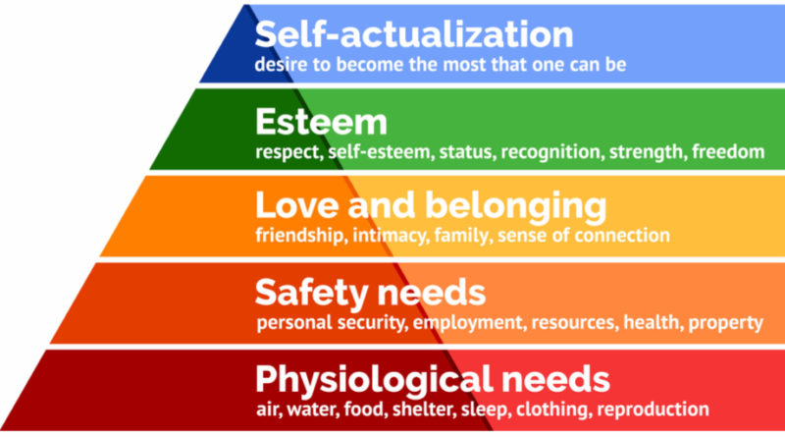
- The types of strategies that manipulate - successful leadership should not be based on manipulation and coercion but on persuasion.
- The type of strategies that persuade people to change (usually based on principles of fairness and mutual gain) Robert Cialdini has identified six influence strategies In Influence: The Psychology of Persuasion. These are :
- Reciprocity - This is when we feel obliged to act the way others have towards us for example when it is your birthday and a person gives you a card, you feel obliged to reciprocate with a card for their birthday, or do something of equal value in return.
- Commitment - Once a commitment is made we feel both internal and external pressure to follow through even if the circumstances prove difficult. For example, If I offered to take an elderly lady's dog for a walk after work each night, I would have the knowledge of that commitment made and my internal pressure of not letting the lady or her companion down and endeavour to fulfil this decision even if I was unwell or feeling unmotivated to complete the action.
- Social Proof - We look to others that are already using techniques we want to consider by seeking out the best practice. This form of influence is more effective when we seek from people we know and trust.
- Likability - People are going to be more willing to listen to your ideas and share your vision if they like and trust you. People like to feel valued and useful, this all helps with team morale and performance.
- Authority - People respond better to requests if they feel it comes from an authority figure. For example a police officer is rarely challenged because they are a person in authority, respected and held in high esteem.
- Scarcity - This is about remaining in control and not allowing other factors to cause major problems or disasters.
Overall a leader needs to have the power to influence using all the above factors to get their staff to perform to the best of their ability to build a workforce that is great and shares the same values and ethics to be able to thrive.

Student Statement:

By submitting this assignment, I confirm that this is my own work.

Student Signature | Miss K Wood | Date | 30.01.19

For Tutor / Assessor Use Only
Total Marks
Marks Obtained
Percentage / Grade

