
Assignment Cover Sheet

Student Name: | Anna Babayan
Student Number: | 8437
Course: | Diploma in Fashion Design Level 4
Assignment NO: | 5

Marking Criteria:
We expect the learners to write minimum one well expressed point in three lines against each allocated mark. This means one needs to write 15 lines with 5 well expressed points to get high grades for a 5 marks question.
For high grades use examples and illustrations where appropriate.
- What is meant by ‘binary colors’?
Binary colors, also known as secondary colors are those that are formed by mixing two primary colors. The later represents fundamental ones which are not formed by mixing other hues, and based on which, the other colors are being created. We have three fundamental colors - red, yellow and blue - positioned in equal distances from each other on color wheel, and consequently three binary colors. Secondary or binary colors are situated in between those three colors as a result of combining two of them. In the picture below, we have three primary colors-red, blue and yellow and in between two each of them - three secondary colors: mixing red and blue we are receiving violet, blue combined with yellow develops green, and lastly yellow and red gives us orange.
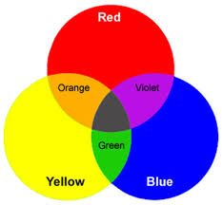
- Grey color is formed when black is mixed with white. Is it a warm or cool color what do you think and how best it can be used in creating an attractive color scheme?
All colors have their undertones which determines their warmth or coolness. For example, in case of peoples’ skin tone, two people can have the same skin color however vary with the warmness and coolness of it because of the different undertones. The latter, as I already mentioned is the defining factor of the color as being cool or warm. Grey is formed by mixing two neutrals (black and white), meaning it is also a true neutral color like black and white. It is also called as achromatic – without color, as it contains only black and white. We can define a “medium” grey as a hue received through mixing equal amount of black and white. Equal or not, grey does not have an undertone of third color to be classified accordingly. However, there is an option to create an attractive color scheme – by adding the third color as an undertone to receive beautiful color scheme of mutually complementing and gradually brightening hues, and also by adding more white or black thus making those pallets appear with higher or lower intensity.
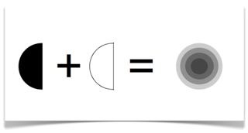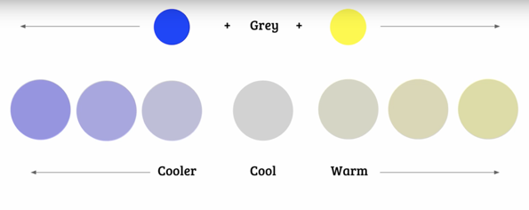
Medium

Neutral

Picture 1
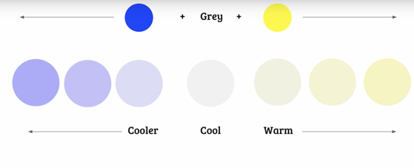
Neutral
Picture 2
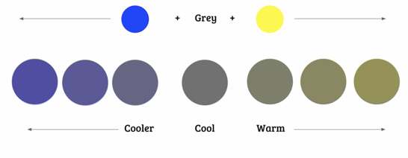 Picture 3
Neutral

Adding warm undertone (pink, yellow, red) to our grey we will receive warmer grey, adding cooler ones (green, purple, blue) will create cooler grey versions. In picture 1 we have medium grey. Adding yellow we will receive warmer yellowish grey that is reaching to beige. On other hand adding blue will create cool bluish grey with deepening blue undertone (as we add more and more of that hue). Thus, adding warm or cool drops into our neutral grey, we will receive different variations of grey which will bear warm or cool undertones. To receive more options in creating an interesting color scheme we can play with the amount of black or white in original medium grey as it is shown in pictures 2 and 3. In the first one we added whiter and created lighter versions of previously gained hues, while in the next one we multiplied black and received more charcoal grey and thus deeper toned versions.
Thus, as a conclusion I may say that grey is a neutral color which is basically the black having a bit of white on it, or white that has drops of black in itself, and purely it is a neutral one. However, grey is also a universal “color” which allows to create many different and interesting color schemes by being the base color on which we can put some third color as an undertone, and the amount of added color determines a new version of grey. In addition to that we also can play with the amount of blackness or whiteness to lighten up or darken the particular hue.

- Which of the following colors should a stout person wear? Dark or light. And why
Colors are like the lines, they create a visual illusion regarding the sizes of person. Light and warm colors when using in clothes make figures appear bigger, and on contrary the dark, cool colors create illusion of figure or the appropriate body part look smaller. This above-mentioned fact is crucial to bear in mind while designing a dress for a particular body type as we want to highlight and make bigger what is small and needs enhancement, and similarly we want to hide or make smaller those parts that are the least beneficial to show.
In case of stout figure, which is a heavily build figure that needs to be slimmed down and appear narrower, is important to use appropriate dark colors that will hide and “consume” the additional centimeters and create slimmer silhouette.
Though the styles of the dresses on every picture below is chosen correctly for the models’ body types, however it is clearly visible how the darker clothes make these wearers appear smaller in size and more slimmed especially in waist part, while the white versions are kind of positioning the light on the body and create stronger accent on it, that not only keeps the eye stared at the body itself but also visually makes it seem bigger and brighter.
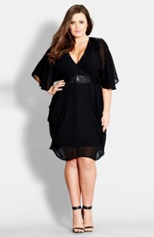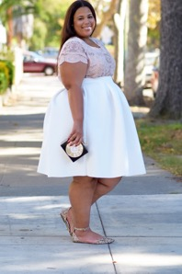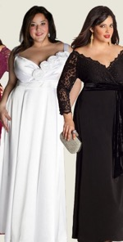
- If you want to create an illusion of height and slimness using color, how would you do it?
As I mentioned above colors create visual illusion of sizes similar to those that are created by lines. Thus, we can highlight or hide, make things longer or shorter with color variations. Slimness can be created for example through making the edges of clothe with dark colors while the center of it highlight with lighter one. This will create the illusion of light hitting at the one narrow part and the figure will appear slimmer. We have options to use one or several colors in our designs. In order to use different hues, we need to pay attention to the harmony that needs to be created while using them and off course the end result of visual aspect that will be created on the wearer. If we use contrasting colors one for top the other for bottom that will create a horizontal division in the middle of them thus a shorter silhouette will appear. To receive height and slimness for the customer I will use a single-color design which won’t visually cut the body and create unnecessary separations rather will show it solid slim and tall. While the height of the model in picture below isn’t quite well visible, however the difference of the two images catch the eye. The girl from the left is wearing two contrasting color top and skirt, both of them capture the eye and cut her body in the middle. Definitely she doesn’t seem to be very tall and, in this case, given choice in clothing make her appear shorter as her up and bottom doesn’t complement each other, they both seem loud. On other side the girl is wearing solid color dress which height is good for her body and definitely makes her slimmer by hugging all her body instead of dividing it into two parts as was in the first case. Here she even seems taller than in the picture left.
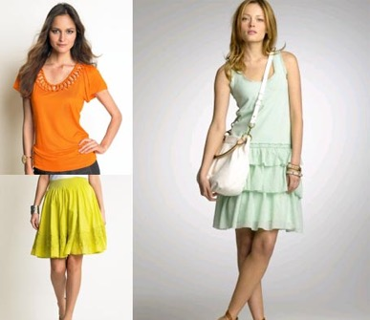

- ‘Wearing black for a grey-haired lady is the most suitable choice’. But how should she wear this in the best possible way?
As It was mentioned earlier true gray is formed with black and white, thus no other color can bring grey into life more than black as well as white. For grey-haired people the choice of black in clothing is the most beneficial, as the black will complement the best to her grey hair and enhance her appearance. However grey and black will create too dark and heavy look and her face will get lost, as the only eye catcher will be gray hair that will shortly merge with black dress. The perfect solution here will be the usage of white in the complexion, and as we want to shed light on the face we will use the white hints on the collar. This will lead the eye toward face and create harmonious appearance.
In all of three pictures below very elegant looks are illustrated: Grey haired lady in black. In the first one she is wearing a total black and though the look is very classy however it’s too dark and feels like the body is separate and doesn’t have any connection to head. On the other two looks of Miranda Priestly (Meryl Streep) a white color presented in her collar lightens up the overall appearance and harmoniously connects grey hair, face and black body resulting in a less heavy and brighter look.

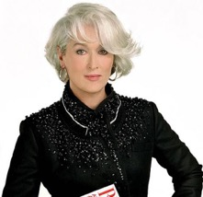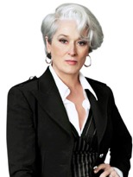
- For a person of sallow complexion which type of colors is best choice? And why?
Sallow complexion refers to one having pale or yellowish skin tone which means those people need to be very careful in choosing colors in clothing as it may even deeper highlight the not healthy skin tone or in contrary help to visually minimize not beneficial condition. The key here is not to highlight the dull complexion and make it paler by repeating the yellow skin tone in clothing, but to bring life and visually add pink in cheeks by adding it to clothes. Definitely choosing yellow or green will deepen the bad situation as they will highlight the yellow tone of the face and even if there is anything reminding of healthy skin color on the persons face, the yellowish and greenish colors will quickly make them fade. The case isn’t the same with colors like pink, red, and also blue-green which being added to dresses will bring up the redness in cheeks and make the complexion brighter.

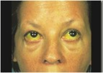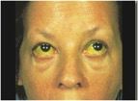

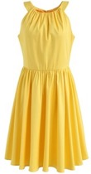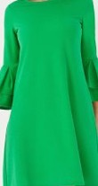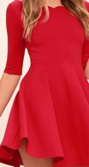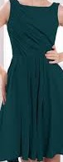
Look at the examples above left; there is a picture of a women suffering from sallow complexion – her skin is of yellow color. Now imagine she is wearing one of these dresses below- she will look worse and more ill. The dresses will add to the yellowness of her skin making the eye to intentionally notice and additionally “remember” that the face is sallow.
Now lets look at the eaxmple above right; Here we see completely opposite effect of how the colors are kind of “brake” the yellow color of the face and add life to complextion making the eye to “forget” about yelowness.

- Which types of colors would be more suitable for a blonde person’s dress?
To answer to this question first we need to bear in mind the skin color of potential blond customer, and consequentially their types – warm blondes and cool bonds.
Cool blonds with pale skin color are the favorites of pastel tones (baby blue, pastel pink, those of with blue or gray undertone). These colors together with the neutral pallet of the blond persons complexion create all feminine look and harmoniously continue their soft colors of skin and hair with clothes creating flattering complexion. These all is because of their cool undertone which is perfectly being complemented by the cool pastel colors.
Warm blondes and those of more brunette color of skin benefit from more brighter colors like warm red, grassy green, aqua, deep purple. These shades go well with the warm undertone of wearer and pick up the brighter tones of hair creating flattering complexion.
The other beneficial tone is metallic, whether classic silver or gold it gets the brightest tones of blond hair and make the wearer to shine bright.
Yellow is thought to be one of the most bothering color for blonds as it is thought to get merged with the hair color and create an ill look complexion. However, it is not quite like that. The bold, statement making yellow is enhancing the overall look of the blond-haired person by taking up the golden tones in hair and creating a sun kissed skin color. Pale yellow is also good for blonds, however is will be good for bright blond hair women as it will complement the hair color by continuing the yellow tones with “lower intensity” and thus highlighting the golden bright hair color.
Another flattering hues for all types of blonds are classic black, dramatic white and all times favorite nude.
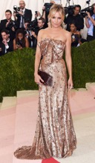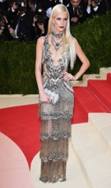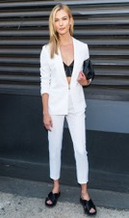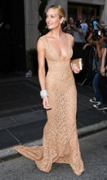
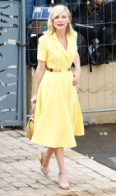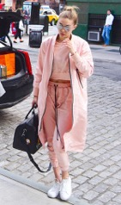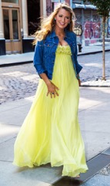

Student Statement:

By submitting this assignment, I confirm that this is my own work.

Student Signature | Anna Babayan | Date | 25.02.2018

For Tutor / Assessor Use Only
Total Marks
Marks Obtained
Percentage / Grade

http://art-design-glossary.musabi.ac.jp/chromatic-and-achromatic-colors/
https://yourcolorstyle.com/color-theory-warm-grey-vs-cool-grey/
https://theidleman.com/manual/mens-hair/guide-styling-grey-hair/
https://www.psychologytoday.com/blog/what-the-wild-things-are/201109/could-gray-be-the-new-black
http://www.whowhatwear.com/colors-for-blondes/slide33

