
Assignment Cover Sheet

Student Name: | Stuart Clark
Student Number: | 28519
Course: | Certificate in Environmental Management Level 3
Assignment NO: | 3

Marking Criteria:
We expect the learners to write minimum one well expressed point in three lines against each allocated mark. This means one needs to write 15 lines with 5 well expressed points to get high grades for a 5 marks question.
For high grades use examples and illustrations where appropriate.

Student Statement:

By submitting this assignment, I confirm that this is my own work.

Student Signature | Stuart Clark | Date | 26/03/19

For Tutor / Assessor Use Only
Total Marks
Marks Obtained
Percentage / Grade

- The Environmental Regulatory Frameworks in the UK, as described by Coxall & Hardacre (2013), are key pieces of environmental legislation which for the most part originate from EU law. These are either implemented directly or through national legislation. The Environmental Protection Act 1990 made provision for the improved control of pollution to the air, water and land by regulating the management of waste and the control of emissions (Cobwell, 2016). The Act applies in England, Scotland and Wales for Northern Ireland, the main provisions of the Act are enclosed in the Waste and Contaminated Land (Northern Ireland) Order 1997. Since the passing of this act several elements have been superseded with new pieces of legislation (Coxall & Hardacre, 2013).
On the whole for the United Kingdom the key environmental regimes can be considered as:
- Environmental Permitting Regime (EPR), combining the pollution prevention and control (PPC) regime and waste management licensing and industrial emissions
- Water
- Waste (in relation to aspects not dealt with under EPR)
- Contaminated land
- Conservation of nature, wildlife and habitats.
- Environmental impact assessments (EIAs)
For environmental legislation in England, and on some matters in Wales, the UK government legislates via the Environment Agency (EA) (Cobweb, 2017). For all remaining matters in Wales the National Assembly for Wales have powers to passes legislation (Coxall & Hardacre, 2013). These powers were appointed thorough the Natural Resources Body for Wales (Establishment) Order 2012, which appointed Natural Resources Wales (NRW) as the environmental regulator for Wales, replacing the EA. For Scotland and Northern Ireland legislation is provided by (Cobweb, 2017):
- Scottish Environment Protection Agency (SEPA)
- Northern Ireland Environment Agency (NIEA)
The various parts of the Environmental Protection Act 1990 and some the subsequent regulations can be found in figure 1 on page 4 below.

- The Environmental Permitting Regulations (England and Wales) 2016 came into force on 6 April 2008 (Cobweb, 2017) and require regulators to control certain activities which could harm the environment or human health. For Scotland and Northern Ireland the appropriate regulations are:

- Pollution Prevention and Control (Scotland) Regulations 2012
- Pollution Prevention and Control (Northern Ireland) Regulations 2003
In 2007 (for England and Wales) the Environmental Permitting Regulations (EPR) combined the Pollution Prevention and Control (PPC), Waste Management Licensing (WML) regulations and Local Air Pollution Control (APIS, 2016). Any PPC permits and waste management licences issued prior to this date were automatically converted to Environmental permits. Subsequently England and Wales brought water discharge, groundwater discharge and radioactive substance registration/ authorisation under the EPR in 2010.
In Scotland on the 1st of September 2018 the Environmental Authorisations (Scotland) Regulations 2018 (EA(S)R) came into effect, these seek to provide an integrated framework, for the authorisation, procedural and enforcement arrangements regarding water, waste management, radioactive substances and pollution prevention and control currently only radioactive substances are covered (SEPA, 2019). Water related matters remain for the moment covered by Water Environment (Controlled Activities) (Scotland) Regulations 2011.
For Northern Ireland the appropriate regulations are
- The Radioactive Substances Act 1993 (Amendment) Regulations (Northern Ireland) 2011
- The Water (Northern Ireland) Order 1999

The Department for Environment Food and Rural Affairs list the activities regulated via the Environmental Permitting Regulations as (DEFRA, 2013):
- Activities or specified installations listed in Schedule 1 to the EPR.
- Waste operations.
- Mobile plant used to conduct either one of the Schedule 1 activities or a waste action
- Mining waste operations.
- Water discharge activities.
- Radioactive substance activities.
- Groundwater activities.
- Small waste incineration plants.
- Solvent emission activities.

- There are various legislation and regulations that cover the remediation of contaminated land in the UK. The two main pieces of legislation that cover this topic are:
- EU Environmental Liability Directive 2004/35/EC
- The Environmental Protection Act 1990.
The regulations that are relevant to the UK under the EU Directive and the Environmental Protection act are displayed in figure 2 on page 4.
Currently the law seeks to identify the appropriate persons responsible for cleaning up contaminated land; UKELA (2019) suggests that in practice, it is common to address this matter at the time the land in question changes ownership and the law offers incentives to deal with this, such as:
- If the appropriate person finances the purchaser to pay for the remediation of the land, providing that the sum offered is adequate then the person paying the money will discharge any future liability (UKELA, 2019).
- If the seller informs the buyer of the presence of contamination and/or allows this to be inspected then they will be freed from any future liability (UKELA, 2019).
It is through these sorts of incentives that the law is endeavouring to have parties consider how to deal with historic pollution. In addition the current planning laws make provision for contaminated land remediation during re-development.

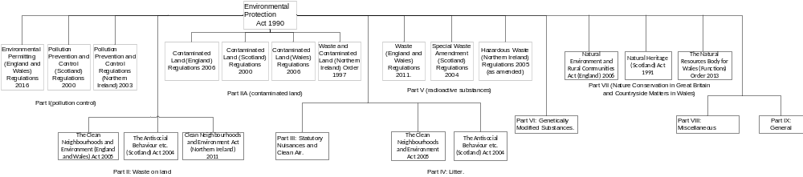Figure 1 Environmental Protection map (Clark, 2019)

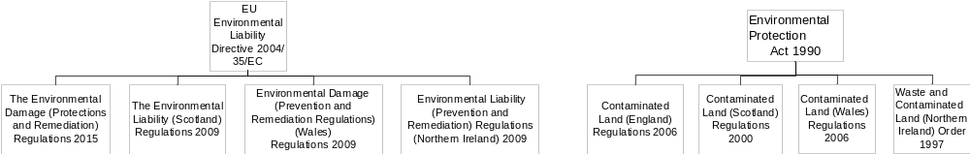
Figure 2 Contaminated Land Legislation (Clark, 2019)

Bibliography
Cobweb, 2017. BIF100 · Environmental Regulations - An Introduction to, Gateshead: s.n.
Coxall & Hardacre, 2018. Q&A on Environmental Law in UK (England and Wales), London: Clifford Chance LLP.
Crown, 2012. The Pollution Prevention and Control (Scotland) Regulations 2012. Norwich: TSO.
Das, P. K., 2016. An Introduction to the Concept of Environmental Management: Indian Context. International Journal of Innovation and Economic Development, 2(4), pp. 25-34.
Dionis, A. et al., 2016. Implementation and Benefits of Environmental Management System. Journal of Maritime Research, Volume 13, pp. 77-81.
Epstein, M. J., 2016. Making Sustainability Work: Best Practices in Managing and Measuring Corporate Social, Environmental, and Economic Impacts. s.l.: Berrett-Koehler.
European Commission, 2019. The European Commission. [Online]
Available at: http://ec.europa.eu/environment/legal/liability/pdf/eld_ms_reports/UK.pdf
[Accessed 06 March 2019].
Hammar, M., 2019. Plan-Do-Check-Act in the ISO 14001 standard, s.l.: 14001 Academy .
International Organization for Standardization, 2018. International Organization for Standardization. [Online]
Available at: https://www.iso.org/about-us.html
[Accessed 23 January 2019].
K.A.CHANDRAKANTH, 2019. Agile Alliance. [Online]
Available at: https://www.agilealliance.org/wp-content/uploads/2016/01/PDCA.pdf
[Accessed Friday February 2019].
Kotze, L. & JG, N., 2009. Environmental management in South Africa. 2nd Edition ed. s.l.:s.n.
Lochner, P., 2005. Guideline for Environmental Management Plans. CSIR Report No ENV-S-C. Cape Town: Department of Environmental Affairs & Development Planning.
Moen, R. & Norman, C., 2006. Evolution of the PDC, s.l.: s.n.
Muttu, S. & Nordin, N., 2016. PDCA CYCLE. SSRG International Journal of Mechanical Engineering (SSRG-IJME) , 3(5).

Rossheim, J., 2019. Environmental Accountants Do It for the Green, s.l.: Monster.
SEPA, 2019. Scottish Environmental Protection Agency. [Online]
Available at: https://www.sepa.org.uk/regulations/water/abstractions/
[Accessed 26 March 2019].
Speroff, T. & O'Conner, G., 2004. Study designs for PDSA quality improvement research. Quality Management Health care, Volume 13, pp. 17-32.
Taylor, M. et al., 2014. Systematic Review of the application of the plan-do-study-act method to improve quality in healthcare. BMJ Qual Saf, Volume 23, pp. 290-298.
Vasovsk, S. & Weinste, J., 2004. The PDCA Continuous Improvement Cycle. s.l.:s.n.

