
Assignment Cover Sheet

Student Name: | Rabih Kanj
Student Number: | 8705
Course: | Diploma in Risk Management
Assignment NO: | 3

Marking Criteria:
We expect the learners to write minimum one well expressed point in three lines against each allocated mark. This means one needs to write 15 lines with 5 well expressed points to get high grades for a 5 marks question.
For high grades use examples and illustrations where appropriate.
Please insert your completed assignment ( in word format) here:

Student Statement:

By submitting this assignment, I confirm that this is my own work.

Student Signature |  | Date

For Tutor / Assessor Use Only
Total Marks
Marks Obtained
Percentage / Grade

Question 1.
- What is enterprise Risk Management?
Enterprise risk management (ERM) is the process of planning, organizing, leading, and controlling the activities of an organization in order to minimize the effects of risk on an organization’s capital and earnings.
As an example you can use the following ERM framework to understand, identify, and analyse the whole situation.
Step 1; Objectives: Understanding & Confirm Business Step 2; Identify Step 3; Analyse Step 4; Monitor Step 5; Report then to identify
- Outline the main responsibilities of a CRO in an Organization.
Risk Officer Must:
- Manage the implementation of all aspects of the risk function, including implementation of processes, tools and systems to identify, asses, measure, manage, monitor, and report risks.
- Assist in the development of and manage processes to identify and evaluate business areas risk, and control self-assessments.
- Manage the process for develop risk policies and procedures, risk limits and approval authorities.
- Monitor major and critical risk issues.
- Manage the process for elevating control risk to more senior levels when appropriate.
- Be leaders in developing and improving management reports.
- Generate project management documents.
- Ensure technical specifications meet the stated needs of the business.
- Conduct compliance & risk assessments.
- Document project plans, action plans, presentations and projects result for clients.
- Implement the security program risk and control framework and global IT risk strategy.

- What is Risk Control?
Control Risk Is the method by which firms evaluate potential losses and take action to reduce or eliminate such threats.
Organizations may control risks in a number of ways; by adopting only one technique or a combination of several practices. The first strategy is to control the risk at its point of origin, such as by improving a configuration or change a management process to reduce the possibility of errors being introduced into systems. Another way to control risks is to examine the interrelated company risks and reduce the overall level of risk for the company, this type of control method usually requires delving into the most risk prone area of the business,
Example;
As part of ABC Construction risk management efforts, the company developed Business Continuity Plans (BCPs) in fiscal 2012 as a means of ensuring core business activities can continue in the event of lack in sales. The BCPs played a role in responding to issues caused by the economy crisis that occurred in March 2014. Because the dropped down sales caused massive damage on an unprecedented scale, far surpassing the damage assumed in the BCPs, some areas of the plans did not reach their goals. Based on lessons learned from the company’s response to the sales dropped down, executives continue promoting practical sales discount and staff training programs, confirming the effectiveness of the plans and improving them as needed. In addition, ABC Co. continues setting up a system for effectiveness in sales programs and skills.
If the Risks cannot be controlled sufficiently within the company, it might become necessary and appropriate to transfer them outside of the company. Allocating risk capital to cover the expected costs of a specific risk event or acquiring additional insurance policies for security against the event are typical ways of doing this.
- Outline the components of a business plan.
ERM is about protecting and improving share value to satisfy the primary business objective of shareholder wealth maximization. It must be a multifaceted approach, addressing all facets of the business plan from the strategic plan through to the business controls;
- Strategic Plan
- Marketing Plan
- Operations Plan:
- Research and development
- Management and organization
- Forecasts and financial data
- Financing
- Risk Management Processes
- Business Control.

- What is the importance of communication in crisis management?
ERM can have a positive effect with the organization stakeholders in the event of a catastrophic occurrence. This communication is definitely important for all categories of affected parties, including the company’s employees, trading partners. Having an effective ERM strategy in place can be a huge benefit to the organization prior to, during and after crisis times. ERM communication is concerned with proactive communication about the organization’s preparation and contingency plans, there is another kind of communication that is an equally important part of any business continuity planning, namely crisis communication. If crisis communication is not planned for and executed properly when a difficult situation actually arises, it can make or break even the best of organizations.

- What is the role of senior executives in risk management of an organization?
Senior Executives need to be made aware of their role in risk management and understand the types of risks that are present within the company. Ultimately, the board of directors must approve the overall approach towards risk-taking. The lines of risk-taking authority and accountability should be clearly defined.
The board is responsible for the following;
- An annual review of risk policies and critical procedures must be created; this is the most critical practice through which the board of directors can express its tolerance for and attitude toward risk management.
- Be involved in approving the risk limits; limits are an explicit statement of the company’s appreciation for risk. Defining limits is an important technique for controlling risks.
- Build a new product development procedure; this is a significant means of controlling future risks. The board should make sure that all new products are comprehensively reviewed by risk management, legal, compliance and operations.
- Monitor policy exceptions; it is just as important for the board to make sure that the proactive elements of risk management defined above are in place, as it has to determine a reactive approach. How to handle exceptions to risk policies should be well defined, strictly audited, and closely monitored by the board.

- Briefly outline the main benefits of implementing ERM.
Benefits of implementing ERM
Type of Risk | Expected Benefits
Business Interruption | Avoid production loss, legal liability, and business failure.
Business Interruption | Achieve Operational Reliability
Environmental | Reduce Insurance premiums. Avoid litigation from government
Environmental | regulatory authorities and other groups
Health & Safety | Prevent worker injuries or fatalities, evade worker litigation and
Health & Safety | decrease insurance premiums
Marketing | Avoid damage to brand or reputation, gain competitive advantage
Marketing | and maintain or increase market share
IT | gain access to information, prevent or avoid operational failures due
IT | to technology, inability to pay or invoice.
Product Liability | Prevent litigation. Protect customers from damage or ham
Technical | Prevent production stoppages. Avoid using out dated equipment,
Technical | Manufacturing techniques or technologies.
Theft and Fraud | Avoid losing money, assets, or intellectual property. Avoid damage
Theft and Fraud | to reputation. Prevent loss of market share

Question 2.
“The fundamental goal of ERM is to avoid disruption or damage to the organization as a result of unplanned or unmanaged risk events”
Unmanaged risk is the greatest source of waste in your business and in our economy as a whole. Major projects fail; customer shifts make our offers irrelevant; billion-dollar brands erode, then collapse; entire industries stop making money; technology shifts or unique competitors kill dozens of companies in one stroke; companies stagnate needlessly. When these risk events happen, thousands of jobs get lost, brilliant organizations are disassembled, expertise gets lost, and assets are destroyed. Yet all of these risks can be understood, identified, anticipated, mitigated, or reversed, thereby averting hundreds of billions of dollars in unnecessary losses
Unmanaged risk … we all know that, in a world of constant change, things happen. Some things are within our control – most are not. However, the consequences of not being prepared for risk can have a damaging effect on our economy, our companies, our employees and the communities in which we operate.
The following diagram appeared in the framework document to illustrate how some companies have integrated preparedness into an overall ERM approach.
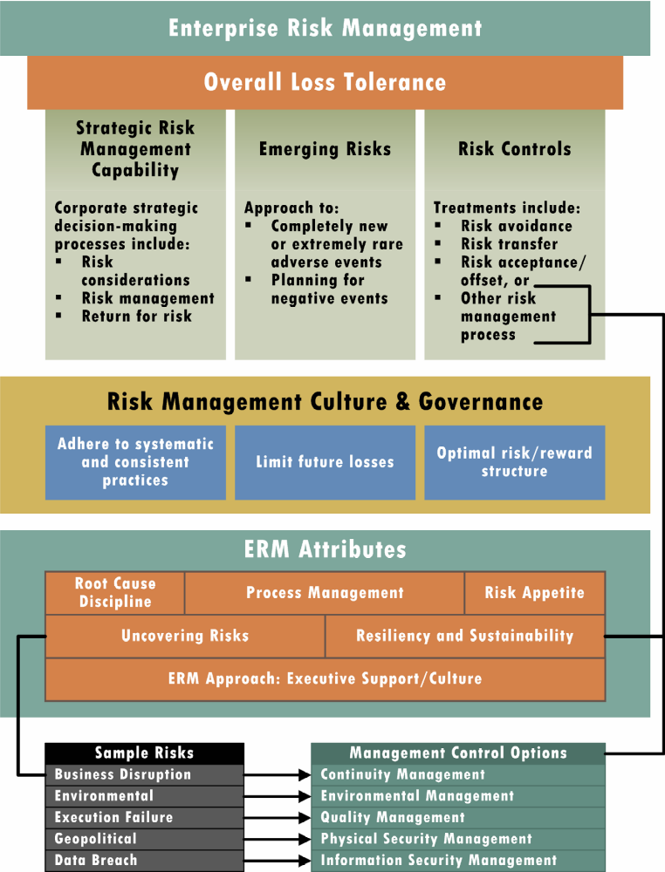

ERM views risk within an organization’s unique strategy, tolerance, culture and governance. The programs generally provide for a consolidated view of emerging risks, including those that require planning for potential adverse events, by a cross-functional governing committee or council. This approach encourages flexibility. All ERM frameworks focus on the organization’s overall business goals and objectives, the amount of risk the organization can tolerate, and what fits within its culture.
ERM enables an organization to prioritize and allocate resources against those risks that underpin the continued sustainability of the organization. In other words, an organization’s ability to maintain something of value (such as the delivery of services or products to customers) relies on its ability to understand and plan for those risks that may impede the achievement of its business objectives / goals or risks that could significantly impair its capital.
ERM encourages cross-functional discussion of potential unintended consequences. By establishing risk reporting as part of management’s normal business reviews – at whatever frequency makes sense for the organization – the decision-makers have a broader perspective of the risk interdependencies. These interdependencies relate not only to the risks themselves, but include the respective risk treatments undertaken for each risk.
Case Study:
- Outline the benefits of risk management which Dylan could share with Nigel.
Dylan has to share Nigel with the following:
- Align risk appetite and strategy: risk appetite is the extent risk on a broad based level, which Nigel is prepared to accept in pursuing its objectives.
- Reduce operational surprises and losses: they should identify potential risk incidents evaluate risks and determine responses. To reduces surprises and losses.
- Improve risk response decisions: Nigel has to provide the ability to identify and select appropriate risk response, such as risk acceptance.
- Resources: he has to understanding the risks that the business is facing then he can improve the effectiveness and use of the management time
- Link growth, risk and return: Nigel has to accept that risk is a part of wealth creation and preservation and they expect returns proportionate to the risks.
- Rationalize capital: Dylan and Nigel have to get more accurate information on risk exposure enables management to asses overall capital needs more effectively and improve capital allocation.

- What is the first step that Dylan will take for risk assessment of the business ?

1st step is by checking the process of the work, to make a clear mission and vision objective for the work.

Vision
Contribute to the creation, optimization and protection of enterprise value by managing our business risks as we create value in the marketplace.
Mission
Create a comprehensive approach to anticipate, identify, prioritize, manage and monitor the portfolio of business risks impacting our organization. Put in place the policies, common processes, competencies, accountabilities, reporting and enabling technology to execute that approach successfully.
After that he has to identify the business, analyze it, monitor it, and then report to Nigel

- What will Dylan do at the risk control stage?
By adopting the techniques or several practices, starting from the point of origin, such as by improving a configuration or change a management process to reduce the possibility of errors being introduced into systems. By examine the interrelated company risks and reduce the overall level of risk for the company.
As an example: Allocating risk capital to cover the expected costs of a specific risk event or acquiring additional insurance policies for security against the event are typical ways of doing this.

