
Assignment Cover Sheet

Student Name: | Victor Omotoso
Student Number: | 34830
Course: | Advanced Diploma in Logistics Management (Level 5)
Assignment NO: | Assessment # 6

Marking Criteria:
We expect the learners to write minimum one well expressed point in three lines against each allocated mark. This means one needs to write 15 lines with 5 well expressed points to get high grades for a 5 marks question.
For high grades use examples and illustrations where appropriate.
Please insert your completed assignment ( in word format) here:
- Give short answers for the following questions:
- What are the aims and functions of warehouses?
A Warehouse can be defined as that function which provides the proper space for the safe keeping of goods, provides a system to economically coordinate the necessary activities, facilities and manpower, and provides for the overall control of the entire operation.
Aims of Warehousing
- Basic Storage. For many small-business owners, the main objective for building a warehouse or renting warehouse space is simply to store inventory
- Efficient Accessibility
- Increased Turnover.
- Better Production Processes
- Decreased Shrinkage
- Optimal Safety

Functions of Warehousing:
- Storage: This is the basic function of warehousing. Surplus commodities which are not needed immediately can be stored in warehouses. They can be supplied as and when needed by the customers.
- Price Stabilization: Warehouses play an important role in the process of price stabilization. It is achieved by the creation of time utility by warehousing. Fall in the prices of goods when their supply is in abundance and rise in their prices during the slack season are avoided.
- Risk bearing: When the goods are stored in warehouses they are exposed to many risks in the form of theft, deterioration, exploration, fire etc. Warehouses are constructed in such a way as to minimise these risks. Contract of bailment operates when the goods are stored in wave-houses. The person keeping the goods in warehouses acts as boiler and warehouse keeper acts as boiler. A warehouse keeper has to take the reasonable care of the goods and safeguard them against various risks. For any loss or damage sustained by goods, warehouse keeper shall be liable to the owner of the goods.
- Financing: Loans can be raised from the warehouse keeper against the goods stored by the owner. Goods act as security for the warehouse keeper. Similarly, banks and other financial institutions also advance loans against warehouse receipts. In this manner, warehousing acts as a source of finance for the businessmen for meeting business operations.
- Grading and Packing: Warehouses nowadays provide the facilities of packing, processing and grading of goods. Goods can be packed in convenient sizes as per the instructions of the owner.

- What is the difference between public and private warehouses?
The following are few of the major differences between private and public warehouses:
- Private warehouses are owned by companies to store and ship their products. On the other hand, Public warehouses are leased to companies for storage and other warehousing services.
- Private warehouses are appropriate for firms that have a substantial demand for their products in a particular region whereas public warehouses are useful to those firms that require inventories to be maintained at different locations.
- Private warehouses involve a fixed cost whereas public warehouses involves a variable cost that is lower than the cost involved in private warehousing. It is because in public warehouses services are availed as when needed.
- Private warehouses operate on-site and off-site whereas public warehouses mainly for short-term usage.

- Explain the advantages of public warehouses.
A public warehouse is a business that provides short or long-term storage to companies on a month-to-month basis. ... The public warehouse is not only a facility where a company can store their products, but the public warehouse offers inventory management, physical inventory counts and shipping functionality.
The advantages of a public warehouse are:
- Storage facilities can be availed at desired locations as and when required, and at a known cost.
- The goods can be despatched to the warehouses with the warehousemen as the consignee for the clearance of the goods at the railhead and transportation to the warehouse.
- The goods can be delivered or despatched to the nominees/allottees of the depositor.
- The warehouseman does entire inventory management, and the depositor is completely free from these costs and botheration’s.
- The goods are handled properly and preserved scientifically by the trained technical personnel without any damage or deterioration during handling and storage.
- The goods can also be insured against all risks like fire, flood, thefts, etc. at nominal cost and the depositor is indemnified against such losses.
- The goods can be kept in the public warehouses till the market price is found remunerative enough for the disposal of goods and, thus, distress sale can be avoided.
- Advance can be obtained against the pledge of the warehouse receipt from banks.
- Uncertainties in the availability of raw materials or finished products due to supply dislocation are avoided.
- Public warehouse helps in the physical distribution of goods like food grains, fertilizers, public distribution items, consumer goods, etc. and therefore helps in marketing of products.
- The public warehouse can also be used for grading, standardization, and packing of goods if the arrangement is on dedicated and a long term usage basis.
- What are manual warehouses?
Manual warehouses / storage systems are storage locations and racking systems which are not accessed by automated systems, but operated by humans. ... Especially in narrow aisle warehouses, however, you can also find order picking stations where goods are collected or made available (goods-to-man).

- What are automated warehouses?
Automated warehouses are efficient, fast, flexible and reliable. ... With automated storage systems, processes such as the storage, retrieval and relocation of goods proceed automatically. This means that warehouse operators do not have to undertake strenuous or monotonous tasks and that errors are reduced to a minimum.

- What are the main materials used for packaging?
- Paper/Paperboard/Fibreboard. Paperboard and fiberboard are used in both primary and secondary packaging for companies throughout the world.
- HDPE/PET/Rigid Packaging.
- LDP/LLDPE/Flexible Packaging.
- Aluminium Packaging
- Glass/Jars.

- Outline the activities that take place in a warehouse.
- Receive goods
- Identify goods (SKU or P/N)
- Dispatch goods
- Hold goods
- Pick goods
- Marshall the shipment
- Dispatch the shipment
- Operate an information system

- Describe, in detail, the general layout of a warehouse. Using examples and illustrations.

Warehouse layout design is a crucial part of an efficient operation.
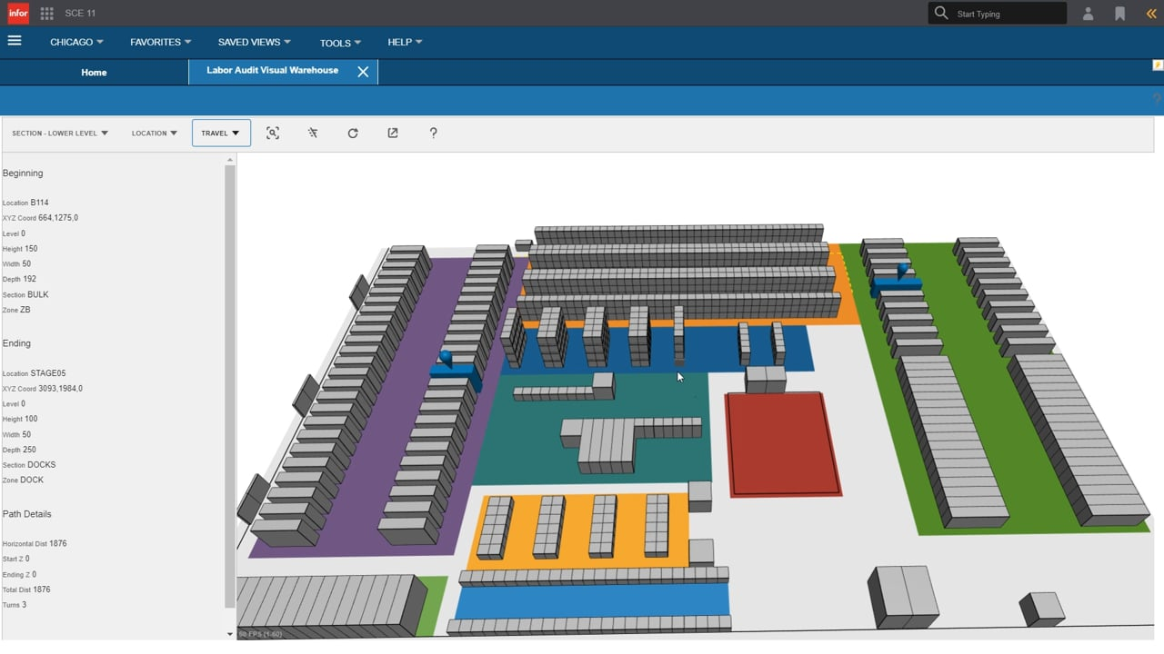

When considering the layout and operation of any warehouse system, there are fundamental principles that embody a general philosophy of good practice. The principles are:
  - Using the most suitable unit load
  - Making the best use of space
  - Minimizing movement
  - Controlling movement and location
  - Providing safe, secure and environmentally sound conditions
  - Maintaining at minimum overall operating cost
Successful warehouse layouts must adhere to the principles, regardless of material being stored to:
- maximize the use of space
- maximize the use of equipment
- maximize the use of labour
- maximize accessibility to all items
- maximize protection of all items

Although the objectives of warehouse layout and operation are easily recognized, warehouse layout problems are often complicated by large varieties of products needing storage, varying areas of required storage space and drastic fluctuations in product demand.
Therefore, an effective layout design of the warehouse is required to address these problems and accomplish the objectives.

Student Statement:

By submitting this assignment, I confirm that this is my own work.

Student Signature | OmotosoVOT | Date | 26/01/2020

For Tutor / Assessor Use Only
Total Marks
Marks Obtained
Percentage / Grade

