
Assignment Cover Sheet

Student Name: | Anne Hodson
Student Number: | 26988
Course: | Fashion Design
Assignment NO: | 2

Marking Criteria:
We expect the learners to write minimum one well expressed point in three lines against each allocated mark. This means one needs to write 15 lines with 5 well expressed points to get high grades for a 5 marks question.
For high grades use examples and illustrations where appropriate.
Please insert your completed assignment ( in word format) here:
(1i) In the elements of fashion design, the term ‘Weight and hand’ is commonly used to describe fabrics. ‘weight’ meaning the heftiness of the fabric and how heavy it is in terms of quality, ‘and hand’ meaning the textural quality and the feel of the fabric.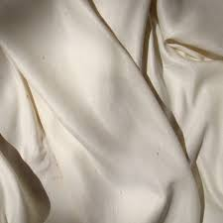
(1ii) Warm colours are an essence of autumn/winter fashion, and weather. These colours consist of reds, yellows and oranges, simulating a lively, aggressive tone depending on their value within the fabrics. Warm colours at their prime are best used in a simpler dress shape. For example, avoiding extravagant, loud dress shapes such as circle and oval dress shapes and going with a more understated style such as a rectangular shape or even triangle. These shapes will best accentuate the firey-ness of warm tones and complement the figure, following the rule of thumb that bright colours should have a simpler design and more muted colours fit well on more daring pieces. On the other hand, warm colours with a deeper value, such as more earthly tones are a very natural colour to work with in dress designing and can be considered rather diverse.
(1iii) Patterned fabrics in dress designing can really make or break the beauty of the garment. Patterns should be thoroughly thought through when catering for a specific size and body shape of a person, as well as the architectural structure of the dress. It is important to consider scale, as the pattern can over power the elegance and can completely change the structural form of the dress by manipulation of the eye, bringing the attention to aspects of the body that are not wanted by the customer. It is important to remember that when using pattern, you are inevitably taking the focus from the shape of the dress and onto the flow of the pattern. Used well, the pattern can gently flatter the figure and the design, while bringing a new, fresh feeling to a garment. The pieces pattern should flow seamlessly into the dress’s architecture and not defy its structure through scale.
(1iv) Two of the styles of women’s fashion are conventional and geometric. A conventional style is conforming to the standards of the tradition of women’s style. It is feminine, being both cute and sweet while still evolving throughout historical fashion and in most cases, is quite understated pattern-wise. Geometric, on the other hand, is structured and the patterns are shapely. It is made up of flattering use of lines, patterns and textures and is the more ‘dramatic and modern’ of the two.
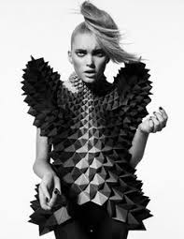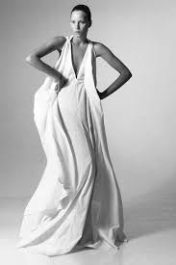
(2) Colour dimension is the elements of colours in their deepest form, giving it a certain hue, value and intensity. Hue is the shade of colour, the glaze that helps us differ between similar colours such as yellow and green. Value is the use of light and dark within a colour giving it a variation of strength. A white value suggests pure light whereas black is the absence of light, these being called tints and shades. The intensity is similar to the value of a colour being that if it has a lot of vibrancy/strength, it is brighter and if it has less strength...it is paler.
(3) All dress shapes and designs are made to fit different body shapes. If you are short and thin, the best dress shape for you should be a square dress. A square dress is usually shorter in length which elongates the legs, giving the illusion of a taller person. It also consists of a box fit making them look thin, tall and elegant. However for tall and thin body shapes, the hourglass design makes them look well proportioned and balanced. The broad shoulder and fluted skirt of this dress cinches the waist in and gives for a curvier looking figure and a smaller looking waist. A downwards triangle style dress is great for bottom heavy women as it gives the illusion of a proportional figure as well as gently flattering the curves and bringing in a smaller looking waist. The highlight of the shoulders gives the body and hourglass looking figure, one of the most desirable to many women. Similarly, the upwards pointing triangle flatters a top heavy, larger busted women by caressing the breasts, while fluting out at the bottom, again giving the illusion of an hourglass. Circular shapes are best worn by younger, more slender figures as it would cling to curves in a rather unflattering manor. It elongates the legs and stretches the length of the body to look even taller, however, this is a dress shape catered more towards the fancier, more ballgown evenings. To conclude, dress shape plays a big role in dress design and figure, it is vital to know the audience you are catering to and be inclusive.
Project

I based my design upon a structured, beige historical dress from the 1800’s. This beige garment consists of a heavily embroidered top with harsh billowing at the shoulders which gives it a sense of masculinity. I took inspiration from the top half of this gown and designed a long sleeved, structured top with the same embelishments. I gave the shoulders a Balmain vibe with harsh shoulder pads that sinches in the waist even more than the triangle portion of the top already does. For the bottom, I kept the Versace style pattern but with a more understated slit on the calf. I kept it simple by using the pattern as hooks for the buttons I used to tie in the bottoms to the top. This adds for a smart done up straight leg trouser with subtle detailing on the side or a sexier open slit that flatters the leg and flouts the trousers just a tad. I decided to keep my modern design in the same beige colour of the historical dress, as unicoloured 2 piece sets were a big hit in 2018 and are planned to stick around in 2019. To add a more Balmain vibe, I also envisioned this piece in black with gold detailing to make for a more evening look.
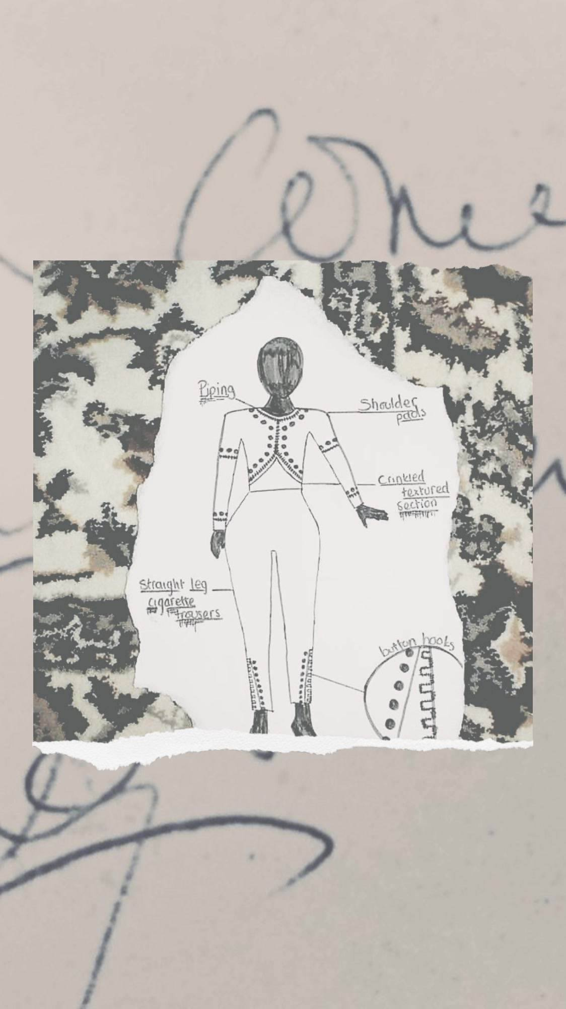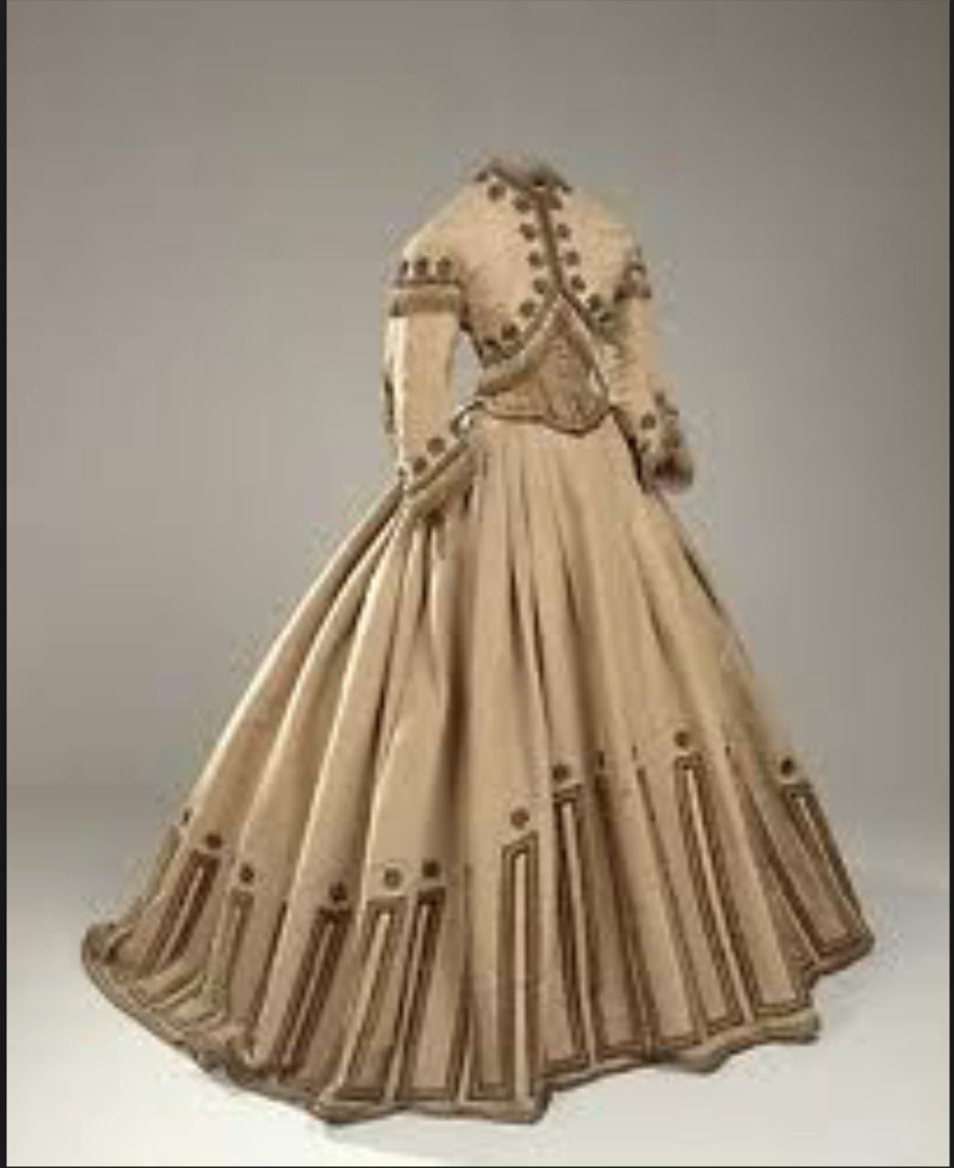

Student Statement:

By submitting this assignment, I confirm that this is my own work.

Student Signature | Annie Hodson | Date | 3.2.2019

For Tutor / Assessor Use Only
Total Marks
Marks Obtained
Percentage / Grade

