
Assignment Cover Sheet

Student Name: | Brigitta Bodnar
Student Number: | 7022
Course: | International Diploma in Project Management
Assignment NO: | 5

Marking Criteria:
We expect the learners to write minimum one well expressed point in three lines against each allocated mark. This means one needs to write 15 lines with 5 well expressed points to get high grades for a 5 marks question.
For high grades use examples and illustrations where appropriate.
Please insert your completed assignment (in word format) here:

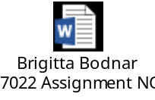

Student Statement:

By submitting this assignment, I confirm that this is my own work.

Student Signature | Brigitta Bodnar | Date | 14.01.2018

For Tutor / Assessor Use Only
Total Marks
Marks Obtained
Percentage / Grade

