
Assignment Cover Sheet

Student Name: | Alexander Brogan
Student Number: | 21743
Course: | Event Management Diploma Level 4
Assignment NO: | 9

Marking Criteria:
We expect the learners to write minimum one well expressed point in three lines against each allocated mark. This means one needs to write 15 lines with 5 well expressed points to get high grades for a 5 marks question.
For high grades use examples and illustrations where appropriate.
- a)
“Imagine Events”

b)
“We aim to deliver a unique, unforgettable event through providing a personal yet professional service, with an affectionate attention to detail and flexible execution to suit your individual needs.”

c)
At Imagine Events, we are a rising business specialising in social events with intermediate levels of capacity and budget. We offer expert services for weddings, birthday and anniversary parties, graduations, funeral receptions and more.
Our team, headed by Alex Brogan (Event Planning Manager), are all highly-skilled and versatile, allowing us to help you plan and enjoy the event of your choice, with adaptable levels of formality and involvement from our clients at their own discretion. We know that no event is the same as the last or the next, so we will tailor the layout of the venue and the delivery of the programme, in a sophisticated manner. We can also guarantee a high level of compassion and professionalism through any difficult times during the process.
The services we provide with regards to the actual event include:
• Arranging to meet with the client once they have secured our services, to initiate a positive working relationship
• During this meeting, gather information to understand the type of event, venue and any catering requirements necessary for the event. It is also at this time that there should be a discussion regarding the payment schedule for the process to go ahead and organise regular follow-up meetings to assess progress
• We will perform extensive investigations to determine the suitability of the client’s chosen venue and catering company, reporting back to them regarding the result
• All legal documentation concerning the venue, catering company and provision of any additional external services will be overseen by the Event Planning Manager and fully understood by the client in order for the relevant aspects of the event to proceed as planned. This may be referred to by any party at any time. Such documents may include for example; a venue’s public liability insurance should the client wish to hire a soft play area for a children’s birthday party.
• At least one representative of Imagine Events will be present to supervise, and assist with, the setting up of the venue prior to the event, to ensure that it mirrors the agreed plan
• Imagine Events will be able to refer clients to close business partners who provide a range of services such as; balloons, cakes and general catering, DJs etc. to reduce the pressure on the client to search for affordable, suitable businesses to do the same

d)
Primary analysis of the industry includes gathering data through contact with customers and event participants. This information can be obtained by conducting internet surveys, written questionnaires and phone calls to find out, first-hand, what people involved with the event felt were positive and negative aspects of it. From this information, those analysing it can determine by general consensus which parts of the event need to be changed for the benefit of the participants in future. Studying the success of the event will allow those providing the service to improve the planning and execution of their business products. This may include details on; value for money, quantity of products available, quality and standard of service, and more.
Secondary analysis requires assessing the information concerned with market share for example. This is the proportion of sales that a given competitor has made based on the industry’s overall sales. Also, during this secondary research, information on promotions, approaches and products can be obtained. As with primary analysis, the information obtained and investigated can be used to develop the business by allowing its representatives to play to their strengths. The data can help them to determine which prices, products and promotions will best benefit the business.

e)
In the events sector, there will be noticeable trends throughout the seasons and across the year, where the business’ leaders should expect rises and falls in demands. For example, an obvious rise will come in Autumn and Winter, where there will be a high concentration of Halloween, and then Christmas and New Years events respectively. Likewise, with the Spring and Summer, there would be frequent weddings and, of course by extension in the future, anniversary parties and events. Despite this, throughout the remainder of the year, the spread of events such as birthdays, christenings and funerals etc would be fairly consistent, so generally speaking there shouldn’t necessarily be any period where business is stagnant.
Competition could come from a range of sources, for example there would be people in the local area with the same intentions as Imagine Events, attempting to establish themselves in the community and gain a reputation as the go-to event planning company. Additionally, there will be event planning companies who are already fairly well-established, perhaps household names, so people who regularly require events to be organised may use one of these companies and be reluctant to change take their business elsewhere. Furthermore, lots of people entrust family members, friends and themselves to plan the majority of their own events, so may actively avoid spending portions of their budget on the services of a professional event planner. All of these factors have the potential to hinder the growth of the Imagine Events company.

f)
Advertising and marketing for the business could be done successfully in a variety of ways. Imagine Events could, similarly to the mention of partnerships with other companies and services in part “c)”, form relationships with venue sales management teams to encourage clients to use certain venues, in exchange for promotion and visual advertisements on their websites or at their site(s). Also, representatives of Imagine Events could be responsible for, at an appropriate time during or after an event, speaking to clients along with their guests, regarding handing out business cards or information leaflets and asking them to generally recommend the name in future.
Also, sourcing as many free or low-cost marketing mediums as possible will be a cost-effective way of projecting the business name and purpose out to the public, of course more specifically it would make sense to channel this into relevant areas where people interested in hiring event planners will likely be. For example, signage at or near existing events and venues, producing an eye-catching, informative website for people to search on the internet, or adding decals to the bodywork of the vehicle used by the representatives of the business travelling to and from venues and meetings could be useful.

g)
• Trademark Business Name – this is to ensure that no other person or company can use this name, it is solely the possession of the business’ owner
• Trade Description Act 1968 – this prevents a company providing a service or a product from misleading its customers regarding what they are paying for
• Consumer Rights Act 2015 – products and services sold should be of a satisfactory quality, fit for purpose and as described by the party selling them
• Employer’s Liability Insurance – protects the business and helps pay compensation in the event that an employee gets injured falls ill due to the work they do for the business. This policy must come from an authorised insurer and cover the business for at least £5million
• Meeting Tax-Related Obligations

h)
Expected Income Expected Expenditure
Bookings Staff wages
Business resources
Travel and transport
Marketing plan
Insurance
The business would be expected to lose a reasonable proportion of the £30,000 investment within the first 12 months, while the name is not particularly well-known, and leads are lost to potential customers preferring more popular companies. However, once the business begins to establish itself in the general public and, more specifically, in the community that concerns itself with the organisation and execution of events, there will be a turn from overall loss into overall profit. It is from this point where the business should consistently turnover a positive net income generation moving forward.

2. a)
Event Summary:
Event Name: The Amateur National Floodlit Football Cup Final
Venue : The Ivy Stadium
Date: Friday 25th January 2019
Time: Stadium Open: 6:00pm, Kick Off: 7:45pm
Contact Person*: Alexander Brogan
Position: Event Planning Manager
Telephone: 0121 429 ****
Mobile : 07*********
Email: brogan***@gmail.com

Website: www.unlimitedevents.co.uk

Mailing Address: 44 Cobble Street, Birmingham, B99 9XZ
“*For a full list with contact details of all involved in the event, please see over the page”
Description: “This event will be a demonstration of the highest standard of amateur football the nation has to offer.”
Vision: “To highlight the quality that grassroots football has to offer, given the support and recognition it deserves countrywide.”
Briefly, the event programme will consist of the Cup Final match, as detailed above commencing 7:45pm, followed by the awards ceremony for the eventual winners and runners-up of the match.
The Event Organisation will be the Football Association (FA), the nation’s governing body for football. The FA will fund a large proportion of the event and contribute to the organisation and execution of it. Sponsors for the funding of the event could include; McDonald’s, Coca-Cola, BT Sport (television), along with franchises that would willingly contribute products or financial support in exchange for media promotion and recognition. For example, for the merchandise sold at the event, the fabrics could be designed and produced by companies such as Fruit of the Loom, who could then of course expect a proportional profit from the subsequent sales.
A large percentage of income generated by the event would come from the ticket sales to prospective attendees. The target market for the event would, of course, be people across the country who are interested in watching amateur football. Encouraging all ages and groups of the public would increase the diversity of the population viewing grassroots football, particularly families and young people who will naturally be more impressionable and should, given a positive experience of the event, be motivated to emulate what they have seen, following the event. In addition to ticket sales, income for the event would come directly from food and beverage sales within the stadium. As shown on the site plan below, there are several food stalls available in both tiers of the stand area.
Just outside the stadium boundary, but still on-site, there are a handful of food stalls that stand alone and will be open for use by local food-related businesspeople. These caterers, for example with sweet carts or burger vans, will be welcome to use the venue as a rent-free source of income for the duration of the event. This would encourage local businesspeople to get involved with the event and would benefit them a great deal financially, on a short-term basis.
Of course, alongside all of the income generating factors of the event, come the factors contributing to the expenditure one can expect from its planning and execution. A large proportion of this expenditure will go towards staff wages for the event; security personnel, stewards, event planning team, match officials, catering teams, ticket office staff, groundsman etc.
Additionally, large sums of money will be spent on the energy resources required to allow the event to go ahead. These will include:
• electricity for; general lighting and pitch floodlights, heaters in the foyer area, turnstiles and perhaps ticket scanners, PA system
• gas for: heating and cooking of food available for the event, central heating in enclosed areas of the stadium such as VIP boxes and changing rooms, hot water in all toilets and changing rooms for players’ and officials’ showers
Waste management for the event will be fairly straightforward, as the venue should already have ample waste disposal bins dotted around all areas, accessible to all audience members. These should be checked regularly by stadium staff and removed/replaced accordingly. The on-site food stalls should have waste disposal access contained within the stadium, away from attendees, but near enough to their working areas to prevent contamination through transport of waste.
The parking for the event will be contained within the venue site, as shown by the site design below. As can be seen in the design, there will be designated areas at either end of the stadium for disabled access parking, where necessary for ticketholders in possession of a “Blue Badge”. In the event that overflow parking is required, stewards will be asked to close off the two, full car parks and divert attendees towards local car parks and safe parking areas along nearby streets.
Insurance for the event should be dealt with by the stadium’s management team and should be provided for the event planning manager for thorough inspection and agreement. The planning manager should also draft a detailed risk assessment and produce and risk management plan with the leader of the stewarding team for the event. Any other permits or licenses necessary for the event should be proposed to the local council for written agreement.
The level of success the event ultimately has will be determined by how much profit it generates and the total number of tickets sold as a proportion of the stadium’s capacity (20,000).

b) Below
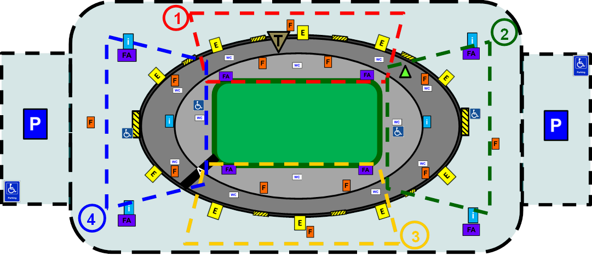

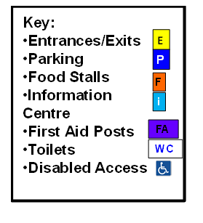
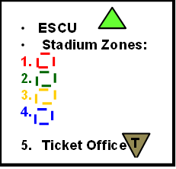
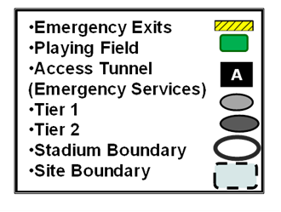
The vast majority of the items identified on the site design above should be fairly self-explanatory. However, for those that are not, a description and reason for their inclusion will be provided.
The Information Centres and First Aid Posts on-site, due to the size of the event and its budget, could simply be members of trained staff in clearly visible clothing, as points of contact encompassing the stadium so that they may be accessed easily by any participants requiring their services. First Aid staff, as shown, will be located at all four corners of the playing field, should they be called into action during the event to help ticketholders, staff or players. The Disabled Access icons highlight, first of all, the specific section of the parking area of the venue dedicated to “Blue Badge” holders, so that they may park and get in and out of their vehicles safely and with ease. Upon their entrance to the stadium they will be directed to either of the emergency exits with disabled icons next to them, located in Zones 2 and 4. Once they have entered these doors, of course as an exception to the other ticketholders, they will be pointed in the direction of their designated seating area in Tier 1 of the stand, at their respective end of the venue.
The Access Tunnel for Emergency Services will of course be reserved for incidents involving potential casualties. This area should be kept obstacle-free for the full duration of the event, allowing for an ambulance, or less likely a fire engine, to gain access to the playing field or the internal section of the stand area.
The ESCU (Emergency Services Control Unit) will be, in Tier 2, a vantage point for continuous investigation during the event used by representatives of; stadium management, commanding steward and police leading body on the day of the event. Within this room, they will be able to access all stadium-wide CCTV to monitor all areas of the venue at their discretion and highlight any potential issues to their team members in positions to act or investigate and report back to their team leaders. Also, the room is directly opposite the Access Tunnel, so those in the room will be able to see clearly whether it is clear and open for the entry of an emergency vehicle.
The Stadium Zones will be used to help direct ticketholders to the correct area of the stadium, should they be having trouble finding the block or zone corresponding to their ticket. Also, in the event of an evacuation, the ticketholders should be advised to leave the stadium and congregate at the assembly point relating to the number and colour of their zone on the site design. This would be used for general identification and for groups of ticketholders, particularly families of course, to reunite and ensure their party is safe.
Finally, the Ticket Office will be used for on-the-day ticket sales and for the collection of pre-paid tickets. Holders of tickets before the day of the event will have no particular need to use this facility and may proceed straight to the (Entrance) turnstiles at their relevant section of the stadium. People purchasing tickets on the day will abide by the general first come, first served basis, provided there are any remaining tickets available.

Student Statement:

By submitting this assignment, I confirm that this is my own work.

Student Signature | Alexander Brogan | Date | 28/11/2018

For Tutor / Assessor Use Only
Total Marks
Marks Obtained
Percentage / Grade

