
Assignment Cover Sheet

Student Name: | Olga Zawada
Student Number: | 25185
Course: | Supply Chain Management level 4
Assignment NO: | 10

Marking Criteria:
We expect the learners to write minimum one well expressed point in three lines against each allocated mark. This means one needs to write 15 lines with 5 well expressed points to get high grades for a 5 marks question.
For high grades use examples and illustrations where appropriate.
ASSESSMENT 10

1.What are the aims and functions of warehouses?
-Functions
Storage of goods
The basic function of warehouses is to store large stock of goods.
These goods are stored from the time of their production or purchase till their
consumption or use.
Protection of goods
A warehouse provides protection of goods from loss or damage
due to heat, dust, wind and moisture, etc. It makes special arrangements for different
products according to their nature. It cuts down losses due to spoilage and wastage
during storage.
Risk bearing
Warehouses take over the risks incidental to storage of goods. Once
goods are handed over to the warehouse-keeper for storage, the responsibility of
these goods passes on to the warehouse-keeper. Thus, the risk of loss or damage to
goods in storage is borne by the warehouse keeper. Since it is bound to return the
goods in good condition, the warehouse becomes responsible for any loss, theft or
damage, etc. Thus, it takes all precautions to prevent any mishap.
Financing
When goods are deposited in any warehouse, the depositor gets a receipt,
which acts as a proof about the deposit of goods. The warehouses can also issue a
document in favour of the owner of the goods, which is called warehouse-keeper’s
warrant. This warrant is a document of title and can be transferred by simple
endorsement and delivery. So while the goods are in custody of the warehouse-keeper,
the businessmen can obtain loans from banks and other financial institutions keeping
this warrant as security. In some cases, warehouses also give advances of money to
the depositors for a short period keeping their goods as security.
Processing
Certain commodities are not consumed in the form they are produced.
Processing is required to make them consumable. For example, paddy is polished,
timber is seasoned, and fruits are ripened, etc. Sometimes warehouses also undertake
these activities on behalf of the owners.
Grading and branding
On request warehouses also perform the functions of grading
and branding of goods on behalf of the manufacturer, wholesaler or the importer of
goods. It also provides facilities for mixing, blending and packaging of goods for the
convenience of handling and sale.
Transportation
In some cases warehouses provide transport arrangement to the
bulk depositors. It collects goods from the place of production and also sends goods
to the place of delivery on request of the depositors.
2.What are difference between public and private warehouses?

PUBLIC :
-warehouse is owned and operated by a third part
-charges in particular for types of services used
-mainly for short term usage
PRIVATE:
-also known as proprietary warehousing
-operated as a division within a company
- on-side and off-side warehousing.
For a public warehouse, insurance is mandatory while for a while a private warehouse, insurance is optional.
A public warehouse is operated as an independent business while a private warehouse is operated as a department of main business.
A public warehouse is located at entry point while a private warehouse is located near the premises of owner.
A public warehouse is large in size while a private warehouse is small in size.
A public warehouse is for hire to members of public while a private warehouse is for exclusive use of owner.

3.Explain the advantages of public warehouses.

- Reduces Your Need for Infrastructure. If you own a warehouse facility,
- Adapts To Your Needs. A warehouse you own costs you money and remains fixed in size regardless...
- Less Costly. If you buy a warehouse, you choose one based on anticipated peak space usage.
- Leveraging Specialty. Businesses manage lots of moving parts.

4.What are manual warehouses?

When it comes to manual storage systems, the handling of goods is static – inbound, outbound and relocation processes are carried out by qualified staff according to the “person-to-goods” principle. Material retrieval is usually carried out without any automatic tools or equipment. Manual warehouses are readily scalable, and offer a high level of flexibility and low acquisition costs, which is why they are used by companies of all sizes and across all industries

5.What are automated warehouses?

An automated warehouse is a facility where all or some of the tasks related to storing, retrieving, and moving inventory are carried out by automated systems. Using automation can cut down on costs associated with running the warehouse in the long term, although such systems are costly to implement initially. It can also provide added security, by keeping human workers out of sensitive environments. Numerous companies offer systems for use in warehouse an automated warehouse, goods can be moved by robots, along with conveyors and overhead pulley systems. Commonly, objects in the warehouse are tagged to allow them to be located by computer, and the inventory is continuously updated as objects move in, out, and around the warehouse. Technology like radio frequency identification (RFID) can be very useful in an automated warehouse .e automation and can provide consulting services, helping companies determine and meet their needs.

6.What are the main materials used for packaging?

- Plastic. Plastic is the most frequently used type of packaging material.
- Boxes. Cardboard boxes have been used for packaging since their introduction.
- Bubble Wrap.
- Shrink Wrap. Shrink wrap is commonly used on commercial.

7.Outline the activities that take place in warehouse.

-Receiving goods
-Identifying the goods
-Dispatching good to storage by sorting & putting away
-Holding goods by keeping and preserving
-Picking goods
-Marshalling the shipment such as goods making up a single order are brought together and checked for discrepancies .Order records are updated
-Dispatching the shipment
-Operating an Information System
-Quality Assurance.

8. Describe ,in detail ,the general layout of a warehouse .Using examples and illustrations.

One of the basics of operating a well run warehouse is the foundation of a well thought out warehouse layout. A layout that provides a solid base can lead to improved productivity and control of the accuracy of the overall operation. Conversely, a poor layout can lead to a myriad of issues and concerns.
Nonetheless, despite the specific circumstances, the general layout of a facility must cover all these needs:
- Making the most of the available space
- Reducing the handling of goods to a minimum
- Providing easy access to the stored product
- Having the highest rotation ratio possible
- Offering maximum flexibility in the positioning of products
- Controlling the amounts stored.
The following areas must be perfectly defined when designing a layout:
A. Loading and unloading areas
B. Reception area
C. Storage area
D. Picking area
E. Dispatch

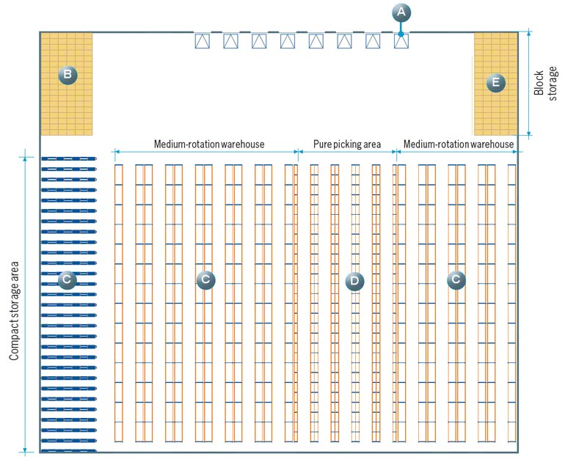

This is an example of a layout that includes all of these areas

Warehouse of a distribution company

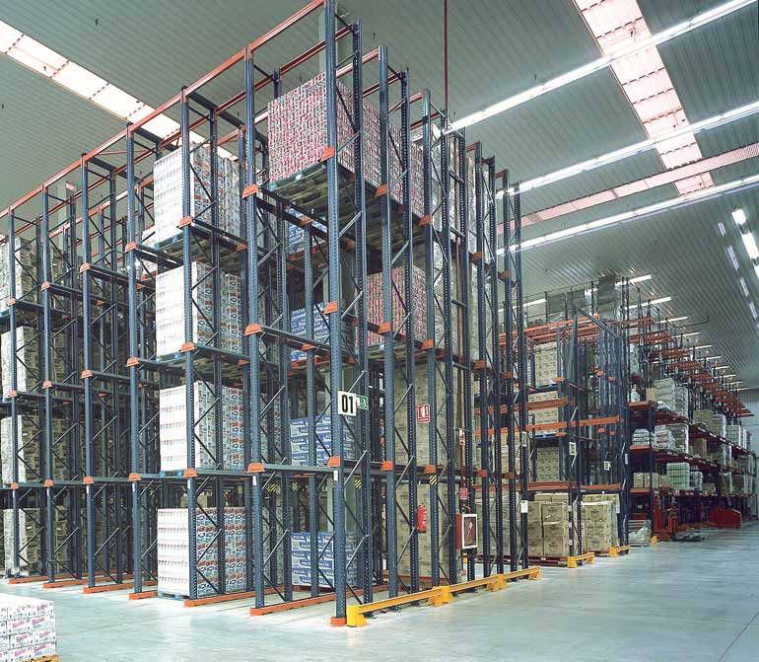

Student Statement:

By submitting this assignment, I confirm that this is my own work.

Student Signature | Olga Zawada | Date | 22.05.2019

For Tutor / Assessor Use Only
Total Marks
Marks Obtained
Percentage / Grade

